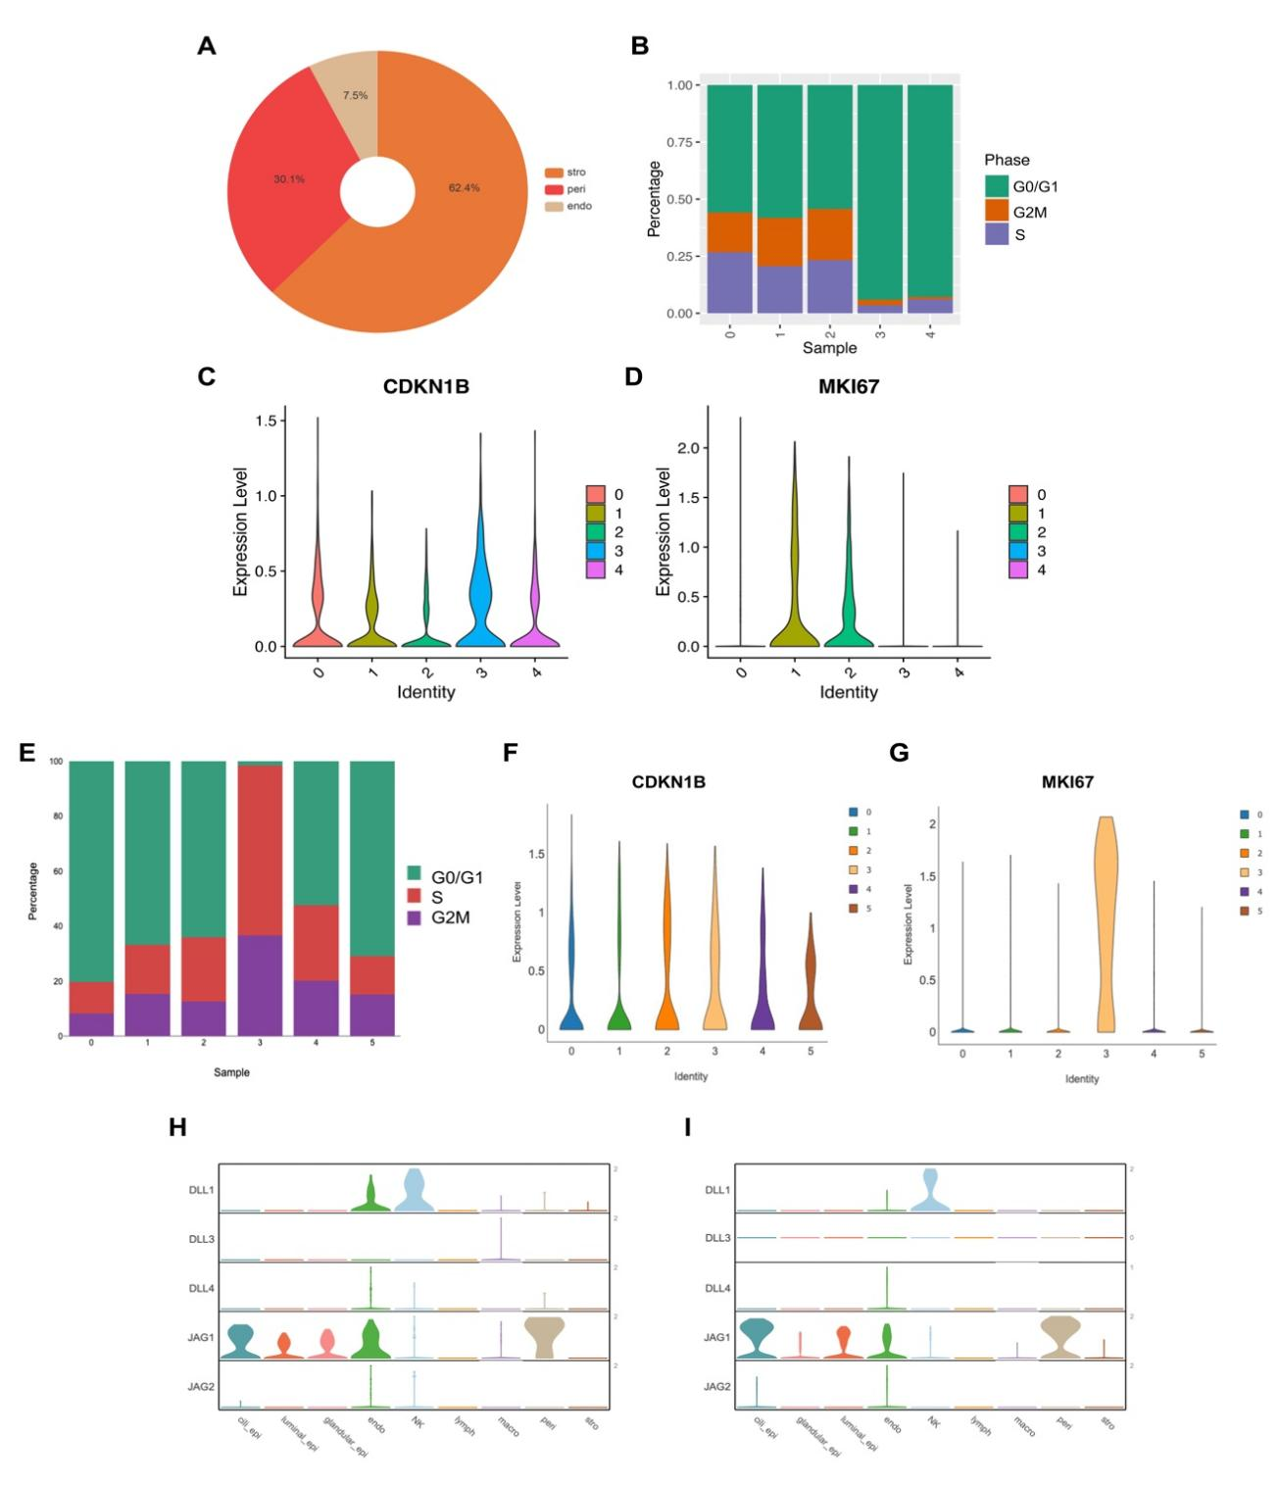

Supplementary Fig S4 – Cell type composition and cell cycle status of LEPR⁺ eMSCs.
(A) Cell type composition of LEPR⁺ eMSCs. Cell cycle distribution of different subsets among (B) cultured and (E) primary eMSCs. The expression and distribution of CDKN1B in different subsets among (C) cultured and (F) primary eMSCs. The expression and distribution of MKI67 in different subsets among (D) cultured and (G) primary eMSCs. Expression patterns of Notch ligands (DLL1, DLL3, DLL4, JAG1, and JAG2) across different endometrial cell types during (H) proliferative and (I) secretory phase.

