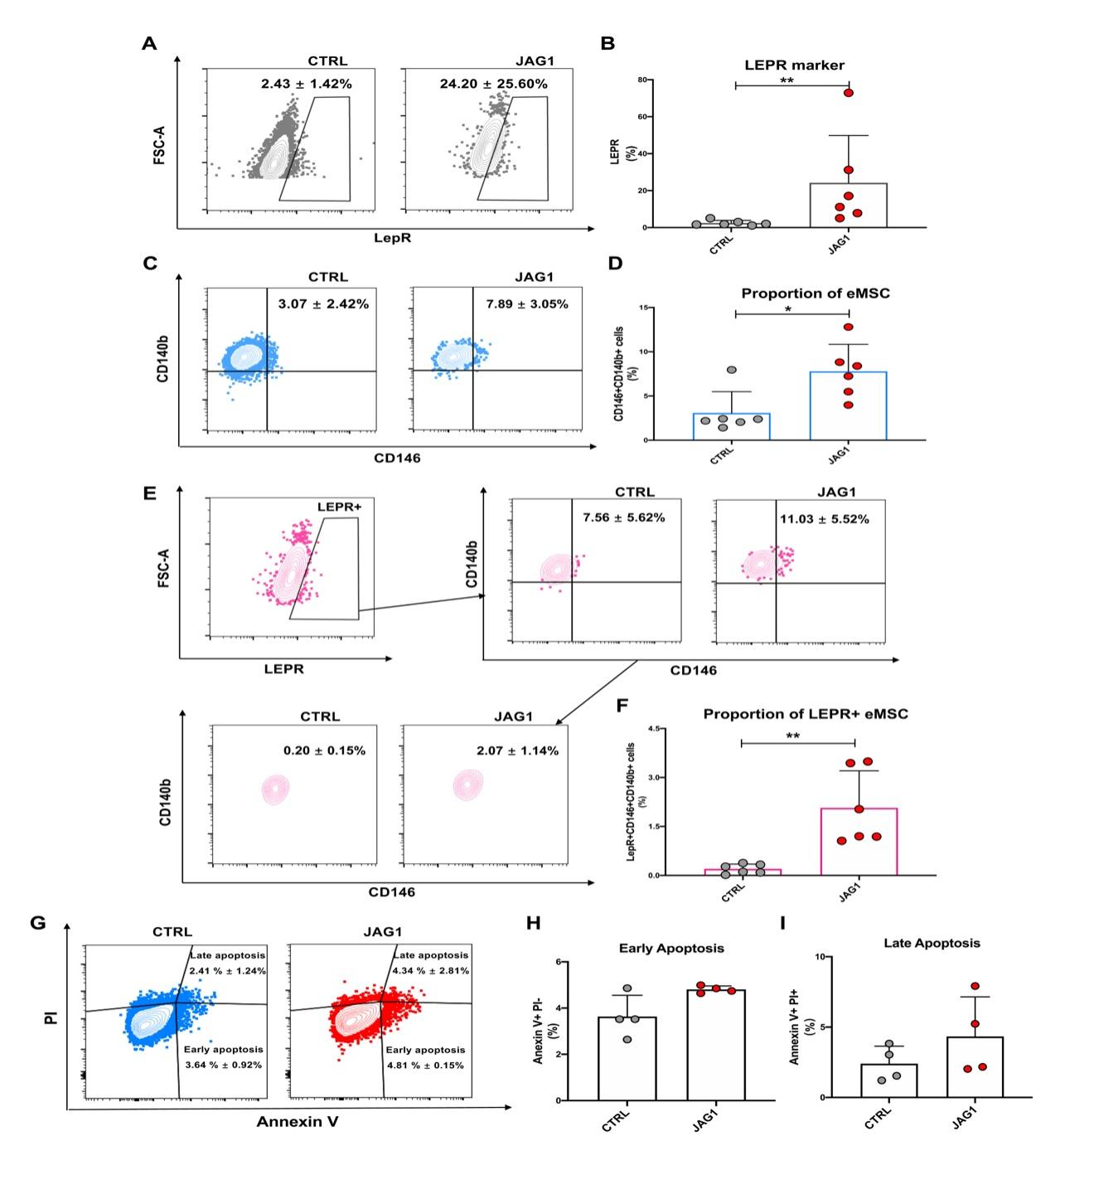

Supplementary figure S5 - The Effect of Notch Signaling on LepR⁺ eMSCs.
Flow cytometry analysis to detected the expression of (A) LEPR; (C) CD140b and CD146; (E) LEPR, CD140b and CD146 in Ctrl and JAG1 coated plates, respectively. The proportions of (B) LEPR⁺, (D) CD140b⁺CD146⁺ and, (F) LEPR⁺CD140b⁺CD146⁺ cells in Ctrl and JAG1 coated plates (n=6). (G) Flow cytometry analysis was performed on cells subjected to uncoated and JAG1 coated plates, and dual stained with Annexin V and PI. The different quadrants on the flow cytometry plot represent distinct cell viability states. Comparison of the proportion of (H) early apoptosis and (I) late apoptosis under different conditions. The results are presented as the mean ± SD, *p<0.05, **p < 0.01.

