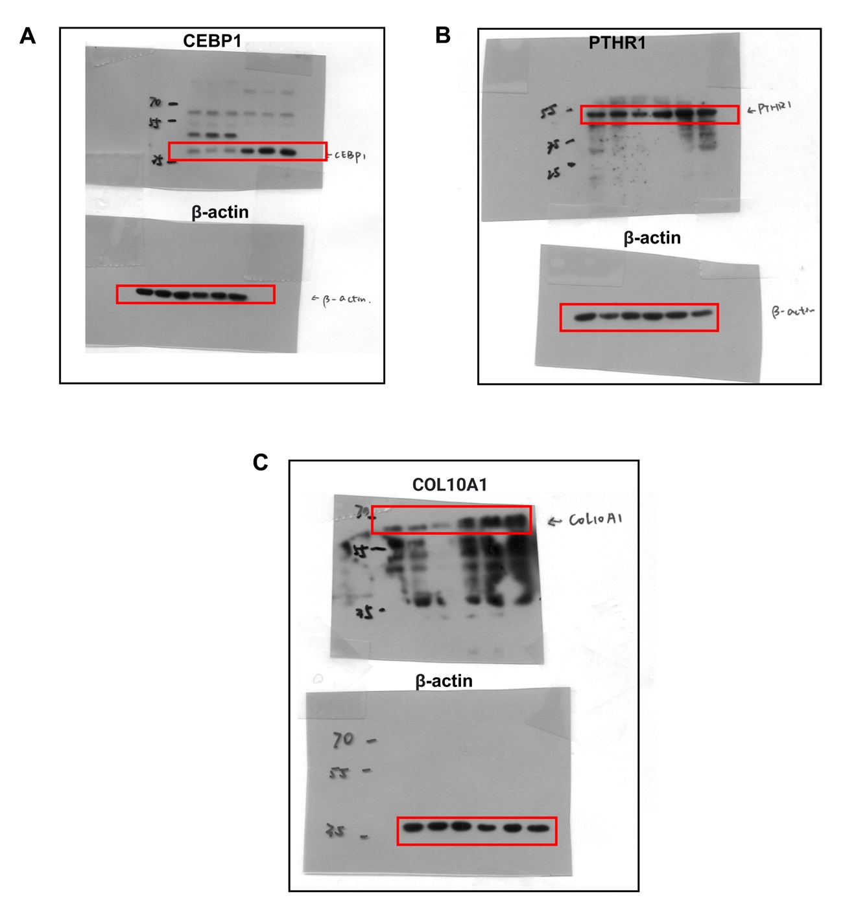
Supplementary Fig S6 - Uncropped scans of western blots.
The cropped region is highlighted with the red boxes for CEBP1, PTHR1, COL10A1 and β-actin.

