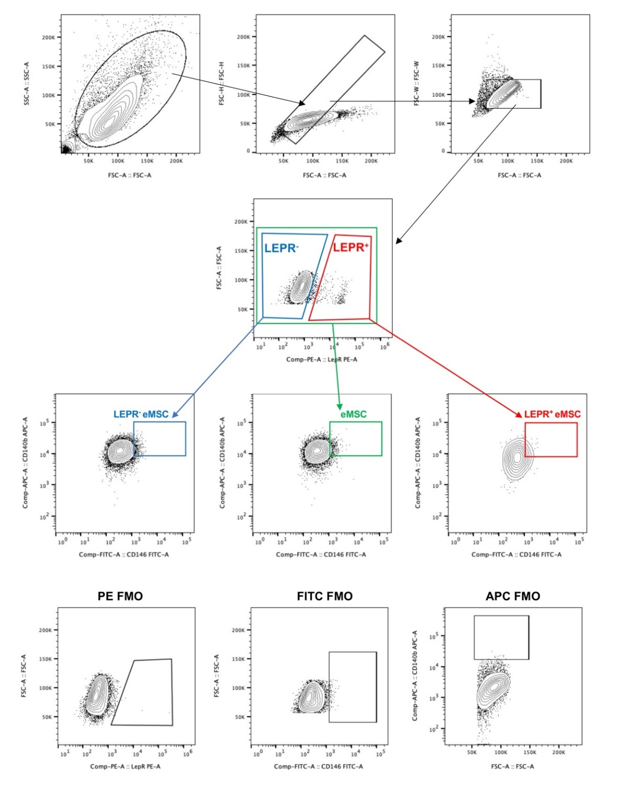
Supplementary Fig S7 - Gating strategy for different subsets of cultured endometrial stromal cells.
Representative figures of a step-by-step gating strategy to identify different stromal subsets (eMSC: CD140b⁺CD146⁺: LEPR⁺ eMSC: LEPR⁺CD140b⁺CD146⁺: and LEPR⁻ eMSC: LEPR⁻CD140b⁺CD146⁺) using multicolor flow cytometry. Cultured endometrial stromal cells were initially distinguished from cellular debris through a flow cytometry profile, with consideration of forward scatter (FSC, related to cell size) and side scatter (SSC, related to cell granularity). Single cells were differentiated from doublets and clustered cells based on their FSC area (FSC-A) and FSC height (FSC-H), as displayed on the dot plot. Gating for FSC-A and FSC weight (FSC-W) to ensure that only single cells were included. The gating strategies for LEPR⁺ and LEPR⁻ cells were established on the basis of PE-FMO, while the eMSCs' gating strategy was determined by FITC-FMO and APC-FMO.

