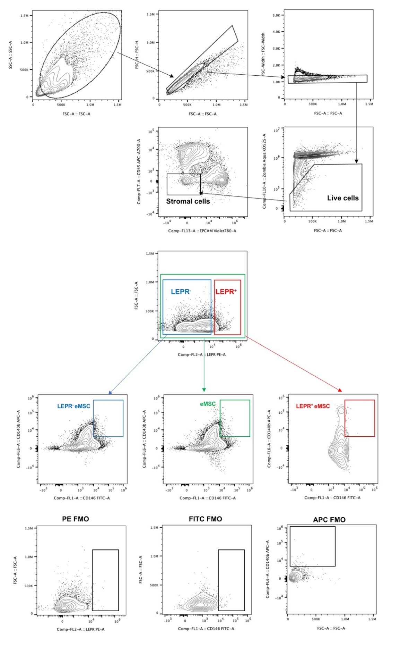
Supplementary Fig S8 - Gating strategy for different subsets of freshly isolated endometrial stromal cells
Representative figures of a step-by-step gating strategy to identify different stromal subsets (eMSC: CD140b⁺CD146⁺: LEPR⁺ eMSC: LEPR⁺CD140b⁺CD146⁺: and LEPR⁻ eMSC: LEPR⁻CD140b⁺CD146⁺) using multicolor flow cytometry. Freshly isolated endometrial stromal cells were distinguished from cellular debris through a flow cytometry profile, with consideration of the forward scatter (FSC, related to cell size) and side scatter (SSC, related to cell granularity). Single cells were differentiated from doublets and clustered cells based on their FSC area (FSC-A) and FSC height (FSC-H) as displayed on the dot plots. Gating for FSC-A and FSC weight (FSC-W) to ensure that only single cells were included. Zombie Aqua dye was used to exclude dead cells. Live endometrial stromal cells were purified by the negative expression for CD45 (leukocyte marker) and CD326 (EpCAM, epithelial marker). Within the stromal cells, the gating strategies for LEPR⁺ and LEPR⁻ cells were set up according to PE-FMO, while the gating strategy for eMSCs was determined by FITC-FMO and APC-FMO.

