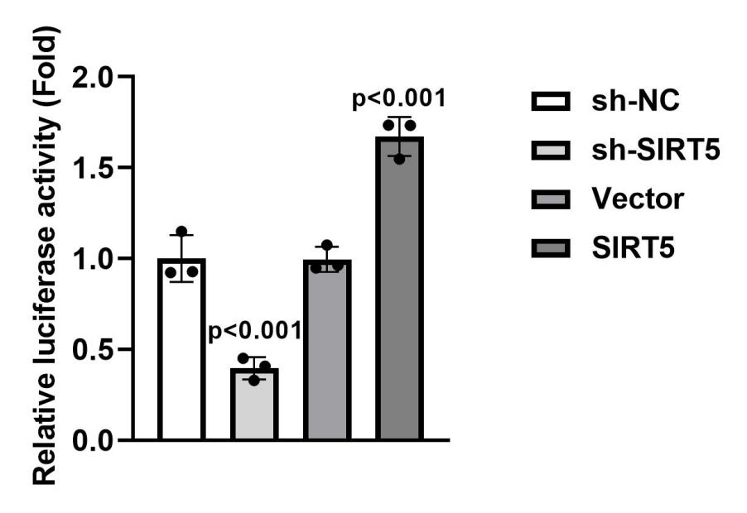
Figure S1. Relative luciferase activity of BMP2 under the regulation of SIRT5 expression.
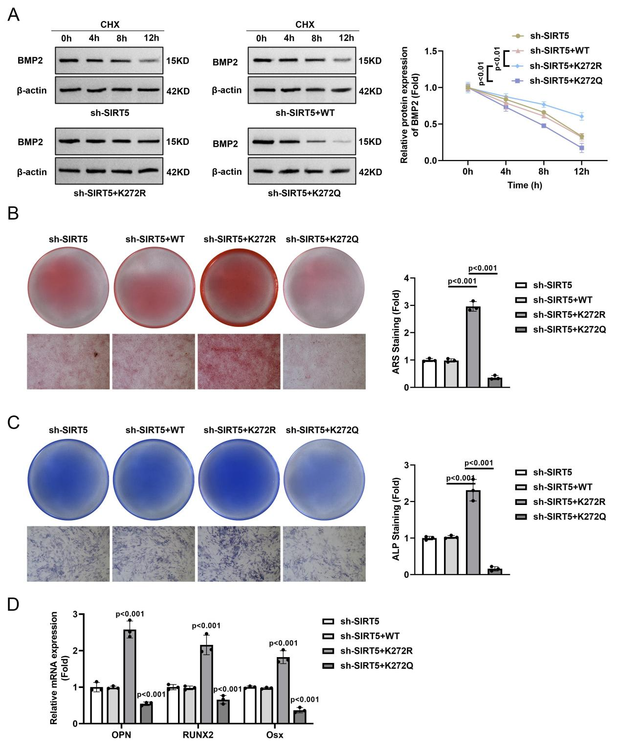
Figure S2. Effects of BMP9 mutagenesis on BMSC properties
A. Assessment of BMP2 protein stability in BMSC with BMP9 mutagenesis at K272 using CHX to inhibit protein synthesis. Western blot analysis at various time points post-CHX treatment reveals that under continuous sh-SIRT5, cells expressing BMP2-K272R displayed prolonged half-life, n=3. B - D) ARS/ALP staining and quantitative analysis of mineralization in BMSCs with BMP9 mutagenesis at K272, n=3. Cells expressing BMP2-K272R restored ARS/ALP mineralisation and downstream RUNX2/OSX/OPN levels under the SIRT5 interference.

