Fig.2D | Time（days）
Ostegenic | 1 | 3 | 7 | 14
SIRT5 | 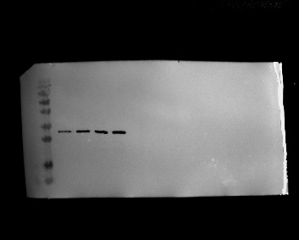
β-actin | 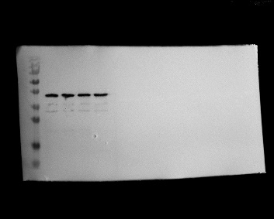

Fig.3B | sh-NC | sh-SIRT5 | Vector | SIRT5
SIRT5
β-actin

Fig.3I | sh-NC | sh-SIRT5 | Vector | SIRT5
OPN | 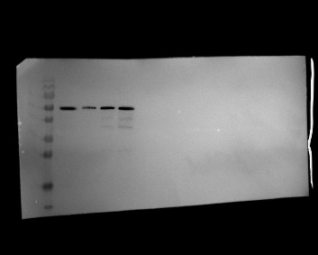
RUNX2 | 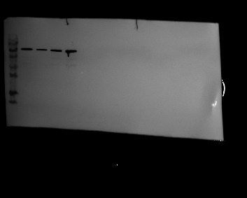
Osx | 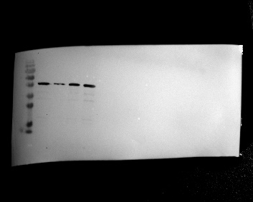
BMP2 | 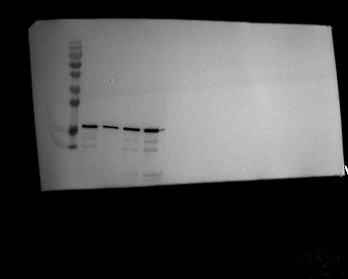
β-actin

Fig.4A | sh-NC | sh-SIRT5 | Vector | SIRT5
suc
β-actin | 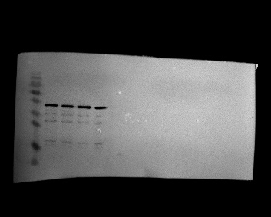

Fig.4B | sh-NC | sh-SIRT5 | Vector | SIRT5
BMP2-suc | 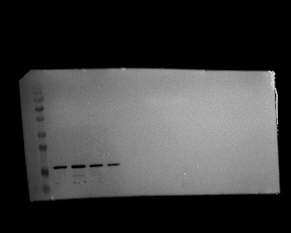
BMP2 | 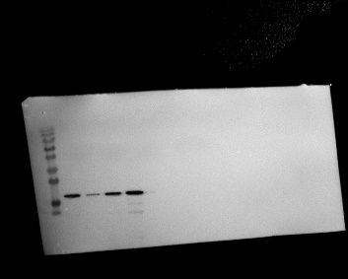
β-actin | 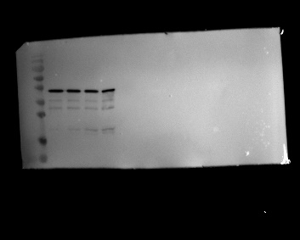

Fig.4C | Input | IgG | SIRT5
SIRT5 | 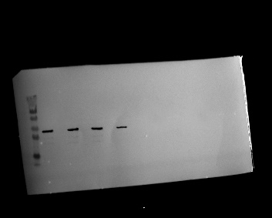
BMP2 | 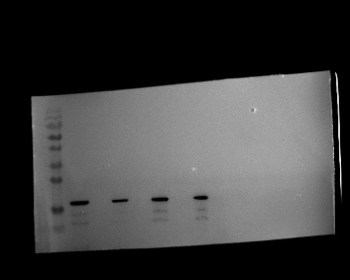
 | Input | IgG | BMP2
SIRT5
BMP2

Fig.4D | WT | K272R | K297R
BMP2 | 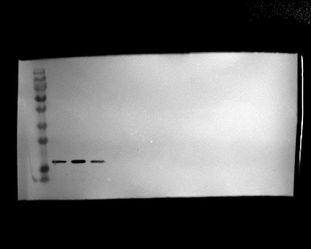
BMP2-suc | 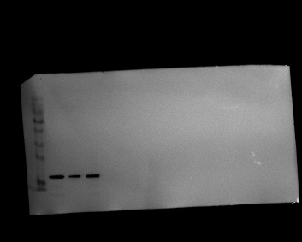
β-actin | 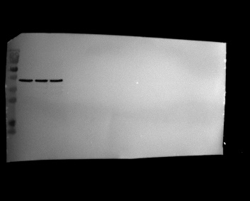

Fig.4E |  | CHX
 |  | 0h | 4h | 8h | 12h
sh-NC | BMP2 | 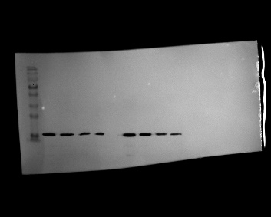
sh-NC | β-actin
sh-SIRT5 | BMP2
sh-SIRT5 | β-actin
Vector | BMP2 | 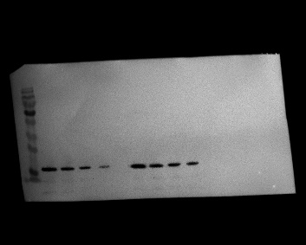
Vector | β-actin | 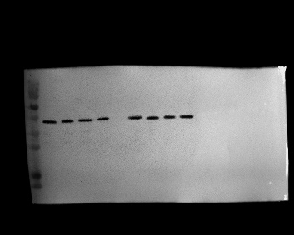
SIRT5 | BMP2
SIRT5 | β-actin

Fig.5A | Vector | BMP2
BMP2
β-actin

Fig.5G | sh-NC | sh-SIRT5 | sh-SIRT5+Vector | sh-SIRT5+BMP2
OPN | 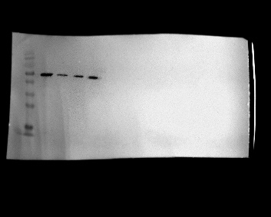
RUNX2 | 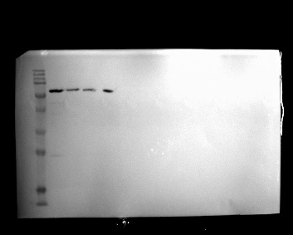
Osx | 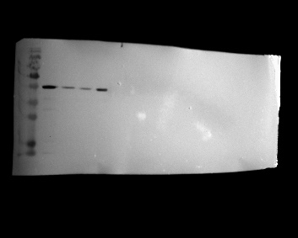
BMP2 | 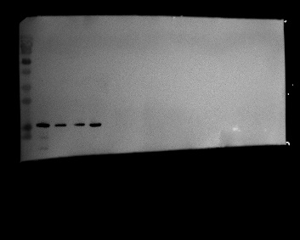
β-actin | 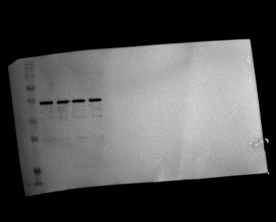

Fig.6F | - | Lv-NC | Lv-SIRT5 | Lv-SIRT5+Lv-sh-NC | Lv-SIRT5+Lv-sh-BMP2
IL-6
TNF-α | 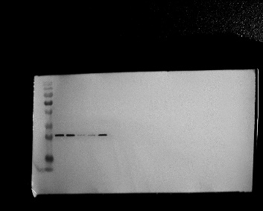
IGF-1 | 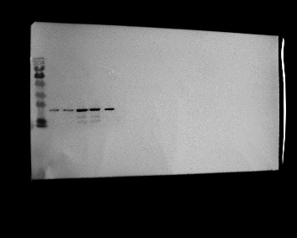
β-actin

Fig.6H | - | Lv-NC | Lv-SIRT5 | Lv-SIRT5+Lv-sh-NC | Lv-SIRT5+Lv-sh-BMP2
BMP2
OPN | 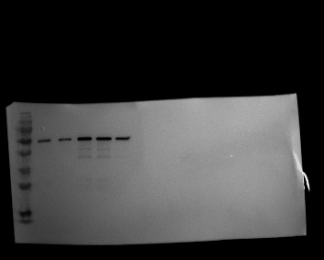
RUNX2 | 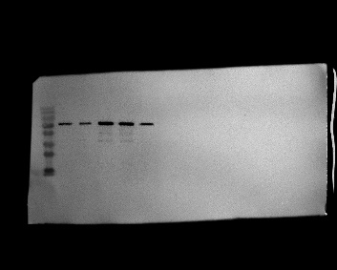
Osx
β-actin | 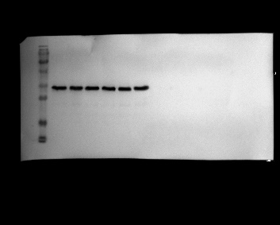

S1 | Vector |  |  | SIRT5
S1 | Mito | Cyto | Nuc | Mito | Cyto | Nuc
SIRT5
β-tubulin
Lamin B1
VDAC1
β-actin

S2 |  | CHX
 |  | 0h | 4h | 8h | 12h
sh-SIRT5 | BMP2
sh-SIRT5 | β-actin
sh-SIRT5+WT | BMP2
sh-SIRT5+WT | β-actin
sh-SIRT5+K272R | BMP2
sh-SIRT5+K272R | β-actin
sh-SIRT5+K272Q | BMP2
sh-SIRT5+K272Q | β-actin

