Supplementary Materials

Human stem cells loaded with visible and near-infrared fluorescent core–shell polymeric nanoparticles and revealing tropism toward inflammatory stimuli: in vitro evaluation

Rana Zaki Abdul Bari ^{1,#}, Iuliia Golovynska ^{1,#}, Sergii Golovynskyi ¹, Jiantao Liu ¹, Yurii V. Stepanov ², Siqi Gao ¹, Hao Xu ¹, Liudmyla I. Stepanova ³, Liudmyla O. Vretik ⁴, Tymish Y. Ohulchanskyy ^{1,*}, Junle Qu ^{1,*}

¹ Center for Biomedical Optics and Photonics, College of Physics and Optoelectronic Engineering, Shenzhen University, Shenzhen, 518060, P.R. China
² R.E. Kavetsky Institute of Experimental Pathology, Oncology and Radiobiology, NAS of Ukraine, Kyiv, 03022, Ukraine
³ Institute of Biology and Medicine, Taras Shevchenko National University of Kyiv, Kyiv 01601, Ukraine
⁴ Faculty of Chemistry, Taras Shevchenko National University of Kyiv, Kyiv, 01601, Ukraine

* Corresponding author e-mail: tyo@szu.edu.cn, jlqu@szu.edu.cn
# Equally contributed authors

Methods
Cell viability assay
The colorimetric SuperKine maximum sensitivity cell counting kit-8 (CCK-8) assay was employed to assess the viability of cells according to the manual. Initially, hESCs were transferred into a 96-well plate at a density of 5 × 10³ cells per well for 24 h. After 24 h, the medium was removed and the cells were incubated for 24 h at 37°C in a medium containing NIR-NPs, Vis-NPs, NIR dye, or Vis dye. Then, the cells were washed, and 10 µL CCK-8 reagent per 100 µL (Abbkine, China) of a fresh medium was added to each well for 4 h. The absorbance of the formazan product at 450 nm was measured using a microplate reader (Rayato, Japan). The absorbance values were used to evaluate cell viability, with the results being normalized to the untreated control group.

Results

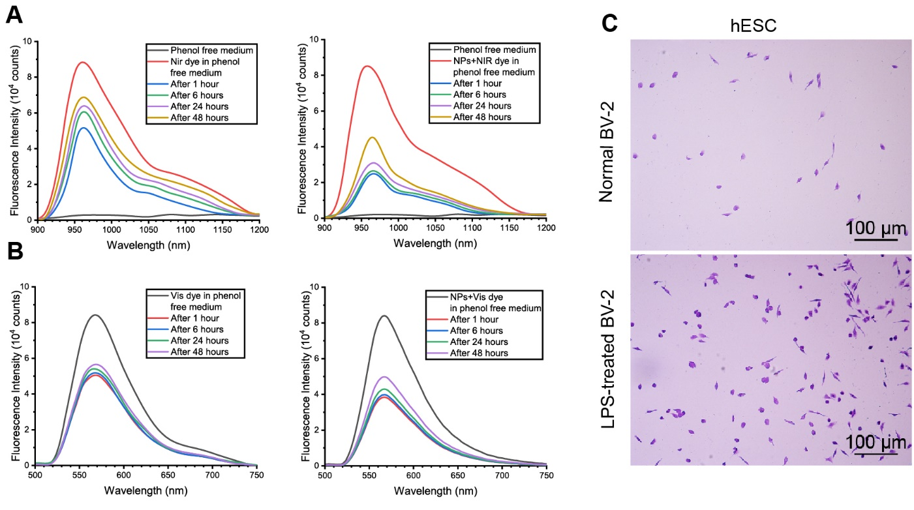

Figure S1. Release of NIR/Vis dyes and NIR/Vis-NPs from stem cells. Comparative analysis of the release dynamics of (A) NIR dye and NIR-NPs from stem cells and (B) Vis dye and Vis-NPs from stem cells. (C) Representative microscopy images showing the migratory ability of hESCs toward the conditioned medium from normal BV-2 and LPS-treated BV-2.

