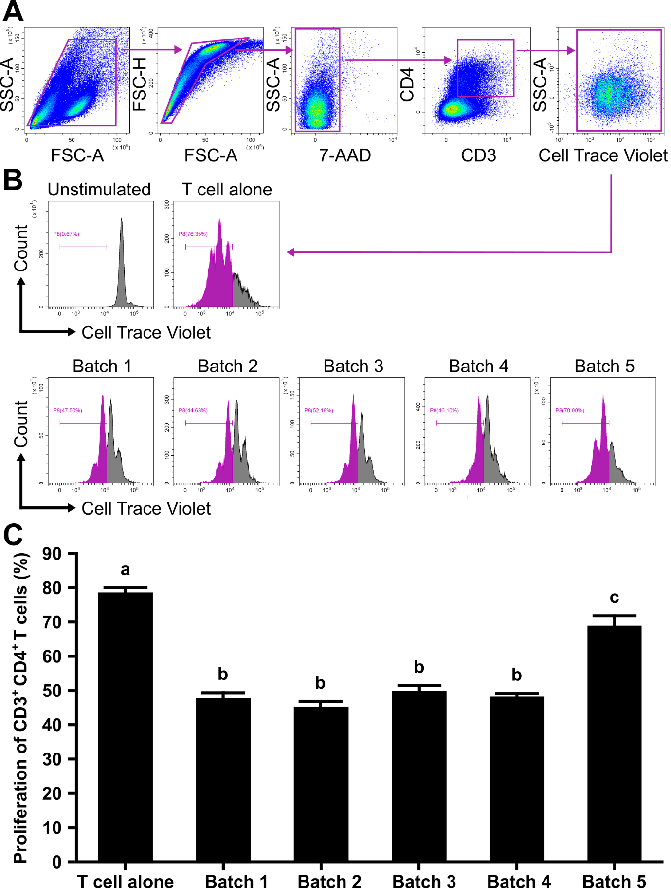
Supplementary Figure. Results of the lymphocyte proliferation inhibition assay as a potency assay for the canine adipose-derived mesenchymal stromal cell (cADSC) batches. (A) Gating strategy in flow cytometry for analyzing CD3⁺CD4⁺ T cell proliferation. Panels from left to right show gating of lymphocyte fractions, removal of doublets, exclusion of dead cells, gating of CD3⁺CD4⁺ cells, and gating of Cell Trace Violet-positive cells; violet boxes indicating gating regions. (B) Representative histograms of Cell Trace Violet–positive CD3⁺CD4⁺ T cells showing cell division when co-cultured with each cADSC batch. (C) Comparison of CD3⁺CD4⁺ T cell proliferation among cADSC batches, quantified as the percentage of Cell Trace Violet–low cells. Bars sharing the same lowercase letter indicate no significant difference between groups (p > 0.05). Data are expressed as the mean ± standard deviation from experiments performed in triplicate; n = 3.

