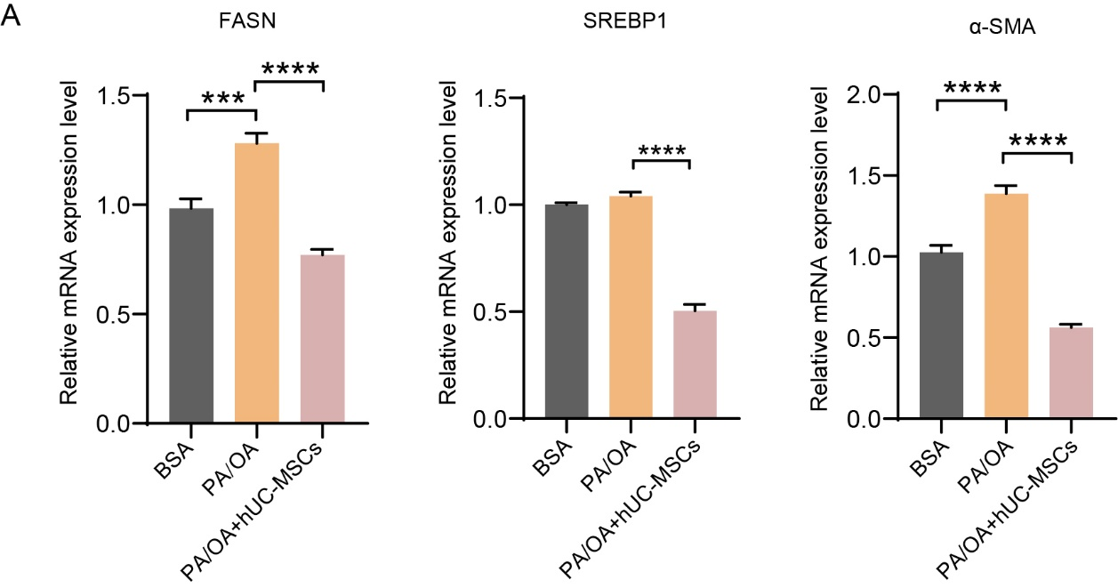
Supplementary Figure 1
Figure S1 HepG2 cells were pretreated with bovine serum albumin (BSA) or PA/OA for 24 h followed by treatment with or without hUC-MSCs for 12 h. The mRNA levels of FASN, SREBP1 and α-SMA were detected by qRT-PCR in the indicated groups. Data were expressed as mean ± SD, ***P < 0.001, ****P < 0.0001.

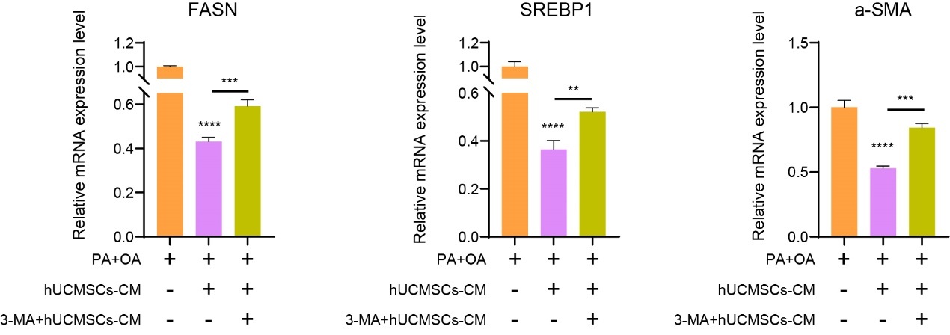
Supplementary Figure 2
Figure S2 After release from PA/OA treatment, HepG2 cells were treated with or without hUCMSC-CM or 3-Methyladenine (3-MA) for 12 h. The mRNA levels of FASN, SREBP1 and α-SMA were detected by qRT-PCR in the indicated groups. hUCMSCs-CM, hUCMSCs-conditioned medium. Data were expressed as mean ± SD, **P < 0.01, ***P < 0.001, ****P < 0.0001.

