Supplementary File 2 (Figures of uncropped blots)
for
Exosomes from LPS-pretreated BMSCs Treated Periodontitis
via Improving Oxidative Stress

Chenyu Xu ^{a, b, 1}, Hanping Wang ^{a, b, 1}, Wenqi Dong ^{a, b}, Wen Cheng ^{a, c}, Yuran Su ^{a, b}, Qiang Yang ^{d, e}, Yue Wang *, ^{a, b}, Yanhong Zhao*, ^{a, b}

ª Department of Orthodontics, Tianjin Medical University School and Hospital of Stomatology & Tianjin Key Laboratory of Oral Soft and Hard Tissues Restoration and Regeneration, No.12 Qixiangtai Road, Heping District, Tianjin 300070, P. R. China
^{b} Tianjin Medical University Institute of Stomatology, No.12 Qixiangtai Road, Heping District, Tianjin 300070, P. R. China
^{c} Department of Stomatology, Liangxiang Hospital of Beijing Fangshan District, Beijing 102400, P. R. China.
^{d} Department of Spine Surgery, Tianjin Hospital, Tianjin University, 406 Jiefang South Road, Tianjin 300211, P. R. China
^{e} Department of Orthopaedics, Beijing Friendship Hospital, Capital Medical University, 100050, Beijing, China

*Corresponding author
E-mail address: yzhao@tmu.edu.cn (Yanhong Zhao), wangyue1@tmu.edu.cn (Yue Wang)
¹ These authors contributed equally to this work.
E-mail address: xuchenyu@tmu.edu.cn (Chenyu Xu), wanghanping@tmu.edu.cn (Hanping Wang)

- CD9
Bright field figure
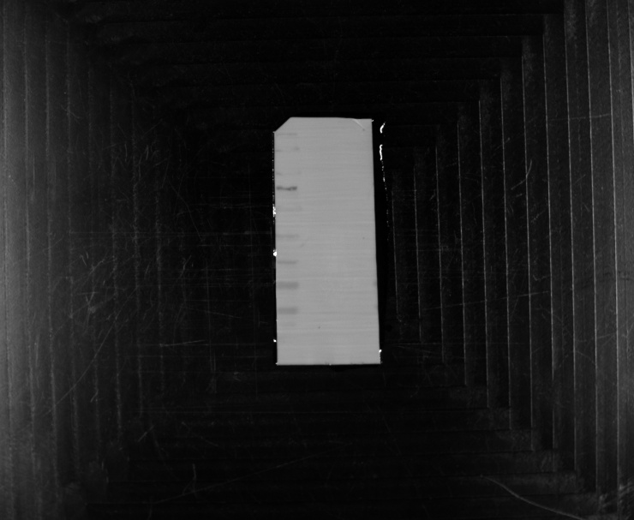
Chemiluminescence figure
Merged figure

B. CD81
Bright field figure
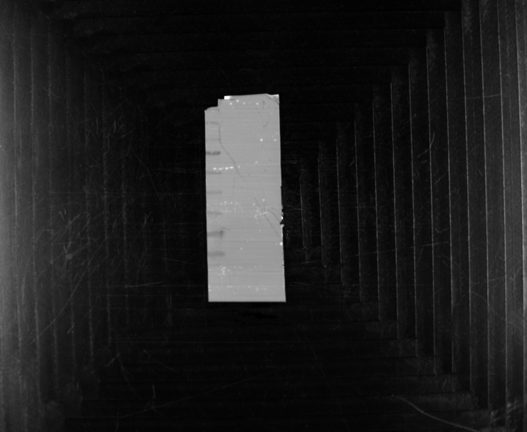
Chemiluminescence figure
Merged figure
C. TSG101
Bright field figure
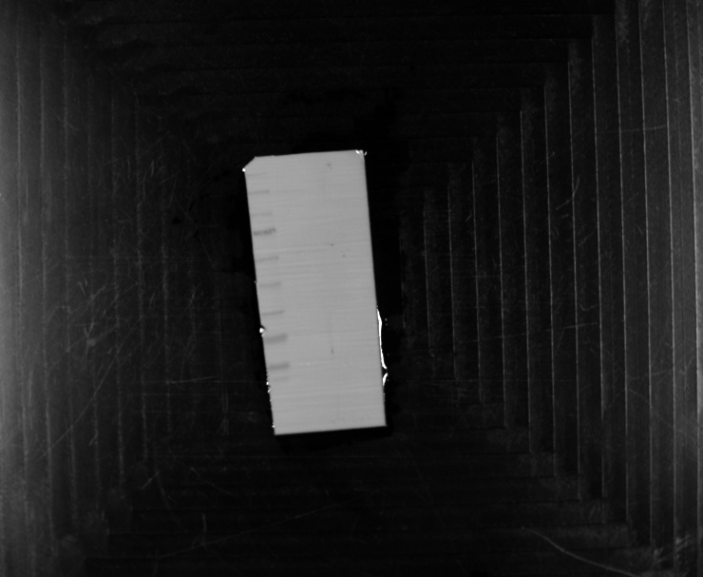
Chemiluminescence figure
Merged figure
D.Galnexin
Bright field figure
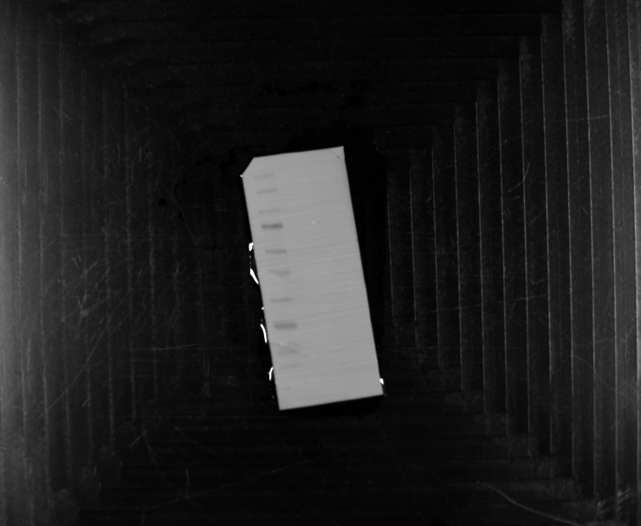
Chemiluminescence figure
Merged figure

