Supporting Information

Modeling Pathogenesis and Progression of Metabolic Dysfunction-Associated Steatotic Liver Disease and Therapeutic Drug Screening Using hESC-Derived Mature Polarized Hepatocyte Organoids

Changlu Qin^{1,2,3}, Haibin Wu^{1,2,3}, Peilin Liao², Wenjiao Yan^{1,2,3}, Xinyi Shi^{1,2,3}, Jinghe Xie^{3,4}, Shoupei Liu^{1,2,3}, Sen Chen^{1,2,3}, Xiangting Cao^{1,2,3}, Yongjian Zhou¹, Yuyou Duan^{1,2,3,5,6}

Affiliations
¹Department of Gastroenterology and Hepatology, Guangzhou Digestive Disease Center, the Second Affiliated Hospital, School of Medicine, South China University of Technology; Guangzhou, 510006, China.
²Laboratory of Stem Cells and Translational Medicine, Center for Medical Research on Innovation and Translation, Institute of Clinical Medicine, the Second Affiliated Hospital, School of Medicine, South China University of Technology; Guangzhou, 510006, China.
³Laboratory of Stem Cells and Translational Medicine, Institute for Life Science, School of Medicine, South China University of Technology; Guangzhou, 510006, China.
⁴School of Life Sciences, Zhaoqing University, Zhaoqing, 526061, China.
⁵National Engineering Research Center for Tissue Restoration and Reconstruction, South China University of Technology; Guangzhou, 510006, China.
⁶The Innovation Centre of Ministry of Education for Development and Diseases, the Second Affiliated Hospital, School of Medicine, South China University of Technology; Guangzhou 510006, China.

Supplementary Tables
Table S1. Reagents used in this study.
Reagent | Catalog Number | Supplier
DMEM/F12 medium | C11330500BT | Gibco
mTeSR1 medium | 85850 | StemCell
RPMI 1640 medium | C11875500BT | Gibco
IMDM medium | C12440500BT | Gibco
Hepatocyte culture medium | CC-3199 | Lonza
Fetal bovine serum | FND500 | ExCell Bio
KnockOut serum replacement | 10828028 | Gibco
Non-essential amino acids | 11140050 | Thermo
GlutaMAX | 35050061 | Thermo
β-mercaptoethanol | M3148 | Sigma
Dexamethasone | D4902 | Sigma
Human insulin | 91077C | Sigma
ITS-E | 00-101-10 | Neobioscience
Nicotinamide | 72340 | Sigma
Human FGF-basic | 100-18B | Peprotech
Y-27632 | HY-10071 | MCE
Activin A | 120-14 | Peprotech
CHIR99021 | HY-10182 | MCE
Human FGF-4 | 100-31 | Peprotech
Human HGF | 100-39 | Peprotech
Human/Murine/Rat BMP-2 | 120-02 | Peprotech
Human BMP-4 | 120-05 | Peprotech
SB431542 | HY-10431 | MCE
Forskolin | HY-15371 | MCE
Human EGF | AF-100-15 | Peprotech
Human Oncostatin M | 300-10 | Peprotech
Gentle Cell Dissociation Reagent | 100-0485 | StemCell
TrypLE | 12604021 | Gibco
Growth Factor Reduced Matrigel Matrix | 354230 | Corning
RNAiso Plus | 9109 | Takara
SYBR Green | Q711-03 | Vazyme
Oleic acid | O1383 | Sigma
palmitic acid | P0500 | Sigma
Human Albumin Elisa kit | E88-129 | Bethyl
Cell Counting Kit-8 | M0856-05 | MIKX
Triglyceride assay kit | A110-1-1 | Nanjing Jiancheng
Oil Red O | O0625 | Sigma
BODIPY 493/503 | C2053S | Beyotime
Glucose assay kit | A154-2-1 | Nanjing Jiancheng
Cholesterol assay kit | A111-1-1 | Nanjing Jiancheng
ROSa ssay kit | S0033 | Beyotime
TUNEL ssay kit | C1086 | Beyotime
RIPA buffer | R0020 | Solarbio
PMSF | ST507 | Beyotime
Protease inhibitors | P1005-1 | Beyotime
SDS-PAGE sample loading buffer (5×) | P0015L | Beyotime
Vitamin E | T834623 | Macklin
Ursodeoxycholic acid | U110695 | Macklin
Empagliflozin | E836891 | Macklin
Urea Nitrogen Detection Kit | BC1535 | Solarbio
Indocyanine green | HY-D0711 | MCE
Periodic Acid-Schiff Staining Kit | C0142S | Beyotime
Rifampicin | R3501 | Sigma
Omeprazole | O104 | Sigma

Table S2 Primers used in this study.
Gene | Forward | Reverse
GAPDH | GAAGATGGTGATGGGATTTC | GAAGGTGAAGGTCGGAGTC
OCT4 | CCTGAAGCAGAAGAGGATCACC | AAAGCGGCAGATGGTCGTTTGG
SOX2 | GAGCTTTGCAGGAAGTTTGC | GCAAGAAGCCTCTCCTTGAA
SOX17 | CGAGTTGAGCAAGATGCTGG | TTGTAGTTGGGGTGGTCCTG
CXCR4 | CTCCTCTTTGTCATCACGCTTCC | GGATGAGGACACTGCTGTAGAG
AFP | GGGAGCGGCTGACATTAT | TGTTTCATCCACCACCAA
ALB | CTGCCTGCCTGTTGCCAAAGC | GGCAAGGTCCGCCCTGTCATC
HNF4α | GGTGTCCATACGCATCCTTGAC | AGCCGCTTGATCTTCCCTGGAT
α1AT | CGAGTTGAGCAAGATGCTGG | TTGTAGTTGGGGTGGTCCTG
FXR | GGTCTCGTAGACGAAGGACTGA | TGTCTGCTCTGAGACTCAGCTC
CPS1 | CTAGCCTGGATTACATGGTCACC | CCTCAAAGGTACGACCAATAGCC
BSEP | AGCCACACAGACCAGGATGTTG | CAATGAACCGCCTCTCCTTTCC
NTCP | GCTCTCTTCTGCCTCAATGGAC | AGTGGTCCAATGACTTCAGGTGG
BCL2L1 | GAGCTGGTGGTTGACTTTCTC | TCCATCTCCGATTCAGTCCCT
CASP3 | GGAAGCGAATCAATGGACTCTGG | GCATCGACATCTGTACCAGACC
CK7 | TCCGCGAGGTCACCATTAAC | GCTCTGTCAACTCCGTCTCAT
HES1 | GGAAATGACAGTGAAGCACCTCC | GAAGCGGGTCACCTCGTTCATG
AE2 | GACTTCCGAGATGCACTTGACC | CCTATCAGGTCCTGCGTCTTCT
MRP3 | GCTGCTGACTTACGAAGAGGTG | CCACCTTTTGCTTCAGCTCGTG
ACADVL | TAGGAGAGGCAGGCAAACAGCT | CACAGTGGCAAACTGCTCCAGA
ACADM | AGAACCTGGAGCAGGCTCTGAT | GGATCTGGATCAGAACGTGCCA
HADHA | GCCGACATGGTGATTGAAGCTG | GGAGAGCAGATGTGTTACTGGC
HADHB | CTGACAAGACTCCTGCTCAC | CACCACCTGCCACGATCACATC
CPT1A | GATCCTGGACAATACCTCGGAG | CTCCACAGCATCAAGAGACTGC
FABP1 | GGAGGAATGTGAGCTGGAGACA | TATGTCGCCGTTGAGTTCGGTC
ABCA1 | CAGGCTACTACCTGACCTTGGT | CTGCTCTGAGAAACACTGTCCTC
ABCG1 | GAGGGATTTGGGTCTGAACTGC | TCTCACCAGCCGACTGTTCTGA
CYP3A4 | TCTGTGCCTGAGAACACCAGAG | TGCATGTACAGAATCCCCGGTT
CYP2C9 | AGGAAAAGCACAACCAACCATC | TTCAGCAGGAGAAGGAGAGCAT
CYP1A1 | AGGCTTTTACATCCCCAAGG | GCAATGGTCTCACCGATACA
CYP1A2 | TCATCCTGGAGACCTTCCGACA | GCCACTGGTTTACGAAGACACAG
CYP1B1 | CACCAAGGCTGAGACAGTGA | GCCAGGTAAACTCCAAGCAC

Table S3 Antibodies used in this study.
Primary antibody
Antibody | Company | Catalog Number | Ig Species | Dilution
Anti-E-Cadherin | Proteintech | 20874-1-AP | Rabbit | 1000
Anti-Factin (Phalloidin-iFluor 594) | Abcam | ab176757 |  | 1000
Anti-ASGPR1 | Santacruz | sc-52623 | Mouse | 100
Anti-ZO-1 | Proteintech | 21773-1-AP | Rabbit | 1000
Anti-Keratin 8/18 | CST | 4546 | Mouse | 200
Anti-ALB | Bethyl | A80-129A | Goat | 1000
Anti-HNF4α | CST | 3113 | Rabbit | 2000
Anti-MDR1 | CST | 13342 | Rabbit | 200
Anti-GAPDH | Abcam | ab128915 | Rabbit | 10000
Anti-CK7 | CST | 4465 | Rabbit | 1000
Anti-BESP | GeneTex | N3C1 | Rabbit | 3000
Anti-OCT4 | Bioss | bs-1111R | Rabbit | 1000
Anti-SOX17 | Immunoway | YM9268 | Rabbit | 5000
Anti-AFP | Thermo | MIA1305 | Mouse | 1 µg/mL
Anti-NTCP | Boster | PA5-80001 | Mouse | 0.5 µg/mL
Anti-MRP2 | Proteintech | 29261-1-AP | Rabbit | 1000
Secondary antibody | Company | Code number | Dilution
Alexa Fluor 488-conjugated goat anti-rabbit IgG | CST | 4412 | 2000
Alexa Fluor 488-conjugated goat anti-mouse IgG | CST | 4408 | 1000
Alexa Fluor 594-conjugated goat anti-rabbit IgG | CST | 8889 | 1000
Alexa Fluor 647-conjugated donkey anti-goat IgG | Abcam | Ab150135 | 1000
Goat Anti-Rabbit IgG-HRP | Abmart | M21002 | 3000
Supplementary Figures
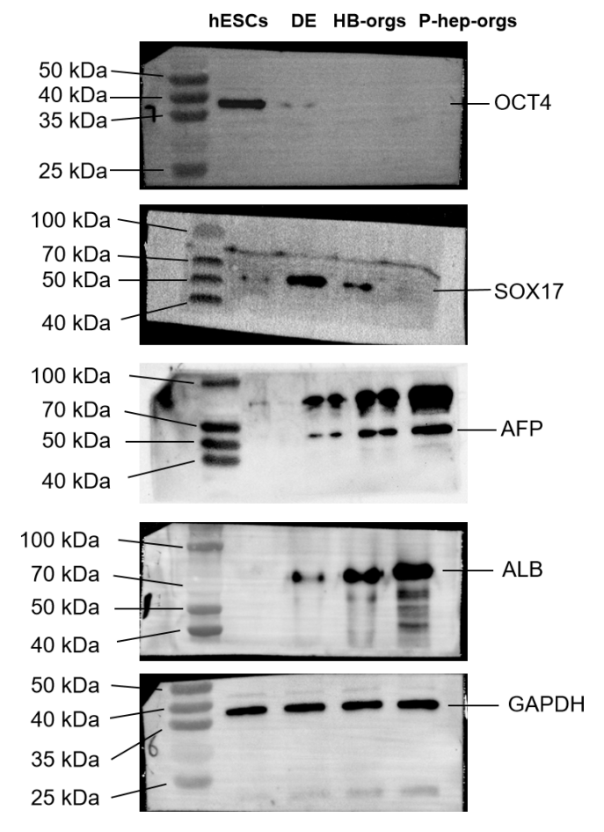
Figure S1. Uncropped Western blots corresponding to Figure 1.
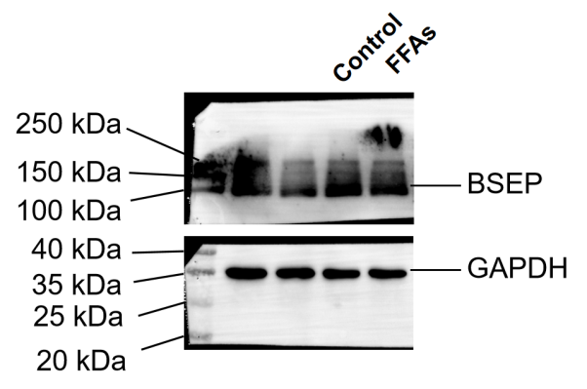
Figure S2. Uncropped Western blots corresponding to Figure 3.
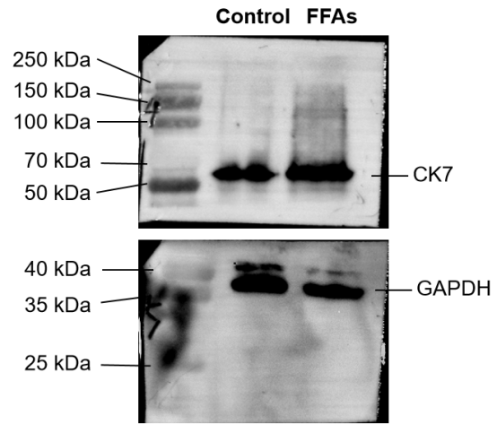
Figure S3. Uncropped Western blots corresponding to Figure 5.

