Supplementary Figure 1. Images of the uncropped immunoblots in Figure 2E regarding COX-2 protein presence in the synovial membrane of the Control, MSC and MSC-MSU groups.

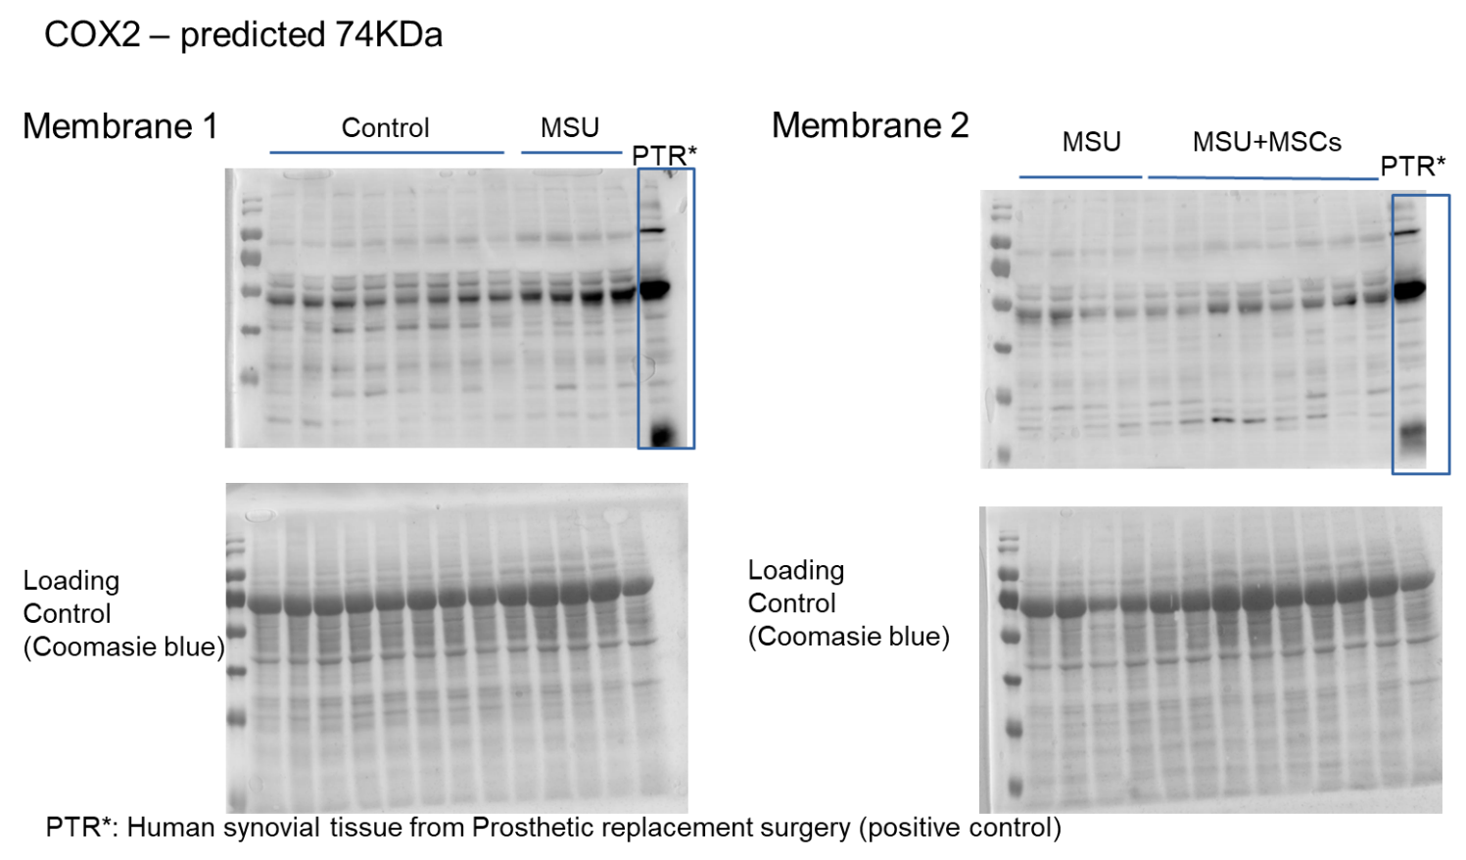

Supplementary Figure 2. Images of the uncropped immunoblots shown in the Figure 5A regarding LOX-5 protein expression in THP-1-derived macrophages or in MSCs. Boxes indicate cropped regions.

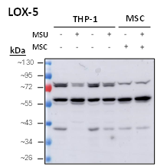

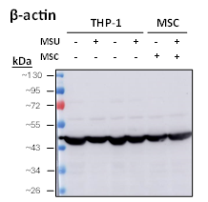

Supplementary Figure 3. Images of the uncropped immunoblots shown in the Figure 5A regarding LOX-12 protein expression in THP-1-derived macrophages or in MSCs. Boxes indicate cropped regions.

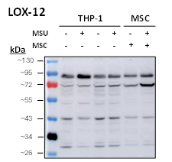

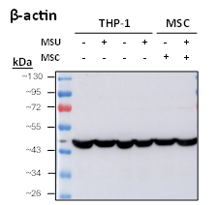

Supplementary Figure 4. Images of the uncropped immunoblots shown in the Figure 5A regarding LOX-15 protein expression in THP-1-derived macrophages or in MSCs. Boxes indicate cropped regions.

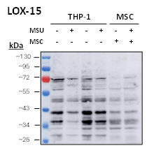

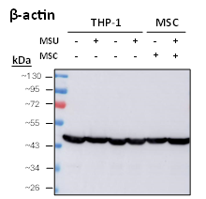

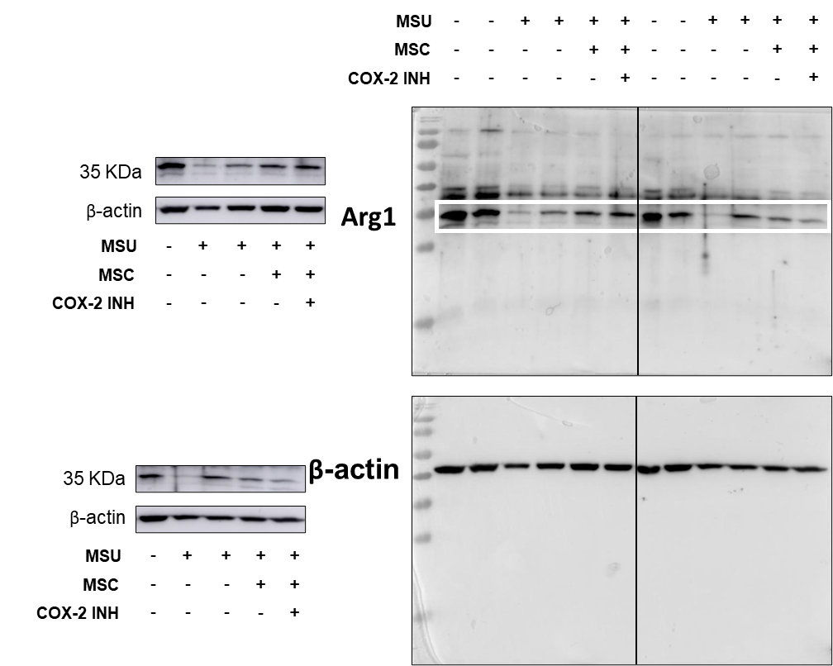
Supplementary Figure 5. Images of the uncropped immunoblots shown in Figure 6F regarding ARG1 protein synthesis in THP-1-derived macrophages. Boxes indicate cropped regions.

