Figure S1. Flow cytometry analysis of surface markers of ECs.

Figure S2. Dose-response of Apo-EVs on EPC viability and differentiation(A) CCK-8 assay showing EPC viability after treatment with different concentrations of Apo-EVs. (B-C) Relative mRNA expression of CD144 and CD105 in EPCs following treatment with different concentrations of Apo-EVs. *p<0.05, **p<0.01, ***p<0.001, ****p<0.0001.

Figure S3. Relative mRNA expression of EGFR, PIK3CD, PIK3R2, AKT1, AKT2, VEGFA and VEGFB of EPCs after different treatments. *p<0.05, **p<0.01, ***p<0.001, ****p<0.0001.

Figure S4. Relative mRNA expression of PML after different treatments. *p<0.05, **p<0.01, ***p<0.001, ****p<0.0001.

Figure S5. Prediction and verification of the binding site between miR-30a-5p and the target gene PML. (A) The binding sites between miR-30a-5p and the 3’-UTR of the PML gene were predicted using the Target Scan database; (B) Statistical results of the dual-luciferase reporter assay. *p<0.05, **p<0.01, ***p<0.001, ****p<0.0001.

Figure S6. Rescue experiments confirm that Apo-EVs induce EPC differentiation via the miR-30a-5p/PML axis. (A-B) Relative mRNA expression of CD144 and CD105 of EPCs after different treatments. (C-D) Percentage of cells co-expressing CD34 and CD105 measured by flow cytometry after different treatments. *p<0.05, **p<0.01, ***p<0.001, ****p<0.0001.

Figure S7. The histological observations in the wound area of the Control, VEGF and Apo-EVs groups at day 3.

Figure S8. The histological observations in the wound area of the Control, VEGF and Apo-EVs groups at day 14 (green arrows: hair follicles; red arrows: sebaceous glands).

Figure S9. The trichrome staining shows collagen deposition in the wound center area of the Control, VEGF and Apo-EVs groups after 3 days of treatment.
Figure S10. Apo-EVs modulate inflammatory responses in wound tissues. (A-B) Representative CCR7 (M1 macrophage marker) and CD206 (M2 macrophage marker) immunohistochemical staining of wound sections in the Control, VEGF, and Apo-EVs groups at Day 3 and Day 7. (C-D) Quantitative analysis of CCR7-positive area and CD206-positive area percentage in wound tissues. *p<0.05, **p<0.01, ***p<0.001, ****p<0.0001.

Figure S11. Comparison of EPC differentiation-promoting effects between Apo-EVs and EVs derived from ECs. (A-B) Relative mRNA expression of CD144 and CD105 of EPCs after different treatments. (C-D) Percentage of cells co-expressing CD34 and CD105 measured by flow cytometry after different treatments. *p<0.05, **p<0.01, ***p<0.001, ****p<0.0001.

Figure S12. Post-hoc power analysis for murine wound healing experiment group size.

Figure S13. CD105 mean fluorescence intensity (MFI) in CD34⁺CD105⁺ EPCs across groups. *p<0.05, **p<0.01, ***p<0.001, ****p<0.0001.

Figure S14. Apo-EVs suppress PML protein expression in EPCs following uptake. (A) Representative Western blot images showing PML protein levels in EPCs. (B) Quantitative analysis of PML protein expression normalized to β-actin.

β-actin
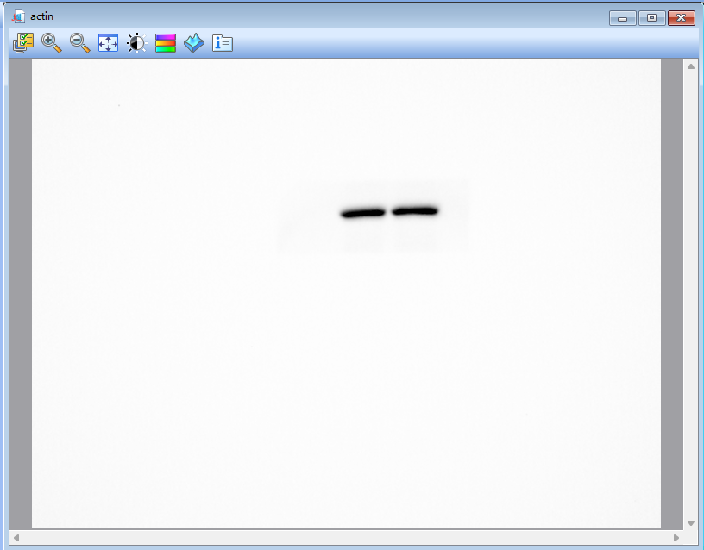
Apo-EVs
ECs
CD63
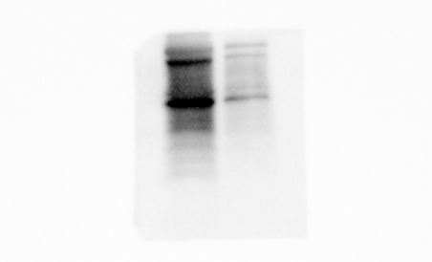
ECs
Apo-EVs
Cleaved caspase3
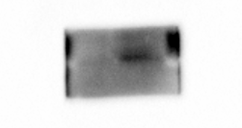
Apo-EVs
ECs
Histone H3
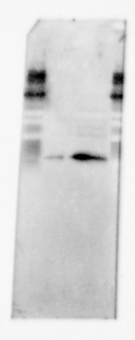
Apo-EVs
ECs

Figure S15. Full-length blots of Figure 2E

β-actin
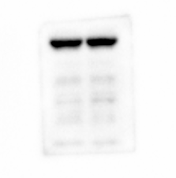
Control
Apo-EVs
EGFR
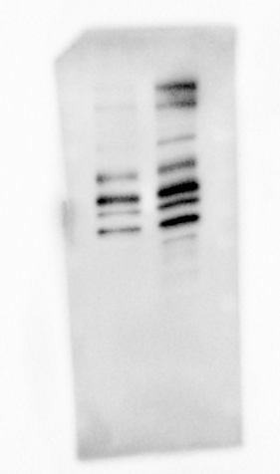
Control
Apo-EVs
p-PI3K
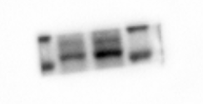
Apo-EVs
Control
PI3K
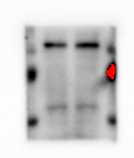
Control
Apo-EVs
p-AKT
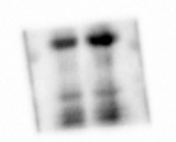
Apo-EVs
Control
AKT
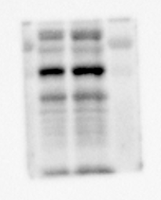
Apo-EVs
Control
VEGF
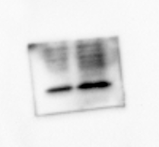
Apo-EVs
Control
Figure S16. Full-length blots of Figure 4F

β-actin
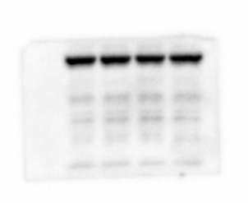
Control
MiR-30a-5p mimic
Apo-EVs + miR-30a-5p inhibitor
Apo-EVs
PML
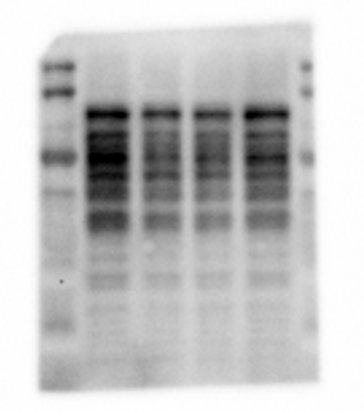
Apo-EVs + miR-30a-5p inhibitor
Apo-EVs
MiR-30a-5p mimic
Control
EGFR
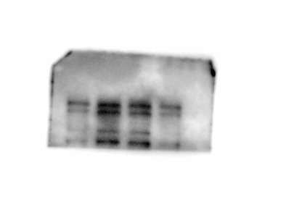
MiR-30a-5p mimic
Apo-EVs
Apo-EVs + miR-30a-5p inhibitor
Control
p-PI3K
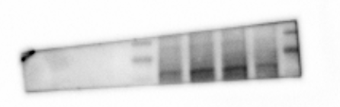
Apo-EVs + miR-30a-5p inhibitor
Apo-EVs
MiR-30a-5p mimic
Control
PI3K
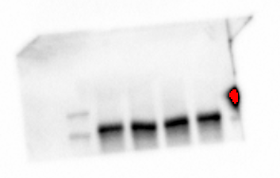
Apo-EVs + miR-30a-5p inhibitor
Apo-EVs
MiR-30a-5p mimic
Control
p-AKT
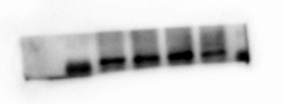
Apo-EVs + miR-30a-5p inhibitor
MiR-30a-5p mimic
Control
Apo-EVs
AKT
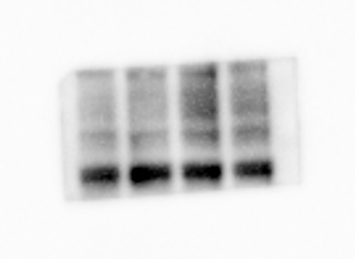
Apo-EVs + miR-30a-5p inhibitor
Apo-EVs
MiR-30a-5p mimic
Control
VEGF
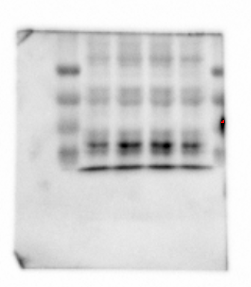
Apo-EVs + miR-30a-5p inhibitor
Apo-EVs
MiR-30a-5p mimic
Control
Figure S17. Full-length blots of Figure 5G

The transcriptomics data supporting the results reported in this paper have been archived in the NCBI Sequence Read Archive (SRA), a public repository. The project accession number is PRJNA1295004

