Supplementary Information
Table S1. Primers and guide sequences
Oligos | Sequence 5' - 3'
AAVS1 guide | GGGGCCACTAGGGACAGGAT
CLYBL guide | ATGTTGGAAGGATGAGGAAA
AAVS1 HAs fwd | TGCTTTCTTTGCCTGGACAC
AAVS1 HAs rvs | GGTTCTGGCAAGGAGAGAGA
AAVS1 puro fwd | CCATAGCTCAGGTCTGGTCTAT
AAVS1 puro rvs | AGGAAGAGAAGAGGTCAGAAGC
CLYBL gt fwd | AGATCATCCAGCCCTAGTCAAG
CLYBL gt rvs | TGGAGCAGTGGATGACAACTT
NeoR rvs | GCCCAGTCATAGCCGAATAG

Table S2. Primary and secondary antibodies for immunostaining
Antibodies | Source | Identifier | Dilution
Anti-TUJ1, mouse | BioLegend | Cat#801213 | 1:1000
Anti-VGLUT1, mouse | Synaptic Systems | Cat#135311 | 1:100
Anti-VGAT, rabbit | Synaptic Systems | Cat#131003 | 1:500
Anti-GABA, rabbit | Millipore | Cat#A2052 | 1:1000
Anti-MAP2, chicken | Abcam | Cat#ab5392 | 1:1000
Anti-NeuN, guinea pig | Millipore | Cat#ABN90 | 1:1000
Anti-Synaptophysin, rabbit | Abcam | Cat#ab32127 | 1:500
Anti-α-Tubulin, guinea pig | Synaptic Systems | Cat#302308 | 1:500
Anti-GFAP, rabbit | Abcam | Cat#ab53554 | 1:500
Anti-GFAP, mouse | Cell Signaling Technology | Cat#3670T | 1:800
Anti-VGLUT2, guinea pig | Synaptic Systems | Cat#135418 | 1:500
Anti-PSD-95, rabbit | Cell Signaling Technology | Cat#3450S | 1:200
Anti-Gephyrin, mouse | Synaptic Systems | Cat#147011 | 1:500
Alexa Fluor 488 Goat anti-Rabbit | Molecular Probes | Cat#A11008 | 1:500
Alexa Fluor 488 Goat anti-Chicken | Invitrogen | Cat#A32931 | 1:500
Alexa Fluor 546 Goat anti-Guinea pig | Invitrogen | Cat#A11074 | 1:500
Alexa Fluor 594 Goat anti-Mouse | Molecular Probes | Cat#A11005 | 1:500
Alexa Fluor 647 Donkey anti-Mouse | Abcam | Cat#ab150107 | 1:500

Table S3. MEA PCA loadings (DIV 28 vs DIV 35)
DIV 28 PCA | PC1 | PC2
Mean Spike Rate | 0.3013235 | -0.0809424
Ratio of Median ISI over Mean ISI | -0.2011922 | 0.05565851
Mean ISI | -0.2618514 | -0.0045651
Mean CV of ISI | 0.3120416 | -0.0196507
Mean Burst Rate | 0.3000224 | -0.0646734
Mean Spike Rate in Bursts | 0.2618433 | 0.06472932
MAD Spikes in Bursts | 0.2748415 | -0.1154009
Mean Isolated Spikes | -0.2700816 | -0.0194834
Mean Burst Duration | 0.2411152 | -0.2780714
Mean IBI | -0.150669 | 0.29995993
Mean CV of IBI | -0.1674618 | -0.4020741
Mean Network Bursts Rate | 0.2256489 | 0.02925366
Mean Network Bursts Duration | 0.2510197 | -0.3240656
Mean Network Bursts Spike Rate | 0.3083191 | -0.0256201
Mean Network Bursts ISI | -0.1160047 | -0.4595806
Mean Network Bursts IBI | -0.1732683 | -0.3678155
Mean Network Bursts CVIBI | -0.1854275 | -0.431135

DIV 35 PCA | PC1 | PC2
Mean Spike Rate | 0.31333352 | -0.0065364
Ratio of Median ISI over Mean ISI | -0.154561 | -0.0731876
Mean ISI | -0.301483 | -0.0263189
Mean CV of ISI | 0.31731772 | -0.1071986
Mean Burst Rate | 0.21913964 | 0.36668586
Mean Spike Rate in Bursts | 0.29897279 | -0.0127419
MAD Spikes in Bursts | 0.24733292 | -0.1570851
Mean Isolated Spikes | -0.2792066 | 0.11558073
Mean Burst Duration | 0.25541307 | -0.1877888
Mean IBI | -0.1810538 | -0.3882405
Mean CV of IBI | -0.2455479 | 0.16942018
Mean Network Bursts Rate | -0.0080815 | 0.51001592
Mean Network Bursts Duration | 0.17621921 | -0.23184
Mean Network Bursts Spike Rate | 0.31287373 | -0.0547696
Mean Network Bursts ISI | -0.2924164 | -0.0356467
Mean Network Bursts IBI | -0.0958448 | -0.4785858
Mean Network Bursts CVIBI | -0.1667379 | -0.2188192

ISI = Interspike Interval; MAD = Median Absolute Deviation; IBI = Interburst Interval; CV = Coefficient of Variation.

Top 5 descriptions of each ontology for iGlutNs
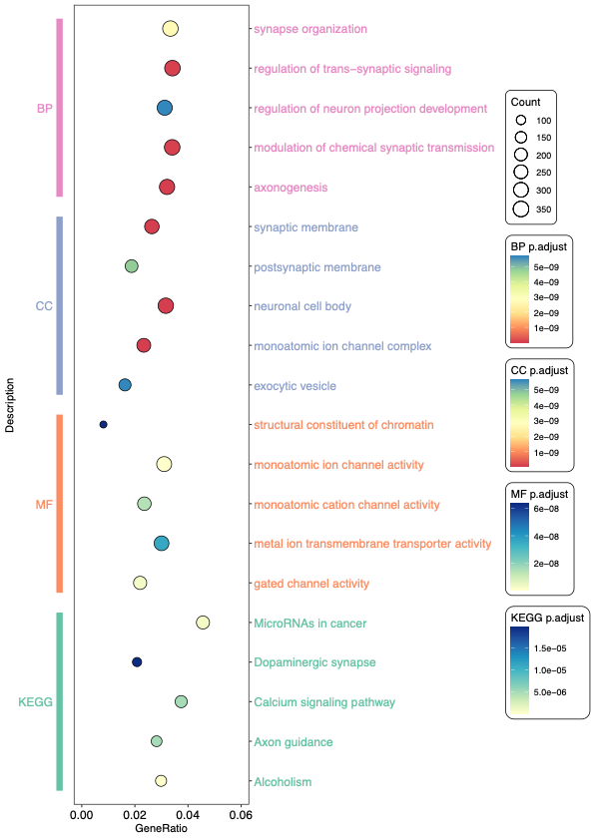

Top 5 descriptions of each ontology for iGABANs
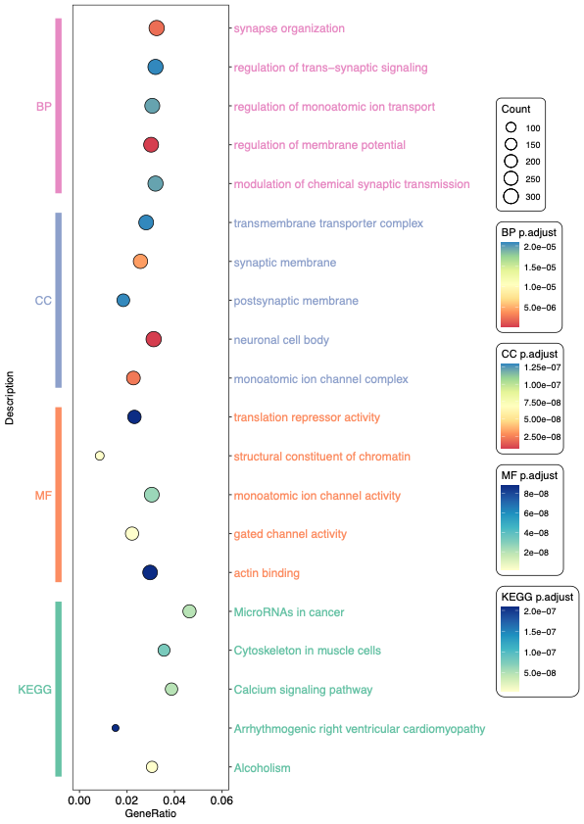

Top 5 descriptions of each ontology for iAstros
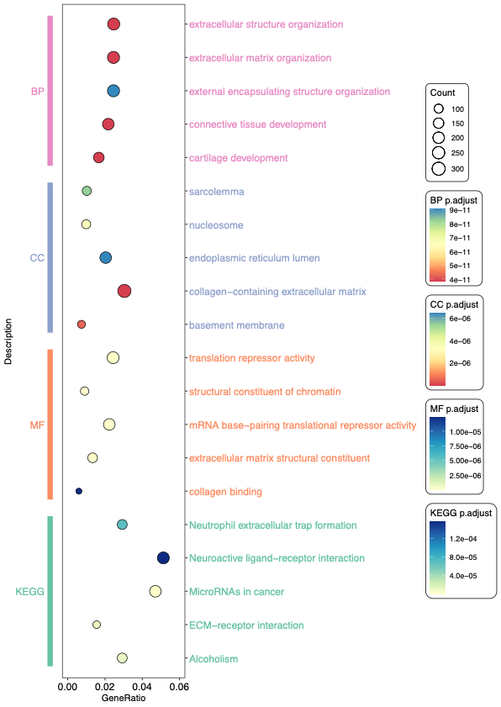

Figure S1. GO and KEGG enrichment analysis for iNs and iAstros. The top five significantly enriched terms were shown in each ontology. BP: biological process; CC: cellular component; MF: molecular function.

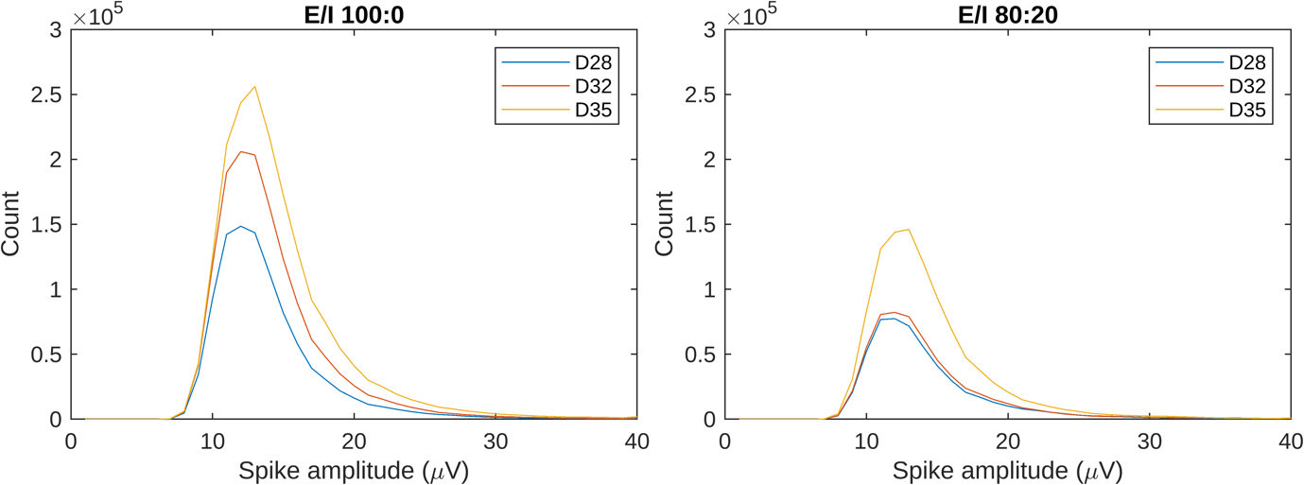
Figure S2. Spike amplitude distribution of E/I 100:0 and E/I 80:20 at DIVs 28, 32 and 35 (n = 36 wells). The peak-to-peak amplitude of each spike was extracted using Multiwell Analyzer. The histograms were plotted with a bin width of 1 μV to represent the distribution. Graphs were generated in MATLAB. The distribution of spike amplitudes was similar between E/I 100:0 and E/I 80:20, with increased spike counts over time. However, spike counts were lower in E/I 80:20 compared to E/I 100:0 at all timepoints.

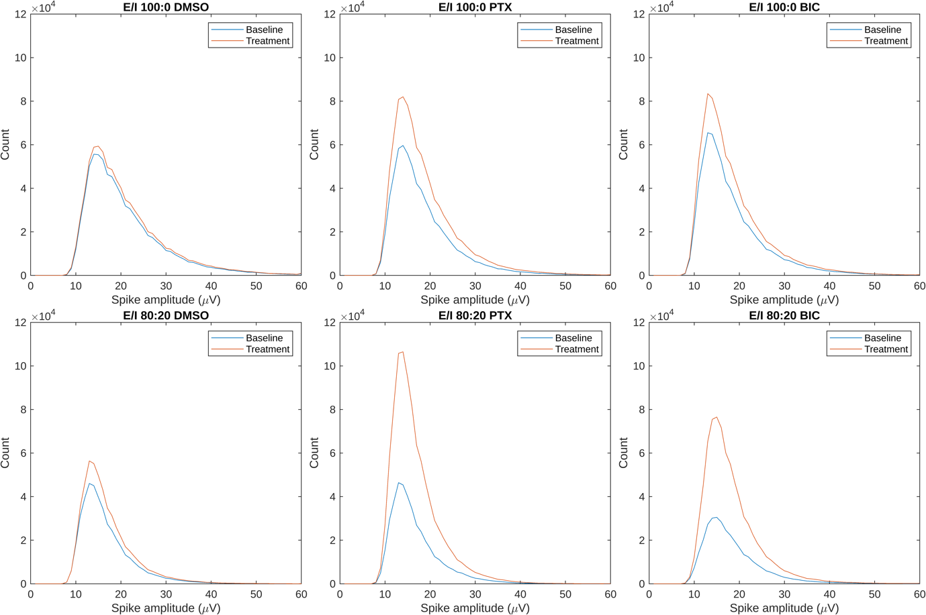
Figure S3. Spike amplitude distribution of E/I 100:0 and 80:20 before and after the addition of DMSO, PTX and BIC (n = 12 wells). The peak-to-peak amplitude of each spike was extracted using Multiwell Analyzer. The histograms were plotted with a bin width of 1 μV to represent the distribution. Graphs were generated in MATLAB. Spike counts were significantly increased after treatment of PTX or BIC compared to the DMSO control, with a greater increase in E/I 80:20.

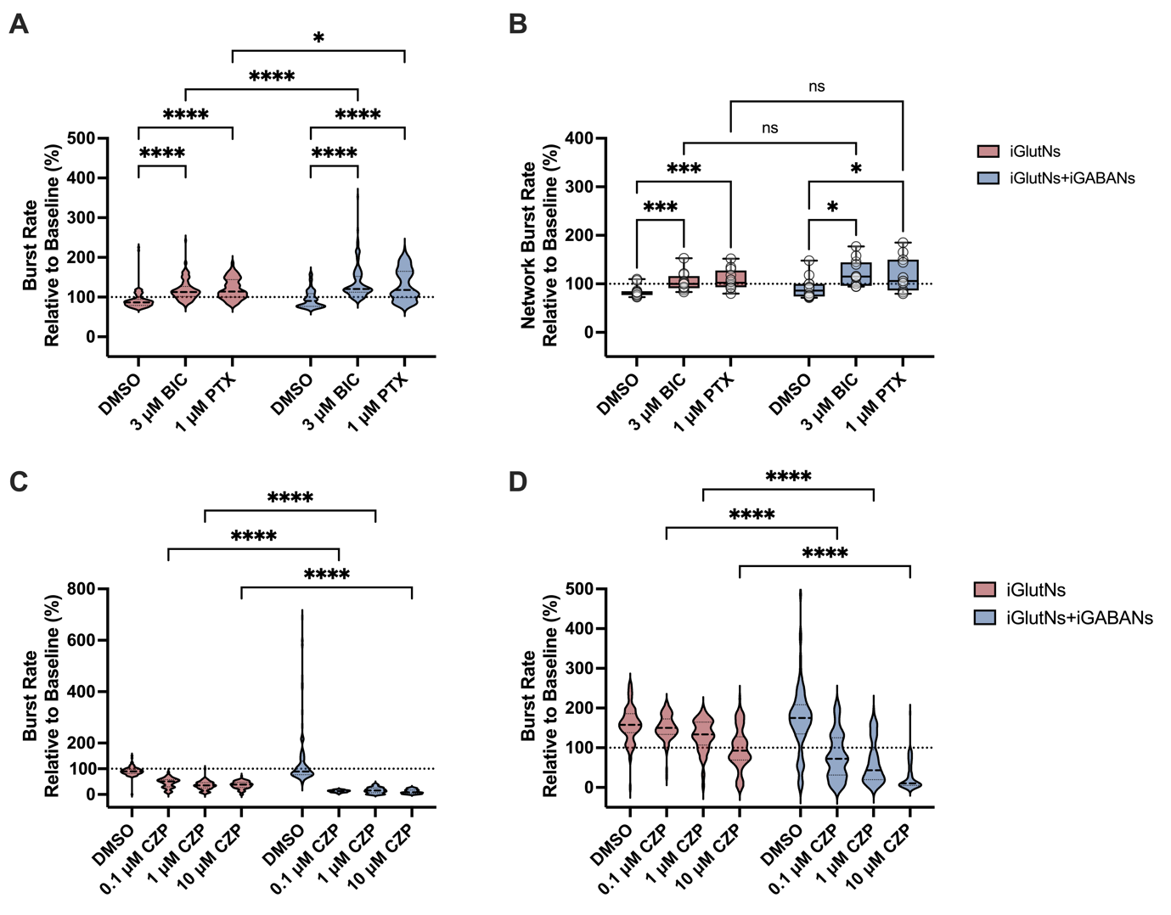
Figure S4. The bursting activity of E/I 100:0 and E/I 80:20 networks after drug applications. (A) Normalized burst rate after addition of BIC or PTX (n = number of electrodes). (B) Normalized network burst rate after addition of BIC or PTX (n = number of wells). (C) Normalized burst rate after addition of CZP (n = number of electrodes). (D) Normalized burst rate after addition of 4-AP following CZP treatment (n = number of electrodes). Electrodes with spike rate < 1 Hz or wells with no network burst were excluded from the analysis. Data are presented as min to max in box plots. ^{ns}p > 0.05, *p ≤ 0.05, **p ≤ 0.01, ***p ≤ 0.001, and **** p < 0.0001. Mixed model two-way ANOVA was performed between timepoints and groups. Multiple comparisons were corrected using Post hoc Tukey statistical hypothesis testing.

