EXO-VNN2 derived from 3D-cultured DPSCs enhances the inflammatory EXO-VNN2 derived from 3D-cultured DPSCs enhances the inflammatory response of PDLSCs and suppresses bone regeneration in periodontitis
Mengting Li ¹, Xiaoxu Liu⁵, Jiabin Xu^{3,4}*, Qin Zhou ¹*, Zhenzhen Wang ^{1,2}*

Correspondence: Zhenzhen Wang, wz6619@xjtu.edu.cn
Qin Zhou, zhouqin0529@126.com
Jiabin Xu, xujiabin@xzhmu.edu.cn

Supplementary Fig. 1
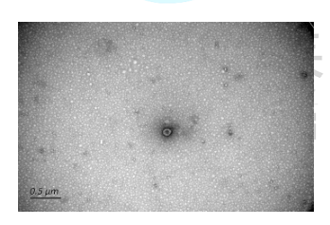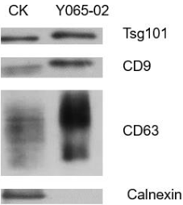
B
A
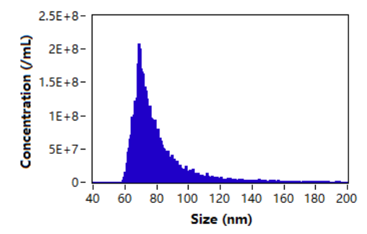

C
Supplementary Fig.1 Extraction and identification of salivary exosomes. A. Exosomes derived by saliva were determined by transmission electron microscopy (TEM). Scale bar = 50 nm. B. Western blot confirmed the positive expression of TSG101, CD63 and CD9 and negative expression of Calnexin in exosomes. C. Nanosight particle tracking analysis (NTA).

Supplementary Fig2
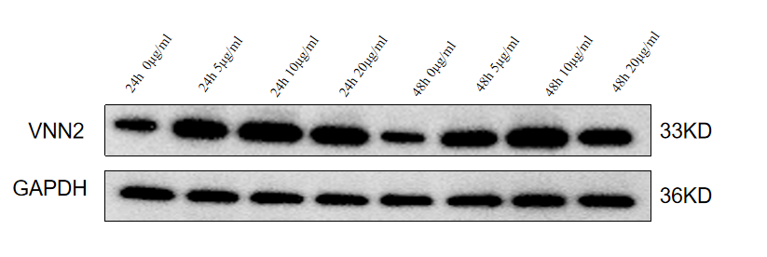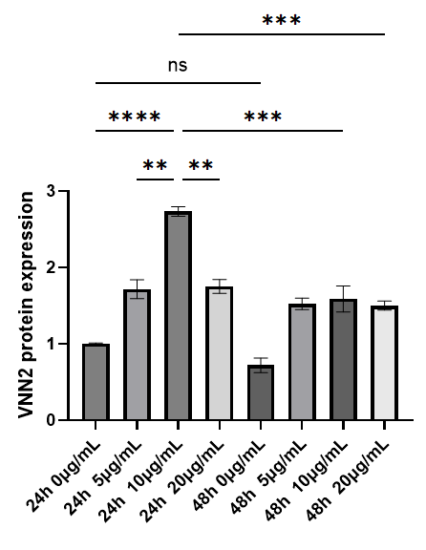
A

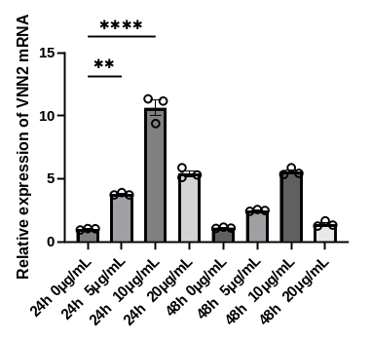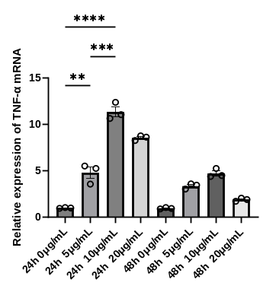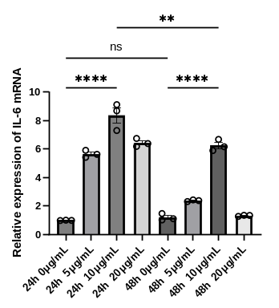
B
Supplementary Fig.2 A,B The expression level of VNN2 protein and mRNA under the action of LPS at different concentration gradients and different time. Data are presented as mean±SEM. *P<0.05. **P<0.01. *** P <0.001. **** P <0.0001.

