Supplementary Materials

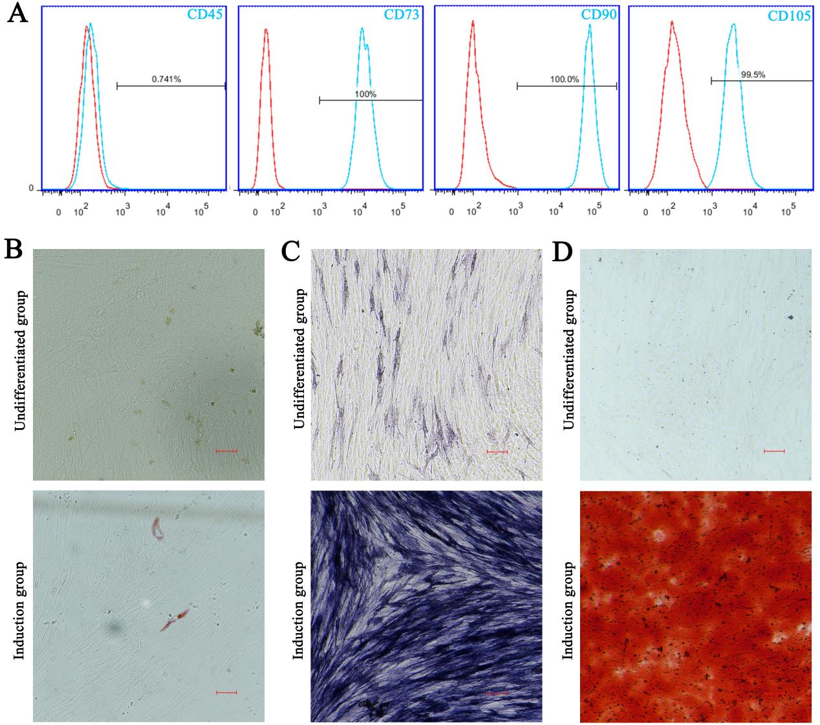
Supplementary Figure 1. Characterization of PDLSCs. (A) Flow cytometry analysis of phenotypic surface marker expression, including CD45, CD73, CD90, and CD105. (B) Adipogenic differentiation potential of PDLSCs assessed after 3 weeks of induction, with intracellular lipid droplet accumulation visualized by ORO staining (scale bar = 100 μm). (C) Early osteogenic potential evaluated after 1 week of induction by ALP staining, a marker of early osteogenic differentiation (scale bar = 100 μm). (D) Mineralized nodule formation capacity, indicative of late-stage osteogenic differentiation, assessed after 3 weeks of induction using ARS staining (scale bar = 100 μm).

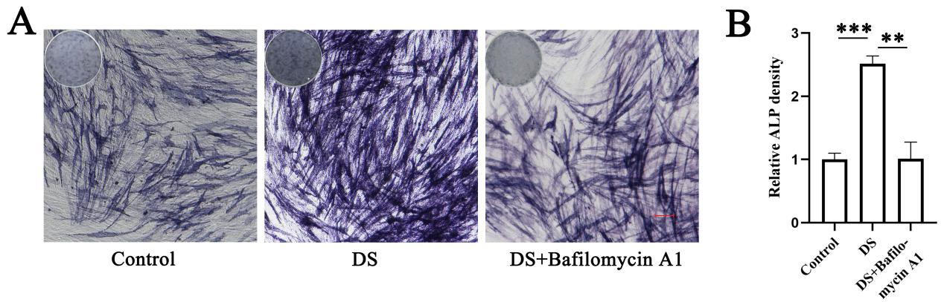
Supplementary Figure 2. Bafilomycin A1 reversed the promoting effect of DS on ALP activity in PDLSCs. (A) ALP activity staining images (scale bar = 100 μm). (B) Quantitative analysis of ALP activity staining shown in (A). **P < 0.01, ***P < 0.001 versus DS.
Supplementary Figure 3. The effect of TNF-α on the viability of PDLSCs. PDLSCs were treated with varying concentrations of TNF-α and cultured for 24 hours, followed by assessment using the CCK-8 assay.

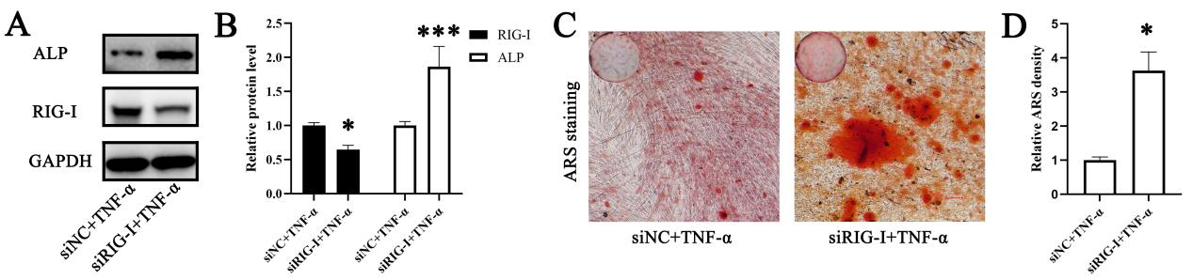
Supplementary Figure 4. Downregulation of RIG-I enhances osteogenic differentiation of PDLSCs under inflammatory conditions. (A) Western blot analysis showing changes in ALP and RIG-I protein expression levels. (B) Quantification of relative band intensities from (A). (C) ARS staining after transfection with small interfering RNA (siRNA), TNF-α stimulation, and 21-day culture in osteogenic induction medium, with images acquired using a scanner and microscope (scale bar = 100 μm). (D) Quantitative analysis of ARS staining from (C). siNC: negative control siRNA. *P < 0.05, ***P < 0.001 versus siNC + TNF-α.

Supplementary Figure 5. The mRNA expression levels of components in the RLR signaling pathway were assessed by RT-qPCR. *P < 0.05, **P < 0.01, ***P < 0.001 versus TNF-α + DS.

