Supplementary Material
 |  | Primer sequences
HIF-1α |  | Forward 5′-GGAGAGCGAGATCTTCACG-3′  Reverse 5′-CTCGATGTTGGACGGGTG-3′
VEGF |  | Forward 5′-GAGTCCCTGTCACATTCCC-3′  Reverse 5′-CACATAAGGCAGAGTTTGG-3′
PI3k |  | Forward 5′-CCACGACGATTGCTCAA-3′  Reverse 5′-AGCCTGCACAGGAGTAA-3′
 | Bmp2 |  | Forward 5′-AGGATTAGCAGGTCTTTG-3′  Reverse 5′-TCACTGAAGTCCACATAC-3′
 | Runx2 |  | Forward 5′-CGTCCACTCTGAATACCTGT-3′  Reverse 5′-TTGCCATTTTCAGTTTTGCAT-3′
 | Ibsp |  | Forward 5′- GGTTTCCAGTTCCGAGCAGTGAC -3′  Reverse 5′- AGTCTCCTCTCCTTCCTCCTCCTC -3′
 | Ocn |  | Forward 5′- GCAGACCTAGCAGACACCAT -3′  Reverse 5′- CTTGGACATGAAGGCTTTGTCA -3′
 | β-actin |  | Forward 5′-AGGGGCCGGACTCGTCATACT-3′  Reverse 5′-GGCGGCACCACCATGTACCCT-3′
Table S1: Primer Sequence.

SiRNA | Primer sequences
Si-Ibsp-1 | Forward 5′- GGUGCAAUAUAUAUAUAUAAC-3′  Reverse 5′- UAUAUAUAUAUAUUGCACCUU-3′
Si-Ibsp-2 | Forward 5′- GAUGUGUGUAGUUCCUUUAUC-3′  Reverse 5′ - UAAAGGAACUACACACAUCGU-3′
Si-NC | Forward 5′- UUCUCCGAACGUGUCACGUTT-3′  Reverse 5′ - ACGUGACACGUUCGGAGAATT-3′
Table S2；SiRNA Primer Sequence.
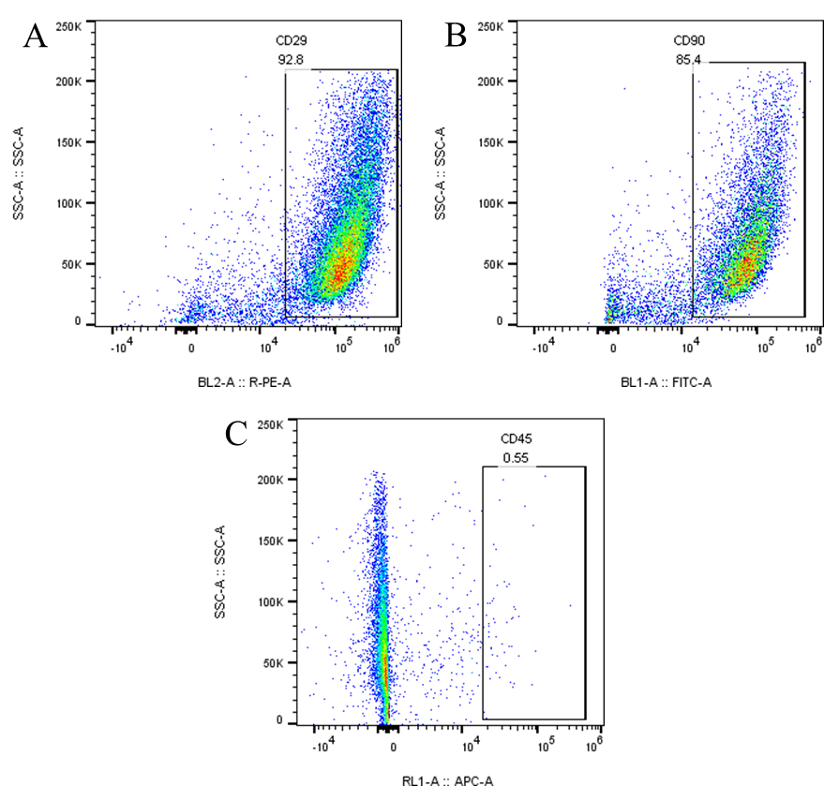
Figure S1: Flow Identification Results for BMSCs. A:the positive rate of CD29; B: the positive rate of CD90; C: the positive rate of CD45.
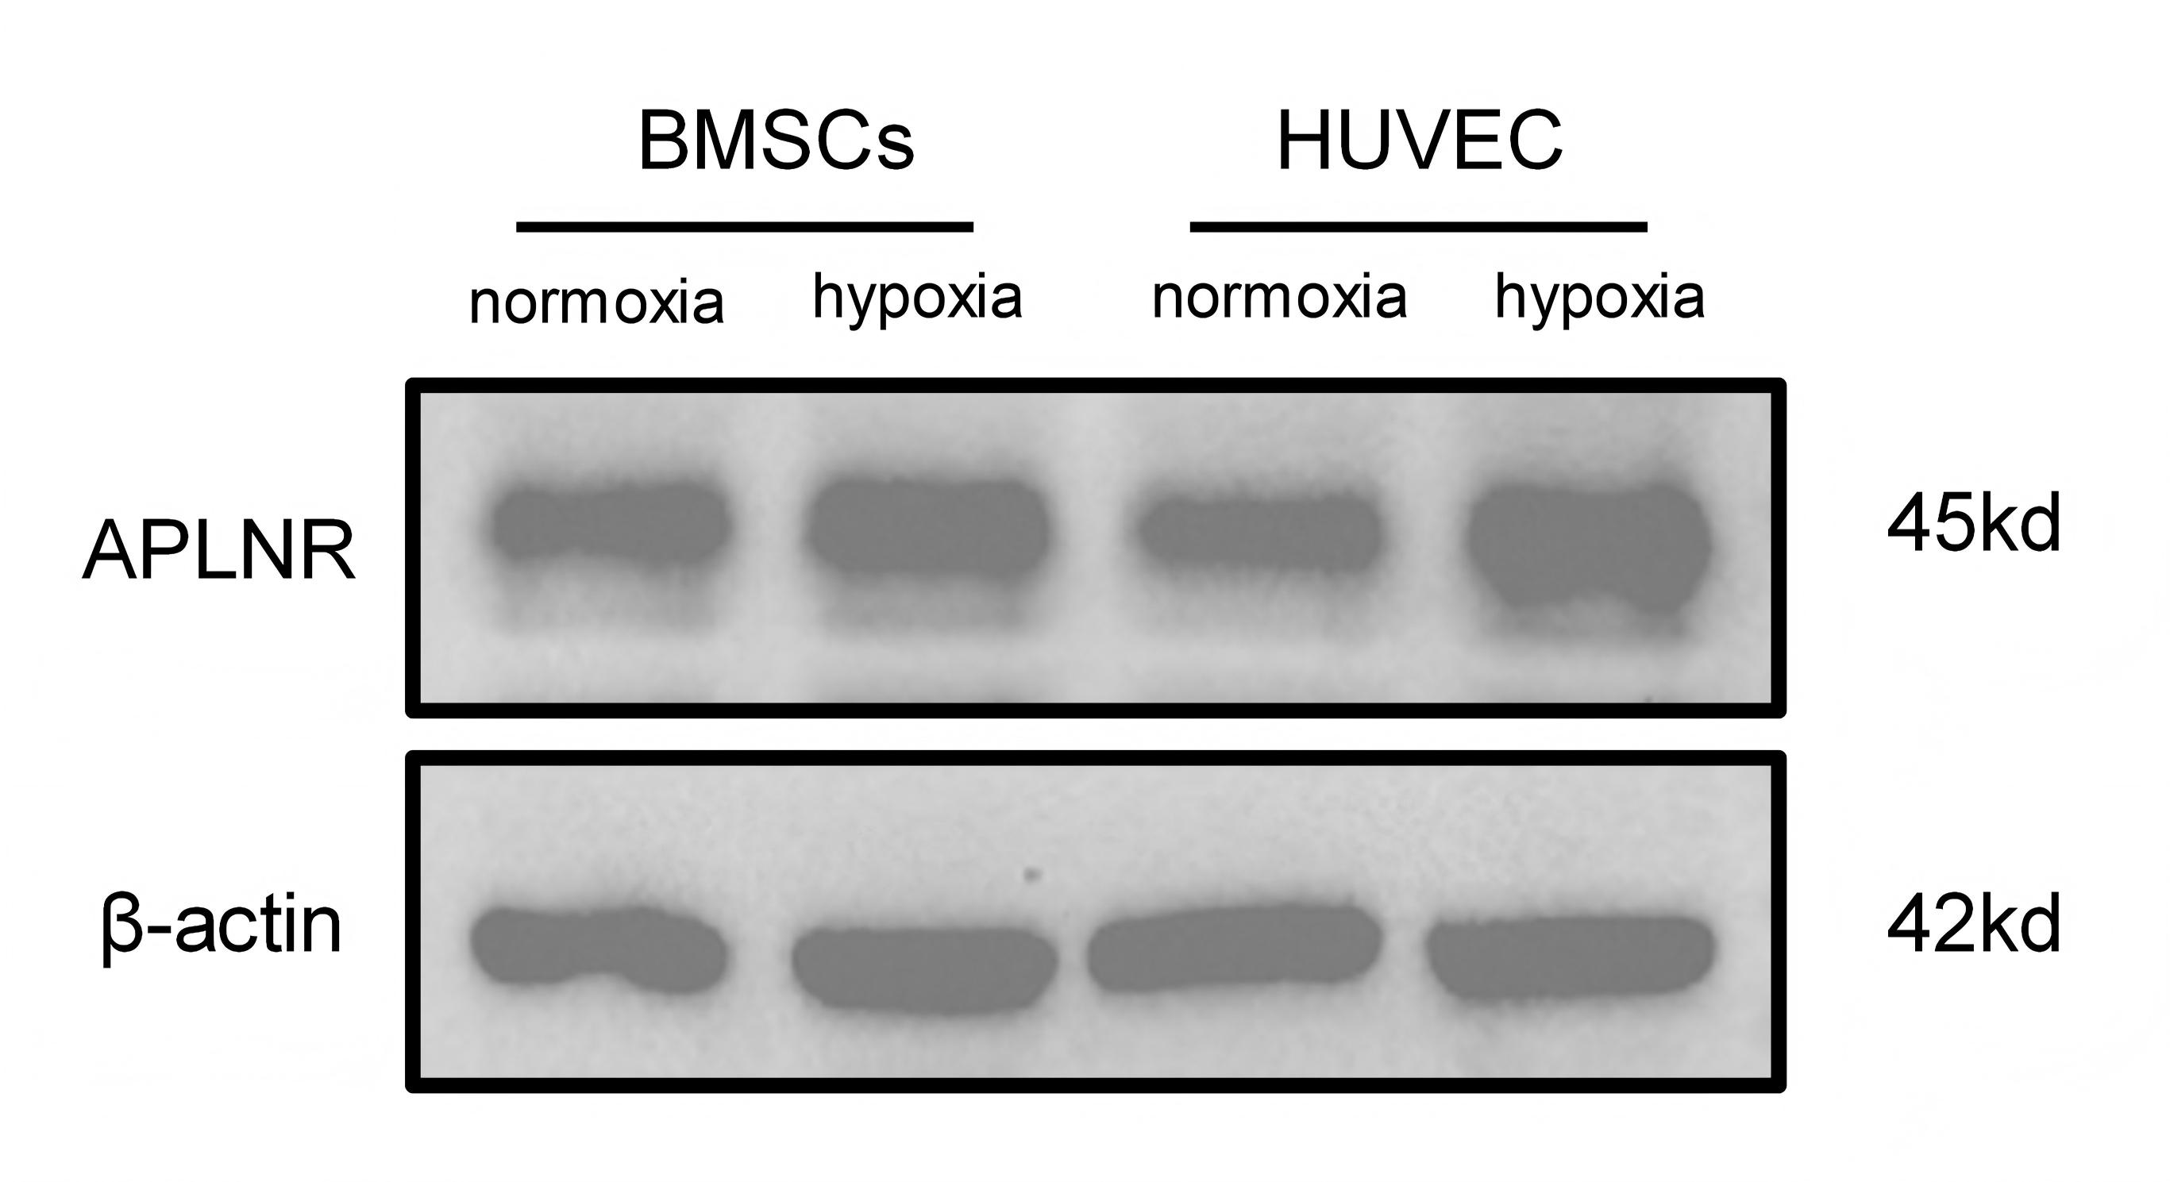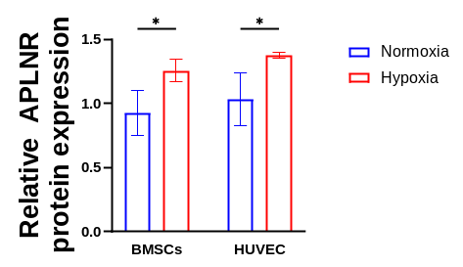
Figure S2: Expression of the Apelin-13 receptor (APLNR) in BMSCs and HUVECs under normoxic and hypoxic conditions. ns: not significant, P>0.05, * P<0.05, ** P<0.01, *** P<0.001, **** P<0.0001.
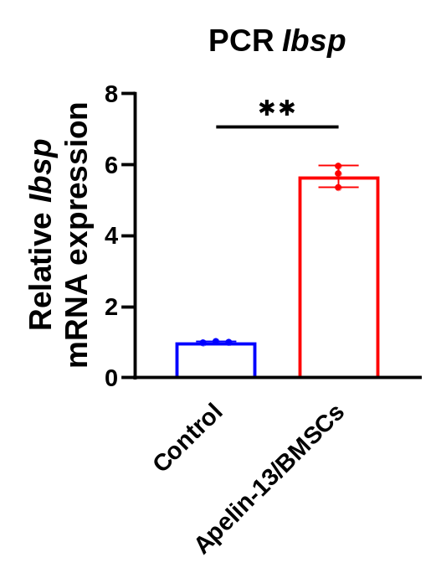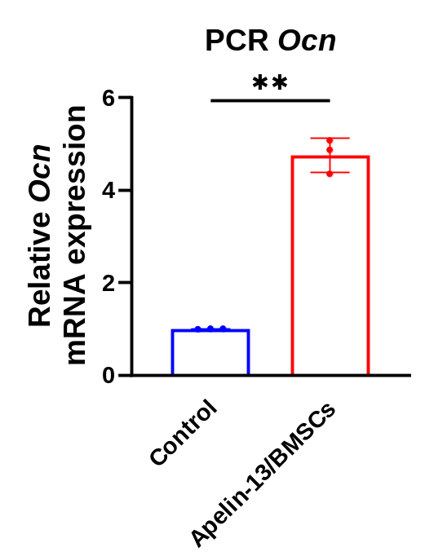
Figure S3: QPCR analysis of Ibsp and Ocn expression in BMSCs, n=3. ns: not significant, P>0.05, * P<0.05, ** P<0.01, *** P<0.001, **** P<0.0001.
Control Apelin/BMSCs Apelin/BMSCs-si-NC Apelin/BMSCs-si-Ibsp
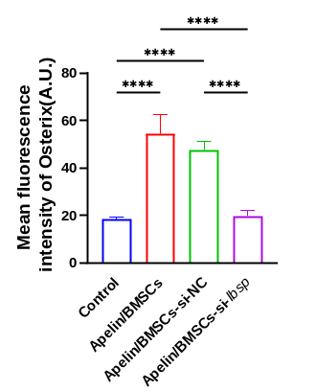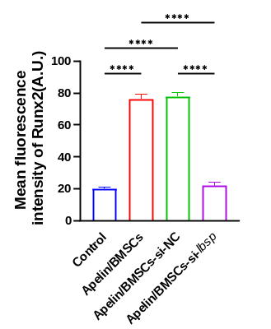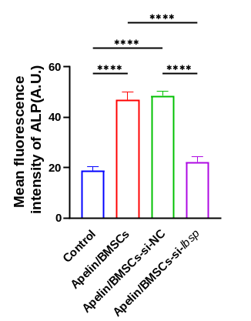
Figure S4: Quantitative analysis of the average fluorescence intensity of Osterix, Runx2, and ALP. ns: not significant, P>0.05, * P<0.05, ** P<0.01, *** P<0.001, **** P<0.0001.

Control Apelin/BMSCs Apelin/BMSCs-si-NC Apelin/BMSCs-si-Ibsp
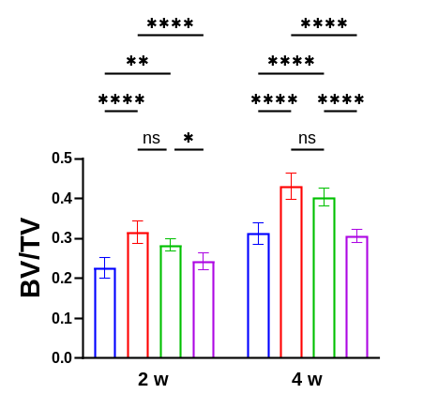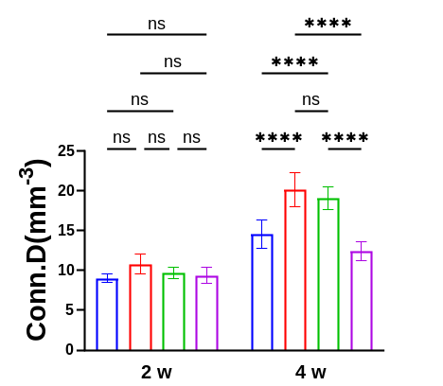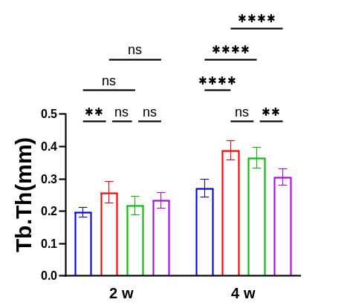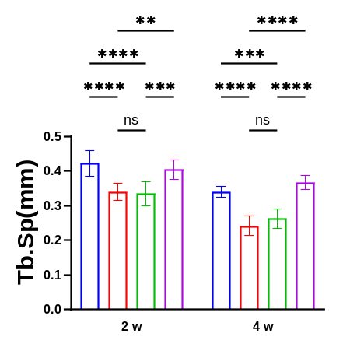
Figure S5: Quantitative micro-CT analysis of BV/TV, Conn.D, Tb.Th and Tb.Sp, n=6. ns: not significant, P>0.05, * P<0.05, ** P<0.01, *** P<0.001, **** P<0.0001.
Control Apelin/BMSCs Apelin/BMSCs-si-NC Apelin/BMSCs-si-Ibsp
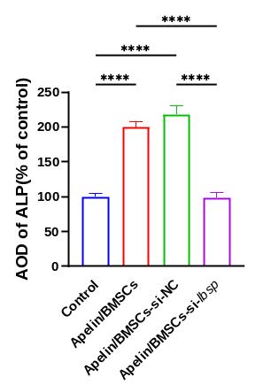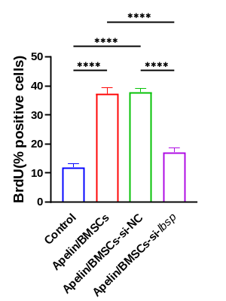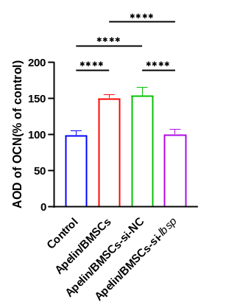
Figure S6: Quantitative analysis of ALP, BrdU, and OCN expression levels in bone tissue. ns: not significant, P>0.05, * P<0.05, ** P<0.01, *** P<0.001, **** P<0.0001.

Control Apelin/BMSCs Apelin/BMSCs-si-NC Apelin/BMSCs-si-Ibsp
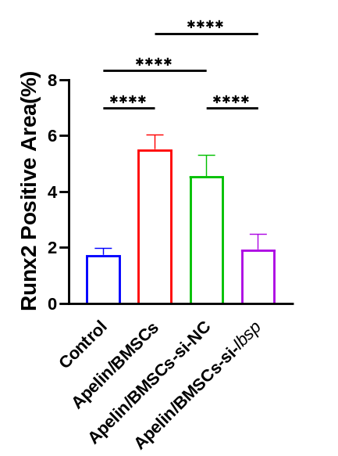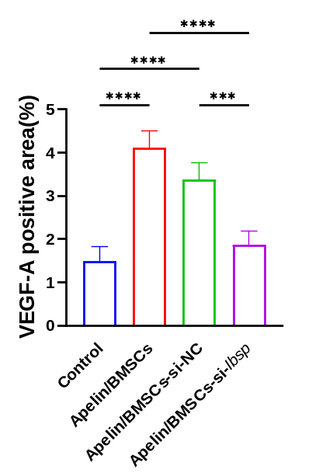
Figure S7: Quantitative analysis of the average fluorescence area of Runx2 and VEGF-A in bone tissue. ns: not significant, P>0.05, * P<0.05, ** P<0.01, *** P<0.001, **** P<0.0001.
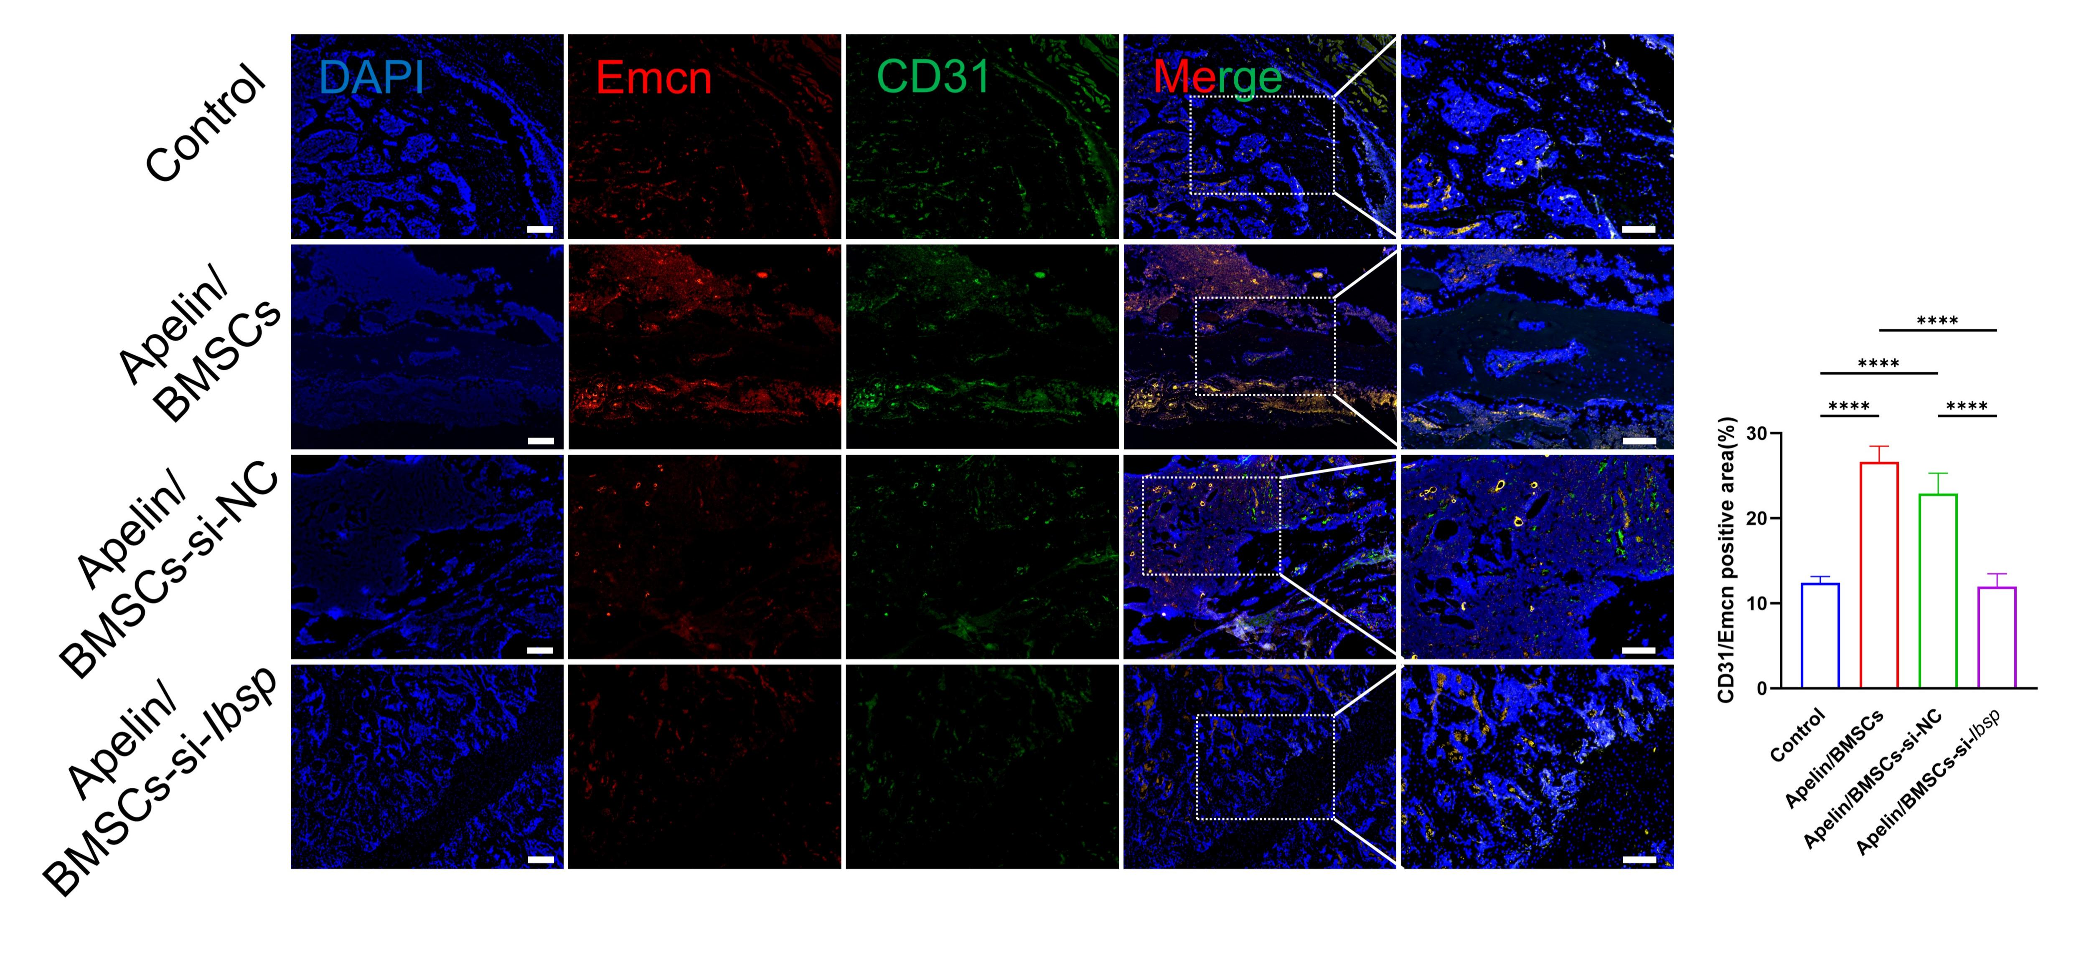
Figure S8: Expression and quantitative analysis of Emcn and CD31 in fracture tissue sections. ns: not significant, P>0.05, * P<0.05, ** P<0.01, *** P<0.001, **** P<0.0001.

