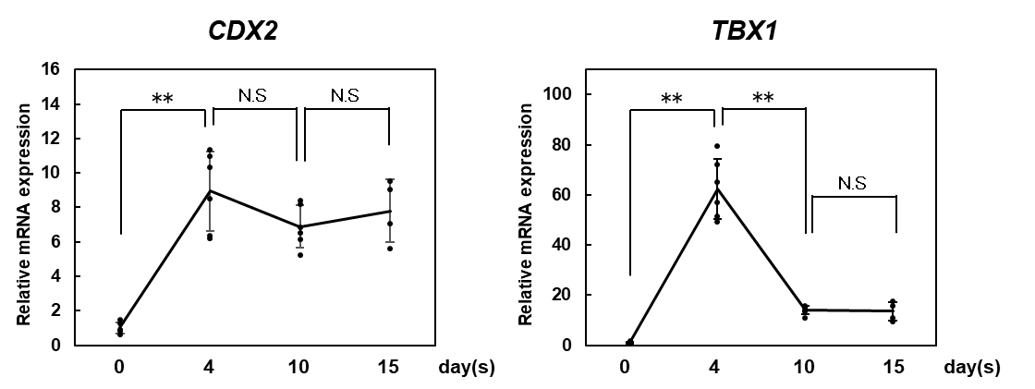
Supplemental Figure 1. the expression of LPM markers.
mRNA expression of mesoderm markers CDX2 and TBX1 during a 15-day experimental periods. Results are shown as the mean ± SD. Each time point included 6 samples, except for day 15, which included 4 samples. **p < 0.01 (ANOVA and Tukey test).
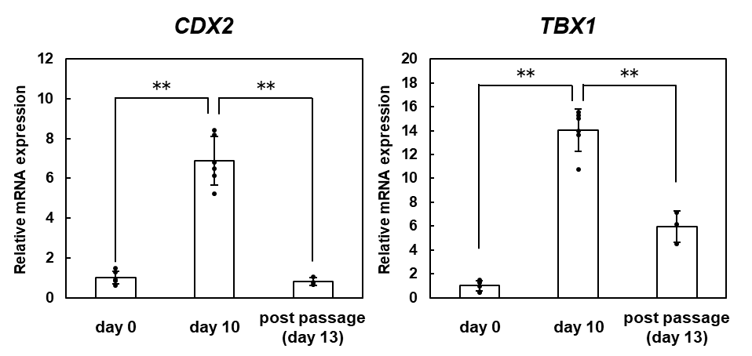
Supplemental Figure 2. Expression of the mesoderm markers after passaging.
mRNA expression of mesoderm markers pre- and post-passage. Values are shown as the mean ± SD. The pre-passage group included 6 samples, whereas the post-passage group included 3 samples. **p < 0.01 (ANOVA and Tukey test).

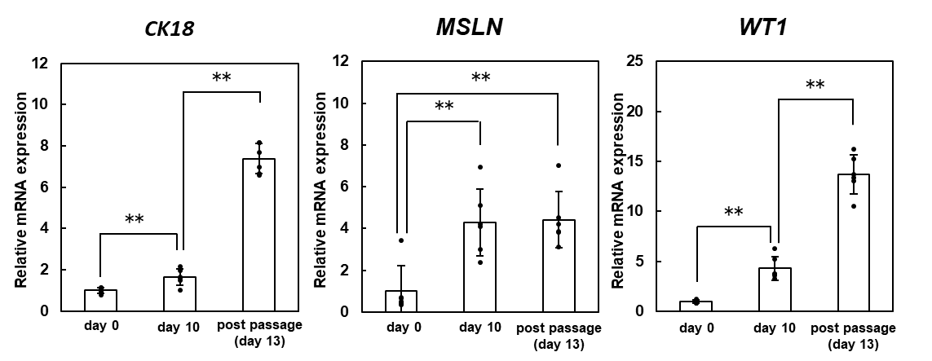
Supplemental Figure 3. Expression of PMC markers in another cell line.
mRNA expression of PMC markers before and after passaging in another cell line (201B7-Ff). Values are shown as the mean ± SD of 6 samples. **p < 0.01 (ANOVA and Tukey test).

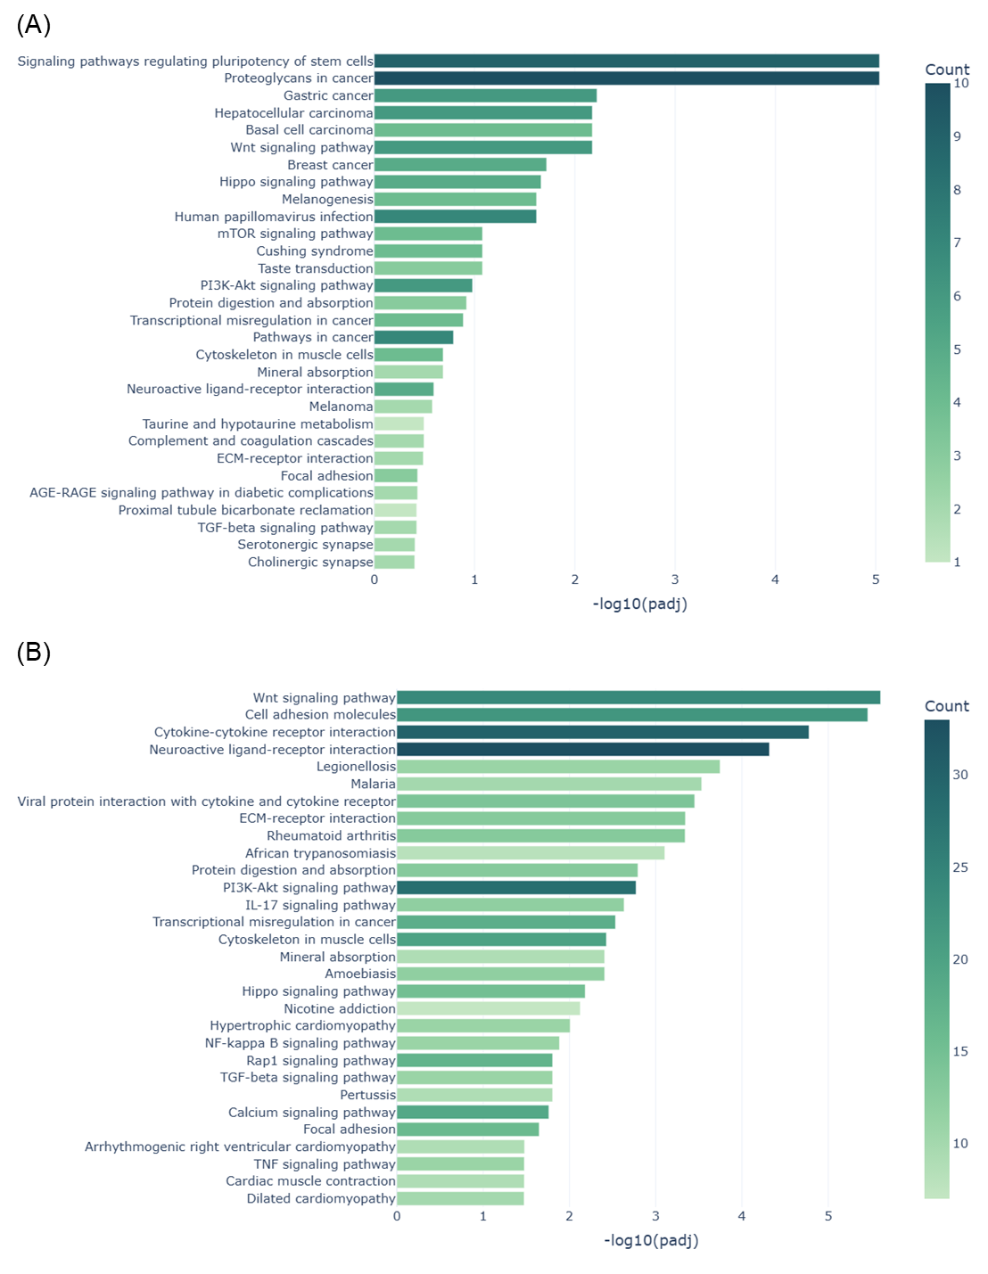Supplemental Figure 4. KEGG pathway enrichment analysis of differentially expressed genes.
(A) Enriched KEGG pathways identified by comparison between iPSCs and iPMCs at day 13 (iPMCd13). (B) Enriched KEGG pathways identified by comparison between iPMCd13 and primary peritoneal mesothelial cells (pPMCs). Differentially expressed genes were defined by an absolute fold change > 1 and an adjusted P value < 0.05. Pathways are shown based on enrichment significance.
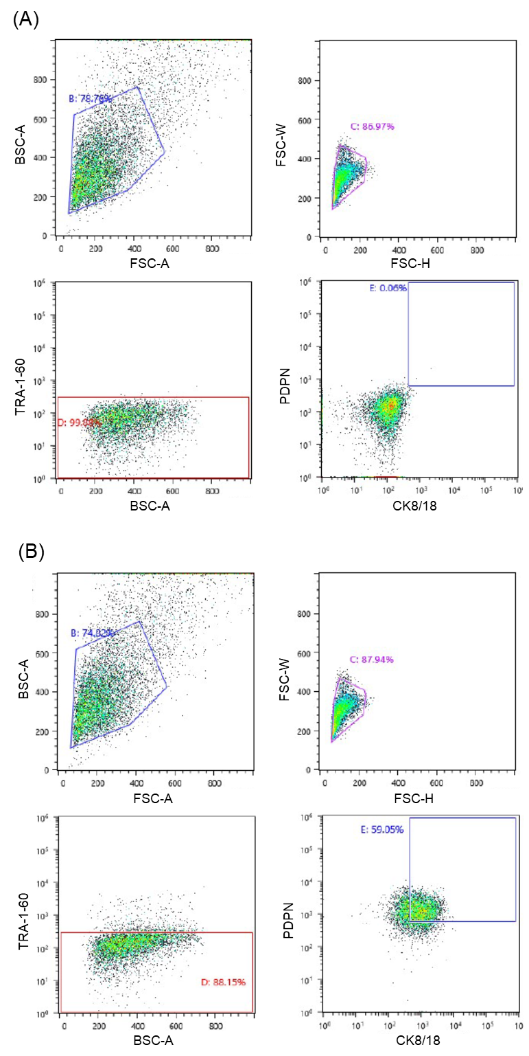
Supplemental Figure 5. Flow cytometric analysis of differentiated iPMCs.
(A) Unstained iPMC population used as a negative control for background fluorescence. (B) Flow cytometric analysis of iPMCs stained with antibodies against TRA-1-60, PDPN, and CK8/18. TRA-1-60–positive cells were rarely detected, whereas a PDPN/CK8/18 double-positive population (34.2%) was identified, supporting differentiation toward a mesothelial-like phenotype.
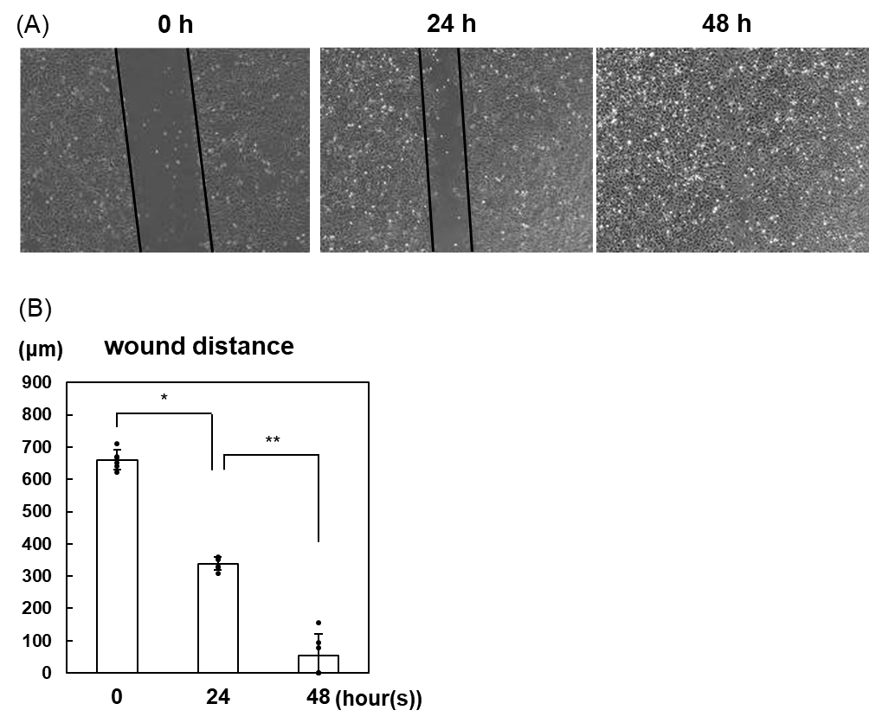
Supplemental Figure 6. Wound-healing assay in MeT- 5A cells.
(A) Representative images of wound-healing assay using MeT-5A cells. (B) Quantitative analysis of wound closure (distance) in MeT-5A cells.
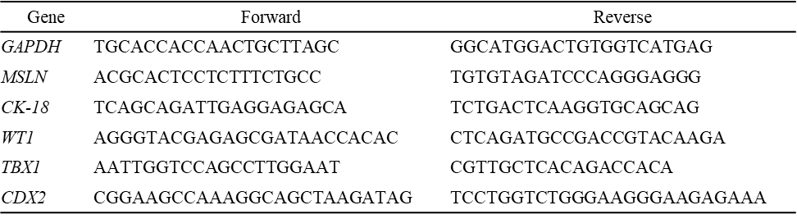
Supplemental Table 1. Primer sequences

