Supplementary Data

Supplementary materials and methods
Preparation of PLCL scaffolds
A 6% (w/v) poly(L-lactide-co-ε-caprolactone) (PLCL) electrospinning solution was prepared by dissolving 0.6 g of PLCL particles in 9.4 g of a mixed solvent composed of dichloromethane and dimethylformamide in a 2:1 weight-to-weight ratio. The solution was continuously stirred until complete dissolution was achieved.Subsequently, the PLCL scaffold was fabricated via electrospinning under ambient conditions, maintained at a temperature of 20-25°C and a relative humidity of 20–45%. The electrospinning process was conducted with the following parameters: a needle-to-collector distance of 15 cm, an applied voltage of 20 kV, and a solution flow rate of 1 mL/h, administered through a syringe pump (LSP02-1B, Baoding Longer Precision Pump Co., Ltd., China) fitted with a 0.45 mm × 25 mm gauge needle.The resultant nanofiber membranes were air-dried for 24 hours, cut to the desired dimensions, and subsequently sterilized using ethylene oxide prior to storage for future applications.
Identification of BMSCs
For the identification of BMSCs, a cell suspension was adjusted to a density of 1×10⁶ cells/mL and aliquoted into four separate centrifuge tubes. Fluorescently conjugated antibodies specific for CD29, CD34, CD45, and CD90 were added to each respective tube. Incubation for antibody binding was conducted at 4°C in the dark for 30 minutes. The cells were then washed with PBS to remove any unbound antibodies. The surface expression rates of CD29, CD34, CD45, and CD90 were analyzed using a flow cytometer.
To assess the multilineage differentiation potential of the isolated BMSCs, osteogenic, adipogenic, and chondrogenic induction experiments were performed in accordance with the manufacturer's protocols (Pricella, China).
Morphological analysis of BMSCs-PLCL complex
The growth status and cellular morphology of BMSCs on PLCL scaffolds were assessed using scanning electron microscopy (SEM; JSM-6700F, JEOL, Japan). Samples were fixed in 2.5% glutaraldehyde in 0.1 M phosphate-buffered saline (PBS, pH 7.4) overnight at 4°C. Following fixation, samples were thoroughly rinsed three times with PBS to eliminate residual fixative.Subsequently, the samples underwent a dehydration process using a gradient ethanol solution comprising 30%, 50%, 70%, 80%, 90%, and 100% ethanol, with each step lasting 15 minutes. Critical point drying with liquid CO₂ was performed to preserve the fine structure of the cells and scaffolds. Finally, the dried specimens were sputter-coated with gold and examined using field emission scanning electron microscopy to obtain high-resolution images of the cellular morphology.
Supplementary result
After 48 hours of medium change, a small number of adherent cells were observed, which exhibited a tightly arranged, vortex-like growth pattern (Fig. S1A). Following osteogenic induction, Alizarin Red staining revealed densely distributed dark red mineralized nodules. Under adipogenic induction conditions, Oil Red O staining showed abundant orange-red lipid droplets accumulated in the cytoplasm. Further chondrogenic induction experiments demonstrated the formation of cartilage-like structures, as indicated by Alcian Blue staining (Fig. S1C), confirming the multi-lineage differentiation potential of BMSCs.Flow cytometric analysis was performed to detect BMSC-related surface markers (CD29, CD90) and hematopoietic markers (CD34, CD45). The results indicated high expression of CD29 (98.4%) and CD90 (96.2%), while CD34 (1.5%) and CD45 (2.4%) were negatively expressed (Fig. S1B). These findings are fully consistent with the phenotypic identification criteria for BMSCs.
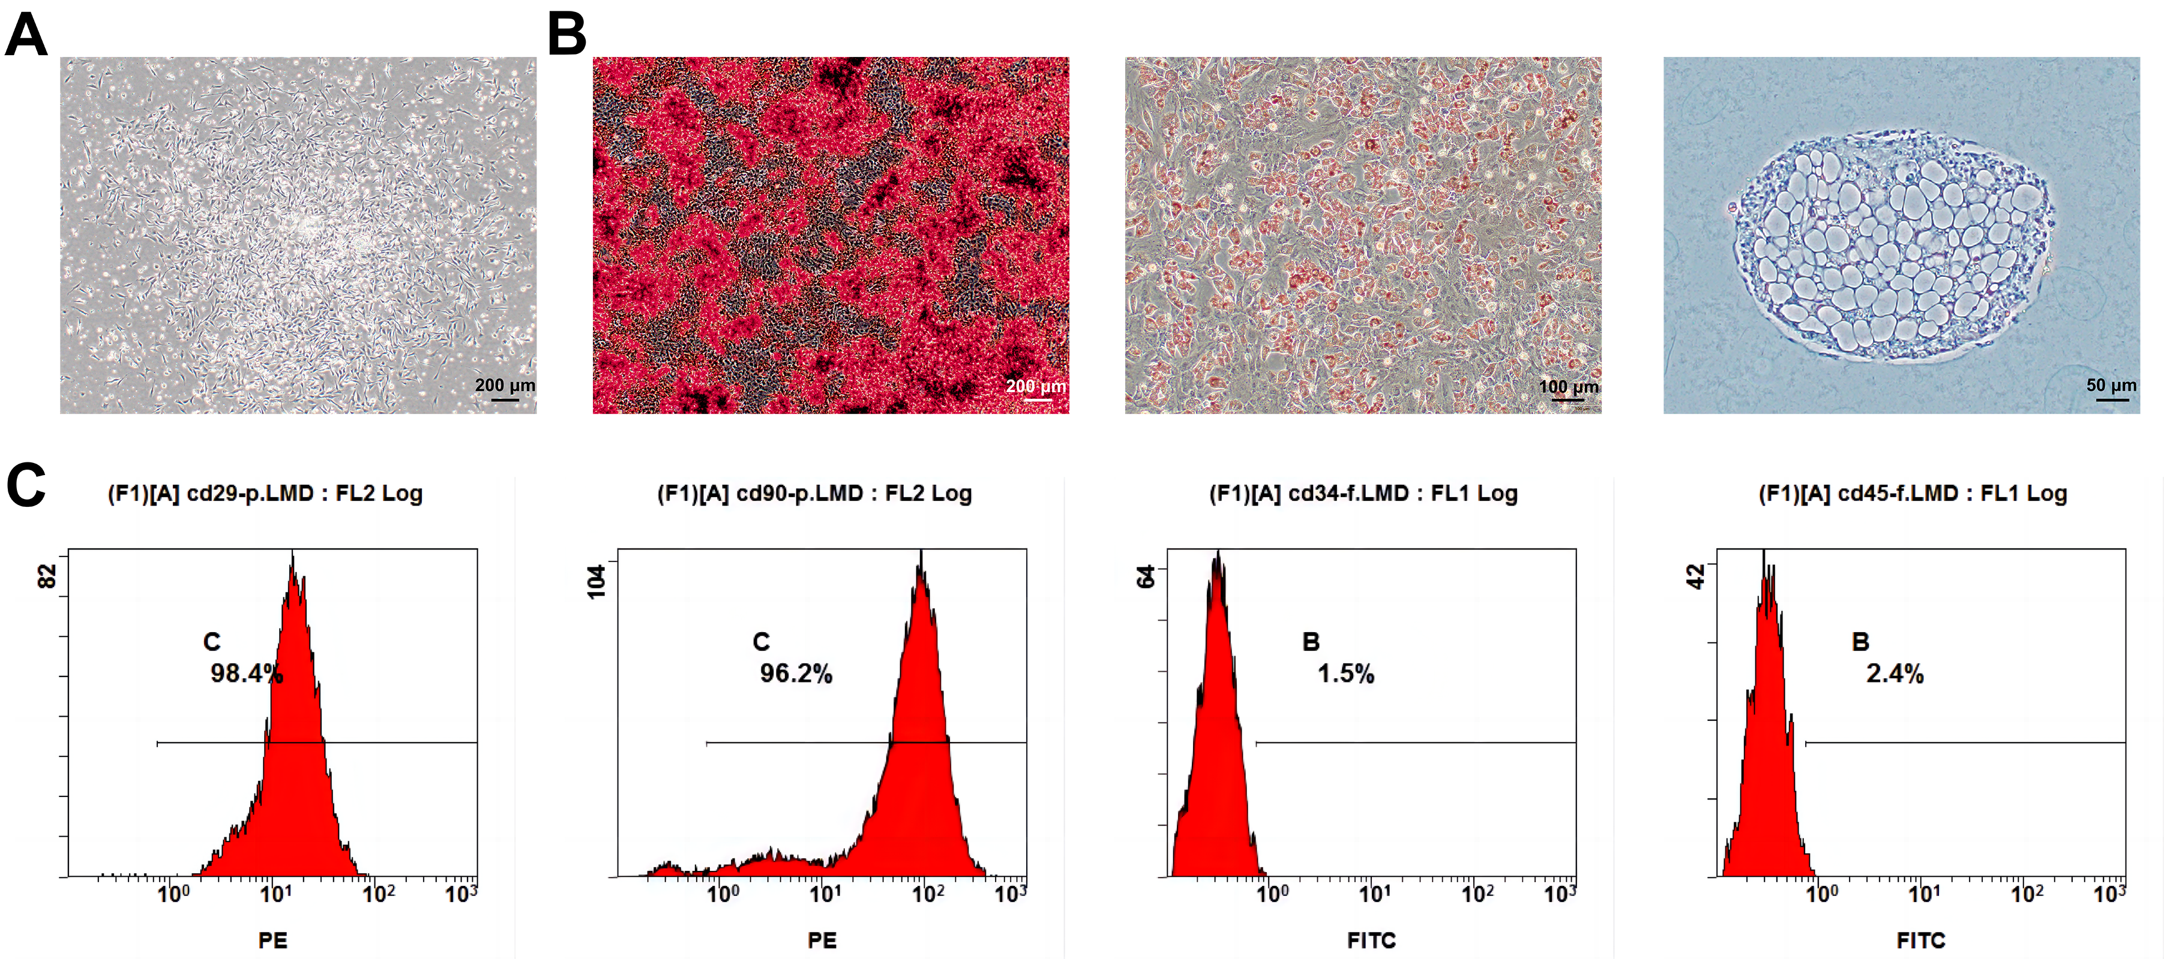
Fig. S1 Characterization of BMSCs. (A) Morphology of BMSCs at 4 days post-isolation under light microscopy (scale bar = 200 μm). (B) Tri-lineage differentiation of BMSCs: osteogenic differentiation (alizarin red staining, left, scale bar = 200 μm), adipogenic differentiation (Oil Red O staining, middle, scale bar = 100 μm), chondrogenic differentiation (Alcian blue staining, right, scale bar = 50 μm). (C) Flow cytometric characterization of BMSCs (CD29: 98.4%, CD34: 1.5%, CD45: 2.4%, CD90: 96.2%).
Optical microscopy observation revealed that the cells exhibited clearly defined edges and were distributed relatively uniformly on the scaffold (Fig. S2A). Under fluorescence microscopy, it was observed that the BMSCs had extended on the scaffold, with cell membranes stained red (Fig. S2B). Furthermore, scanning electron microscopy (SEM) results demonstrated that the PLCL scaffold possessed a three-dimensional porous structure highly resembling the natural extracellular matrix, effectively mimicking the microenvironment required for cell growth. The BMSCs formed a fully confluent cell layer through cellular connections, covering almost the entire nanofibrous scaffold surface, and extracellular matrix deposition was also observed (Fig. S2C). These results confirm that the PLCL scaffold provides a favorable microenvironment for BMSCs adhesion and spreading.
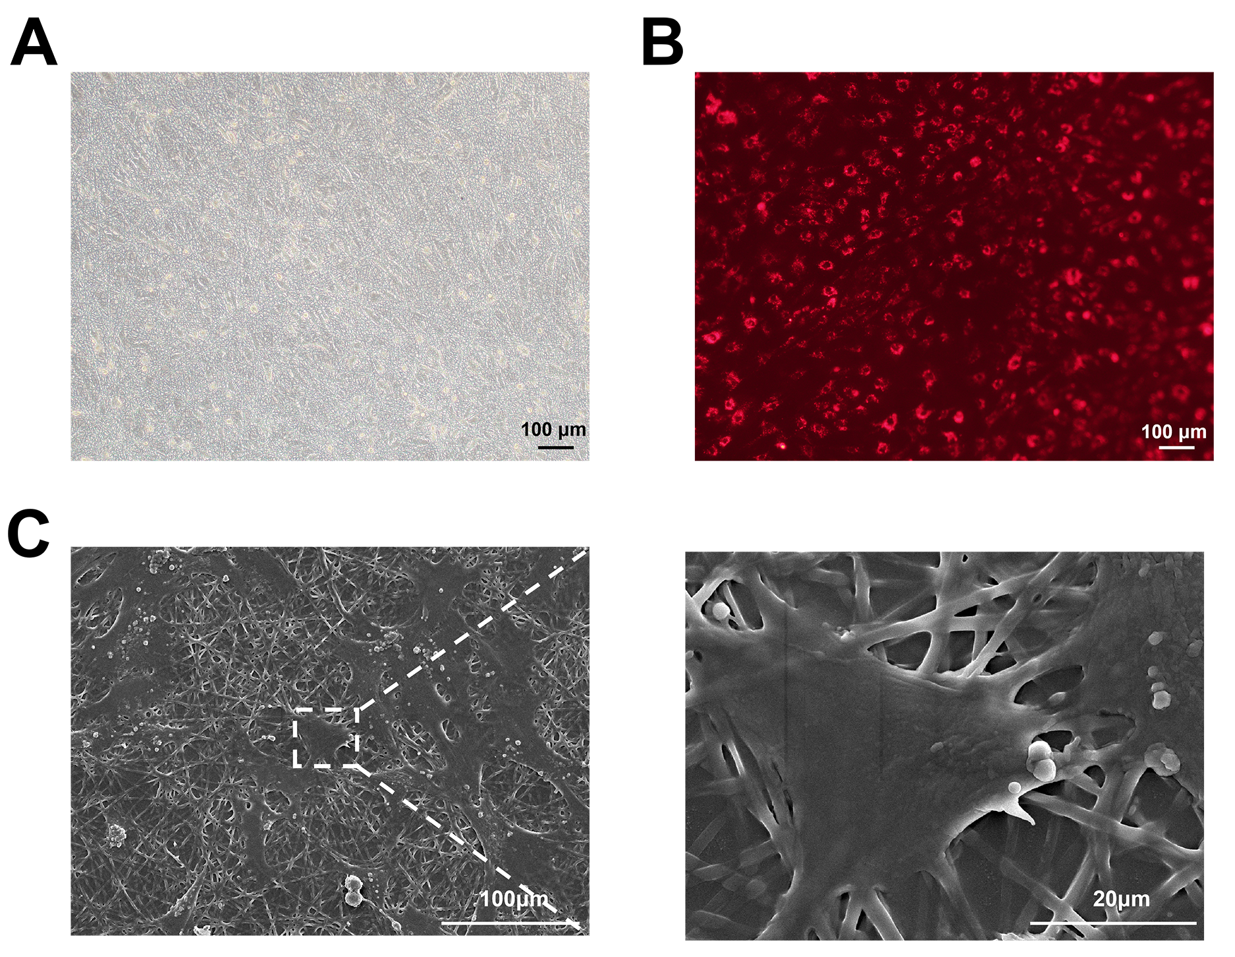
Fig. S2 Morphological characteristics of BMSC-PLCL scaffold complex. (A) Light microscopy image of the BMSCs-PLCL scaffold composite. Scale bar = 100μm. (B) Fluorescence image of PKH26-labeled BMSCs seeded on the PLCL scaffold. Scale bar = 100 μm. (C) Representative SEM images of BMSCs-PLCL scaffold (Left: magnification 500×, scale bar = 100 μm; Right: magnification 3000×, scale bar = 20 μm.

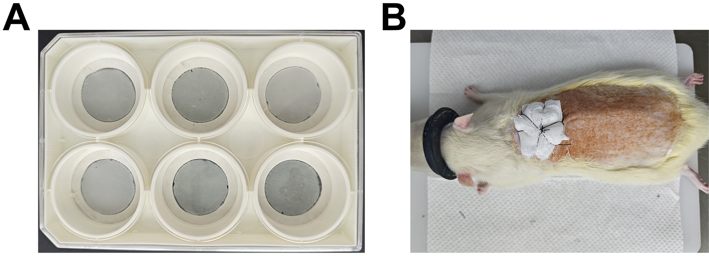
Fig. S3 (A) Flexcell elastic six-well culture plate with PLCL scaffold for tensile testing. (B) Photograph of gauze packing after rat treatment.

Fig. S4 Full-length uncropped blots for Fig. 6B
kDa
GAPDH
Postn
73
10550
53
40
22
18
10

30
73
10550
14050
20050

Table S1 Sequences of primers used for RT-qPCR
Genes | Forward primer (5'-3') | Reverse primer (5'-3')
Mgp | CCCTTCACCAACCGGAGAAA | CGGACTCTTTCCTGGGCTTT
Postn | TGGTGAGAGGAAGCAAGCAG | GCTGAAGCGCTTATCTTGGC
Ccn3 | TCTGAGATGAGACCCTGCGA | TGACCCCATCGAACACACAG
Tgfbr3 | CAGCATTTGTGATCGGAGCG | AGAGCAGGGGGTACTCTGAG
GAPDH | TGATGGGTGTGAACCACGAG | AGTGATGGCATGGACTGTGG

