SUPPLEMENTAL Figure
Fig. S1. Different concentrations of CoCl₂ were used to assess the performance of eahy926 endothelial cells and H9C2 myocardial cells. (A) Under varying concentrations of CoCl₂, the numbers of EA.hy926 and H9C2 cells and their morphological changes were observed under a standard light microscope (scale bars = 400 μm). (B-C) The survival rates of EA.hy92 and H9C2 cells were analyzed at different CoCl₂ concentrations (n = 5 per group). Dates are presented as mean ± s.d., and statistical significance was evaluated via one-way ANOVA followed by Tukey's post hoc test. ns: non-significant, *p < 0.05, **p < 0.01, ***p < 0.001, and ****p < 0.0001.
Fig. S2. Effect of hucMSC-Exo on the survival rate of EA·hy926 and H9C2 cells. (A) Under a light microscope (scale bar = 400 μm), clear changes in cell morphology and cell number are evident in each group. (B-C) CCK8 results show significant differences in the exosome treatment group (n = 5 per group). Dates are presented as mean ± s.d., and statistical significance was evaluated via one-way ANOVA followed by Tukey's post hoc test. ns: non-significant, *p < 0.05, **p < 0.01, ***p < 0.001, and ****p < 0.0001.
Fig. S3. Effect of hucMSC-Exo on the migration ability of EA·hy926 and H9C2 cells. (A and C) Microscopic images of endothelial cells (EA.hy926) and cardiomyocytes (H9C2) (scale bars=400 μm). (B and D) Statistical analysis of cell migration in the scratch assay for both cardiomyocytes and endothelial cells (n = 5 per group). Dates are presented as mean ± s.d., and statistical significance was evaluated via one-way ANOVA followed by Tukey's post hoc test. ns: non-significant, *p < 0.05, **p < 0.01, ***p < 0.001, and ****p < 0.0001.
Fig. S4. Effect of hucMSC-Exo on the tubulogenesis of EA·hy926 cells. (A) EA.hy926 cell formation under different conditions under a light microscope (scale bars=400 μm). (B) Statistical analysis of angiogenic ability (n = 5 per group). Dates are presented as mean ± s.d., and statistical significance was evaluated via one-way ANOVA followed by Tukey's post hoc test. ns: non-significant, *p < 0.05, **p < 0.01, ***p < 0.001, and ****p < 0.0001.
Fig. S5. The internalization of hucMSC-Exo uptake by HUCEC and H9C2 cells. Under fluorescence microscopy, hucMSC-Exo (indicated by red arrows) labeled with a green marker was observed within the membranes of HUCEC and H9C2 cells(scale bars=20 μm).
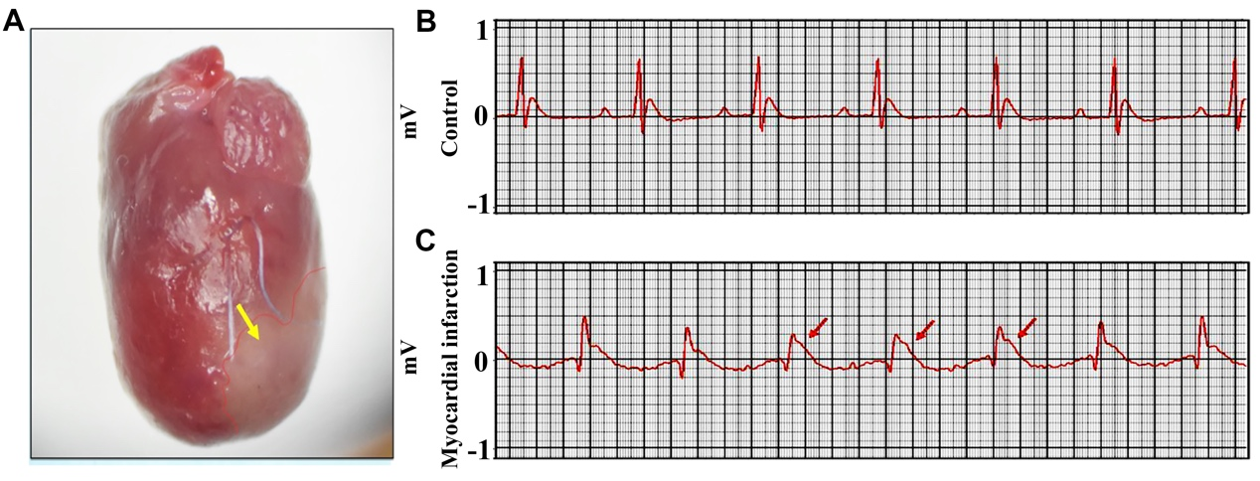
Fig. S6. Changes in Myocardial Color and Electrocardiogram Following Myocardial Infarction. (A) Gross cardiac morphology observed under an anatomical microscope 3 days post-MI. (B) Lead I electrocardiogram changes in rats before and 30 minutes after myocardial infarction.
Fig. S7. Fluorescence images and statistical analysis of labeled hucMSC-Exo and exosomes encapsulated in SFMA/HA-E hydrogel within myocardial sections (scale bars=25 μm). (n = 3 per group). Dates are presented as mean ± s.d., and statistical significance was evaluated via one-way ANOVA followed by Tukey's post hoc test. ns: non-significant, *p < 0.05, **p < 0.01, ***p < 0.001, and ****p < 0.0001.
Fig. S8. Effects of SFMA/HA-E hydrogel on the levels of inflammatory cytokines. (A-C) The expression levels of the genes associated with inflammation in myocardial tissue. (D-F) Levels of TNF-𝑎、IL-6, and IL-10 in blood 28 days post-MI (n = 3 per group). Dates are presented as mean ± s.d., and statistical significance was evaluated via one-way ANOVA followed by Tukey's post hoc test. ns: non-significant, *p < 0.05, **p < 0.01, ***p < 0.001, and ****p < 0.0001.

Table S1. Primer sequences used in the RT-PCR assay.
Gene | Forward primer(5’-3’) | Reverse primer(5’-3’)
GAPDH | GGCACAGTCAAGGCTGAGAATG | ATGGTGGTGAAGACGCCAGTA
IL-10 | GCTGAGAACCAAGACCCAGAC | GCTGAGAACCAAGACCCAGAC
TNF-α | CCACCACGCTCTTCTGTCTACTG | GGGCTTGTCACTCGAATTTTGAGA
IL-6 | CCTTCCTACCCCAATTTCCA | AGATGAATTGGATGGTCTTGGT

