Supplementary Material
Table of Contents

Fig. S1. Axillary subcutaneous white adipose tissue (Axilla SWAT Tx) transplantation and intramuscular transplantation (Muscle Tx) of human embryonic stem cell (hESC)-derived pituitary–hypothalamus organoids in mice. ------------------------------------------------------------------------------------------------------------------------------2

Fig. S2. Angiogenic pretreatment in subcutaneous transplantation. -----------------------------------------------------3

Fig. S3. Transplantation in monkey model. ---------------------------------------------------------------------------------4

Fig. S4. Body weight changes in cynomolgus monkey during the observation period and analysis of a segmented regression model allowing slope changes at multiple timepoints. ------------------------------------------5

Fig. S5. Immunosuppressive protocol. ---------------------------------------------------------------------------------------6

Fig. S6. Transportation of human embryonic stem cell (hESC)-derived pituitary–hypothalamus organoids. -----7

Fig. S7. Trough levels of tacrolimus and mycophenol mofetil in the peripheral blood. -------------------------------8

Fig. S8. Comparison between the cell-transplantation group and the non-transplantation group. -------------------9

Fig. S9. Immunostaining of pituitary–hypothalamus organoids for Ki67. ---------------------------------------------10

Fig. S10. Histological findings in the lung and liver after subcutaneous cell transplantation in cynomolgus monkey. -------------------------------------------------------------------------------------------------------------------------11

Fig. S11. In vitro assessment of immunosuppressant effects on pituitary-hypothalamic organoids. ---------------12

Fig. S12. Histological findings after subcutaneous cell transplantation in mice. -------------------------------------13

Table S1. Hormonal changes in cynomolgus monkey following hypophysectomy and organoid transplantation.-------------------------------------------------------------------------------------------------- -----------------------------------14

Table S2. Haematological and biochemical test results before and after hypophysectomy in cynomolgus monkey. -------------------------------------------------------------------------------------------------------------------------15

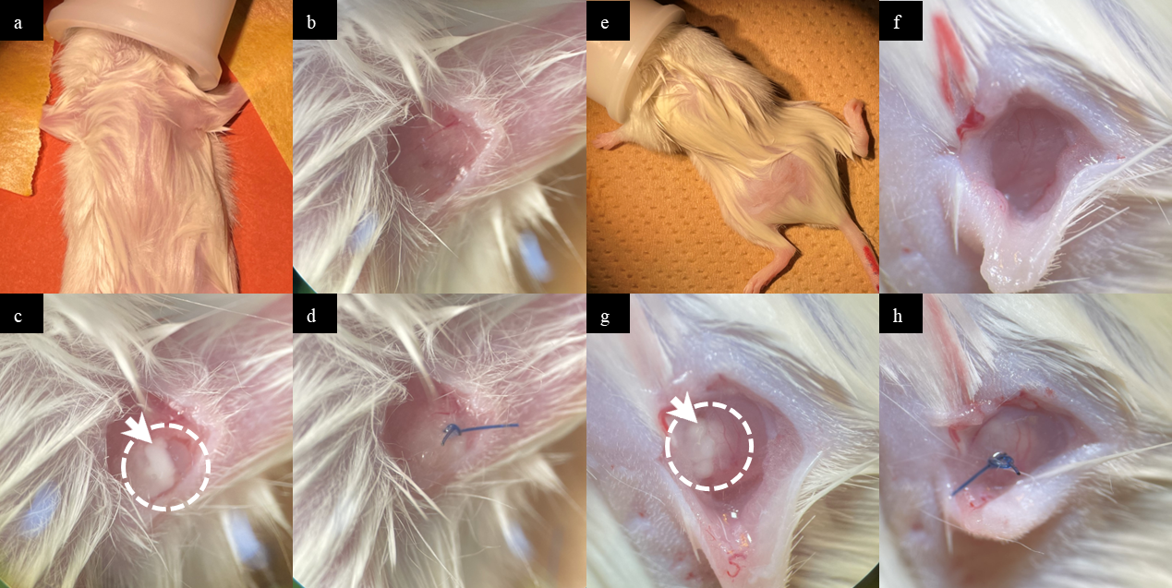

Fig. S1. Axillary subcutaneous white adipose tissue transplantation and intramuscular transplantation of human embryonic stem cell (hESC)-derived pituitary–hypothalamus organoids in mice.
(a) The left axillary region of a mouse, secured in the supine position under inhalational anaesthesia, was shaved. (b) A vertical skin incision of 4 mm was made.
(c) Pituitary–hypothalamus organoids were transplanted. (d) The adipose tissue was repositioned over the organoids and the wound was closed with nylon sutures.
(e) The left gluteal region of a mouse, secured in the prone position under inhalational anaesthesia, was shaved. (f) A vertical skin incision of 6 mm was made.
(g) Pituitary–hypothalamus organoids were transplanted. (h) The muscle tissue and skin overlying the organoids were closed with nylon sutures.
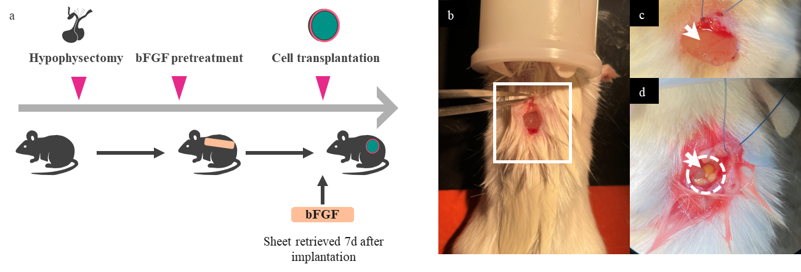
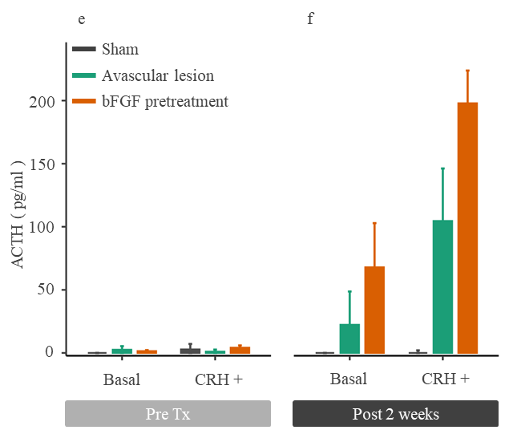
Fig. S2. Angiogenic pretreatment in subcutaneous transplantation
(a) Schematic and experimental procedures in mice. The workflow includes hypophysectomy, transplantation of a basic fibroblast growth factor (bFGF) carrier device, transplantation of pituitary–hypothalamus organoids after removal of the bFGF carrier device, and functional assessment of grafts. (b) Implantation of a bFGF carrier device into the dorsal subcutaneous space of mice secured in the prone position under inhalational anaesthesia. (c) Removal of the bFGF carrier device. (d) Transplantation of pituitary–hypothalamus organoids.
(e) Plasma ACTH concentrations at basal state and after CRH stimulation in mice transplanted with pituitary–hypothalamus organoids, with (bFGF pretreatment) or without bFGF pretreatment (Avascular lesion). Sham (n=4, grey), Avascular lesion (n=4, green), and bFGF pretreatment (n=4, orange). Plasma ACTH concentrations did not differ significantly among the 3 groups before transplantation (bFGF pretreatment vs. Avascular lesion vs. Sham, basal: 1.45 pg/ml [IQR 0.50-2.24] vs. 2.55 pg/ml [IQR 0-5.39] vs. 0 pg/ml [IQR 0], p=0.166, Fig. S2e; CRH +: 4.17 pg/ml [IQR 2.11-5.95] vs. 1.06 pg/ml [IQR 0-2.65] vs. 2.81 pg/ml [IQR 0-7.09], p=0.561, Fig. S2e). However, at 2 w after transplantation, both basal and CRH-stimulated ACTH concentrations differed significantly among the 3 groups (basal: 67.9 pg/ml [IQR 35.1-103] vs. 22.3 pg/ml [IQR 14.5-48.7] vs. 0 pg/ml (IQR 0), p＜0.05, Fig S2f; CRH+: 198 pg/ml [IQR 168-224] vs. 105 pg/ml [IQR 65-146] vs. 0 pg/ml [IQR 0-2.05], p＜0.05, Fig. S2f). Statistical analyses were performed using the Kruskal-Wallis test.

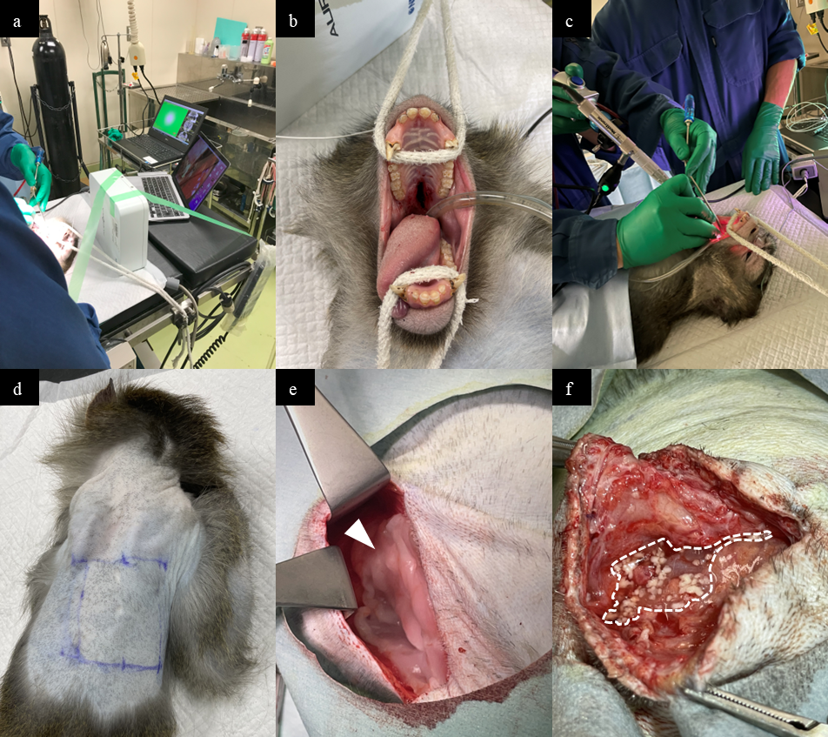

Fig. S3. Transplantation in monkey model.
(a-c) Hypophysectomy was performed via an endoscopic transoral trans-sphenoidal approach with the aid of a surgical navigation system. (d) A 7 cm horizontal skin incision was made across the midline of the back of a cynomolgus monkey, followed by creation of a subcutaneous pocket. (e) A basic fibroblast growth factor carrier device was implanted subcutaneously 1 w before cell transplantation. (f) Cell transplantation was then performed.

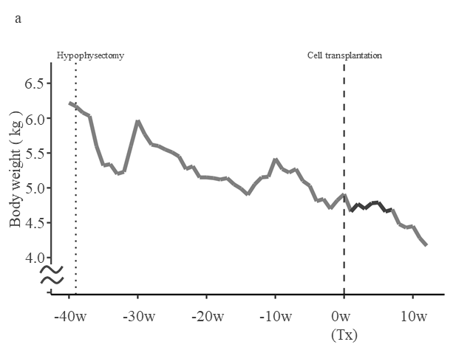
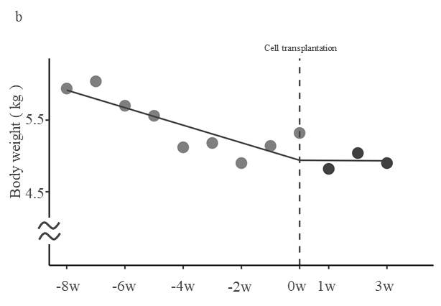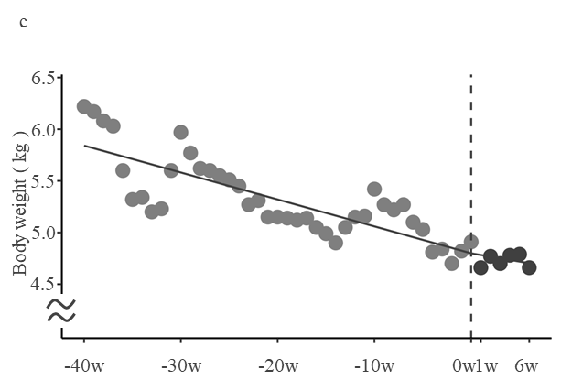

Fig. S4. Body weight changes in cynomolgus monkey during the observation period and analysis of a segmented regression model allowing slope changes at multiple timepoints.
(a) Physiological changes in cynomolgus monkey following hypophysectomy and organoid transplantation.
(b) The timepoints preceding cell therapy were defined from the beginning of immunosuppressive therapy to ensure consistency with post-transplant conditions, while those following cell therapy were determined by levels of ACTH and cortisol (in this case, 3 w after transplantation). Before transplantation, body weight significantly decreased by -0.061 kg/w (${\hat{β}}_{1}$ = -0.061; SE 0.013; t = -4.561; p < 0.05; Fig. S4b). After transplantation, the slope shifted to -0.001 (${\hat{β}}_{1}$+${\hat{β}}_{2}$) kg/w (${\hat{β}}_{2}$ = 0.060; SE 0.048; t = 1.236; p = 0.25; Fig. S4b).
(c) The timepoints preceding cell therapy were defined from the start of the experiment and those after cell therapy were determined by levels of ACTH and cortisol. Before transplantation, bodyweight significantly decreased by -0.026 kg/w (${\hat{β}}_{1}$ = -0.026; SE 0.003; t = -9.552; p < 0.05; Fig. S4c). After transplantation, the slope shifted to -0.016 (${\hat{β}}_{1}$+${\hat{β}}_{2}$) kg/w (${\hat{β}}_{2}$ = 0.010; SE 0.028; t = 0.361; p = 0.72; Fig. S4c).

Fig. S5. Immunosuppressive protocol
Immunosuppressive and anti-inflammatory drugs used in this study.

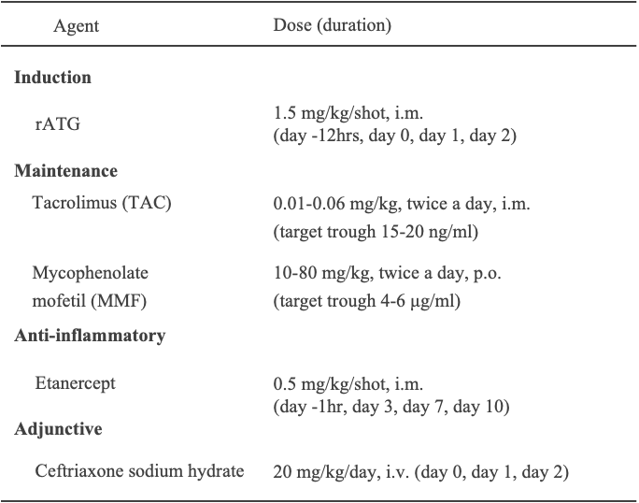

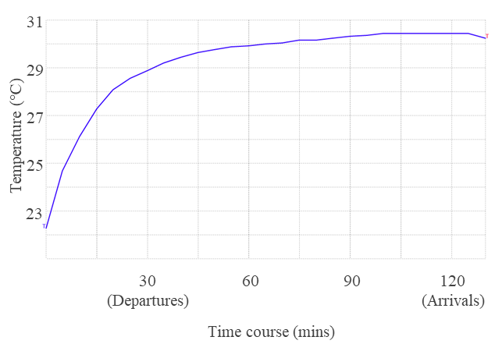

Fig. S6. Transportation of human embryonic stem cell (hESC) derived pituitary–hypothalamus organoids
hESC-derived pituitary–hypothalamus organoids were generated and transported on the day of transplantation from Nagoya University (Nagoya, Japan) to the Research Centre for Animal Life Science, Shiga University of Medical Science (Shiga, Japan). Samples were maintained at 30 °C during transport and were transplanted into animals immediately upon arrival.

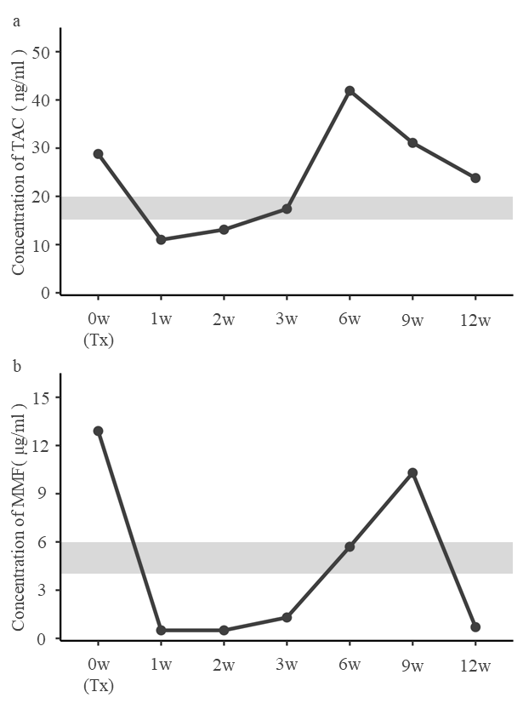

Fig. S7. Trough levels of tacrolimus and mycophenol mofetil in the peripheral blood.
(a) Blood concentrations of tacrolimus (TAC) in non-human primate transplantation experiment using hESC-derived pituitary–hypothalamus organoids. (b) Blood concentrations of mycophenolic acid (MMF).
(a-b) Grey areas indicate the target trough ranges of TAC and MMF required to prevent acute rejection after cell transplantation in non-human primates.

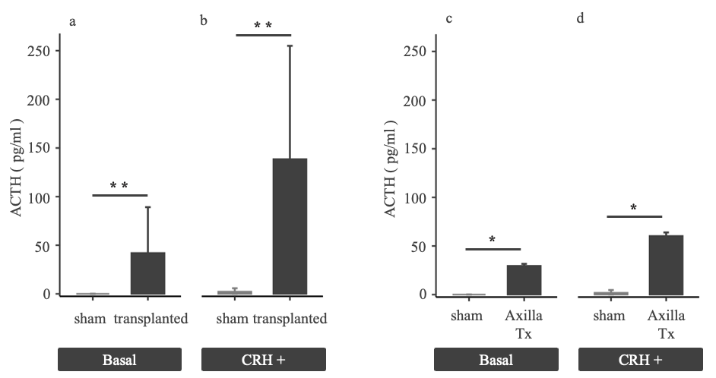

Fig. S8. Comparison between the cell-transplantation group and the non-transplantation group.
Plasma ACTH concentrations at 6 mo after transplantation of pituitary–hypothalamus organoids in mice. (a-b)
Sham-operated mice (sham, n=4, mid-grey) and transplanted mice (including Axilla SWAT Tx, Inguinal SWAT Tx, and Muscle Tx; n=17, black).
At 6 mo post-transplantation, both basal plasma ACTH concentrations (Basal ACTH; Fig. S6a) and plasma CRH-stimulated ACTH concentrations (CRH-stimulated ACTH; Fig. S6b) were significantly higher in transplanted mice than in sham mice (Basal ACTH: 0 pg/ml (IQR 0-0.09) vs. 42 pg/ml (IQR 29-89.1), p<0.05, Fig. S8a; CRH-stimulated ACTH: 1.84 pg/ml (IQR 0-4.71) vs. 112 pg/ml (IQR 62.1-207), p<0.05, Fig. S8b).
Sham-operated mice (sham, n=4, mid-grey) and axilla subcutaneous white adipose tissue transplantation (Axilla Tx, n=3, black). a comparison between axilla subcutaneous white adipose tissue transplantation (Axilla Tx) and sham-operated controls revealed significant increase in both basal and CRH-stimulated ACTH concentrations in the Axilla Tx group (basal: 0 pg/mL [IQR 0-0.09] vs. 29.6 pg/mL [IQR 16.9-31.6], p<0.05; Fig. S8c, CRH+: 1.84 pg/mL [IQR 0-4.71] vs. 60.3 pg/mL [IQR 40.3-64.0], p<0.05; Fig. S8d). Statistical differences were assessed with the Wilcoxon rank-sum test. *p<0.05, **p<0.01. Bars indicate medians (IQR).

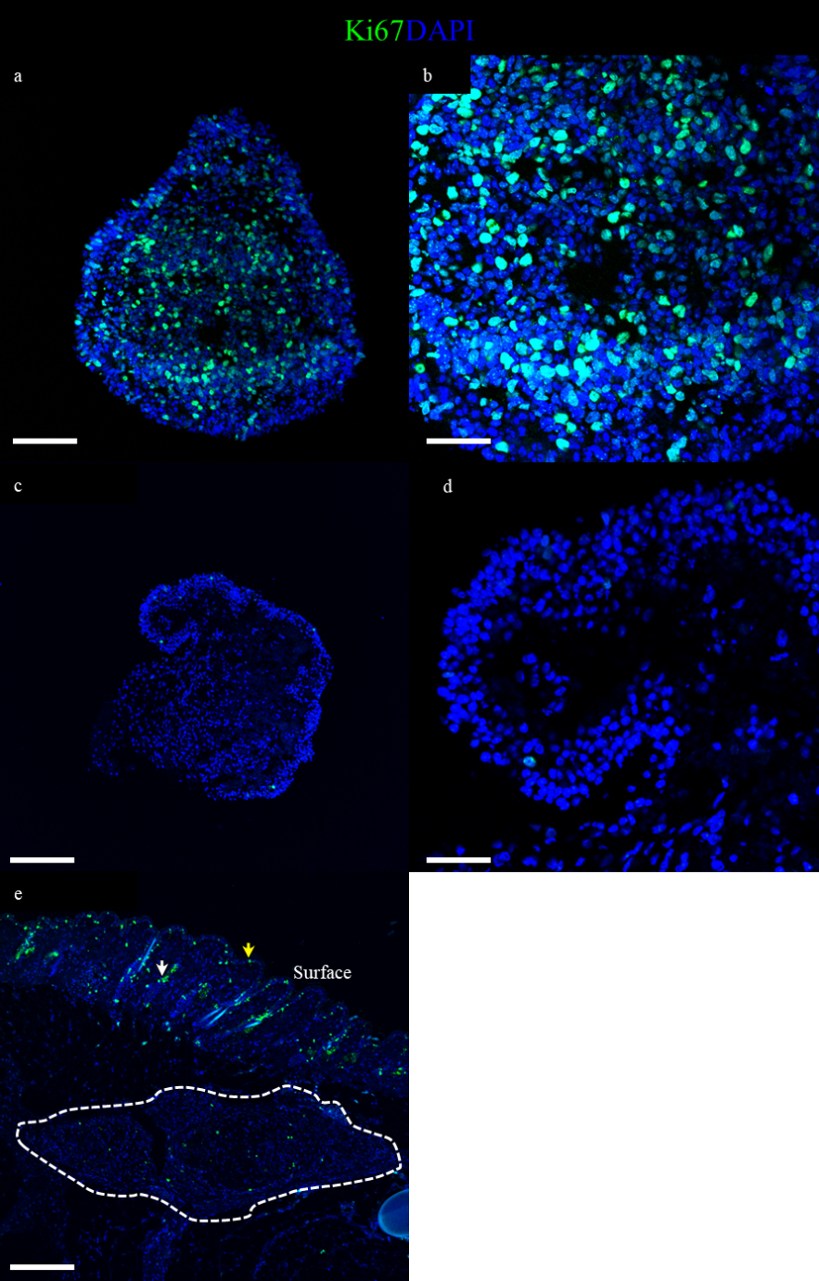

Fig. S9. Immunostaining (green) of pituitary–hypothalamus organoids for Ki67 (a-d).
(a-b) Ki67 immunostaining in immature pituitary–hypothalamus organoids at day 20 of differentiation. Scattered cells mark for Ki67.
(c-d) Ki67 immunostaining in pituitary–hypothalamus organoids at day 138 of differentiation, used for cell transplantation in mice. Only a few cells that mark for Ki67 remain.
(e) Epithelial cells lining hair follicles and sebaceous ducts in the subcutaneous region (white arrow), as well as basal keratinocytes (yellow arrow), exhibited Ki67 expression. Only minimal residual Ki67 expression was observed within grafts located in subcutaneous white adipose tissue. Pituitary–hypothalamus organoids are outlined by a white dashed line.
Scale bars: 200 μm (e), 100 μm (a, c), 50 μm (b, d).

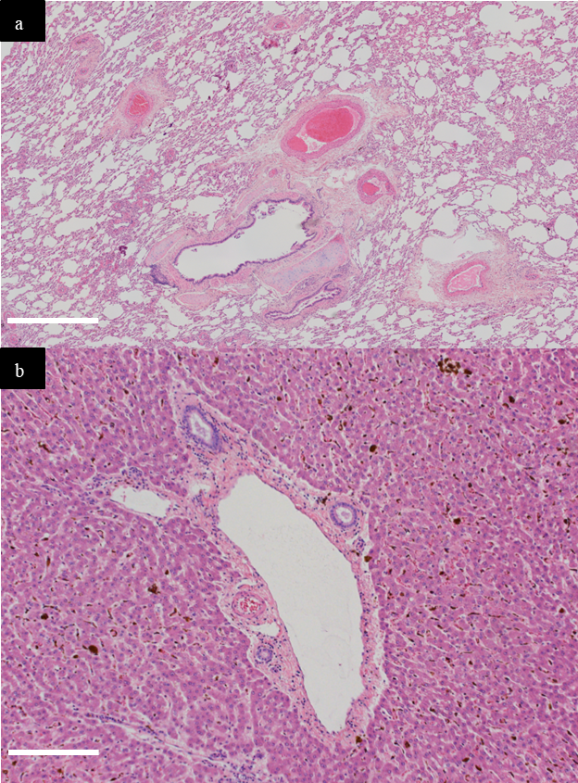

Fig. S10. Histological findings in lung and liver after subcutaneous cell transplantation in cynomolgus monkey.
Lung and liver 12 w after transplantation. (a) No histological evidence of graft dissemination was detected in lung within the observed fields. (b) While hemoglobin deposition associated with iron administration was noted, no histological evidence indicative of graft dissemination was observed in liver within the examined fields. Haematoxylin and eosin staining. Scale bars: 1 mm (a), 200 μm (b).

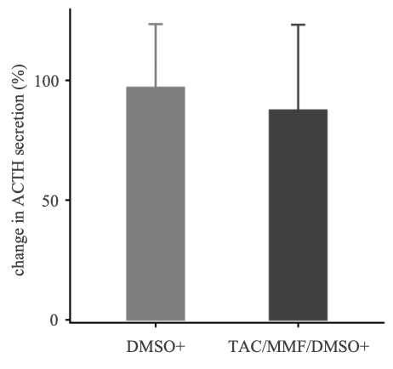
Fig. S11. In vitro assessment of immunosuppressant effects on pituitary-hypothalamic organoids.
Comparison of percentage change in ACTH secretion between the vehicle control group (DMSO+, n = 10 wells, mid-grey) and the TAC/MMF/DMSO-treated group (TAC/MMF/DMSO+, n = 10 wells, black). Relative values are presented as a bar chart, with the median pre-treatment ACTH concentration for each respective group set to 100%. The TAC/MMF/DMSO-treated group (TAC/MMF/DMSO+) did not exhibit a significant decrease in basal ACTH secretion compared with the vehicle control group (DMSO+) (DMSO+ vs. TAC/MMF/DMSO+; 0.97 [IQR 0.80–1.24] vs. 0.88 [IQR 0.74–1.23], p = 0.73, Fig. S11). Statistical differences were assessed using the Wilcoxon rank-sum test. Bars indicate medians (interquartile range; IQR).

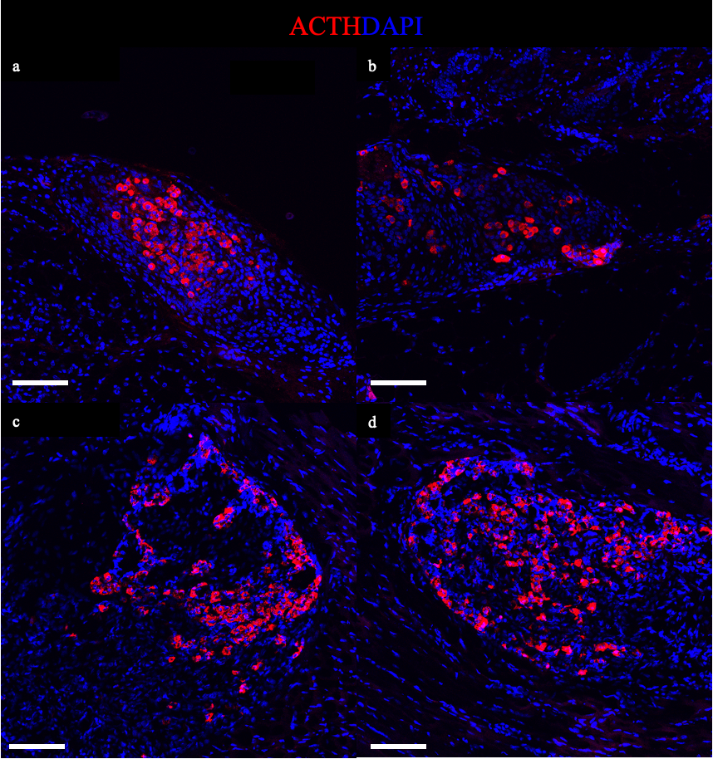

Fig. S12. Histological findings after subcutaneous cell transplantation in mice.
(a–b) Sections of skin and subcutaneous adipose tissue containing the grafts, harvested 3 mo after transplantation. ACTH-expressing cells (red) were observed within the subcutaneous white adipose tissue.
(c–d) Sections of muscle tissue containing the grafts, harvested 3 mo after transplantation. ACTH-expressing cells (red) were observed within the host muscle.
For all panels, immunofluorescence staining was performed to detect specific antigens, and nuclei were counterstained with 4′,6-diamidino-2-phenylindole dihydrochloride (DAPI).
Scale bars: 100 μm (a–d).

Table S1. Hormonal levels in cynomolgus monkey after hypophysectomy.
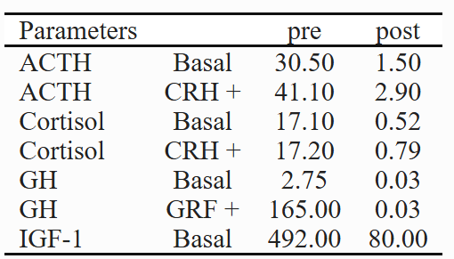

Table S2. Haematological and biochemical test results before and after hypophysectomy in cynomolgus monkey.
