iMSC-secreted Factors Preserve Renal Capillary Networks and Ameliorate Fibrosis by Interrupting Macrophage STING/CD8+ T Cell Axis in Ischemic Kidney Disease——Full uncropped Gels and Blots image(s)

S figure 1: Figure 8B Protein bands of p-IRF3 2
S figure 2: Figure 8B Protein bands of IRF3 3
S figure 3: Figure 8B Protein bands of P-TBK1 4
S figure 4: Figure 8B Protein bands of TBK1 5
S figure 5: Figure 8B Protein bands of STING 6
S figure 6: Figure 8B Protein bands of P-STING 7
S figure 7: Figure 8B Protein bands of P-P65/β-actin 8
S figure 8: Figure 8B Protein bands of P65 9
S figure 9: Figure 8B Protein bands of β-actin 10
S figure 10: Figure 8B Protein bands of FN/COLⅠ/β-actin 11
S figure 11: Figure 8B Protein bands of VIMENTIN/β-actin 12

S figure 1: Figure 8B Protein bands of P-IRF3

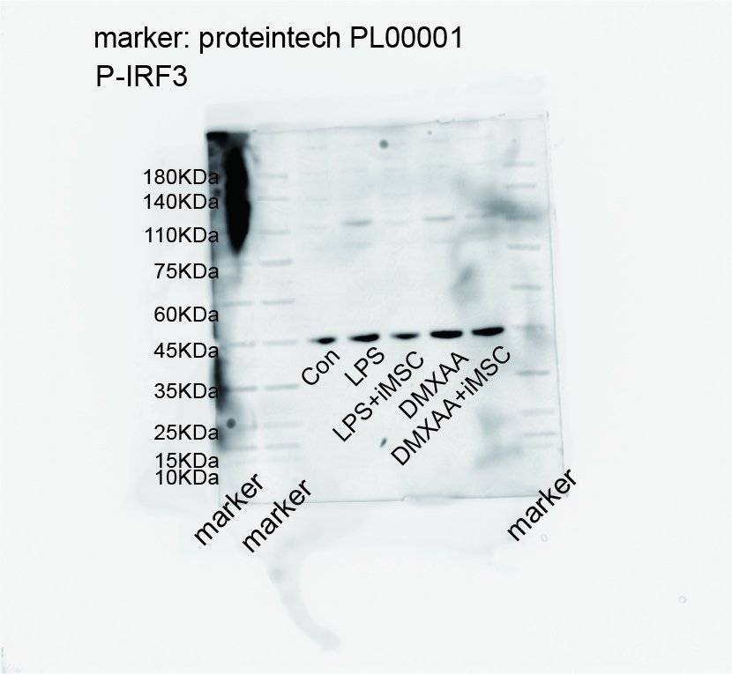

S figure 2: Figure 8B Protein bands of IRF3
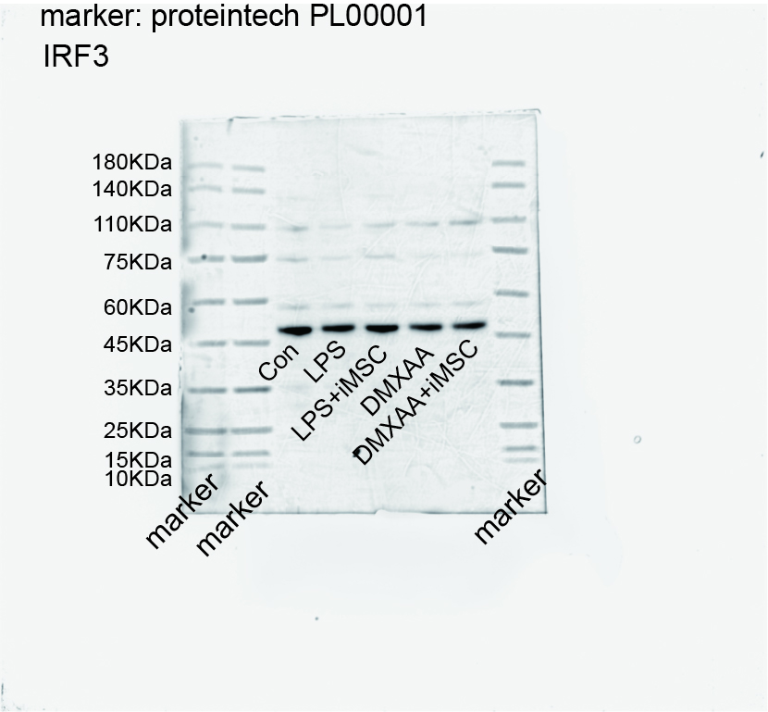

S figure 3: Figure 8B Protein bands of P-TBK1

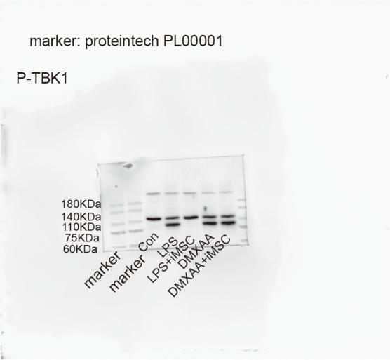

S figure 4: Figure 8B Protein bands of TBK1
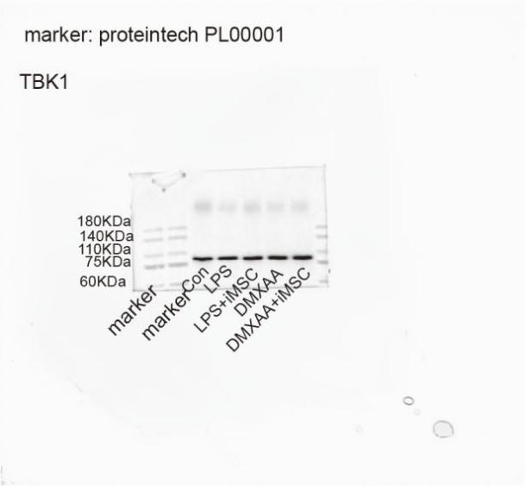

S figure 5: Figure 8B Protein bands of STING

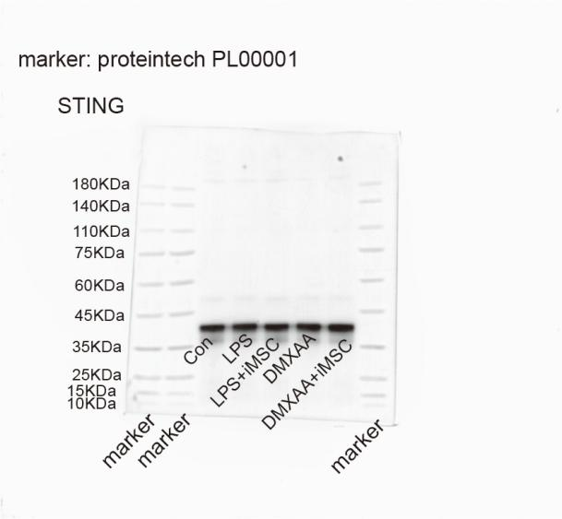

S figure 6: Figure 8B Protein bands of P-STING
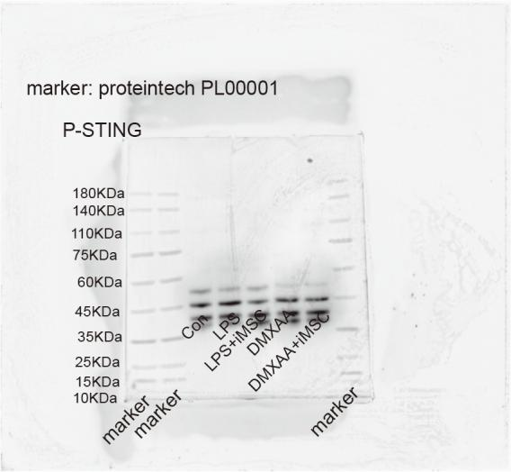

S figure 7: Figure 8B Protein bands of P-P65/β-actin

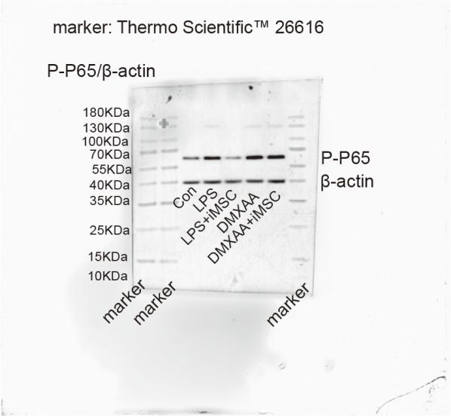

S figure 8: Figure 8B Protein bands of P65

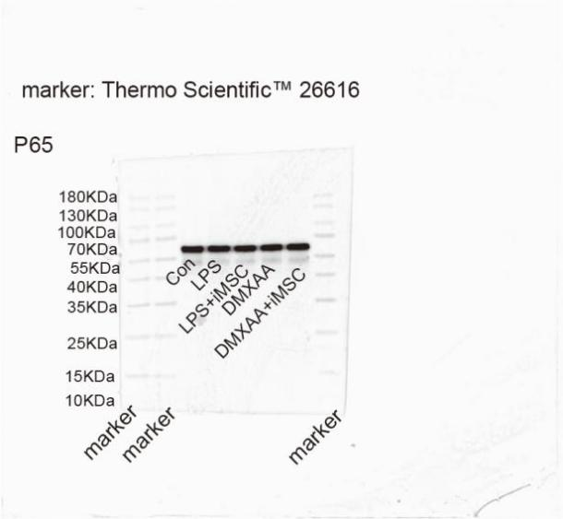

S figure 9: Figure 8B Protein bands of β-actin

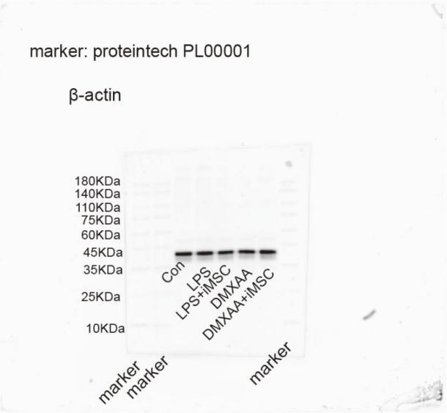

S figure 10: Figure 8B Protein bands of FN/COLⅠ/β-actin
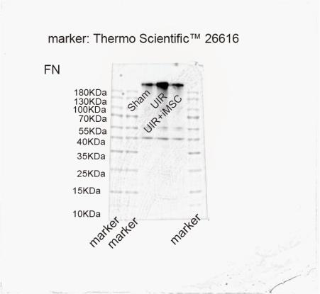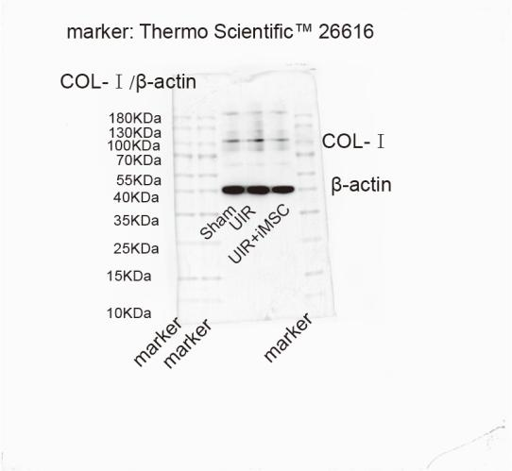

S figure 11: Figure 8B Protein bands of VIMENTIN/β-actin
