iMSC-secreted Factors Preserve Renal Capillary Networks and Ameliorate Fibrosis by Interrupting the Macrophage STING/CD8+ T Cell Axis in Ischemic Kidney Disease

S figure 1: Figure 8C Protein bands of β-actin 2
S figure 2: Figure 8C Protein bands of CD206/GAPDH 3
S figure 3: Figure 8C Protein bands of iNOS 4
S figure 4: Figure 8C Protein bands of p-IRF3 5
S figure 5: Figure 8C Protein bands of IRF3 6
S figure 6: Figure 8C Protein bands of p-TBK1 7
S figure 7: Figure 8C Protein bands of TBK1 8
S figure 8: Figure 8C Protein bands of p-p65 9
S figure 9: Figure 8C Protein bands of p65 10
S figure 10: Figure 8C Protein bands of p-STING 11
S figure 11: Figure 8C Protein bands of STING 12
S figure 12: Figure 8C Protein bands of IFN-β 13
S figure 13: Figure 9B Protein bands of Vimentin 14
S figure 14: Figure 9B Protein bands of ColⅠ 15
S figure 15: Figure 9B Protein bands of CD206 16
S figure 16: Figure 9B Protein bands of iNOS 17
S figure 17: Figure 9B Protein bands of P-IRF3 18
S figure 18: Figure 9B Protein bands of IRF3 19
S figure 19: Figure 9B Protein bands of P-TBK1 20
S figure 20: Figure 9B Protein bands of TBK1 21
S figure 21: Figure 9B Protein bands of P65 22
S figure 22: Figure 9B Protein bands of P-STING 23
S figure 23: Figure 9B Protein bands of STING 24
S figure 24: Figure 9B Protein bands of IFN-β 25
S figure 25: Figure 8A Quantitative analysis of ROS levels (number of ROS‑positive cells per field) was performed for RAW264.7 cells. 26

S figure 1: Figure 8C Protein bands of β-actin
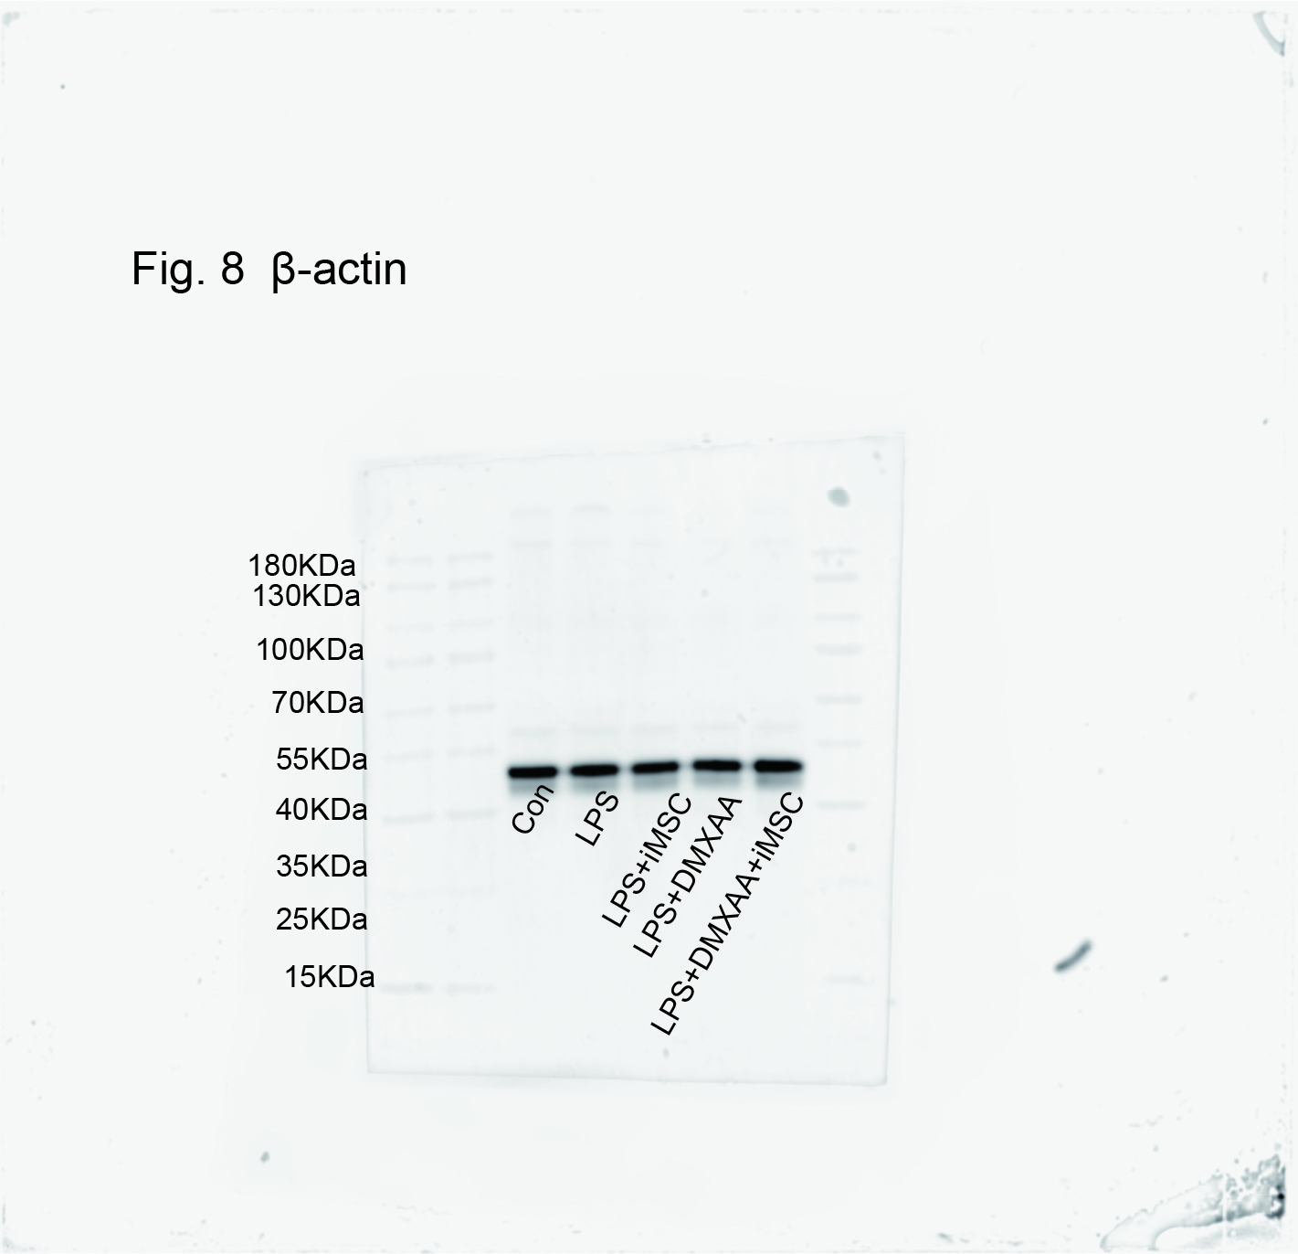

S figure 2: Figure 8C Protein bands of CD206/GAPDH

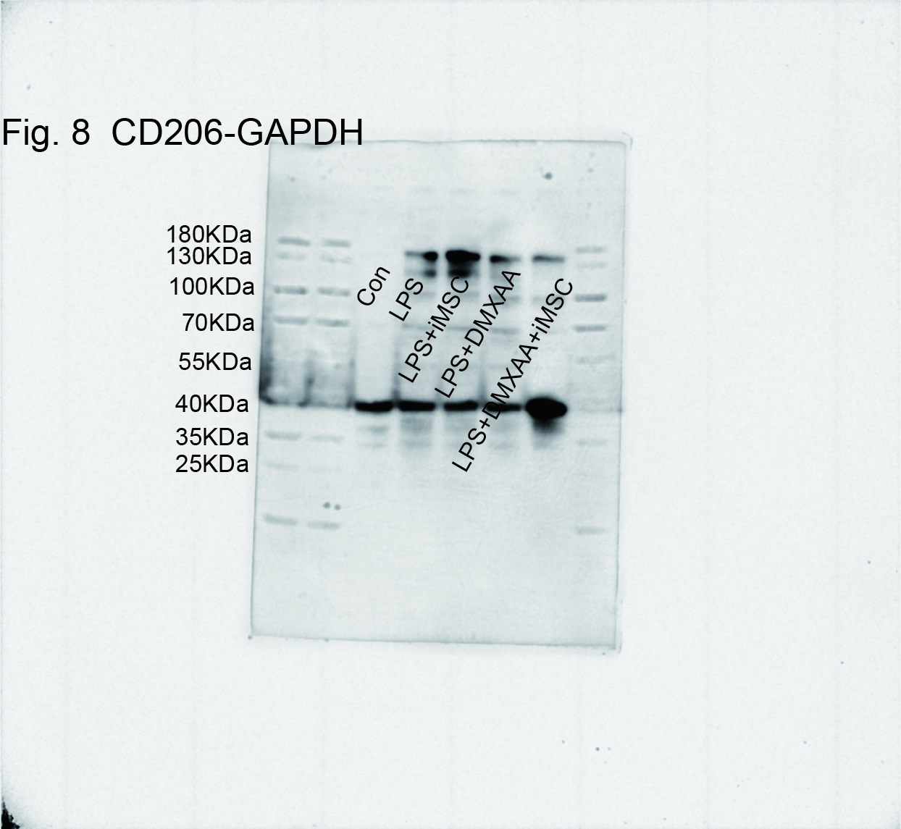

S figure 3: Figure 8C Protein bands of iNOS

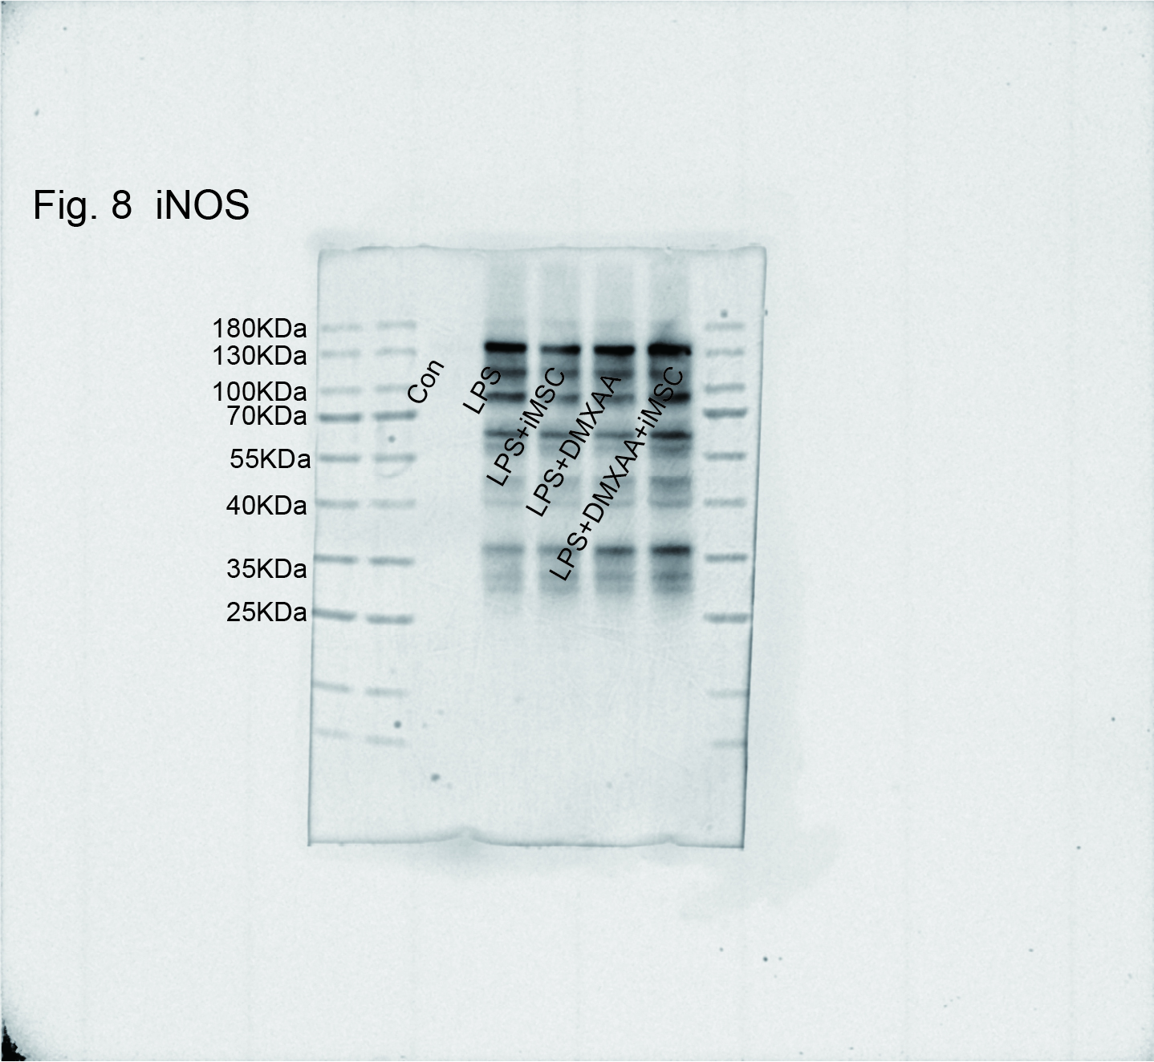

S figure 4: Figure 8C Protein bands of p-IRF3
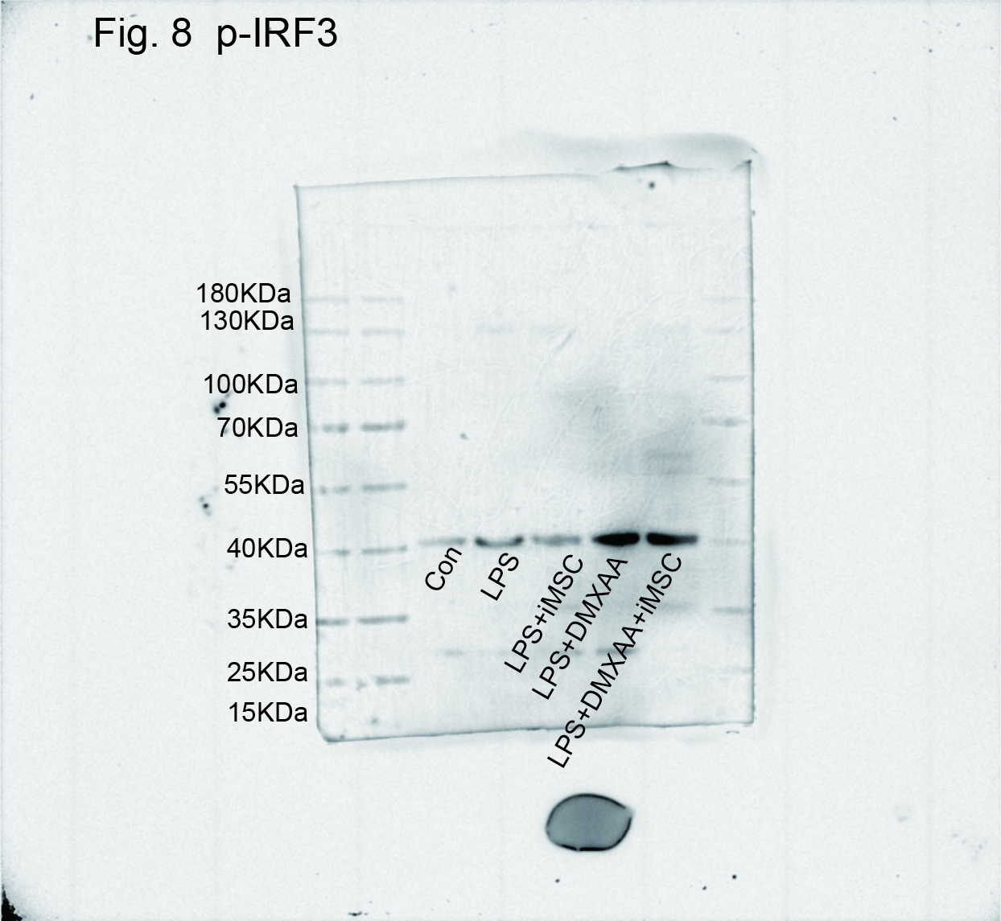

S figure 5: Figure 8C Protein bands of IRF3

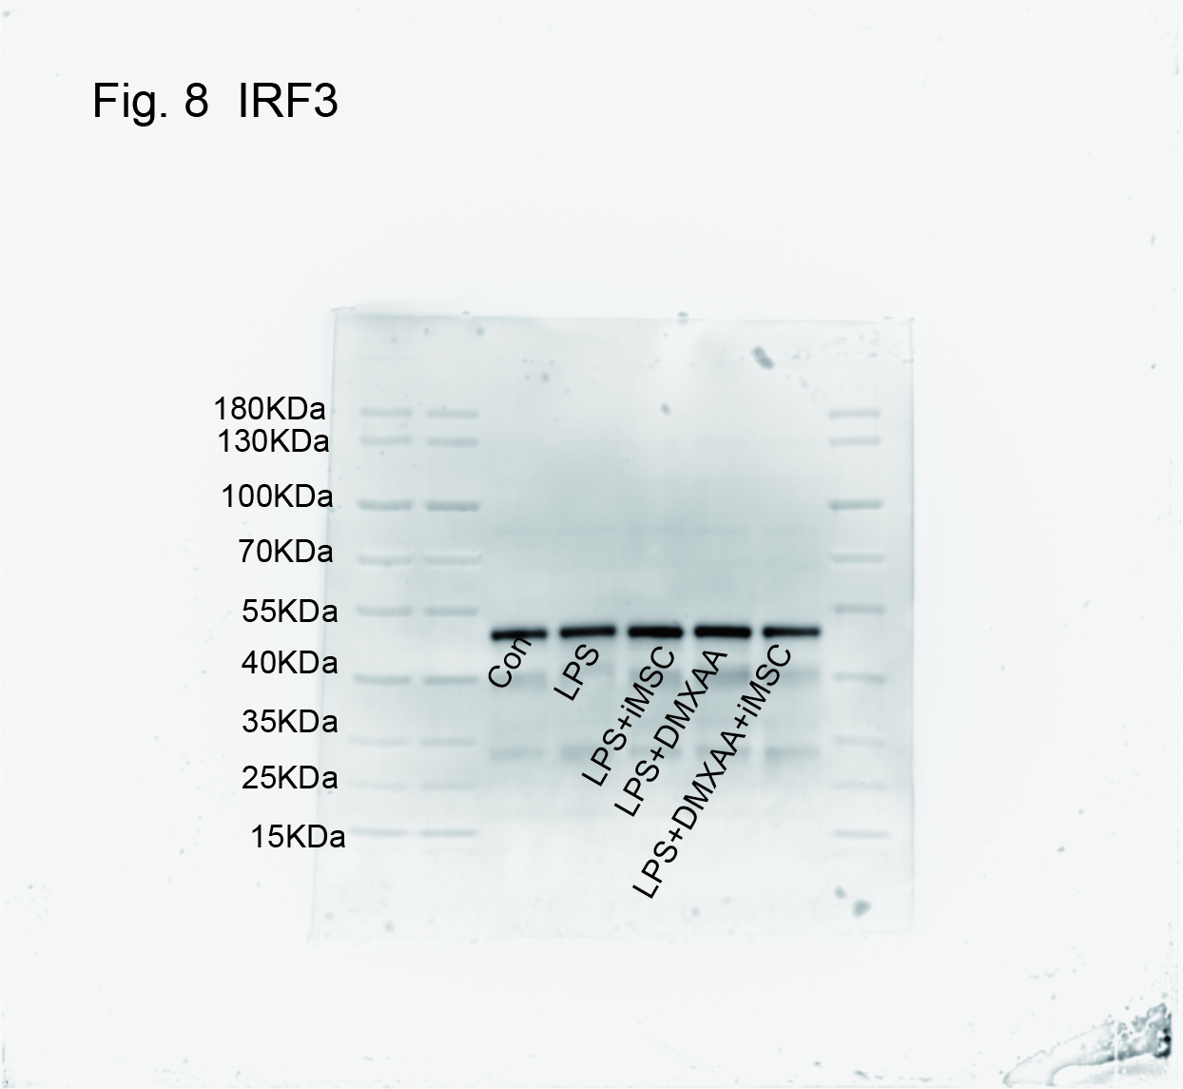

S figure 6: Figure 8C Protein bands of p-TBK1
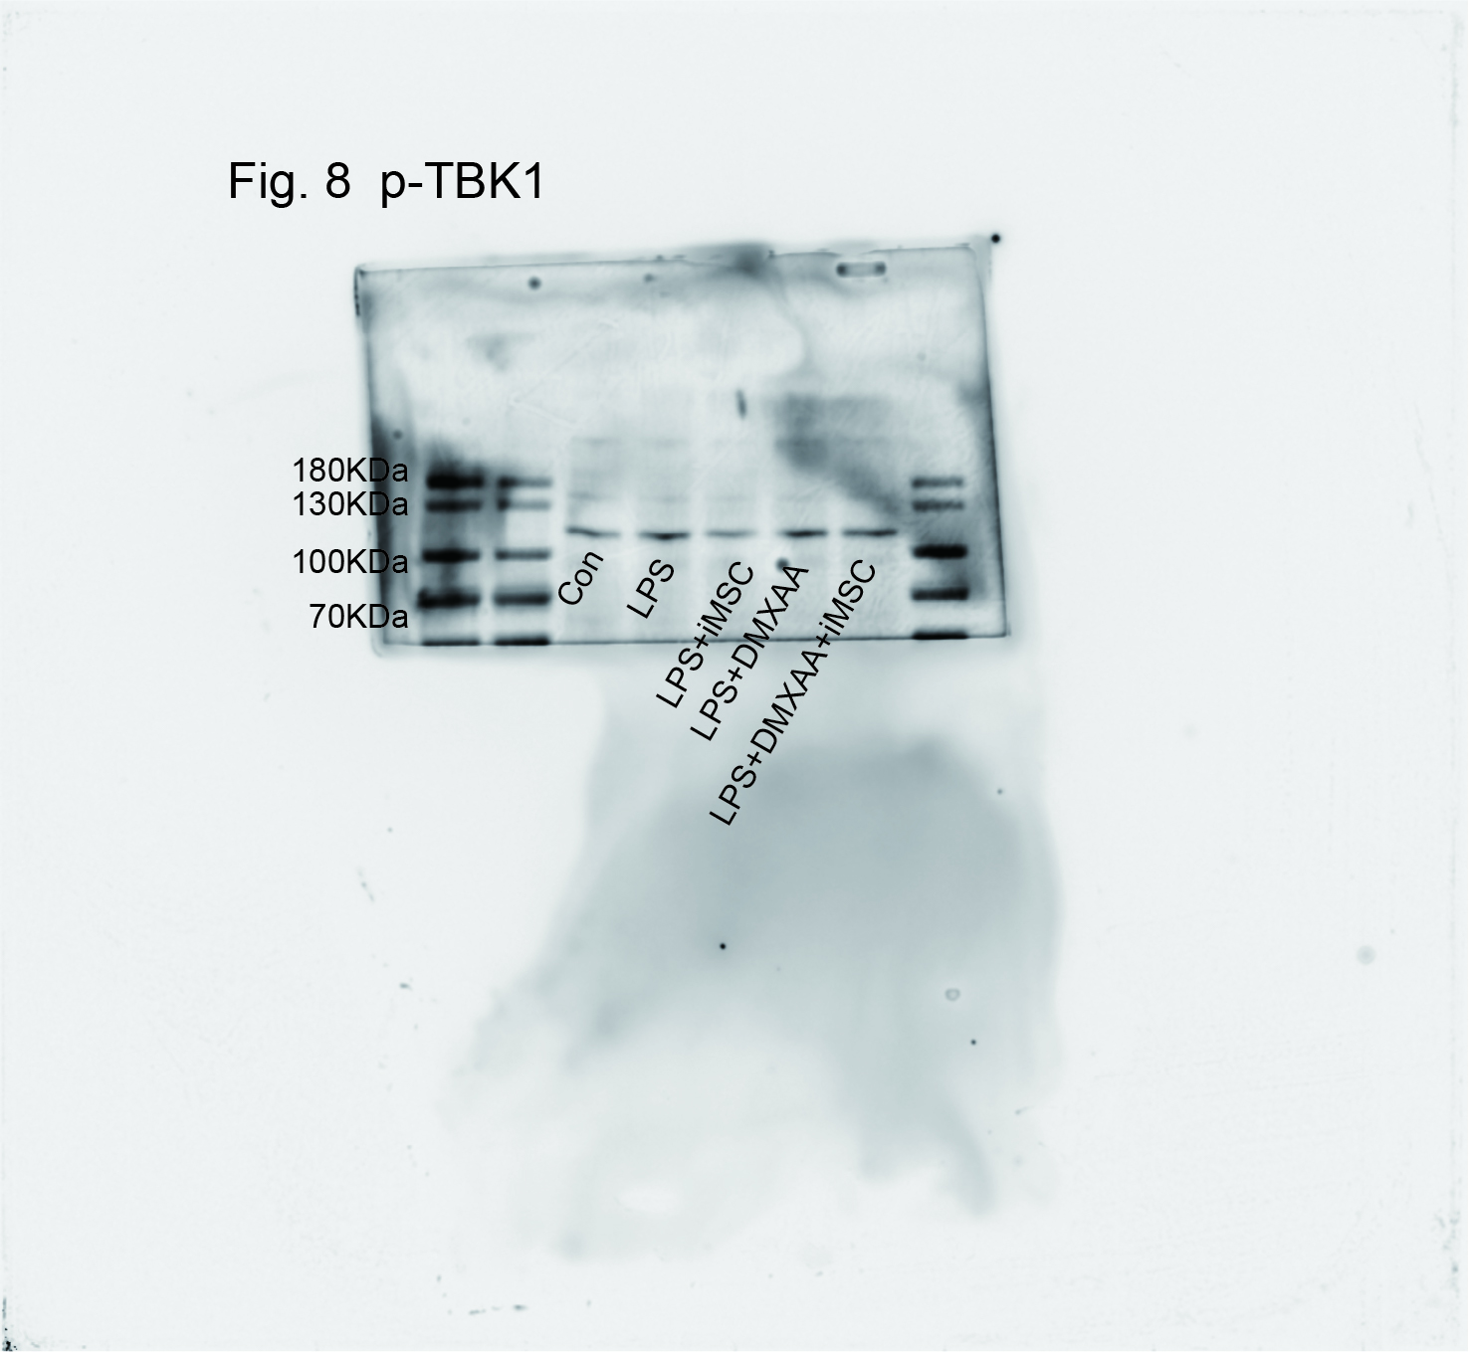

S figure 7: Figure 8C Protein bands of TBK1

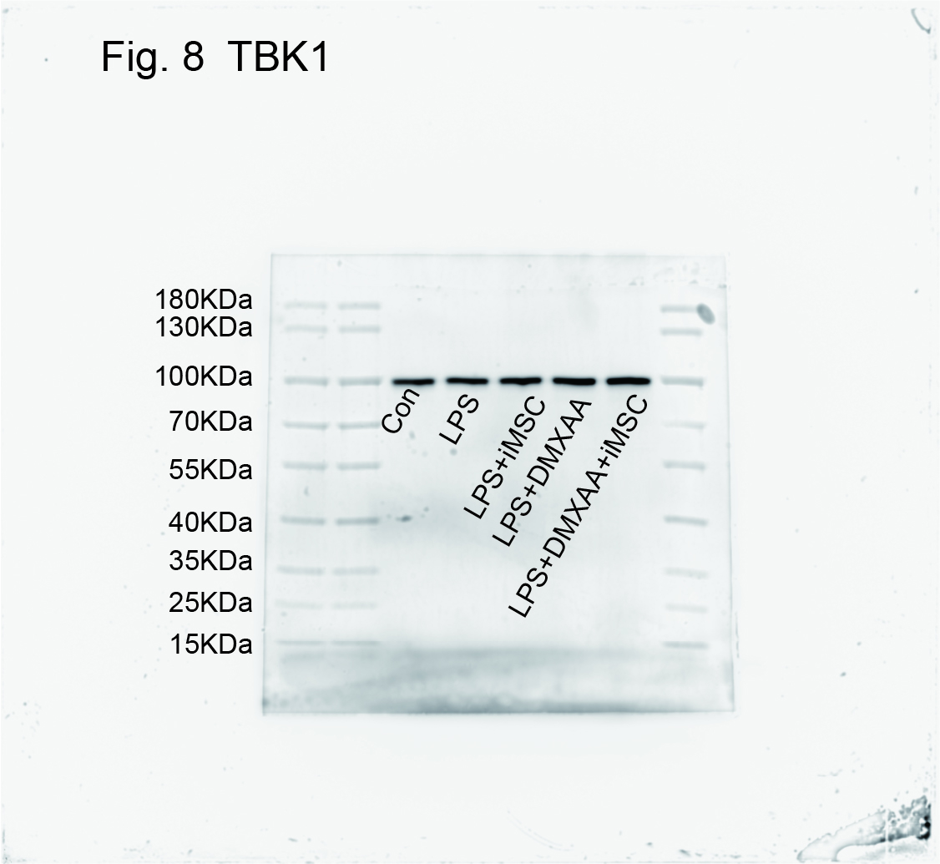

S figure 8: Figure 8C Protein bands of p-p65

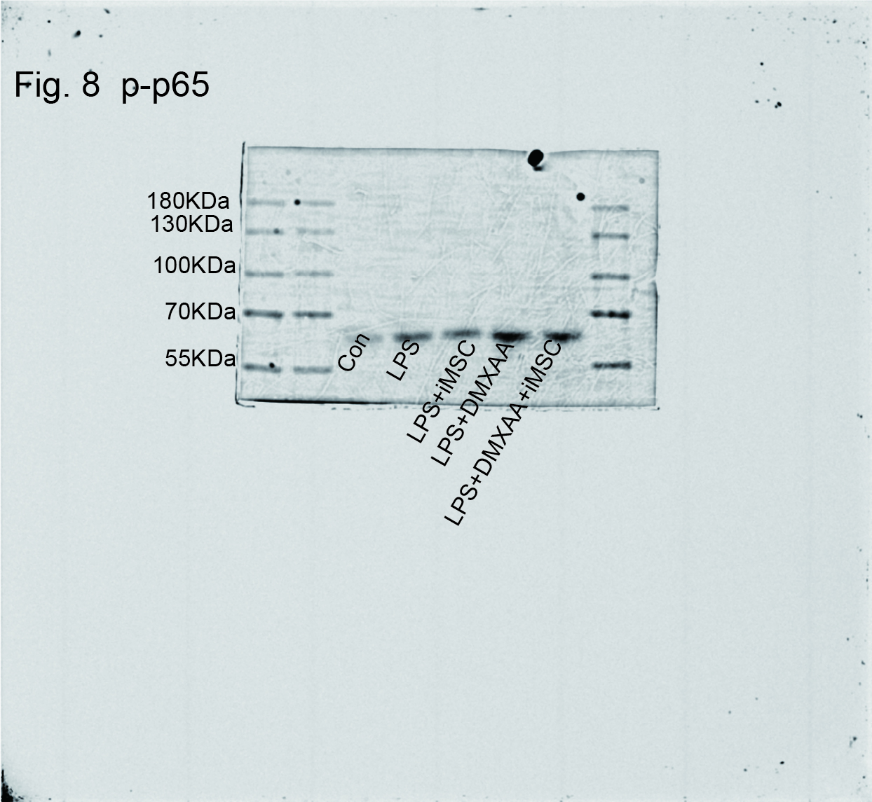

S figure 9: Figure 8C Protein bands of p65
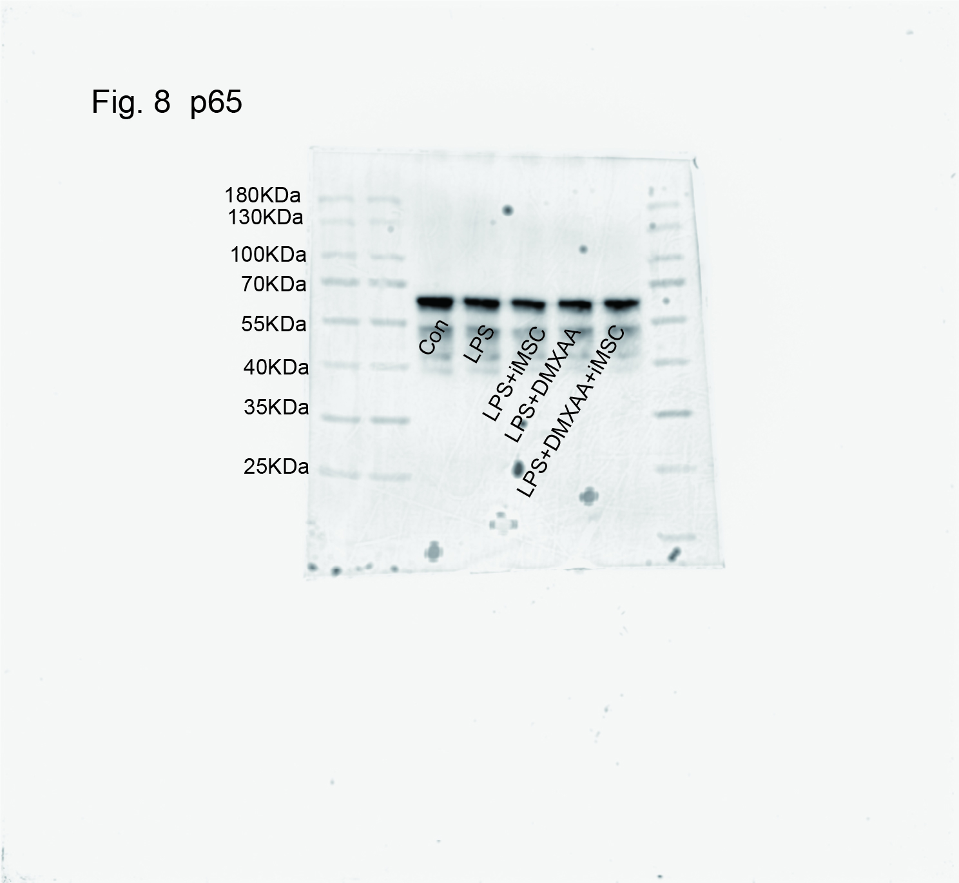

S figure 10: Figure 8C Protein bands of p-STING
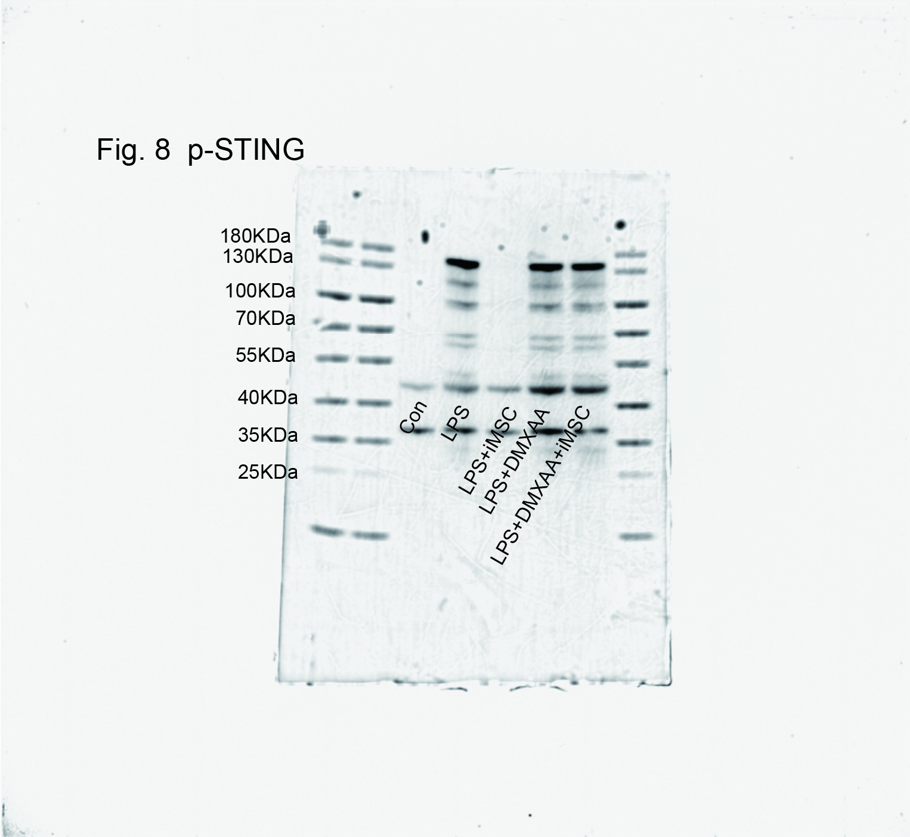

S figure 11: Figure 8C Protein bands of STING
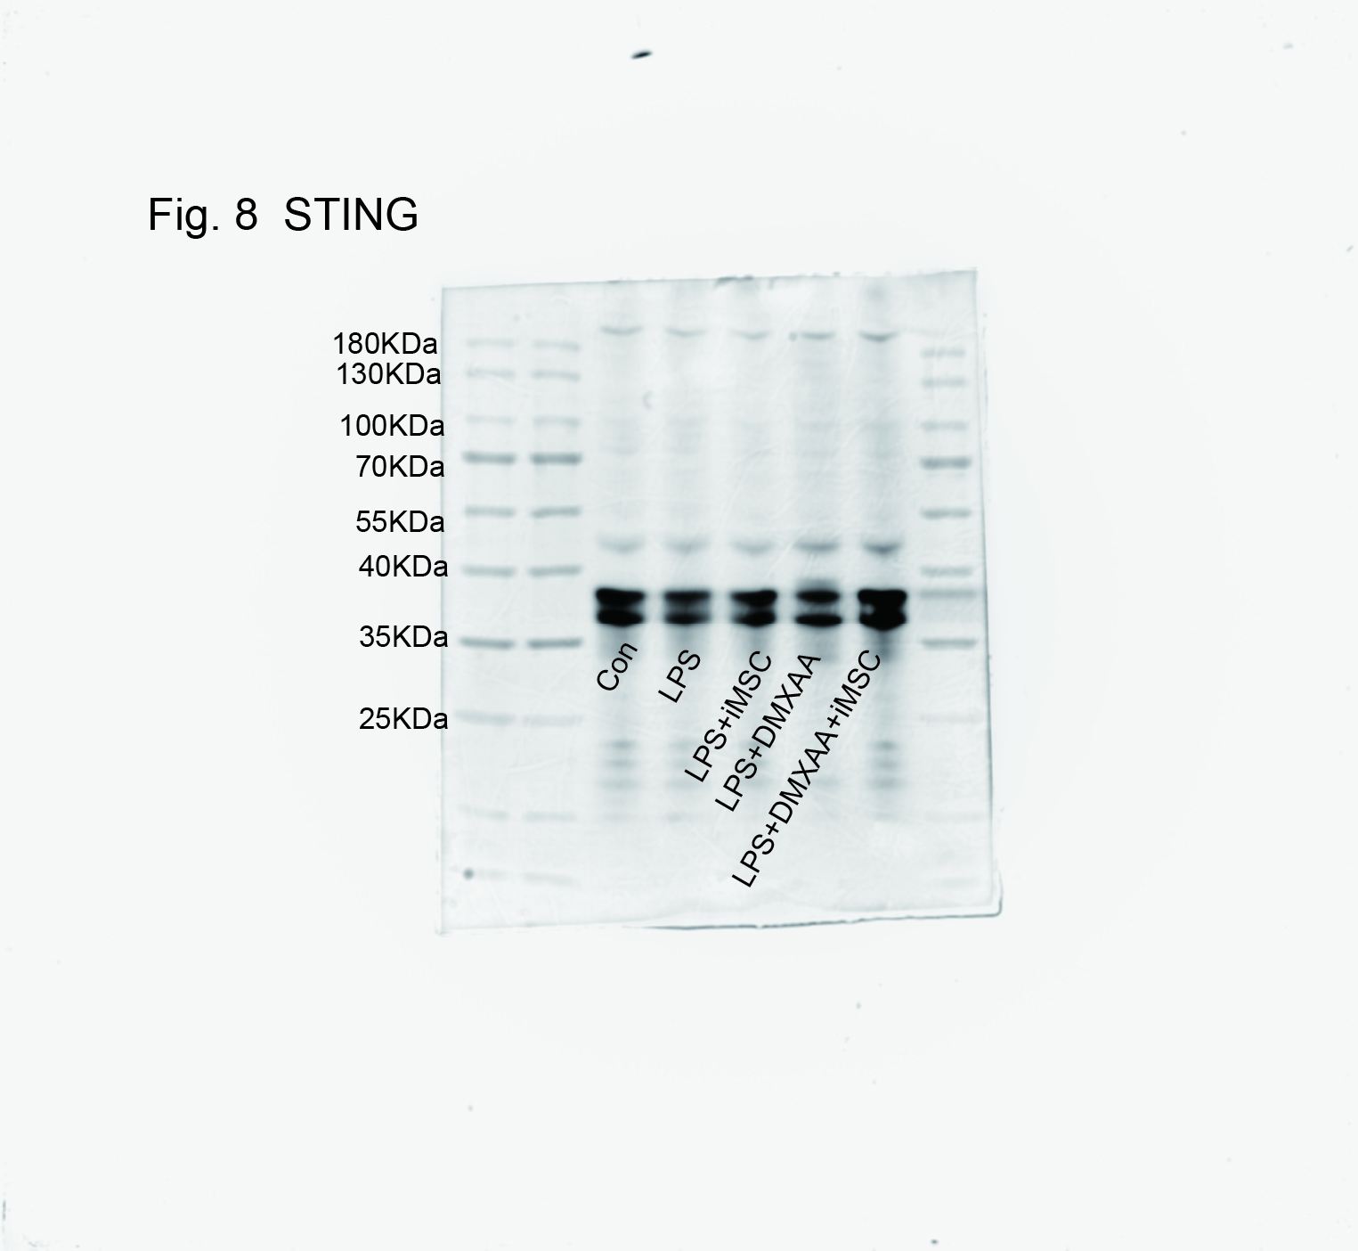

S figure 12: Figure 8C Protein bands of IFN-β
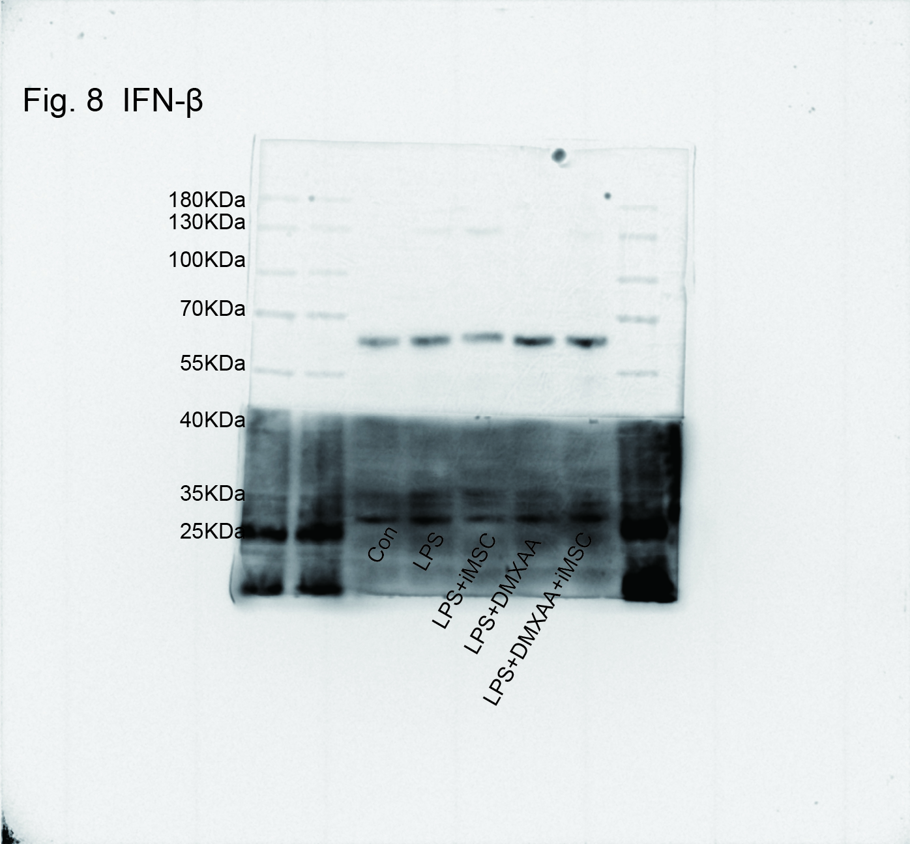

S figure 13: Figure 9B Protein bands of Vimentin
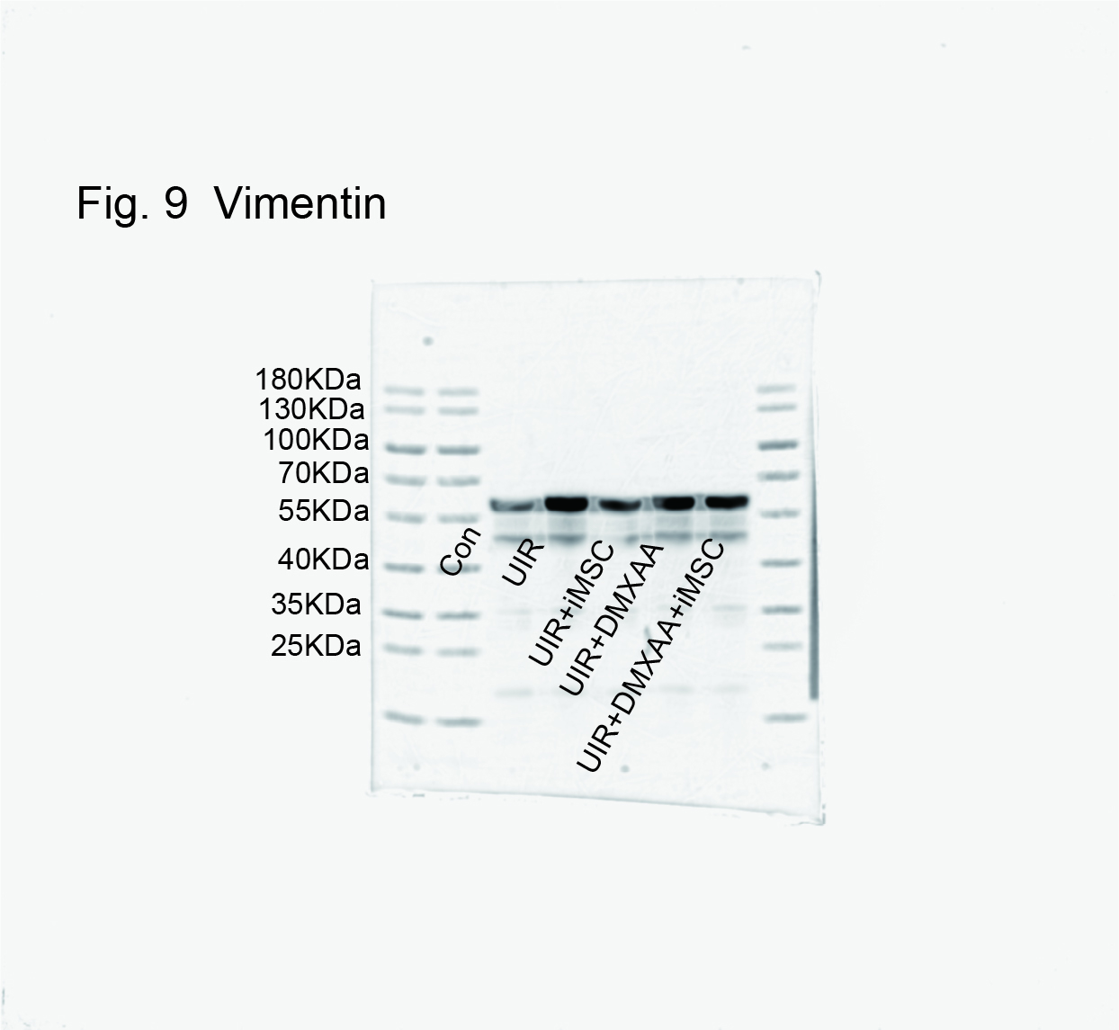

S figure 14: Figure 9B Protein bands of ColⅠ
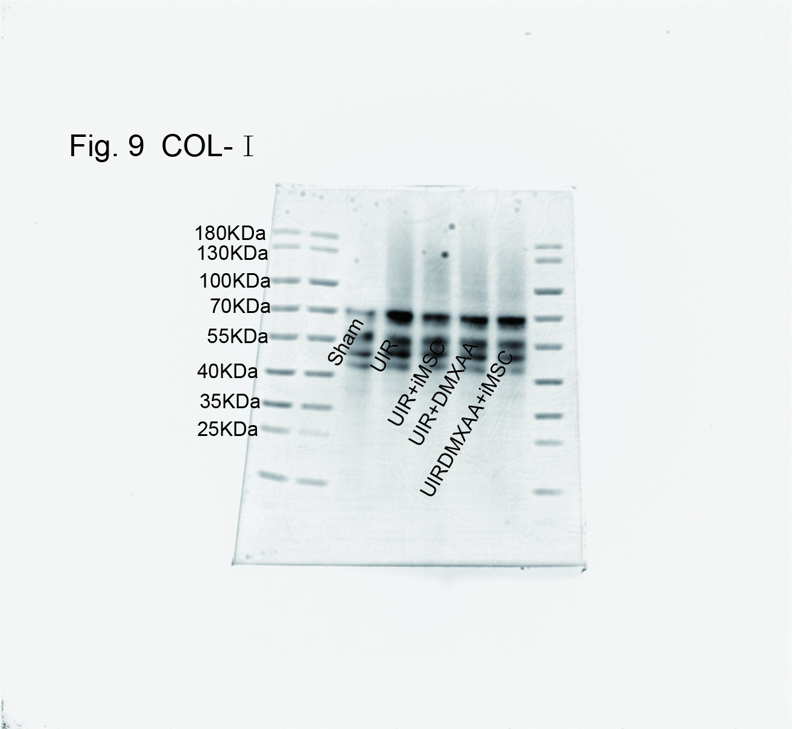

S figure 15: Figure 9B Protein bands of CD206

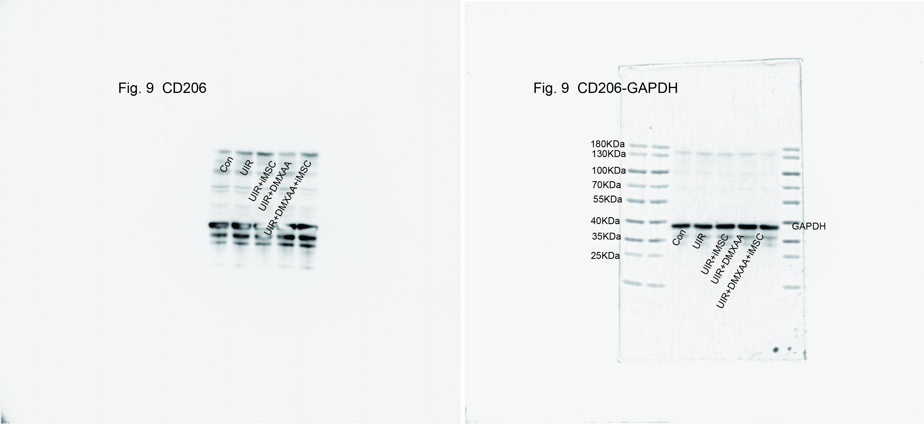

S figure 16: Figure 9B Protein bands of iNOS
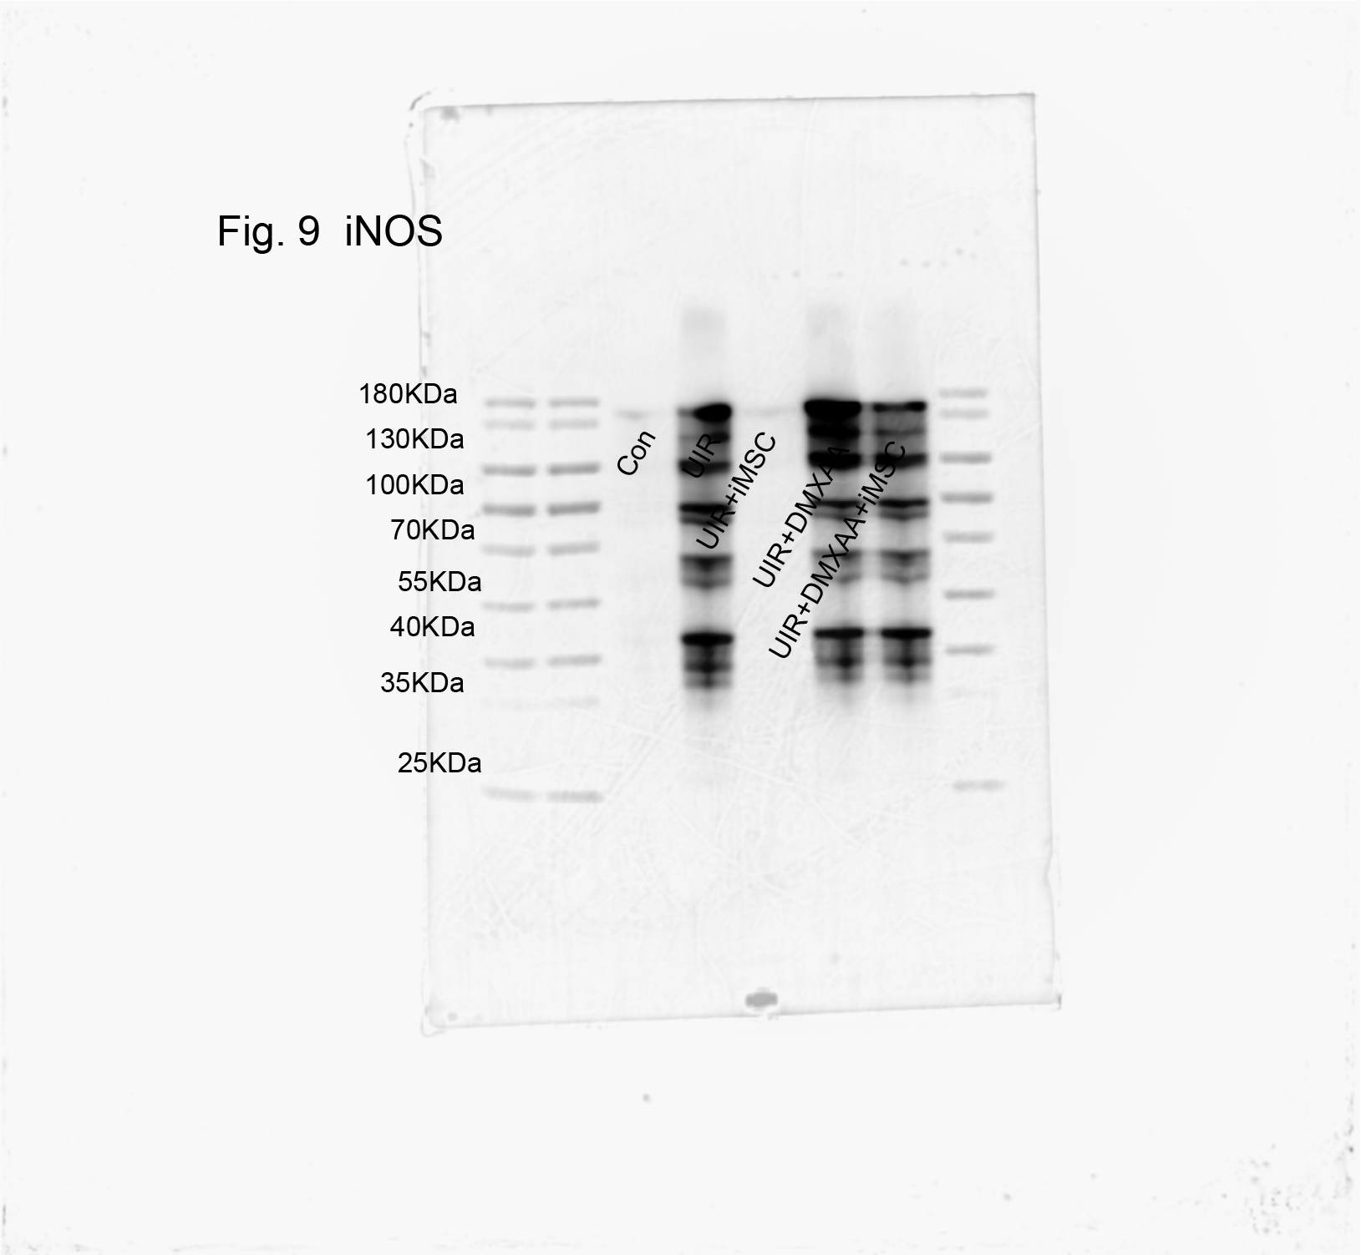

S figure 17: Figure 9B Protein bands of P-IRF3
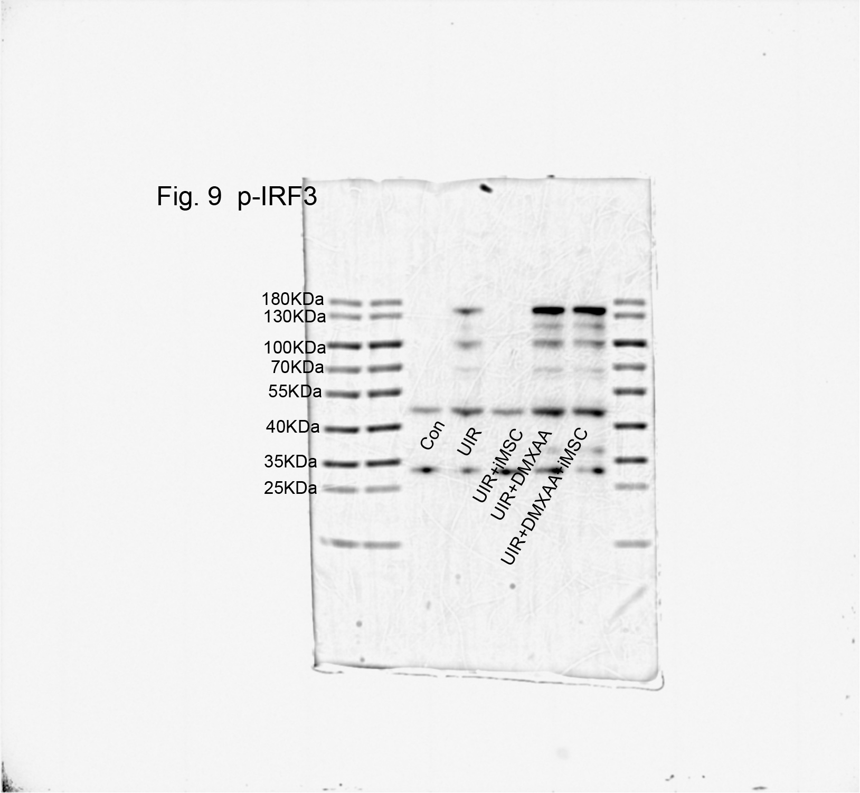

S figure 18: Figure 9B Protein bands of IRF3
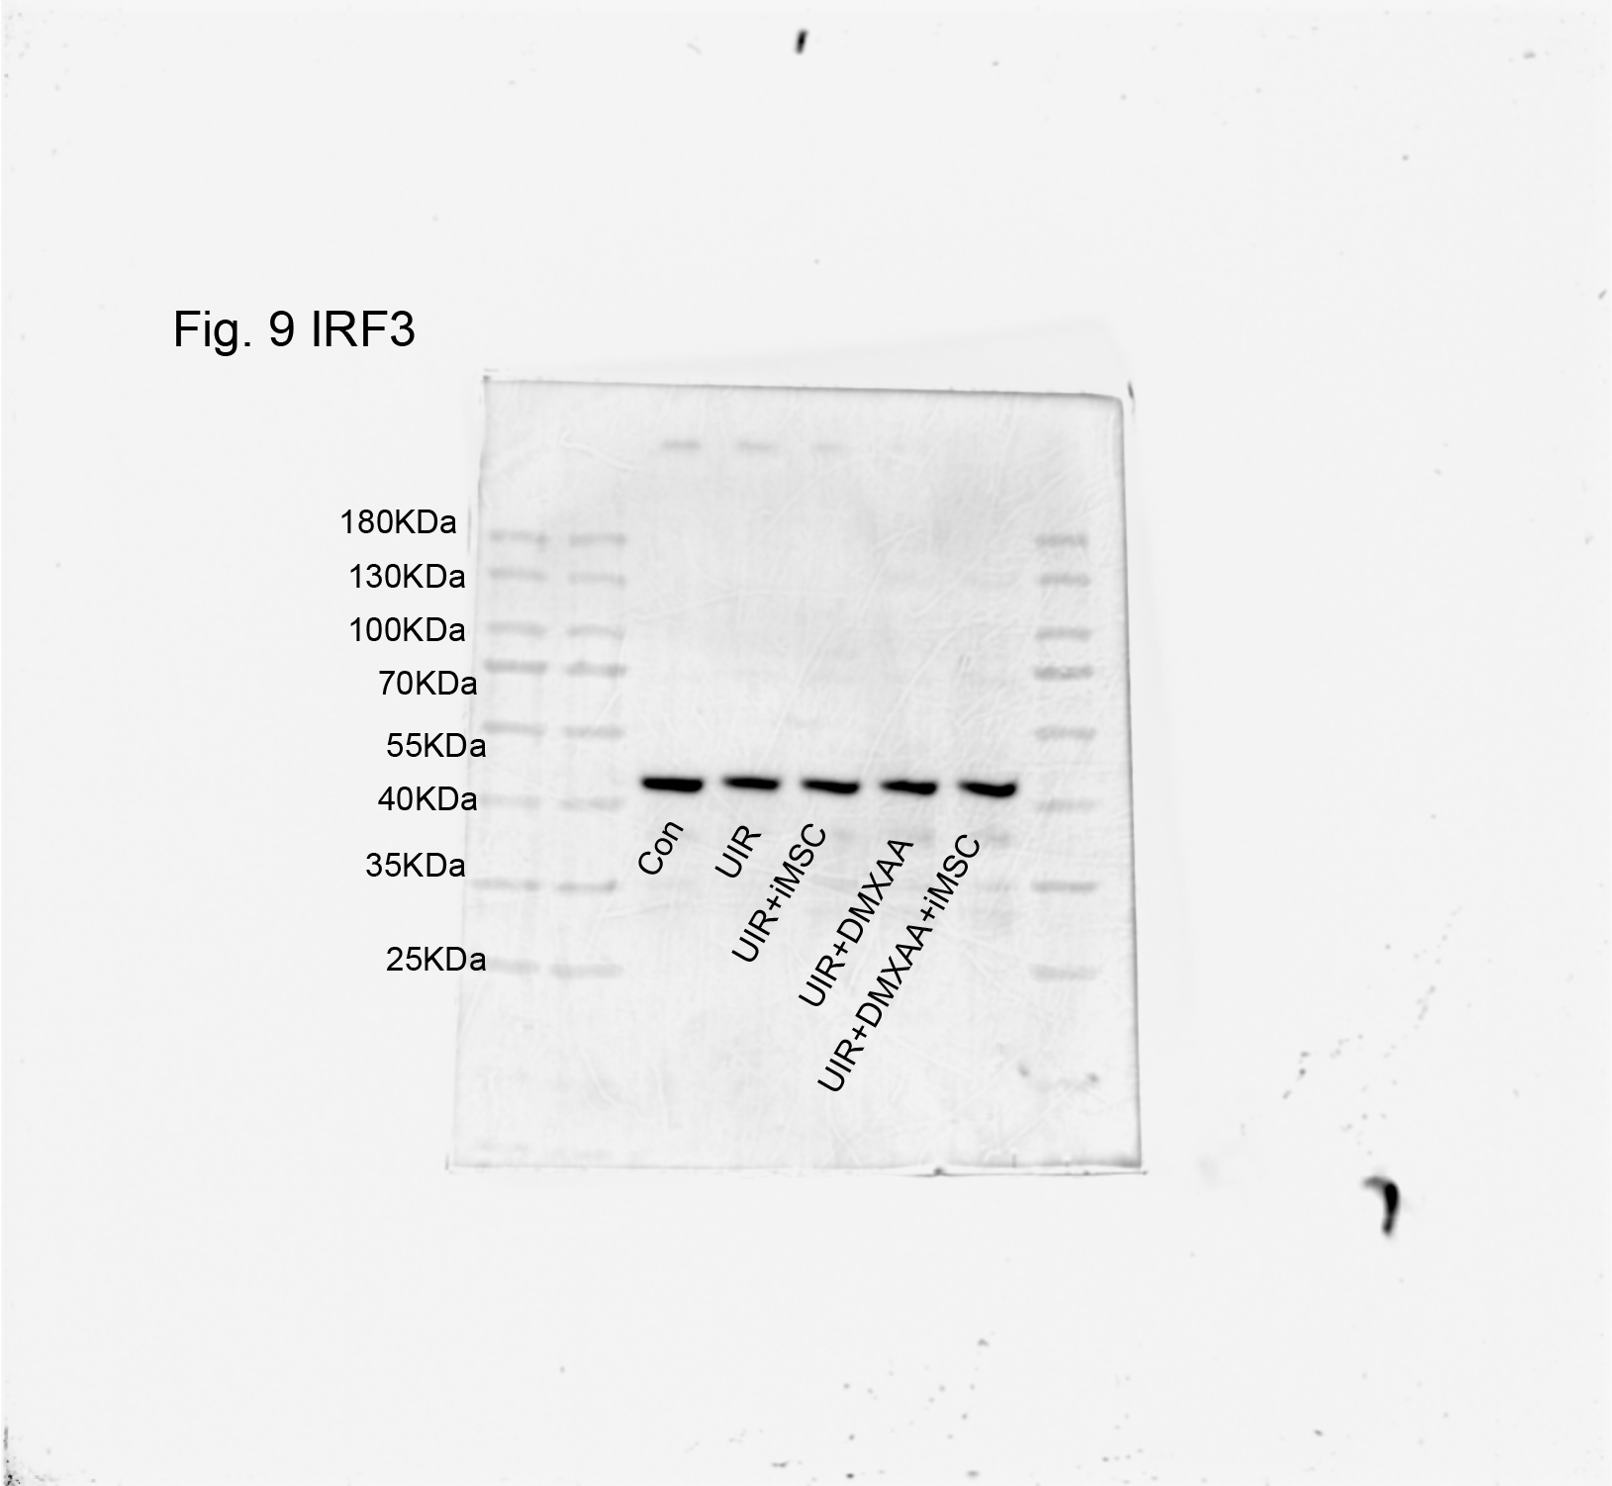

S figure 19: Figure 9B Protein bands of P-TBK1
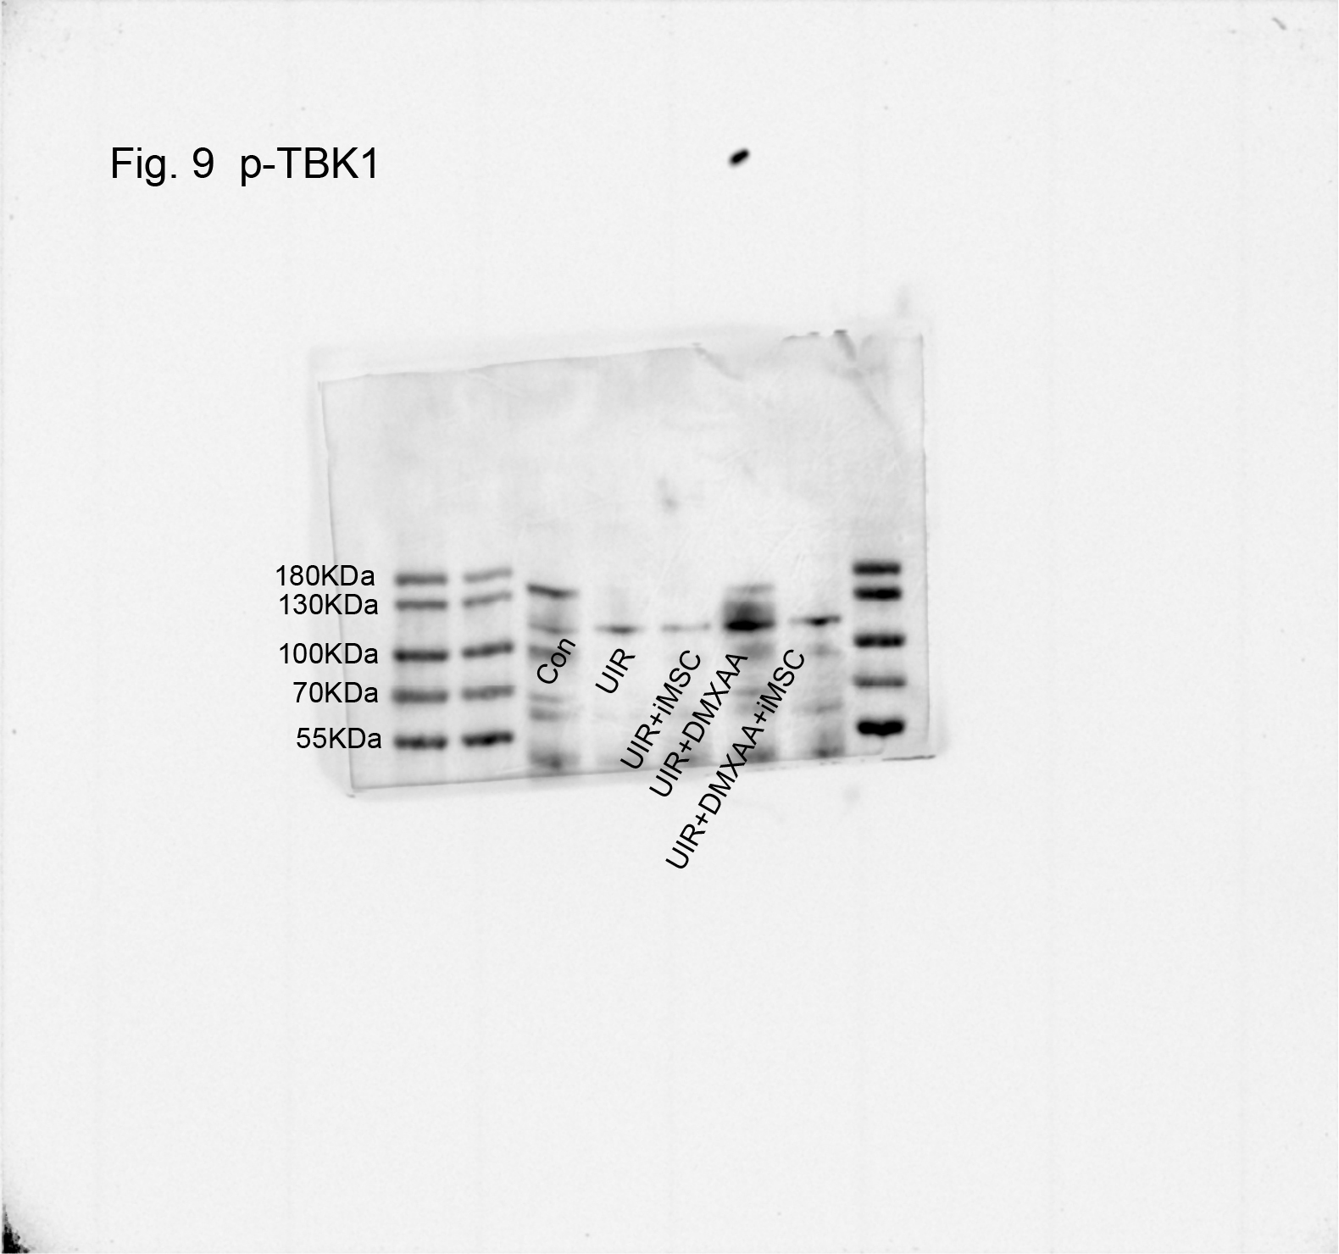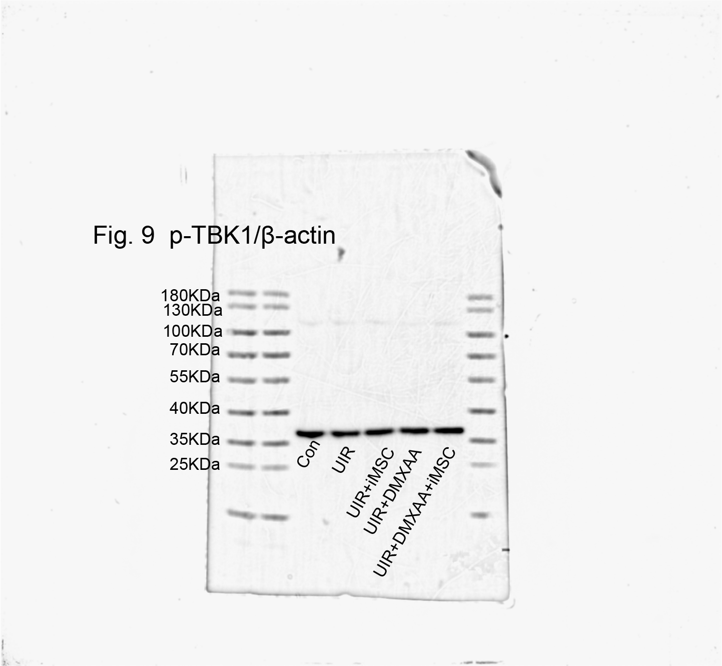

S figure 20: Figure 9B Protein bands of TBK1
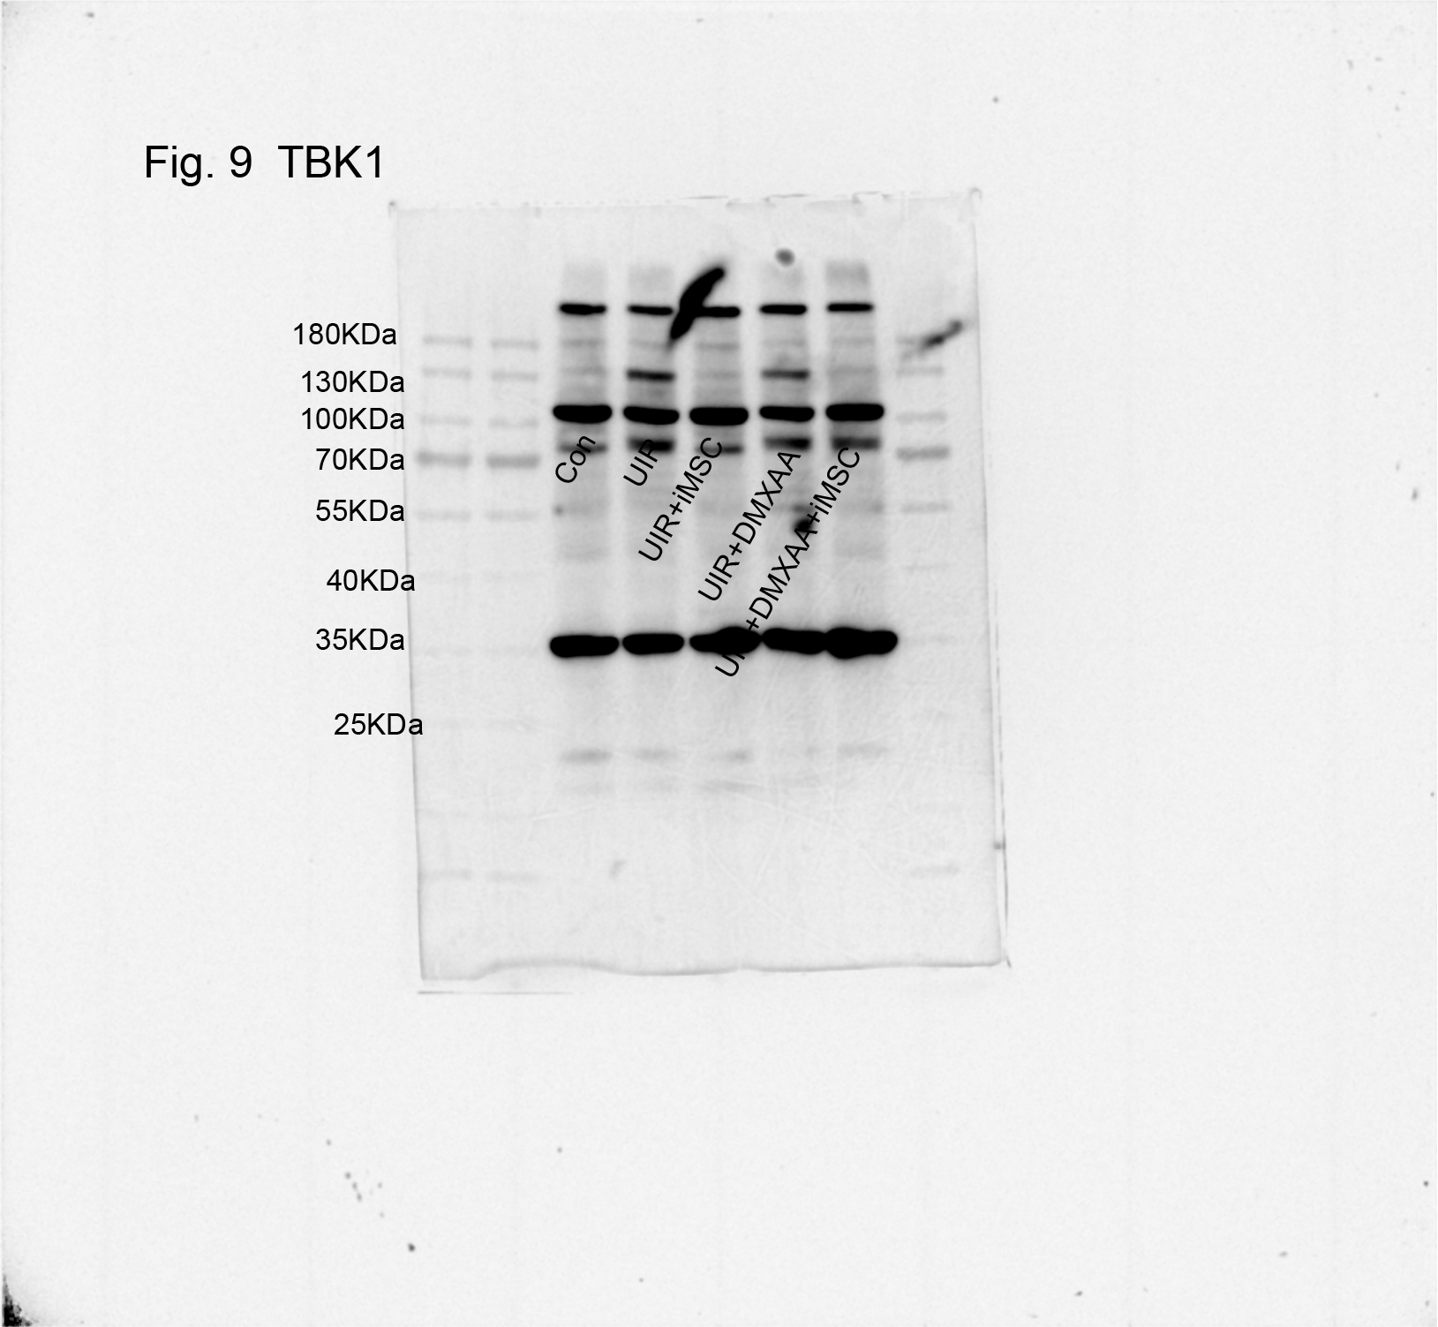

S figure 21: Figure 9B Protein bands of P65
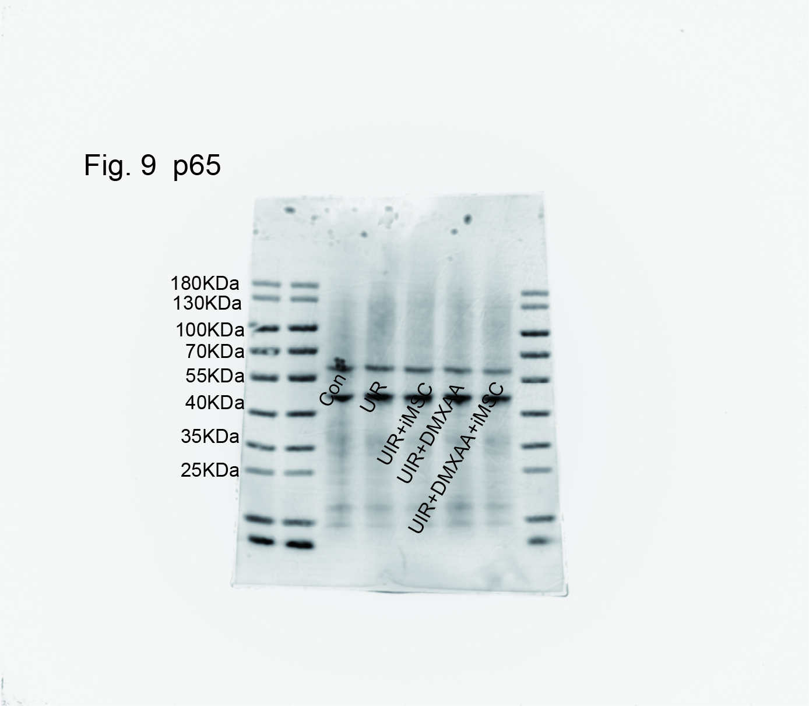

S figure 22: Figure 9B Protein bands of P-STING

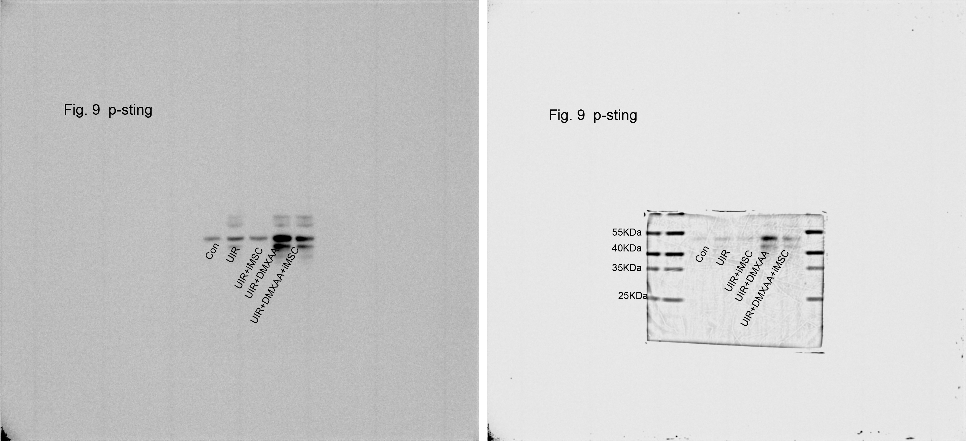

S figure 23: Figure 9B Protein bands of STING
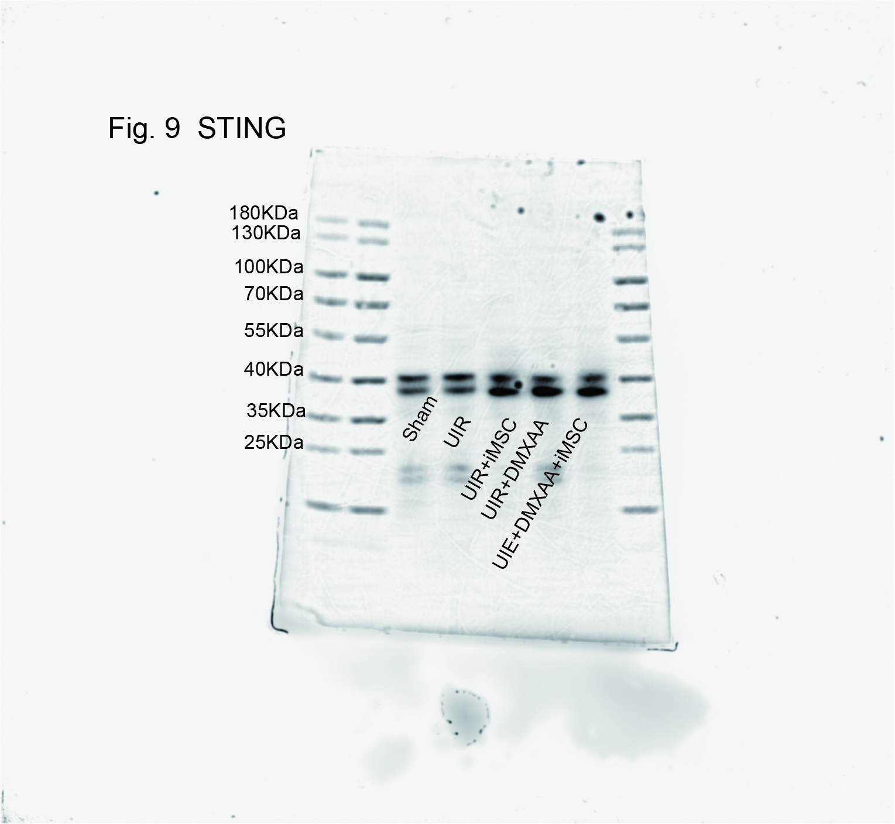

S figure 24: Figure 9B Protein bands of IFN-β

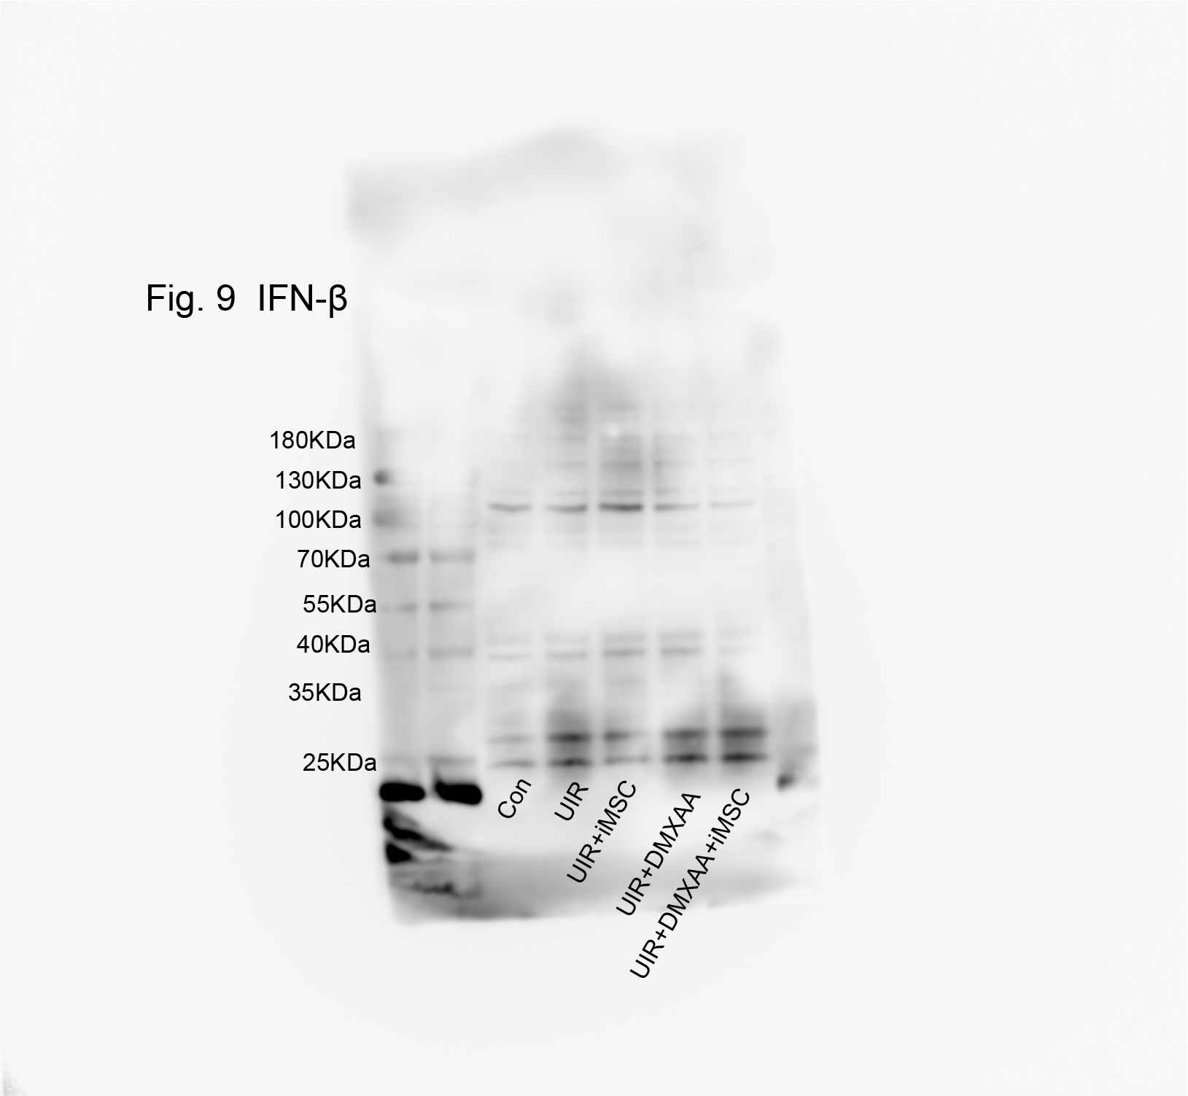

S figure 25: Figure 8A Quantitative analysis of ROS levels (number of ROS‑positive cells per field) was performed for RAW264.7 cells.
