Identification of a long-term surviving human mesenchymal stromal cell subpopulation and implications for recessive dystrophic epidermolysis bullosa treatment

Bonnet des Claustres et al.

Supplementary material

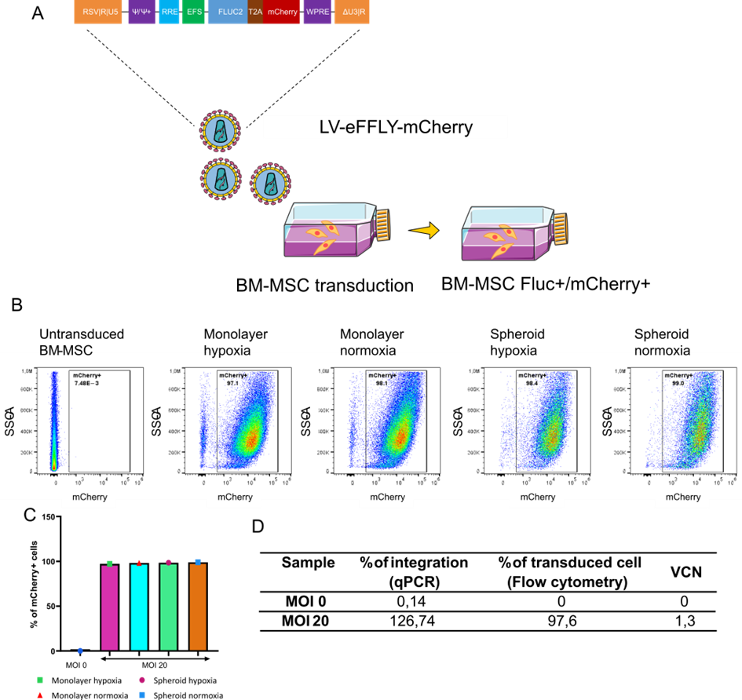
Figure S1. Generation of stably transduced Fluc+/mCherry+ BM-MSC. (A) Schematic representation of the bicistronic pEFS-EFFLy-mCherry lentiviral construct carrying an expression cassette containing enhanced Firefly Luciferase (eFFLY, colored in yellow) and mCherry fluorescente protein (mCherry, colored in red) linked by a 2A self-cleaving peptides sequence (T2A, colored in purple) and under the regulation of the human short Elongation Factor 1 alpha promoter (EFS, colored in blue). (B) Assessment of mCherry expression by flow cytometry analysis of transduced BM-MSC at MOI 20. Non-transduced cells were used as negative control (MOI 0). (C) Mean percentage of mCherry+ BM-MSC determined by flow cytometry are similar among all tested conditions. (D) qPCR analyses and flow cytometry analyses showing a mean vector copy number (VCN) of 1.3 at MOI 20.

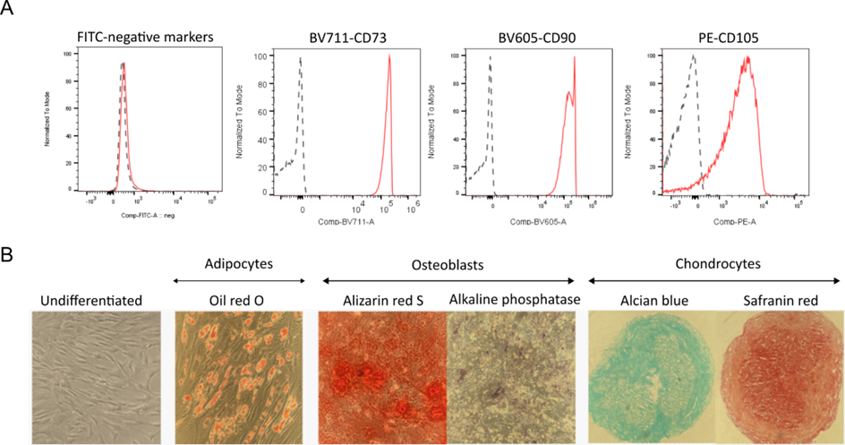
Figure S2. Characterization of Fluc+/mCherry+ BM-MSC. (A) Fluc+/mCherry+ BM-MSC were CD73+, CD90+, CD105+ and CD31-, CD34-, CD45-, HLA-DR-, CD19-, CD16- (FITC negative). (B) Fluc+/mCherry+ BM-MSC differentiation into adipogenic, osteogenic, and chondrogenic lineages.

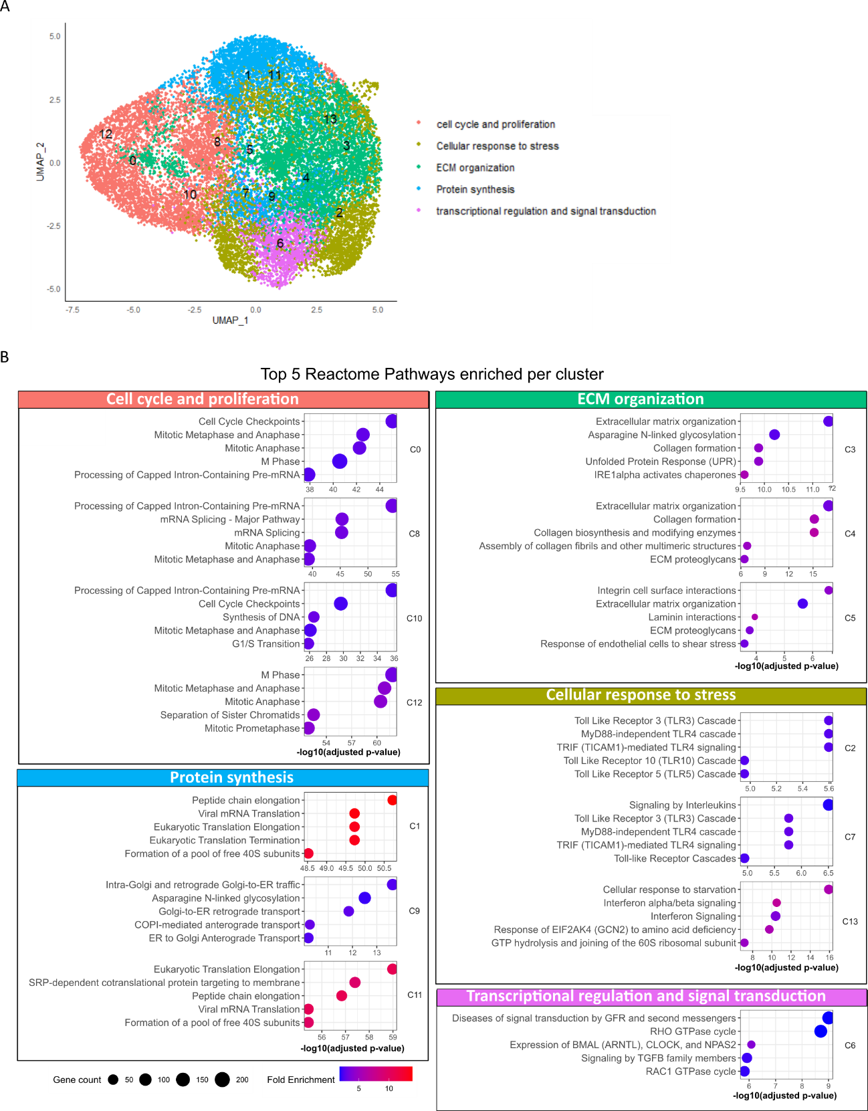
Figure S3. GO and Reactome ontologies of scRNAseq data. (A) UMAP projection of the integrated single-cell trancriptome of the four conditions colored by the five main categories determined by enrichment analysis. (B) Dotplot representing the top 5 reactome terms for each cluster ordered by adjusted p-value (p-adjust < 0.05).

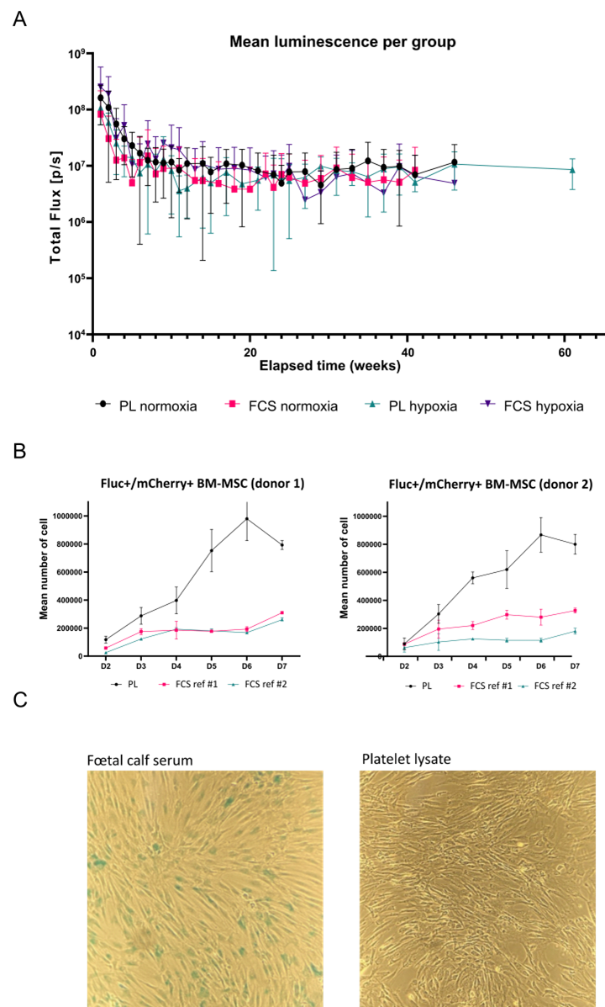
Figure S4. Long-term engraftment of Fluc+/mCherry+ BM-MSC upon ID injection in immunodeficient mice. (A) Total Flux (photons/sec) integrated over the ROI area and measured for each mouse and each tested condition. Bioluminescent signals from each time point representing mean ± standard deviation of all mice for each group. Total n = 15 (PL normoxia: n = 4, FCS normoxia: n = 4, PL hypoxia: n = 4, and FCS hypoxia n = 3). One-way ANOVA with Tukey’s multiple comparison test was performed. (B) Proliferation assay. (C) Senescence assay. ID: intradermal; ns: not significant; n: number of mice; ROI: region of interest.

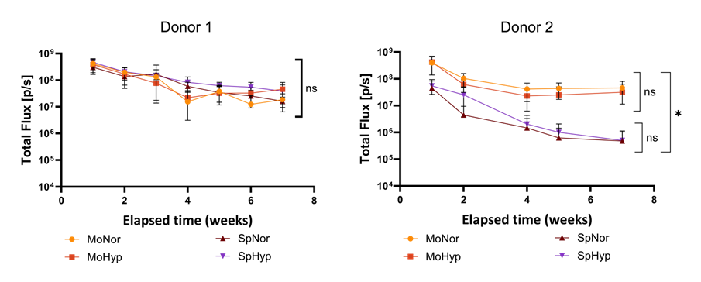
Figure S5. In vivo survival of Fluc+/mCherry+ BM-MSC from donor 1 and donor 2 upon ID injection in immunodeficient mice. (A) and (B) Total Flux (photons/sec) integrated over the ROI area is measured weekly for 7 weeks for donor 1 (A) and donor 2 (B) for each mouse and each tested condition. Bioluminescent signals from each time point represents the mean ± standard deviation of all animals for each group. Total n = 45 (donor 1: MoNor: n = 7, MoHyp n = 7, SpNor: n = 7, and SpHyp n = 8. Donor 2: MoNor: n = 7, MoHyp n = 5, SpNor: n = 2, and SpHyp n = 2). One-way ANOVA with Tukey’s multiple comparison test was performed. * p<0.05; ns: not significative; n: number of mice.
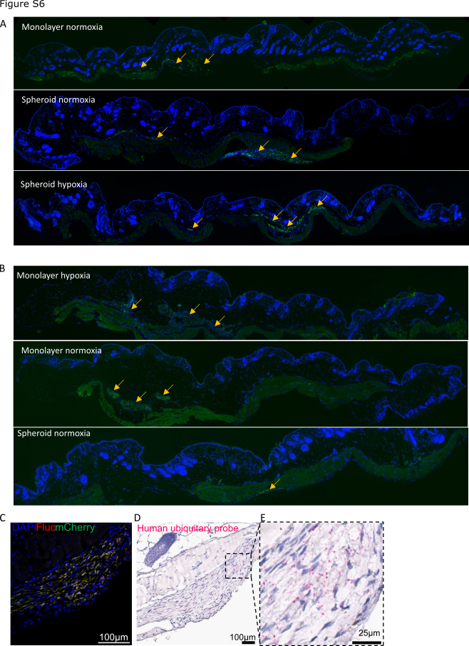
Figure S6. Co-immunostainings of Fluc and mCherry in the dermis of murine skin injected ID with Fluc+/mCherry+ BM-MSC. (A) and (B) Human cells detected in the dermis of murine skin injected ID with Fluc+/mCherry+ BM-MSC by co-immunostaining of Fluc and mCherry from donor 1 (A) and from donor 2 (B). Nuclei were counterstained with DAPI (blue). Representative pictures of 3 independent experiments are shown (magnification x10). (C) Enlargement of Fluc and mCherry immunostainings (magnification x40). (D) Human cells detected in the dermis of murine skin injected ID with Fluc+/mCherry+ BM-MSC by in situ hybridization (RNAscope) analysis using a probe targeting a human housekeeping gene (UBC). (E) Enlargement of Fluc and mCherry immunostaining (magnification x120).

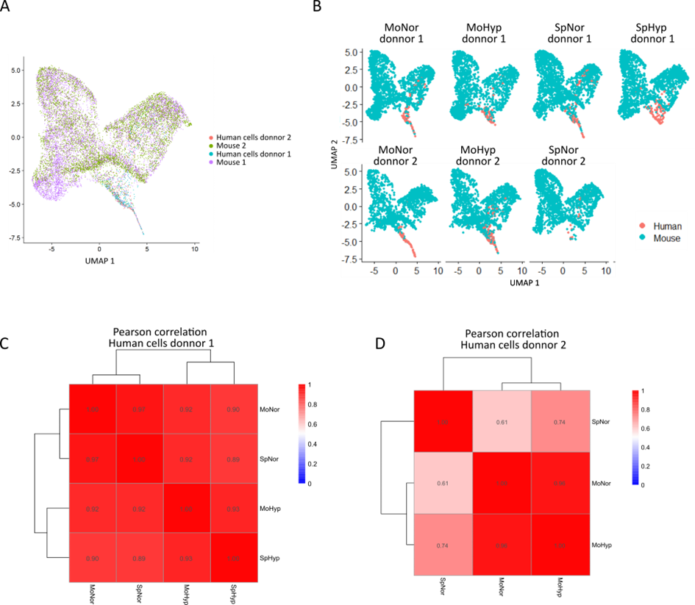
Figure S7. Spatial transcriptomic data from donor 1 and donor. 2 (A) UMAP projection of integrated spatial transcriptomes from donor 1 (four conditions) and donor 2 (three conditions), with cells colored by origin: mouse colored in blue and human colored in pink. (B) UMAP projections displayed separately of transcriptomes from donor 1 (four conditions) and donor 2 (three conditions), with dots colored by organism of origin: mouse (blue), and human (pink). (C) and (D) Heat map of the Pearson correlation between the human subset of the spatial transcriptomic data from donor 1 (four conditions) (C) and donor 2 (three conditions) (D). UMAP: Uniform manifold approximation and projection.
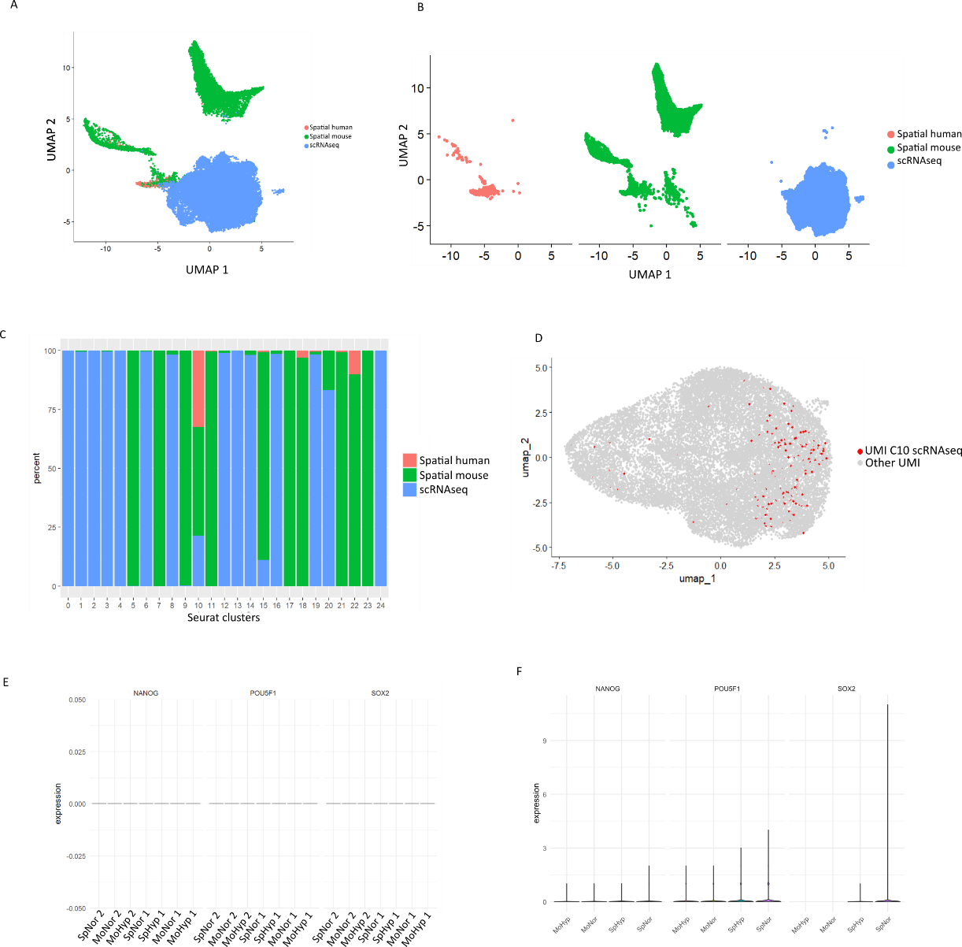
Figure S8. Spatial transcriptomic and scRNAseq data integration. (A) and (B) UMAP projection of the integrated datasets of scRNAseq and human spatial transcriptomic colored by cluster experiment origin projected together (A) or displayed separately (B). (C) Percentage of each dataset (scRNAseq in blue, human spatial transcriptomic in pink, and mouse in green) contributing to the composition of each cluster. (D) UMAP projection of the integrated datasets of scRNAseq displaying UMI identified in C10 scRNAseq cluster (red dots) compared to the other UMI from the scRNAseq dataset (light grey dots). (E) and (F) Absence of expression of Muse markers in spatial data (E) and Fluc⁺/mCherry⁺ MSC cultured in different conditions (F). UMAP: Uniform manifold approximation and projection.
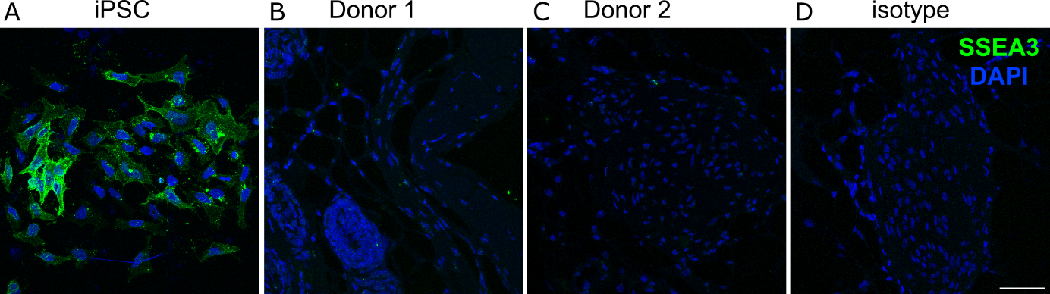
Figure S9. Immunofluorescent analysis of SSEA3. (A) Positive SSEA3 staining (in green) in control cells (human induced pluripotent stem cells). (B) and (C) Absence of staining in the dermis of murine skin injected ID with Fluc+/mCherry+ BM-MSC. (D) Isotype control. Nuclei were counterstained with DAPI (blue). Representative pictures of 3 independent experiments are shown (magnification x40). iPSC: induced pluripotent stem cells.

