Supplementary Material

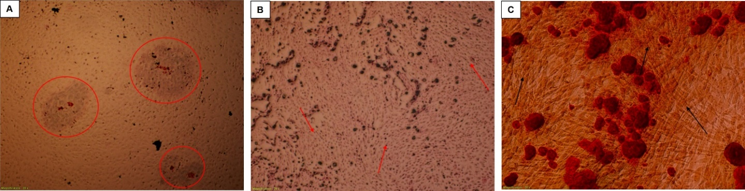
Figure 1S: Differentiation assay of placental mesenchymal stem cells (20X magnification).(A) Evaluation of adipogenesis. Areas of triglyceride producing cells are encircled (Oil-red O stain). (B) Evaluation of chondrogenesis. Chondrocyte-like cells producing mucopolysaccharides and glycosaminoglycans are stained violet (Alcian Blue stain). (C) Evaluation of ostegenesis. Calcium producing cells are stained red (Alizarine Red stain)..

hPSCs PL5 3D 1: 2,5 ratio
unstim
stim
hPSCs PL3 2Dp2 1: 2,5 ratio

Figure 2S: Exemplary histograms of activated CD4+ cells co-incubated with 2D p2 pMSCs from PL3 at 1:2,5 ratio (third panel from the left), and 3D pMSCs from PL5 at 1:2,5 ratio (right panel).

Figure 3S: Impact of hPSCs and hPSC-derived EVs on the activation of CD8+ and CD4+ T-cells. Exemplary histograms of activated CD8+ and CD4+ T-cells co-incubated with pMSCs from PL3 at a 1:2,5 hPSCs: PBMC ratio and EVs from PL3 at a 1:300 PBMC:EV ratio. The gate was set on CD69+ cells of the CD3+CD8+ or CD3+CD4+ T-cell population, respectively. Positive gates were set based on appropriate isotype controls.

Figure 4S: Impact of hPSCs and hPSC-derived EVs on the induction of the Treg compartment (CD4+CD25high T-cells). Exemplary histograms of activated CD8+ and CD4+ T-cells co-incubated with pMSCs from PL3 at a 1:2,5 hPSCs: PBMC ratio and EVs from PL3 at a 1:300 PBMC:EV ratio. The gate was set on CD25high+ cells of the CD3+CD4+CD127low T-cell population. Positive gates were set based on appropriate isotype controls.

A.
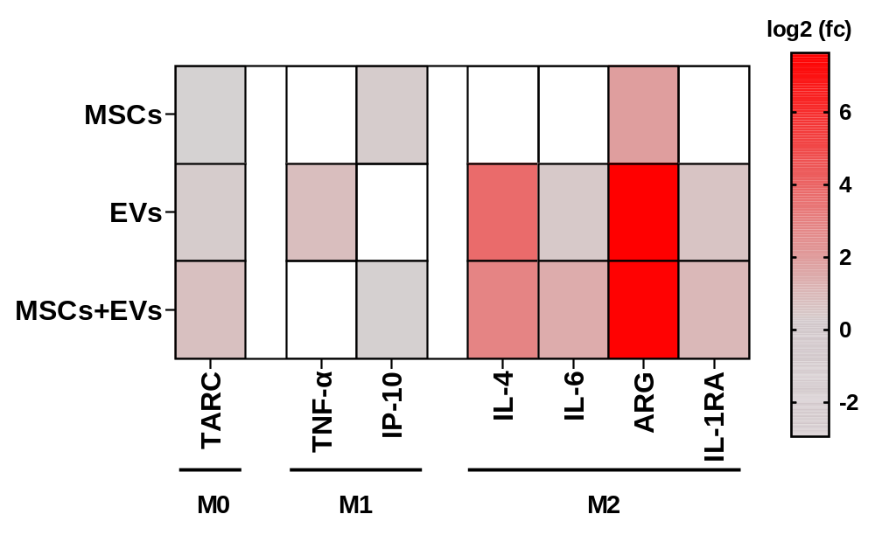
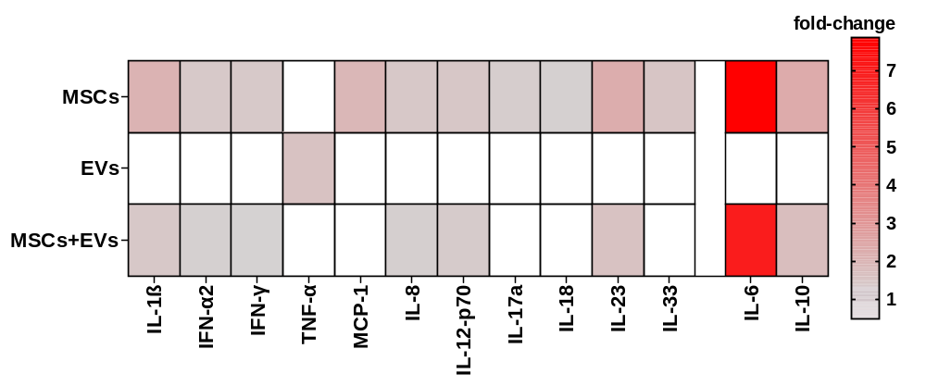
B.

Figure 5S: Summary of the immunomodulatory impact of pMSCs and pMSC-derived EVs (from PL6) in a human 3D in vitro disease model of ARDS. Heatmap representing the mean (n=4 technical replicates) of the fold-change of cytokine concentration measured in the (A) collected basal culture media (epithelial compartment) or (B) in the collected apical culture media (macrophage compartment) in comparison to the untreated control of one placenta donor Heatmaps served as descriptive summaries of cytokine directionality, therefore no statistical testing or multiple-comparison correction was applied to fold-change values.

Certificates of Analysis of the obtained SmallAir™ tissues and alveolar macrophages for the 3D lung models:
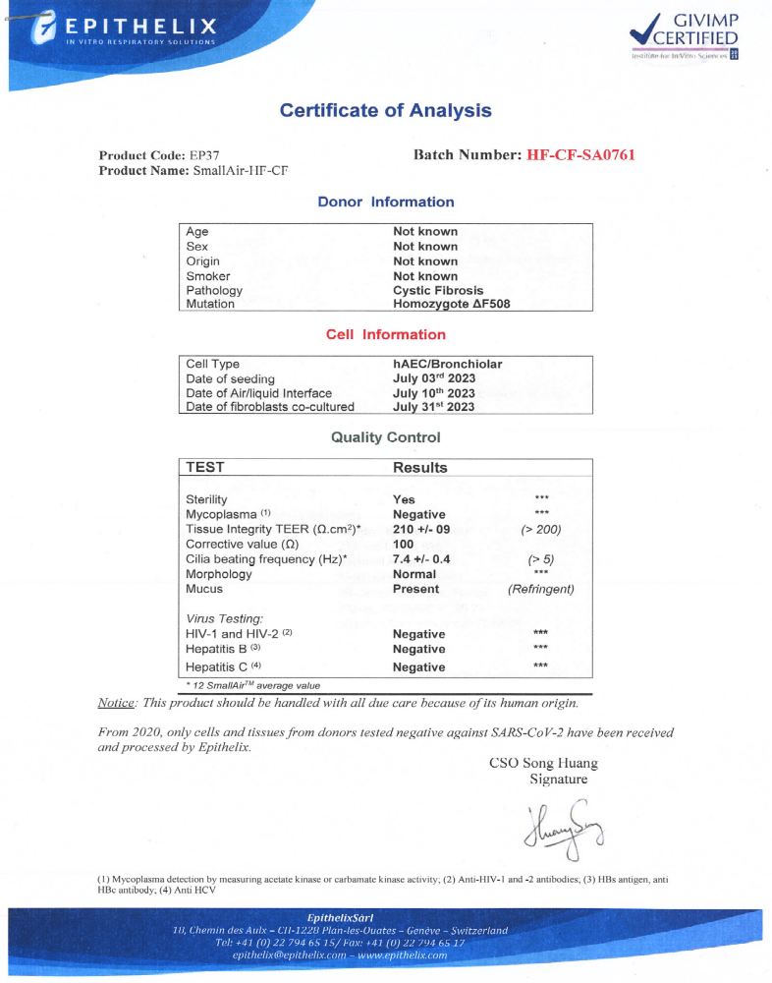

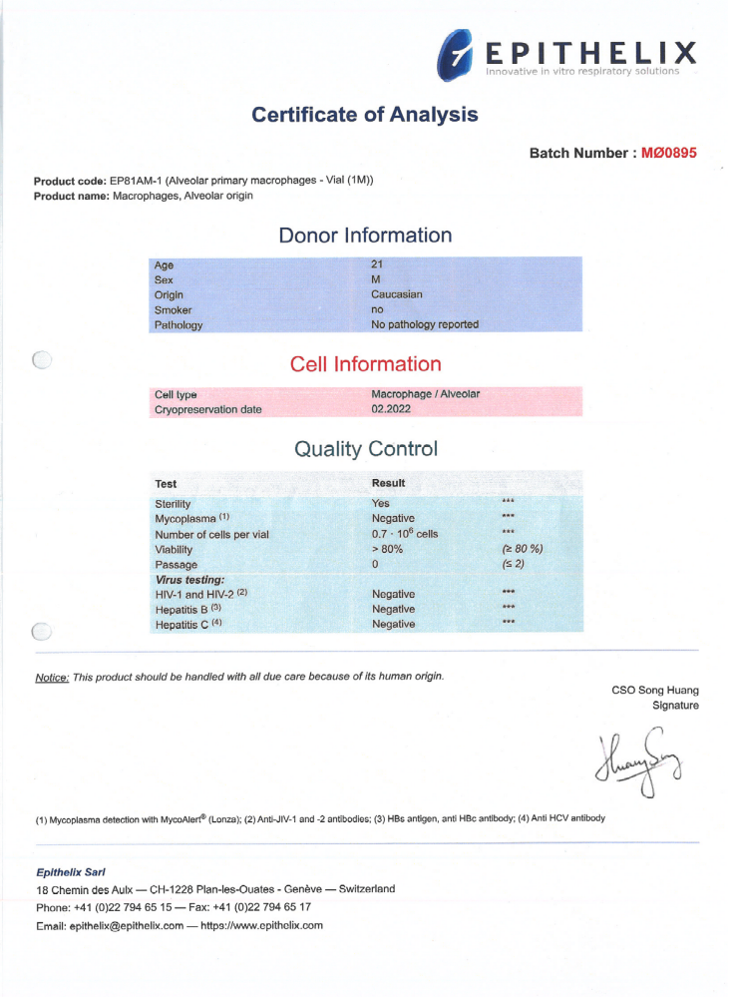

Table 1S: Antibodies used for fNTA analysis and for flow cytometry analysis of T-cell activation and Treg induction
Name | Clone, cat.nr | manufacturer
CD9-PE | 5A6, 349506 | Biolegend
CD81-APC | Eat-2, 104905 | Biolegend
CD3-eF780 | OKT-3, 47-0037-42 | Invitrogen
CD8α-FITC | HIT8α, 11-0089-42 | Invitrogen
CD4-APC | RM4-5, 100516 | Biolegend
CD69-PECy7 | FN50, 310912 | Biolegend
CD25-PECy7 | MA251, 557741 | BD Biosciences
CD127-BV605 | HIL-7R-M21, 562662 | BD Biosciences

Tables 2S: Statistical analysis of individual cytokines measured in the culture supernatants of the hPSC-PBMC co-cultures:

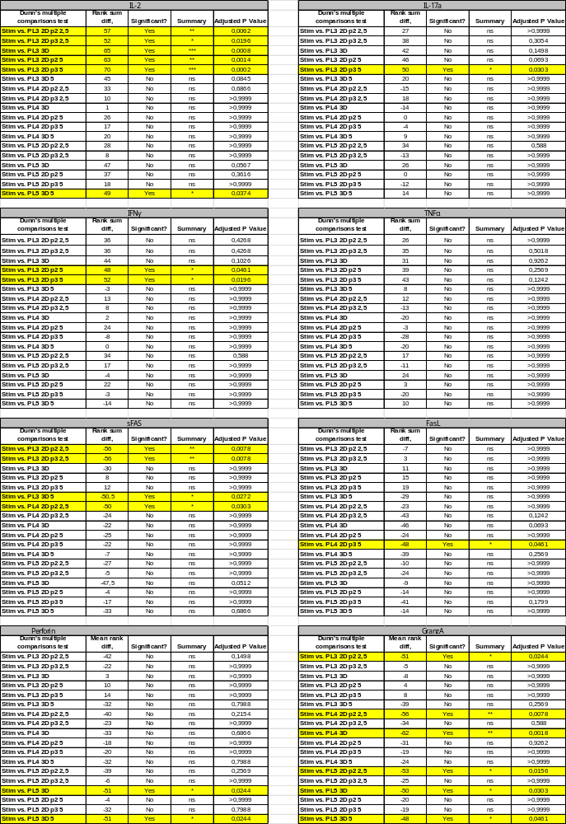

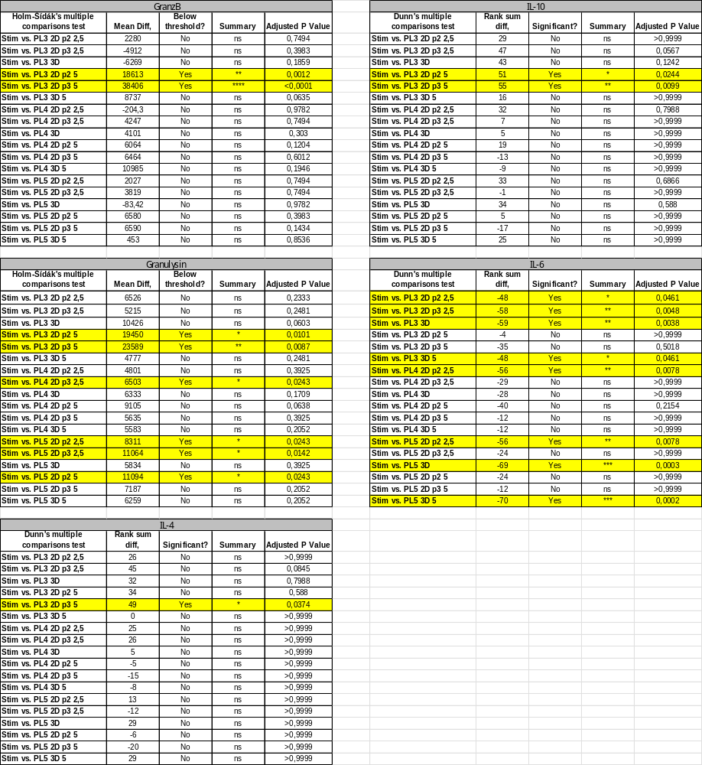

Table 3S: Statistical analysis of individual cytokines measured in the culture supernatants of the EVs-PBMC co-cultures:

Tables 4S: Statistical analysis of individual cytokines measured in the basal media of the 3D CF model – co-incubation with 2D hPSCs/EVs
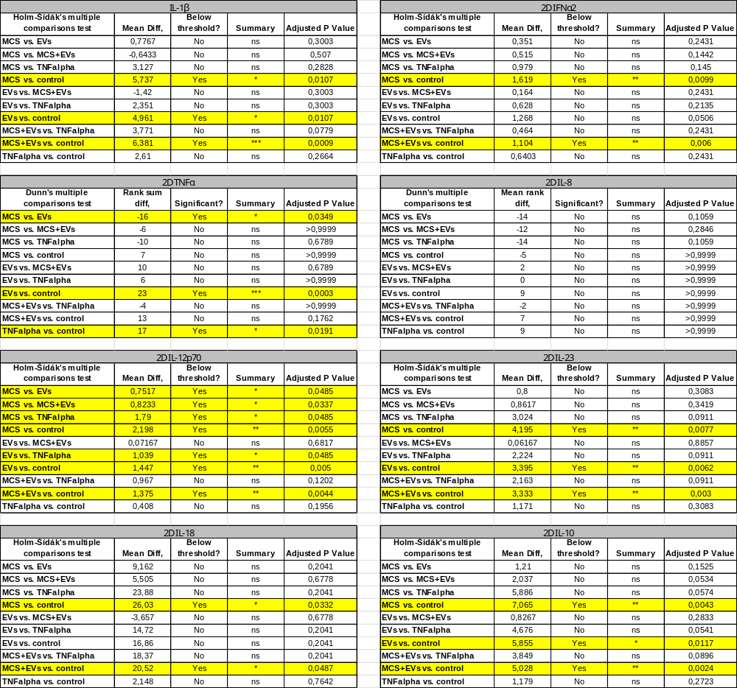

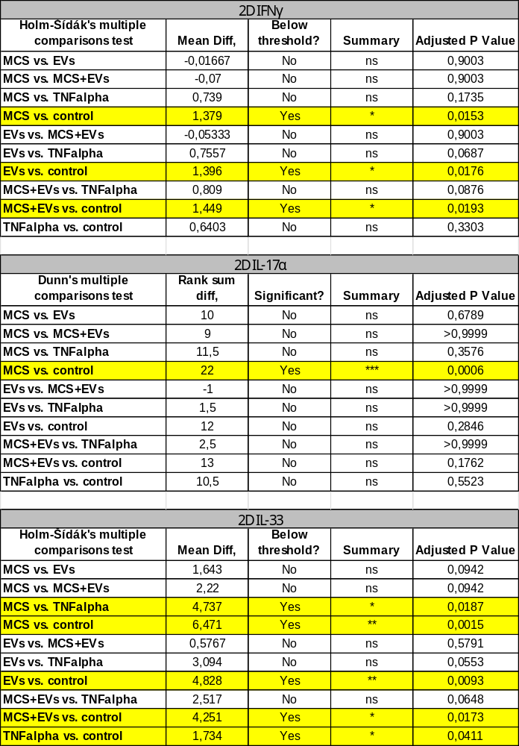

Tables 5S: Statistical analysis of individual cytokines measured in the basal media of the 3D CF model – co-incubation with 3D hPSCs/EVs
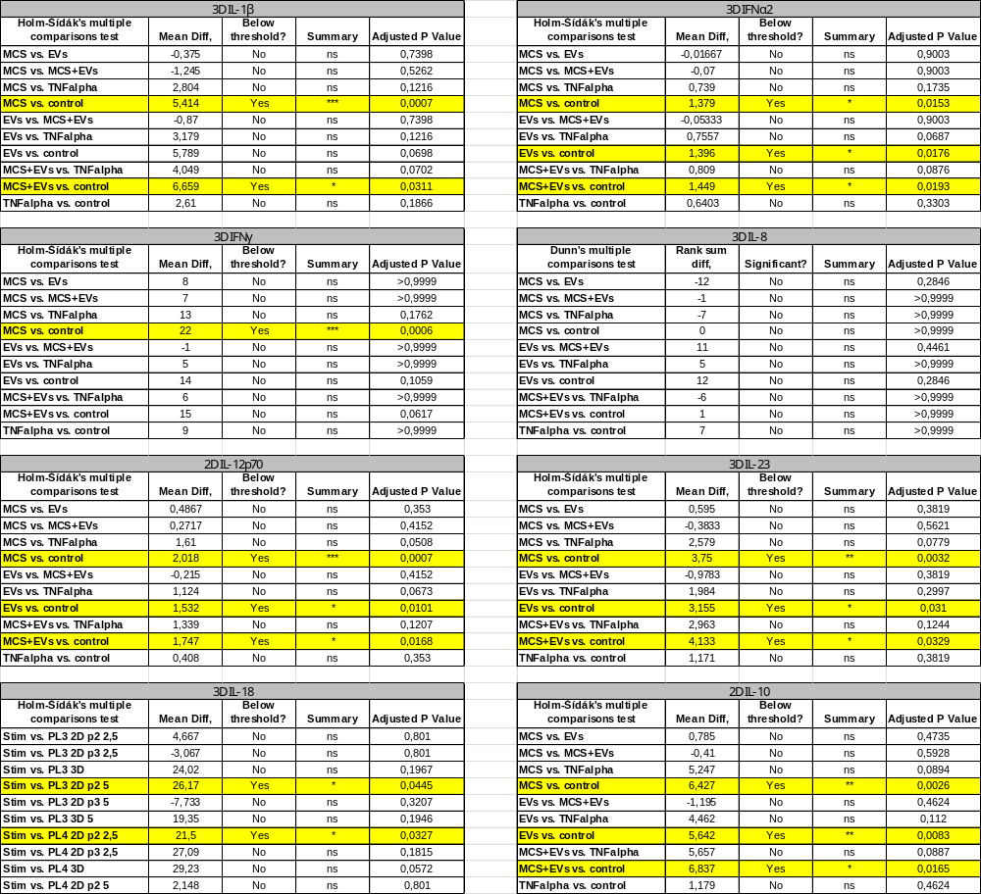

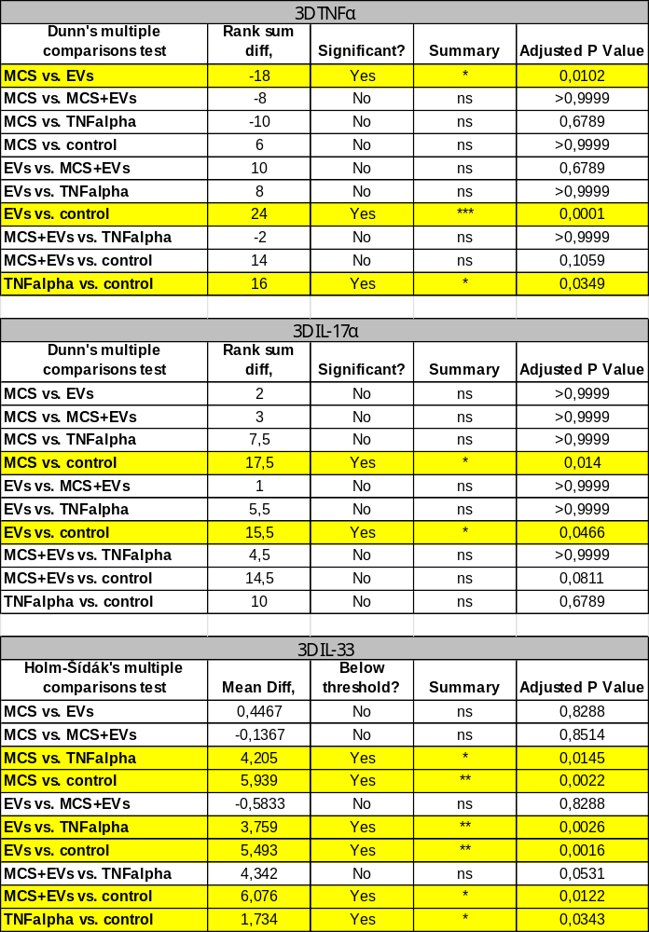

Tables 6S: Statistical analysis of individual cytokines measured in the apical media of the 3D CF model – co-incubation with 2D hPSCs/EVs
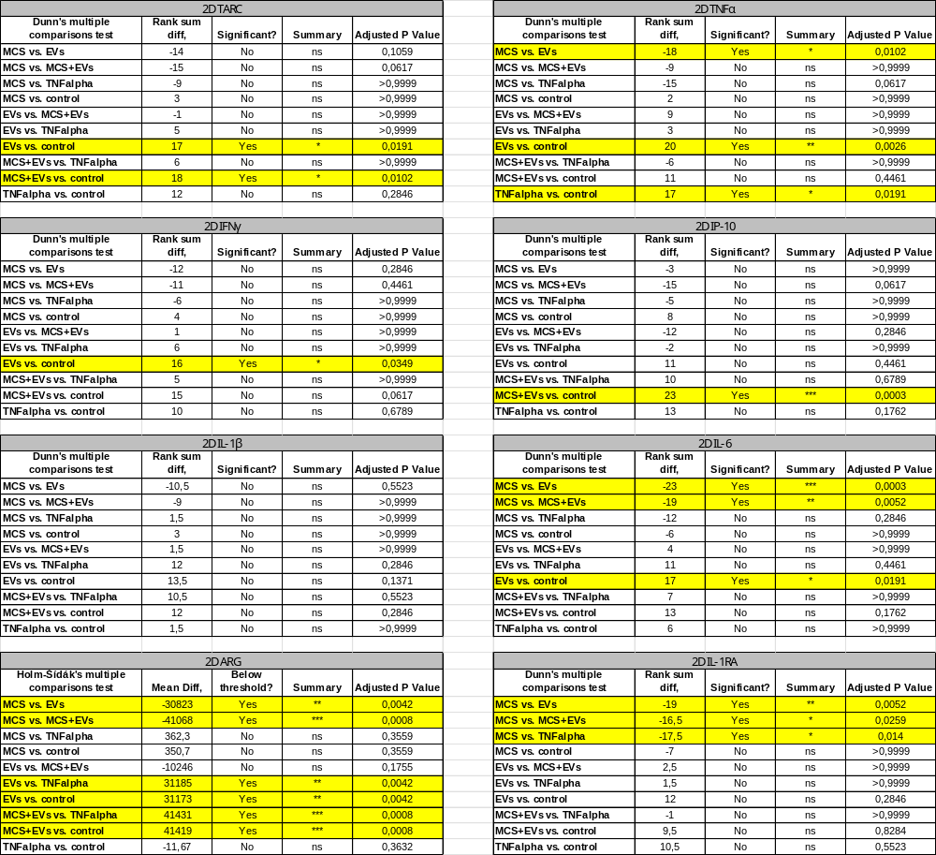

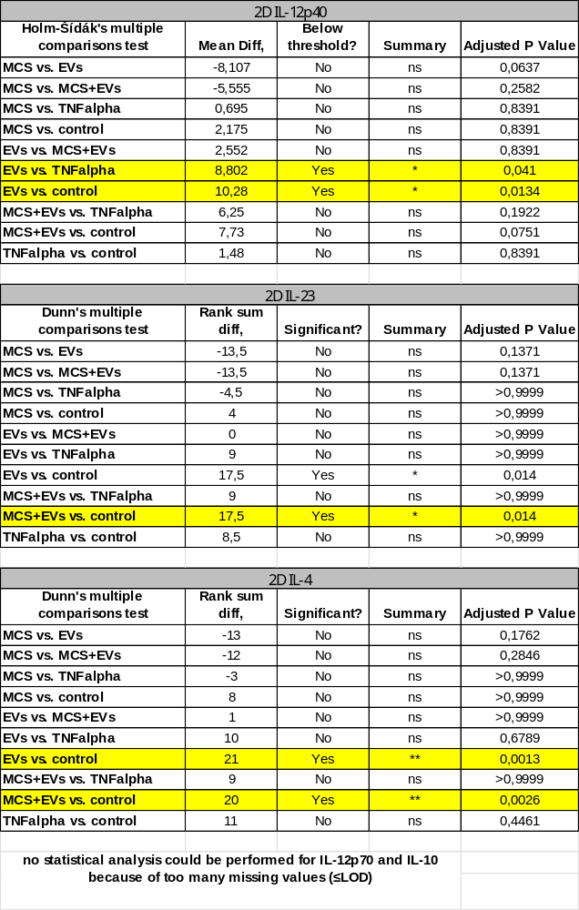
Tables 7S: Statistical analysis of individual cytokines measured in the apical media of the 3D CF model – co-incubation with 3D hPSCs/EVs
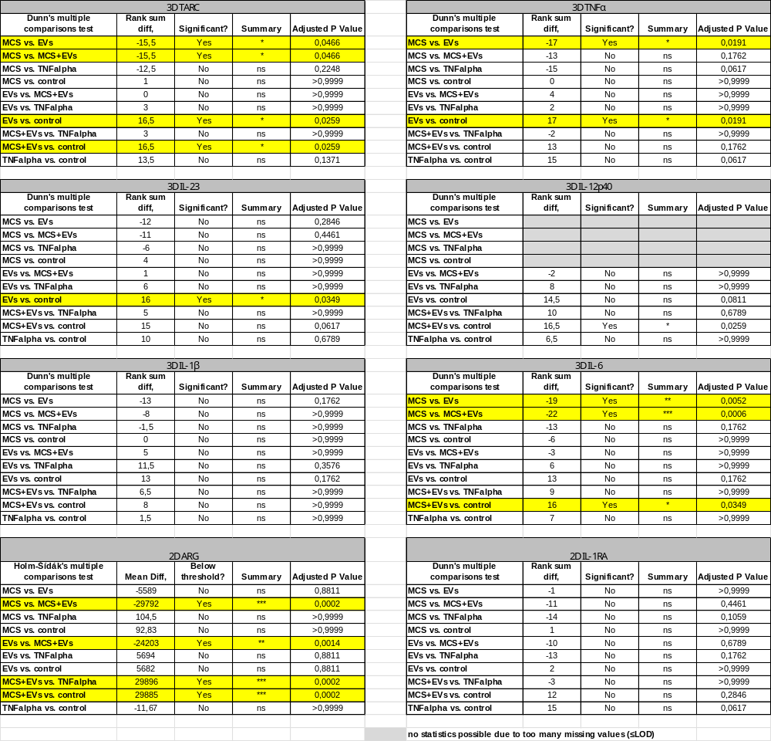

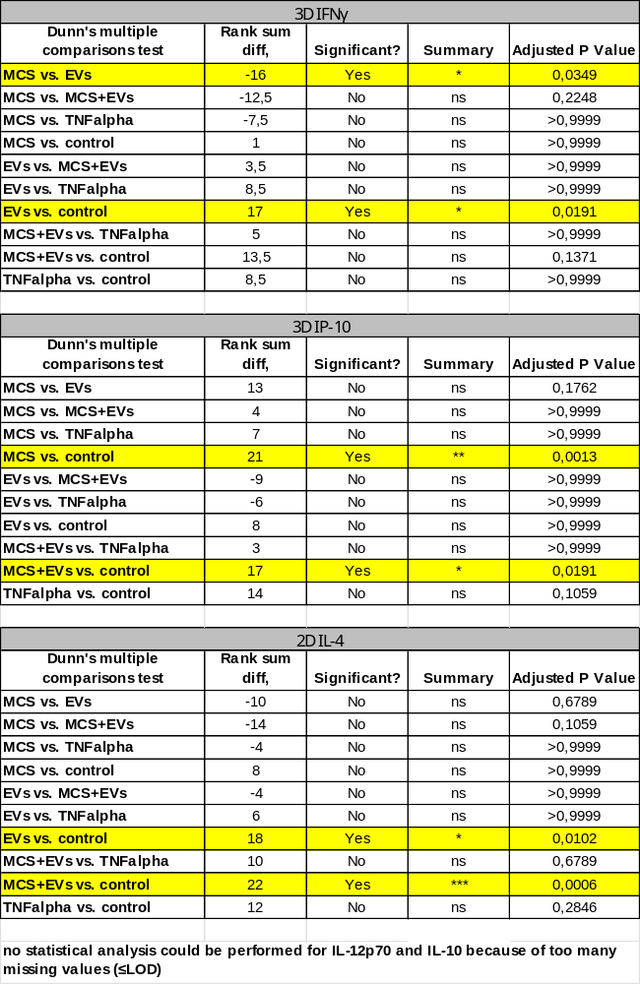
Tables 8S: Statistical analysis of individual cytokines measured in the basal media of the 3D ARDS model
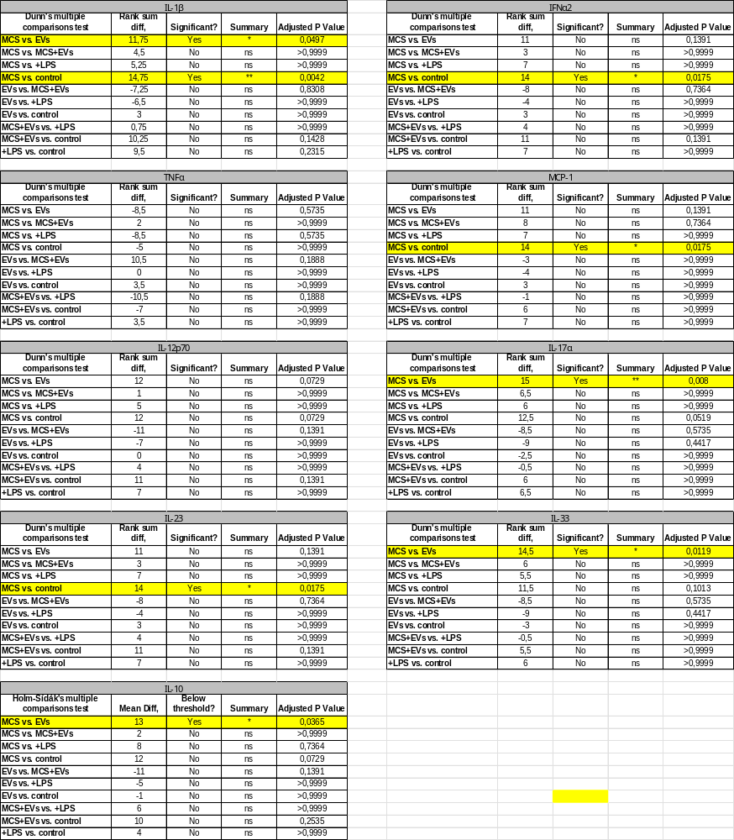

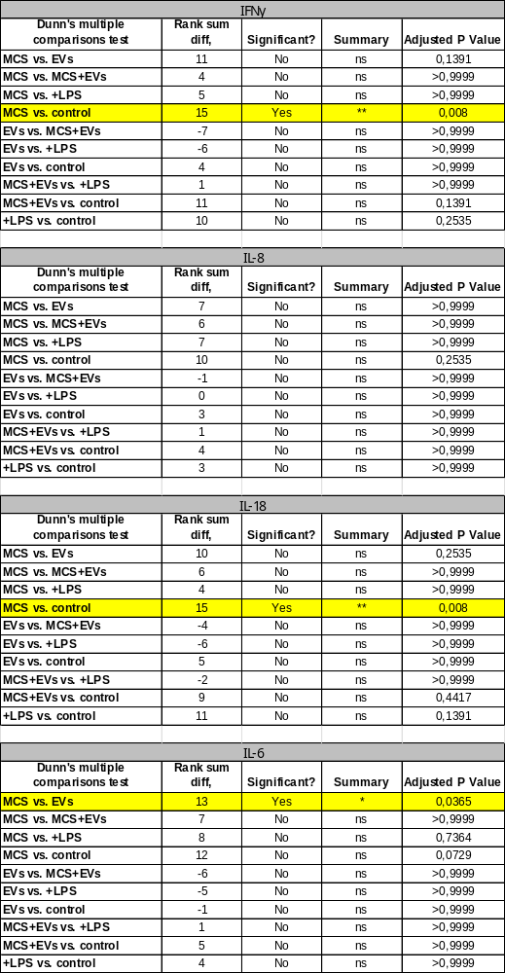
Tables 9S: Statistical analysis of individual cytokines measured in the apical media of the 3D ARDS model
