Data S3.
Representative flow cytometry data showing gating strategies used to quantify D50 and D100 PR populations in L/M-CRR ROs.
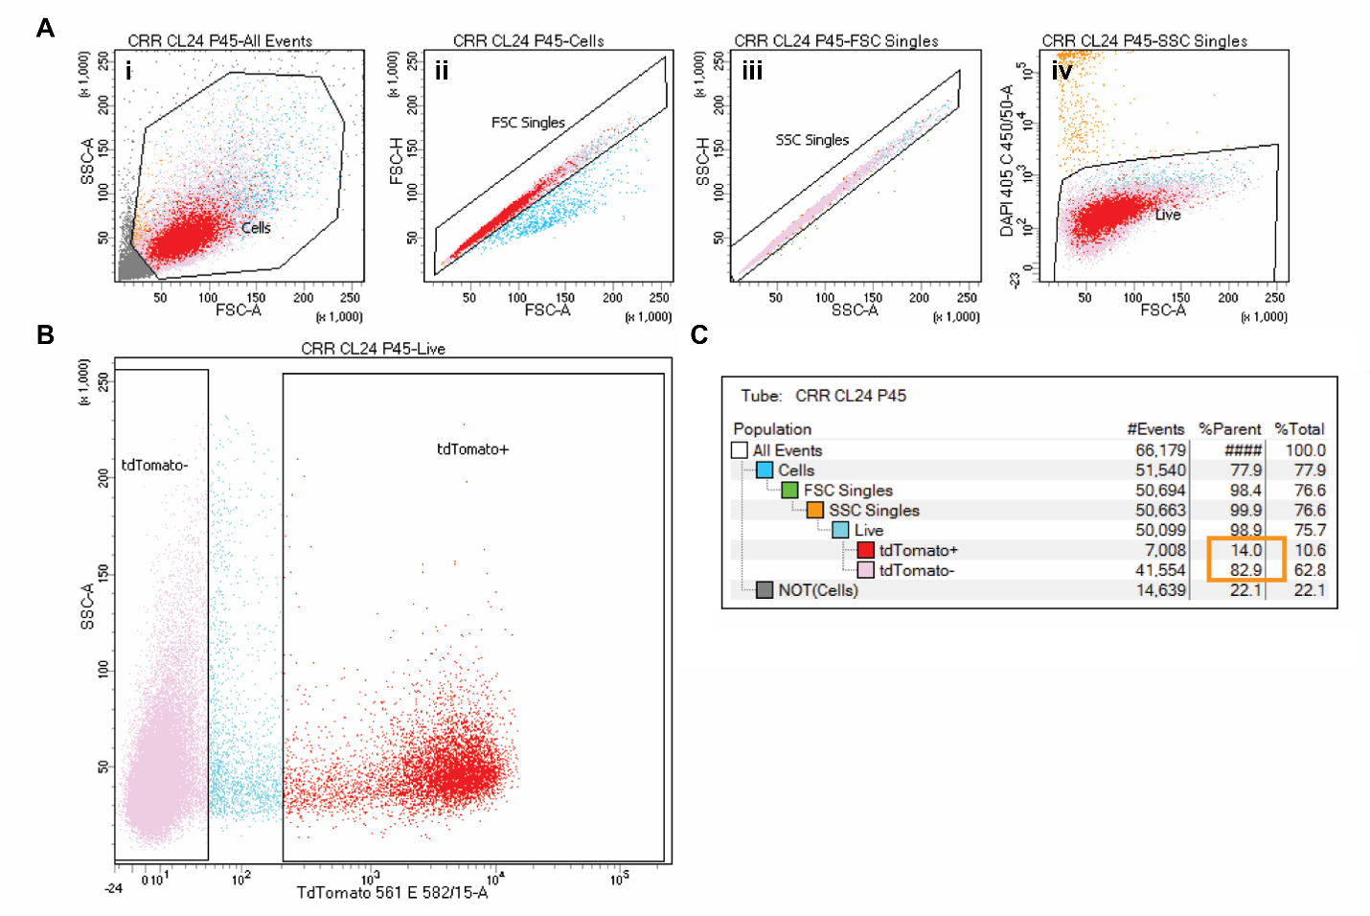

FACS gating strategy for D50 L/M-CRR ROs. Debris was excluded using FSC/SSC (Ai), singlets were gated using FSC-A vs FSC-H (Aii) and SSC-A vs SSC-H (Aiii), and live cells were identified by exclusion of DAPI (Aiv). (B) The live cell population was then subdivided into tdTomato-negative (left box) and tdTomato-positive (right box) fractions based on reporter fluorescence intensity. (C) Percentages of THRB2:tdTomato-positive and THRB2:tdTomato-negtaive populations within the live cell gate were 14.0% and 82.9%, respectively (orange box).

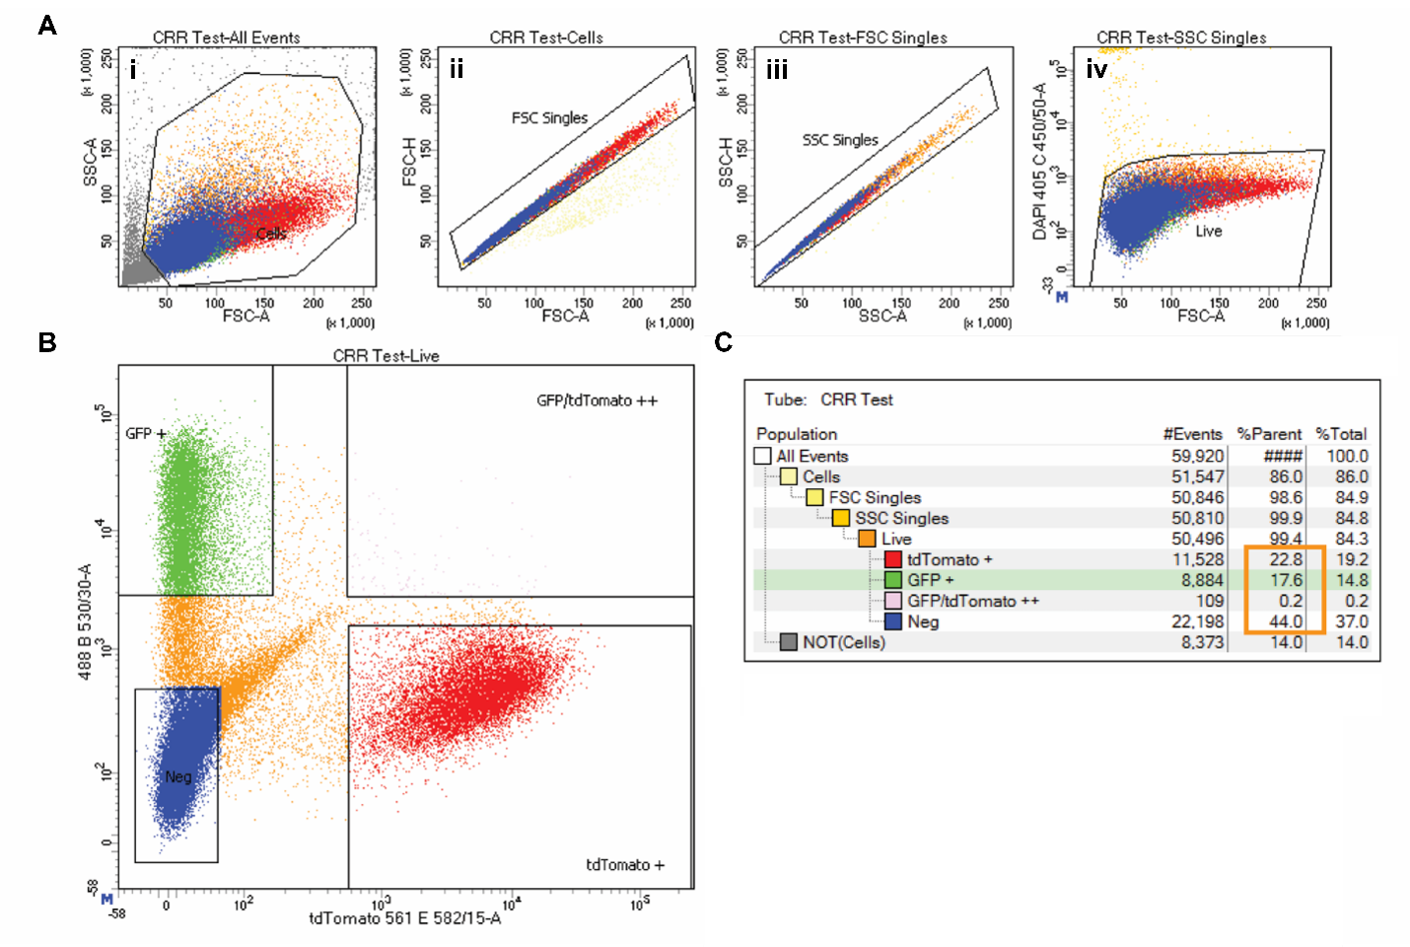

FACS gating strategy for D100 L/M-CRR ROs. Debris was excluded using FSC/SSC (Ai), singlets were gated using FSC-A vs FSC-H (Aii) and SSC-A vs SSC-H (Aiii), and live cells were identified by exclusion of DAPI (Aiv). (B) The live cell population was then subdivided into tdTomato-positive (bottom right), eGFP-positive (top left), eGFP/tdTomato double-positive (top right), and eGFP/tdTomato double-negative (bottom left) populations. (C) Percentages of THRB2:tdTomato-positive, NRL:eGFP-positive, eGFP/tdTomato double-positive, and eGFP/tdTomato double-negative populations within the live cell gate were 22.8%, 17.6%, 0.2%, and 44.0%, respectively (orange box).

