Supplementary material to
PDLSC-CM targets HAPLN1 in macrophages to reduce root resorption in delayed replanted teeth
Lu Jia ^{1,2,3#} Zengbo Zhao^{2,3#}, Ying Zhang¹, Liping Zhang¹, Yan Liu⁴, Hongyu Ma¹, Peng Zhang¹, Xiangdong Liu³, Lu Zhang¹, Hang Yang¹, Zihan Yang¹, Zhe Ma³, Huimin Wang³, Zhiyong Hou^{5,6}*, Huijie Ma^{1,7,8}*
¹ Department of Physiology, Hebei Medical University, Shijiazhuang, Hebei, China
² Department of Emergency General Dentistry, Stomatology Hospital of Hebei Medical University, Shijiazhuang, Hebei, China
³ Hebei Key Laboratory of Stomatology, Hebei Clinical Research Center for Oral Diseases, School and Hospital of Stomatology, Hebei Medical University, Shijiazhuang, Hebei, China
⁴ Departments of Endocrinology, Third Hospital of Hebei Medical University, Shijiazhuang, Hebei, China
⁵ Department of Orthopedic Surgery, Third Hospital of Hebei Medical University, Shijiazhuang, Hebei, China
⁶ Orthopedic Research Institute of Hebei Province, NHC Key Laboratory of Intelligent Orthopedic Equipment, Third Hospital of Hebei Medical University, Shijiazhuang, Hebei, China
⁷ Key Laboratory of Neural and Vascular Biology, Ministry of Education, Hebei Key Laboratory of Neurophysiology, Hebei Medical University, Shijiazhuang, Hebei, China
⁸ Hebei Key Laboratory of Brain Science and Brain-Inspired Intelligence, Shijiazhuang, Hebei, China
* Corresponding authors: Huijie Ma and Zhiyong Hou.
Address correspondence to: Huijie Ma, Department of Physiology, Hebei Medical University, 361 Eastern Zhongshan Road, Shijiazhuang, Hebei, China. E-mail: huijiema@hebmu.edu.cn. Or to: Zhiyong Hou, Department of Orthopedic Surgery, Third Hospital of Hebei Medical University, 139 Ziqiang Road, Shijiazhuang, Hebei, China. E-mail: drzyhou@hebmu.edu.cn.
# These two authors contributed equally to this work.
The authors have declared that no conflict of interest exists.

Supplementary Figures
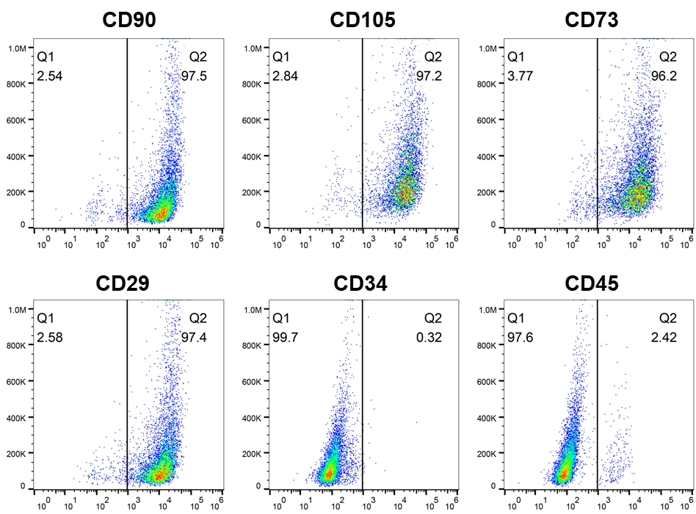
Figure S1. Flow cytometry analysis the surface markers of PDLSC. The expression of CD90, CD105, CD73, CD29, CD34, and CD45 on the cell surface identified by flow cytometry. PDLSC: periodontal ligament stem cells.

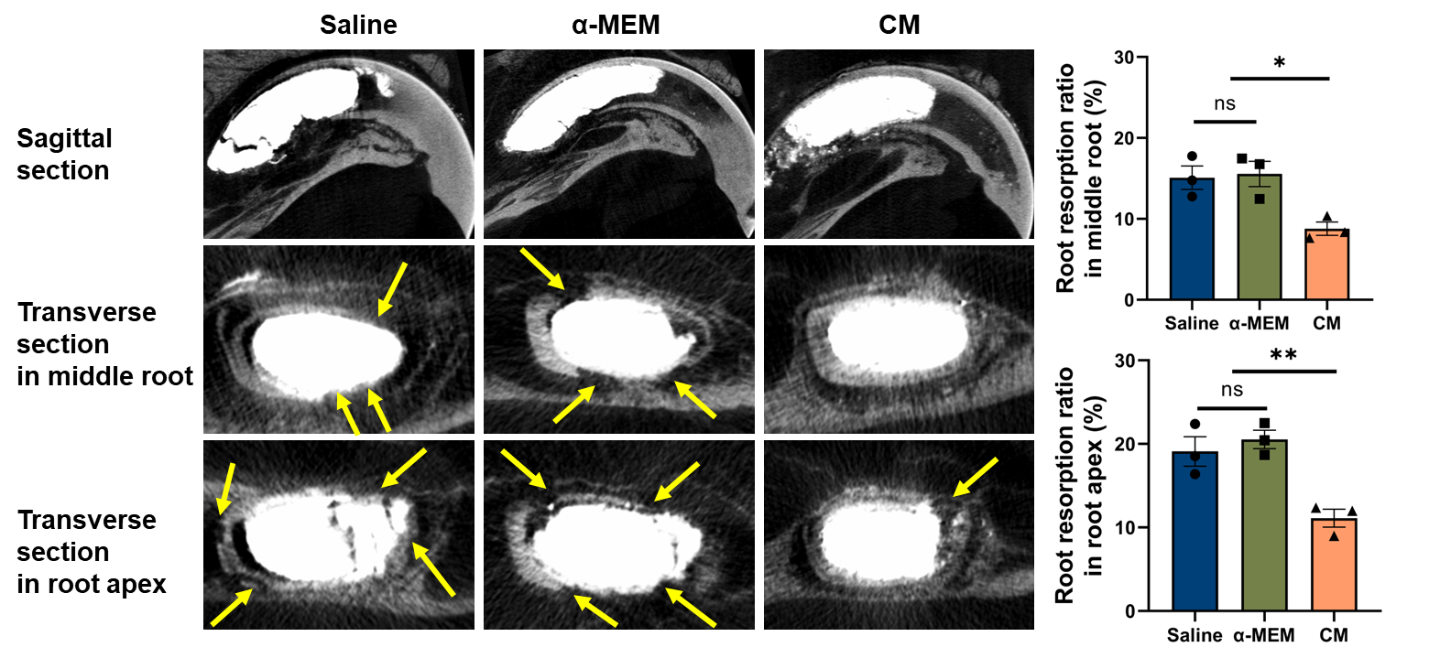
Figure S2. α-MEM does not alleviate root resorption of avulsed teeth in rats. Representative images and quantitative analysis of micro-CT scanning showing tooth root resorption at 28 days post-delayed tooth replantation in the Saline, α-MEM, and CM groups of rats. Root resorption and continuous interruptions were indicated by the yellow arrows. Saline: the normal saline group; α-MEM: the α-MEM group; CM: the conditioned medium group. One-way ANOVA followed by the Tukey’s post hoc test was used to compare data among multiple groups. Data are expressed as means ± SEM. n = 3 per group. *P < 0.05, **P < 0.01.

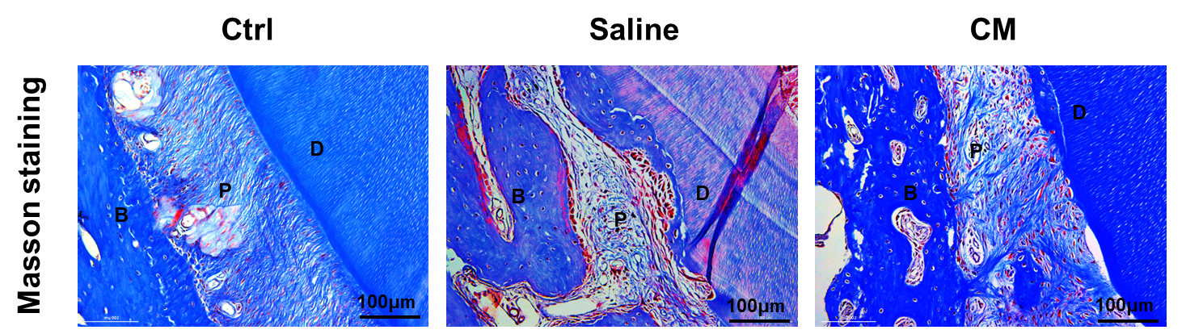
Figure S3. Masson staining revealed the impact of PDLSC-CM on the organization and alignment of the periodontal ligament in replanted tooth roots.
Representative images of Masson staining showing the health status of periodontal ligaments on the surface of the tooth root in the Ctrl, Saline and CM groups of rats. Scale bar: 100 μm. PDLSC: periodontal ligament stem cells; Ctrl: the control group; Saline: the normal saline group; CM: the conditioned medium group; D: dentin; P: periodontal ligament; B: bone.

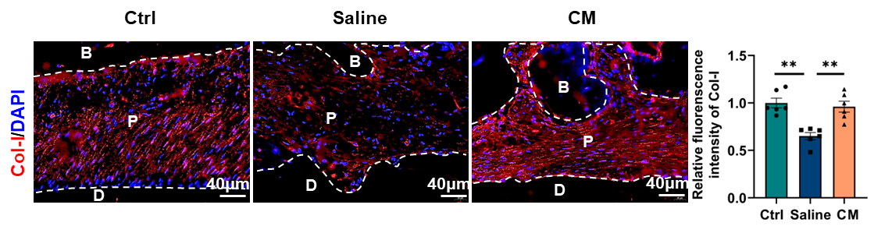
Figure S4. PDLSC-CM increases the content of Col-I in periodontal ligament. Immunofluorescence staining of representative images and quantitative analysis showing Col-I positive cells in the periodontal ligament of the Ctrl, Saline and CM groups of rats. Scale bar: 40 μm. PDLSC: periodontal ligament stem cells; Ctrl: the control group; Saline: the normal saline group; CM: the conditioned medium group; D: dentin; P: periodontal ligament; B: bone. One-way ANOVA followed by the Tukey’s post hoc test was used to compare data among multiple groups. Data are expressed as means ± SEM. n = 6 per group. ** P < 0.01.

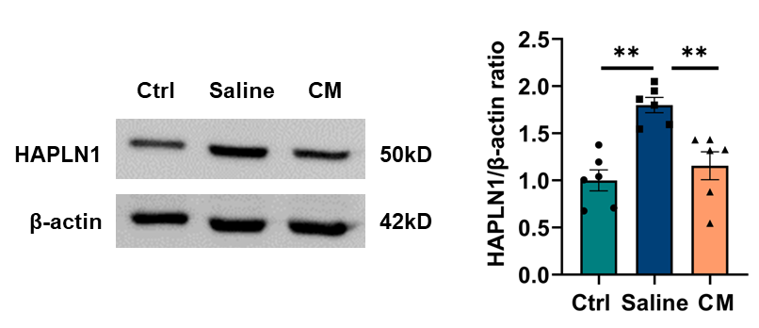
Figure S5. PDLSC-CM reduces the protein expression of HAPLN1 in delayed replantation of avulsed tooth roots in rats. Representative bands and quantitative analysis of Western blotting showing HAPLN1 protein expressions in root and periapical tissues of the Ctrl, Saline and CM groups of rats. PDLSC: periodontal ligament stem cells; Ctrl: the control group; Saline: the normal saline group; CM: the conditioned medium group. Data are expressed as means ± SEM. n = 6 per group. ** P < 0.01.

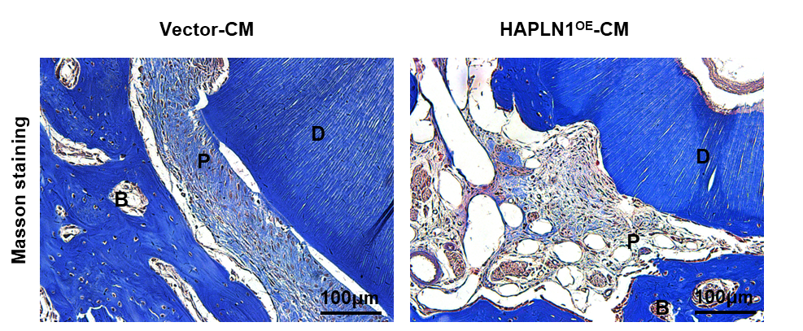
Figure S6. Overexpression of HAPLN1 cancels the protective effect of PDLSC-CM on the periodontal ligament of delayed replanted tooth roots. Representative images of Masson staining showing the health status of periodontal ligaments on the surface of the tooth root in the Vector-CM and the HAPLN1^{OE}-CM groups of rats. Scale bar: 100 μm. PDLSC: periodontal ligament stem cells; Vector-CM: the control vector injection and conditioned medium treatment group; HAPLN1^{OE}-CM: the HAPLN1 overexpression AAV injection group and conditioned medium treatment group; D: dentin; P: periodontal ligament; B: bone.

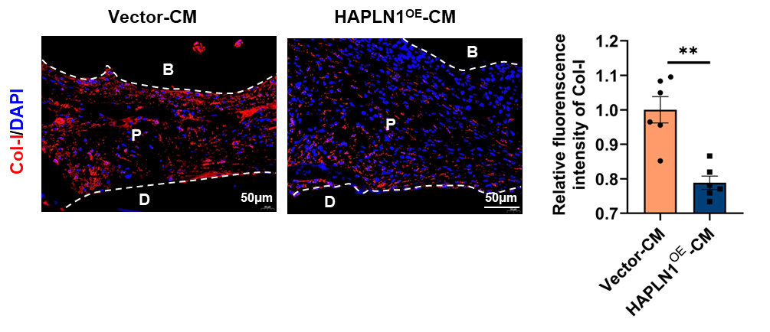
Figure S7. Overexpression of HAPLN1 counteracts the upregulation of Col-I content in the periodontal ligament of delayed replanted roots by PDLSC-CM. Immunofluorescence staining of representative images and quantitative analysis showing Col-I positive cells in periodontal ligament of the Vector-CM and the HAPLN1^{OE}-CM groups of rats. Scale bar: 50 μm. PDLSC: periodontal ligament stem cells; Vector-CM: the control vector injection and conditioned medium treatment group; HAPLN1^{OE}-CM: the HAPLN1 overexpression AAV injection group and conditioned medium treatment group; D: dentin; P: periodontal ligament; B: bone. Unpaired two-tailed Student’s t-test was used to compare data between two groups. Data are expressed as means ± SEM. n = 6 per group. ** P < 0.01.

