Supplementary Table S1. RT-qPCR primer sequences used in this study
Gene | Species | Forward (5′→3′) | Reverse (5′→3′)
ACAN (Aggrecan) | Rat | TCCTGCAGAGAGACATCGGA | GGGGCGAACAAACAAGACAC
COL2A1 | Rat | TTGTCTGAATGGAGCCACCTG | TCCTCACATTGCTCCTGGTC
SOX9 | Rat | AGGGGACTCACGTTTGGGTA | CCCTGAAGCCTGATCCAAGT
COL10A1 | Rat | TGTTGACATTGCACCCATGG | CAGCCATTCAGTGCAGATCC

Supplementary Figure S1. Early in vitro degradation profiles of acellular, chondrocyte-laden, and CO-laden constructs.
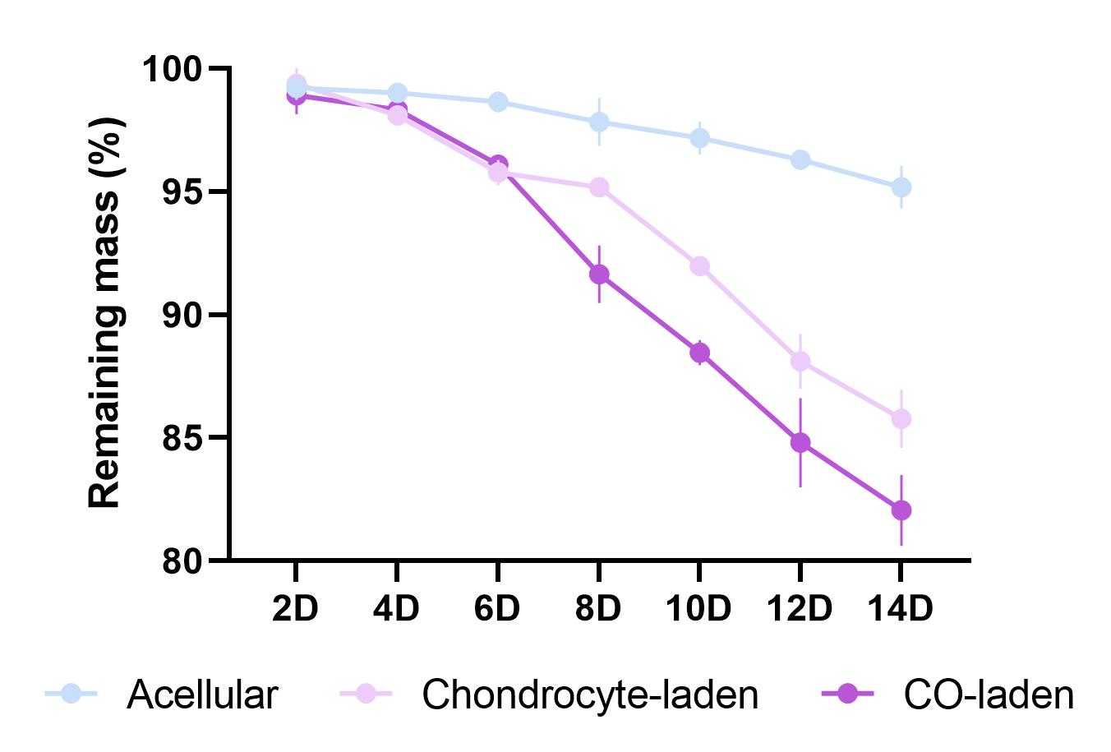
Fig. S1. Early in vitro degradation profiles of acellular, chondrocyte-laden, and CO-laden constructs. The degradation behavior of the printed constructs was evaluated over 14 days in vitro by measuring the remaining mass after gently removing excess surface liquid. The acellular group showed the slowest mass loss, whereas the cell-laden groups exhibited faster degradation, with the CO-laden group showing the most pronounced decrease in remaining mass during the observation period.

Supplementary Figure S2. Total DNA quantification of printed chondrocyte-laden and CO-laden constructs after complete digestion.
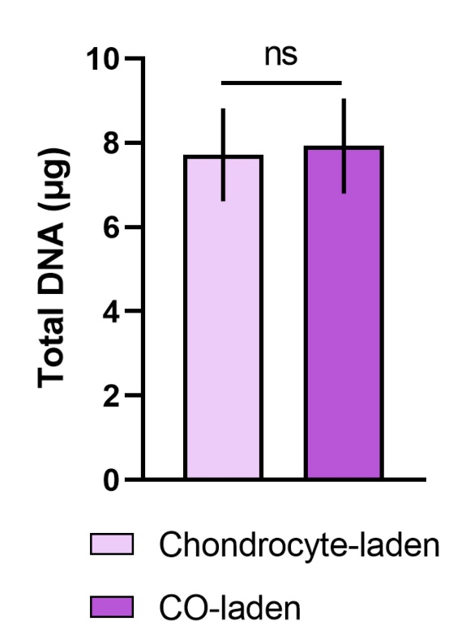
Fig. S2. Total DNA quantification of printed chondrocyte-laden and CO-laden constructs after complete digestion. To compare the total cellular content of the printed constructs, chondrocyte-laden and CO-laden constructs were fully digested with collagenase, and the released cells/organoids were collected for DNA quantification. No significant difference in total DNA content was observed between the two groups, suggesting that the superior performance of the CO-laden constructs was unlikely to be explained simply by differences in effective cell dose. Data are presented as mean ± SD; ns, not significant.

