Exo Marker | Integrated Density
Alix | 42235.91
CD9 | 43117.51
CD81 | 29882.61
TSG101 | 15380.58

Table S1. Quantitative analysis of WB results for Exo markers. The WB results for Exo markers were quantitatively analysed (Alix, CD9, CD81, TSG101) using Image J software.
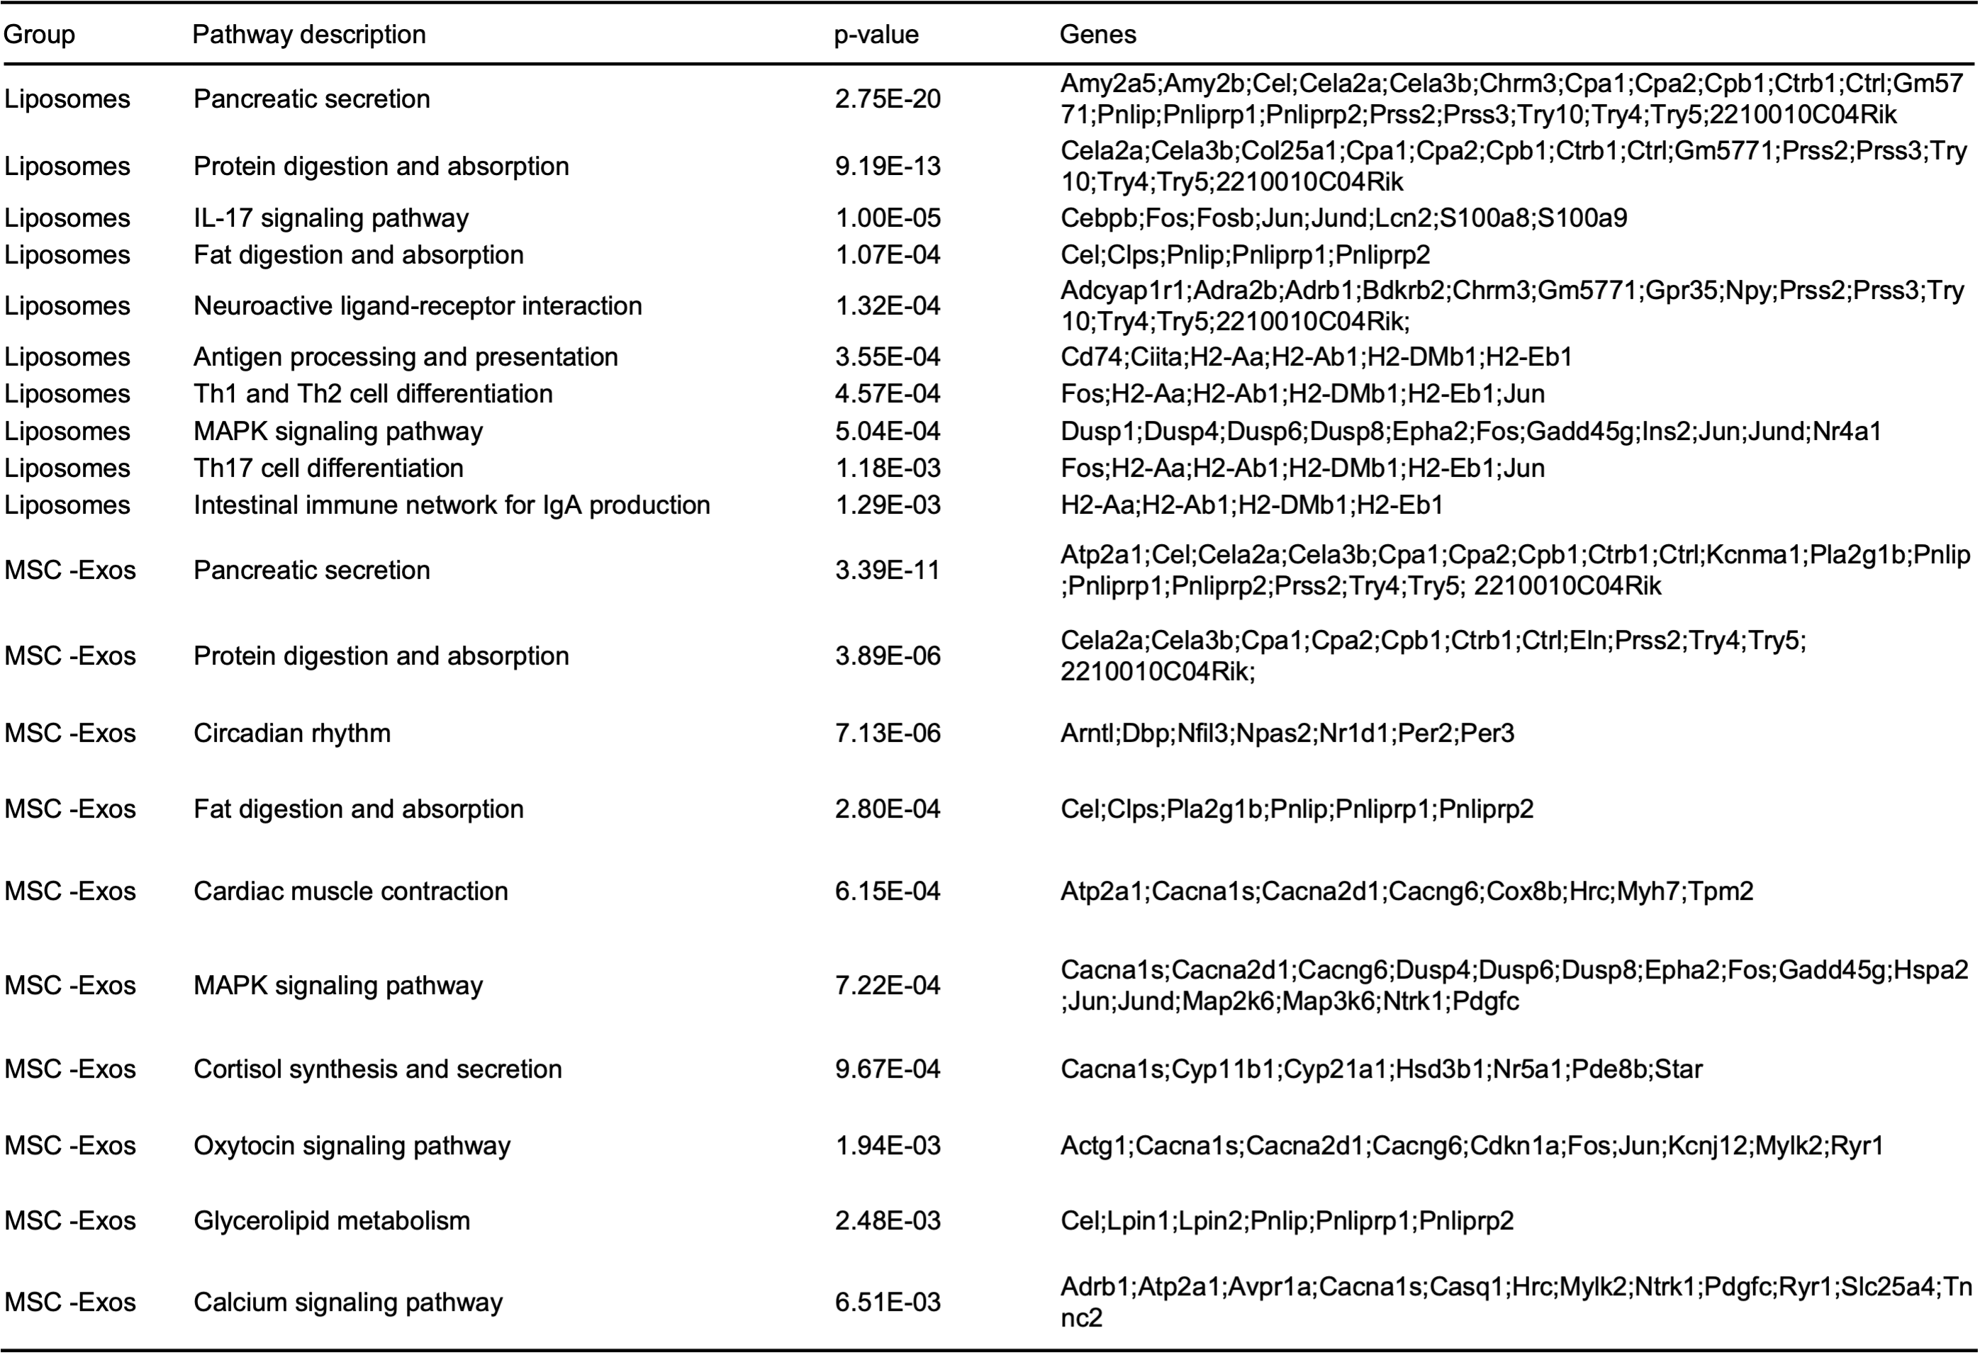
Table S2. Enrichment of DEGs across KEGG pathways in the liver. Pathways were identified via a hypergeometric test with FDR correction (FDR < 0.05). Gene symbols of DEGs enriched in each pathway are listed.

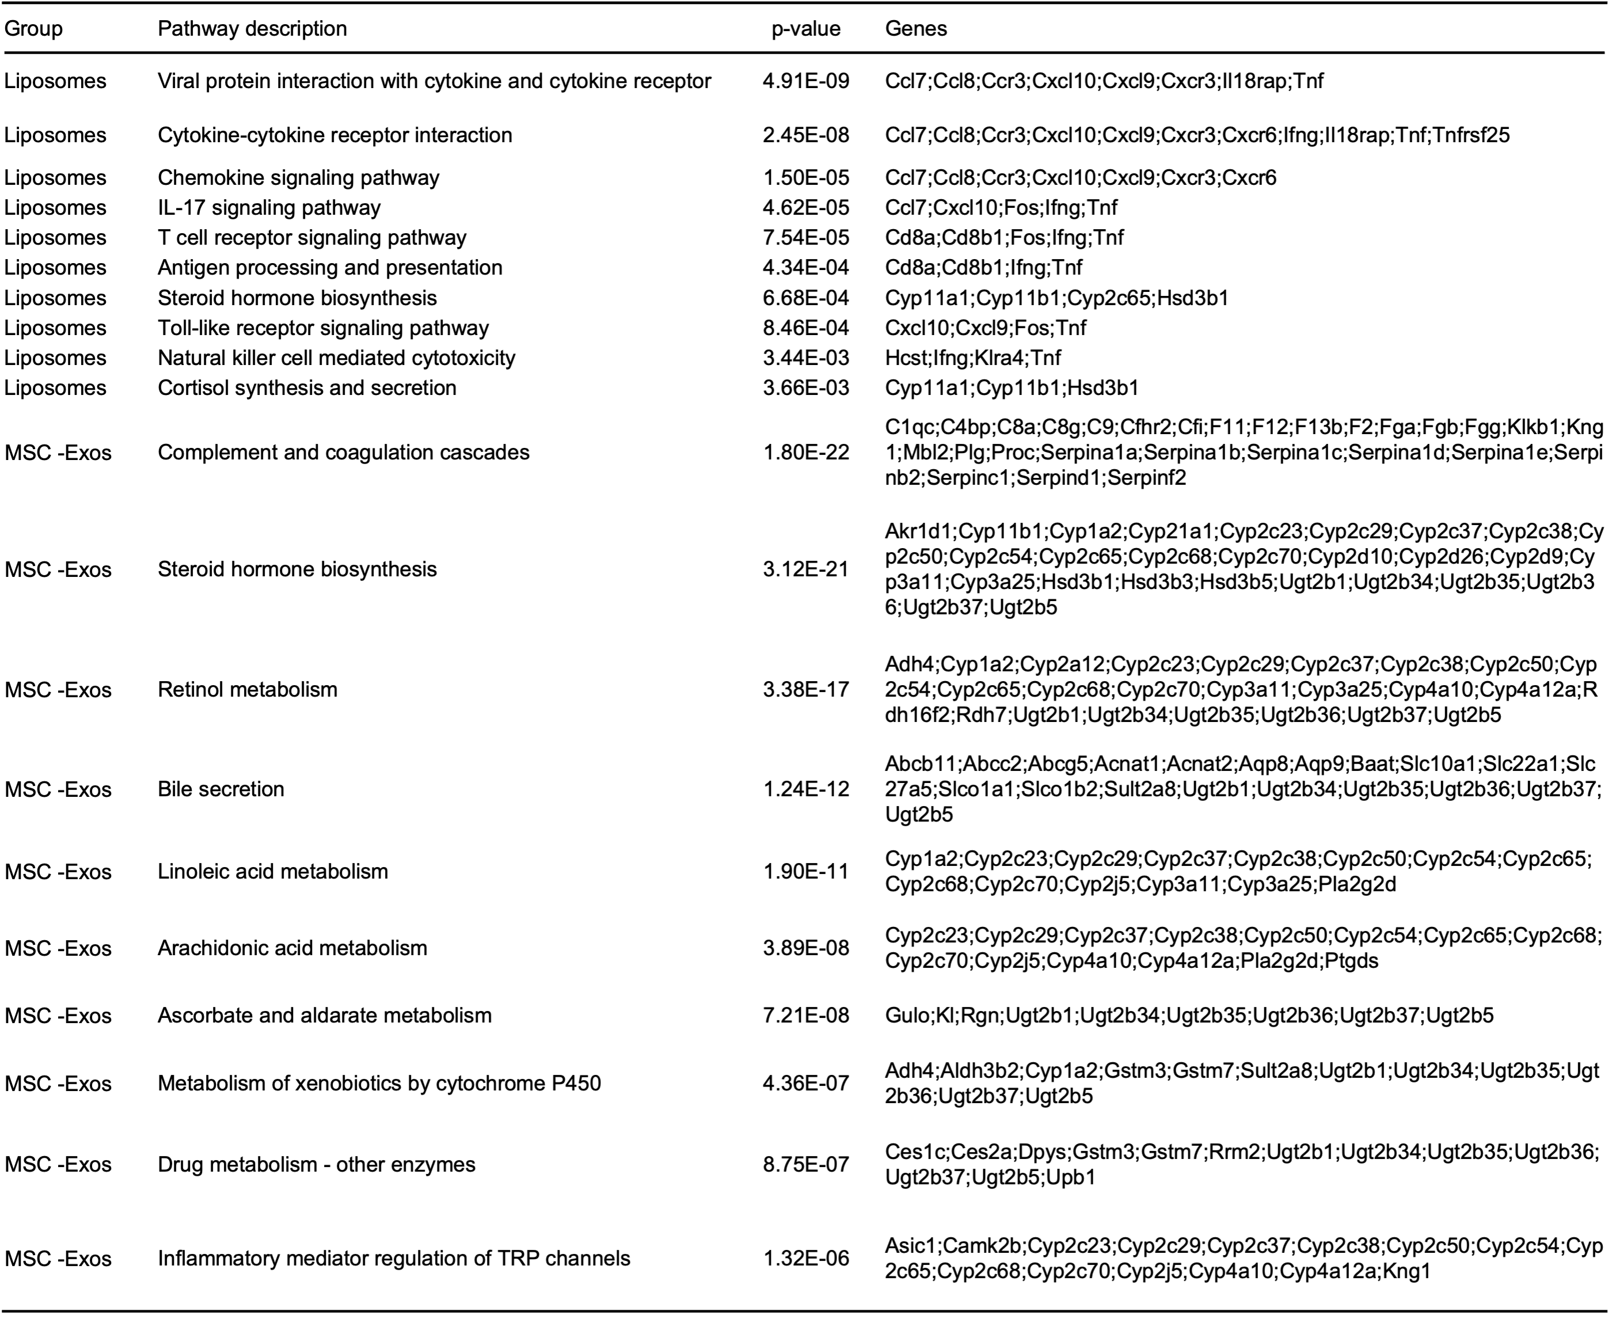
Table S3. Enrichment of DEGs across KEGG pathways in the lung. Pathways were identified via a hypergeometric test with FDR correction (FDR < 0.05). Gene symbols of DEGs enriched in each pathway are listed.

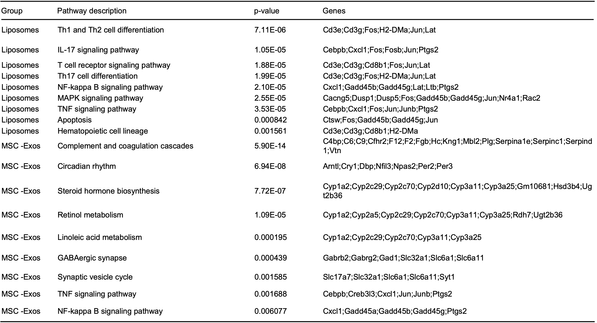
Table S4. Enrichment of DEGs across KEGG pathways in the kidney. Pathways were identified via a hypergeometric test with FDR correction (FDR < 0.05). Gene symbols of DEGs enriched in each pathway are listed.

ID | Maternal age | Apgar score | Exo quality parameters
ID | Maternal age | Apgar score | Particle yield supernatant/mL | Particle concentration/mL | Protein concentration (mg/mL) | Particle number/μg protein
UC01 | 28 | 10 | 3.9×10⁸ | 1.0×10¹¹ | 0.22 | 4.5×10⁸
UC02 | 27 | 10 | 4.6×10⁸ | 1.2×10¹¹ | 0.21 | 5.7×10⁸
UC03 | 28 | 10 | 4.6×10⁸ | 1.2×10¹¹ | 0.19 | 6.3×10⁸
UC04 | 25 | 9 | 3.0×10⁸ | 8.0×10¹⁰ | 0.22 | 3.6×10⁸
Table S5. Donor characteristics and quality control parameters of umbilical cord-derived MSC-Exos.

Inclusion criteria | Exclusion criteria
Approved by the hospital ethics committee, and signed written informed consent was obtained. | Genetic and underlying conditions: Family history of genetic disorders (within three generations), history of metabolic disorders (diabetes, thyroid disease, etc.), history of autoimmune diseases.
Elective cesarean section for singleton pregnancy | Pregnancy Complications: Gestational hypertension/diabetes, placental dysfunction, meconium-stained amniotic fluid, or premature rupture of membranes.
Women of childbearing age  (25-30 years) | Risk of infection: Serological test positive (HIV/HBV/HCV/TP), TORCH infection during pregnancy (IgM positive)
Newborn Apgar score of 8-10 | Abnormal appearance of the umbilical  cord: vascular malformations, umbilical  cord cysts
Table S6. The inclusion criteria and exclusion criteria of UC-MSC donors.

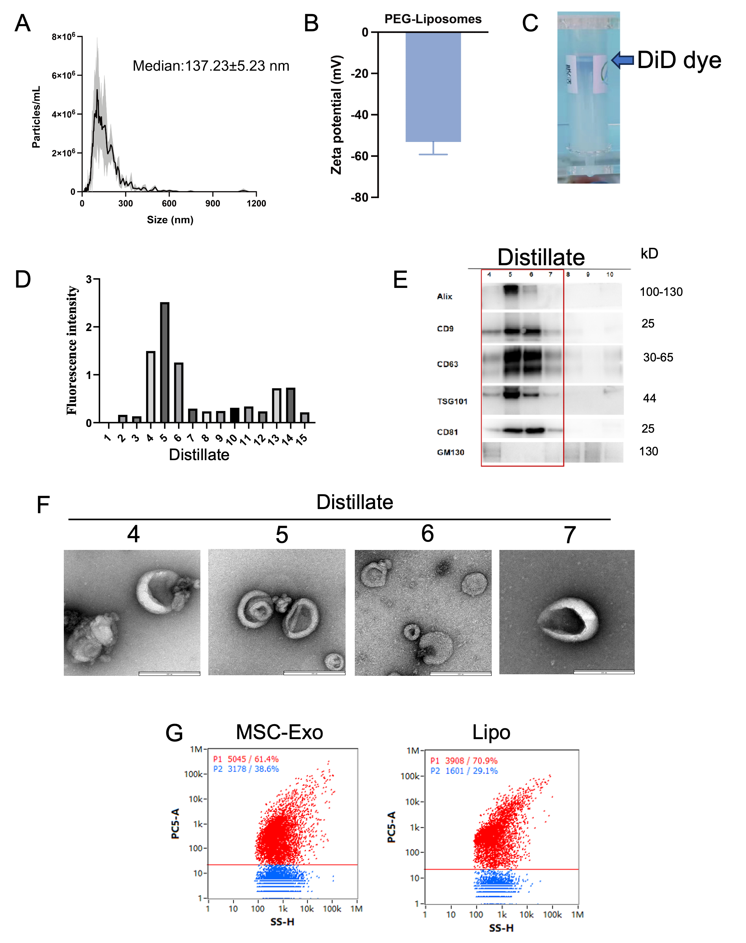
Figure S1. DiD labelling of MSC-Exos and removal of free dye by SEC. (A, B) NTA detection of PEG-Liposomes median particle size: 137.23 ± 5.23 nm (A) and zeta potential (B): -53.21 ± 6.21 mV. n = 4. (C) Residual free dye in the upper layer is visible after SEC separation of DiD-labelled MSC-Exos (blue arrow pointing). (D) Fluorescence intensity of each fraction was detected by SEC after DiD labelling of hucMSC-Exos. (E) WB identification of Exo markers: Alix, CD9, CD63, TSG101, CD81, and Golgi matrix marker: GM130. (F) TEM images of different fractions. Scale bars show 200 nm. (G) DiD labelling efficiency of the nanoflow assay hucMSC-Exos (61.4%) and PEG-Liposomes (70.9%). Data are expressed as the mean ± SD.

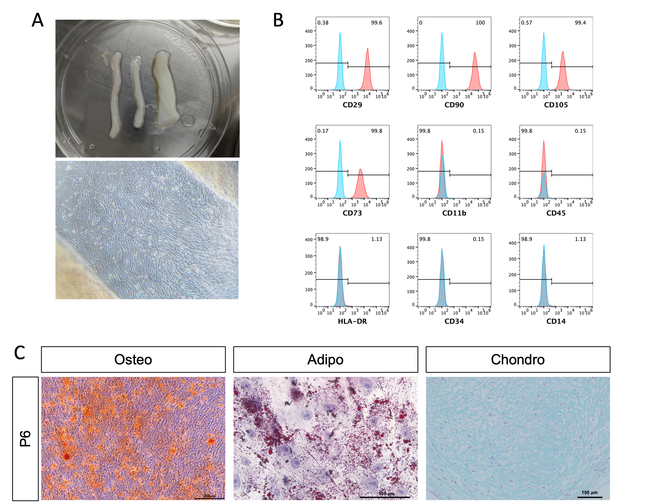
Figure S2. Isolation, culture, and characterisation of MSCs. (A) Primary MSCs migrating from the explanted Wharton's jelly of human umbilical cord tissue under adherent culture conditions. Scale bar shows 100 μm. (B) Flow cytometric analysis of surface markers in passage 6 MSCs. Positive markers: CD29 (99.6%), CD90 (100%), CD105 (99.4%), CD73 (99.8%); negative markers: CD11b (0.15%), CD45 (0.15%), HLA-DR (1.13%), CD34 (0.15%), CD14 (1.13%). (C) Tri-lineage differentiation of MSCs at passage 6 after induction for the indicated durations (C), scale bars show 200 μm (Osteo) and 100 μm (Adipo and Chondro).

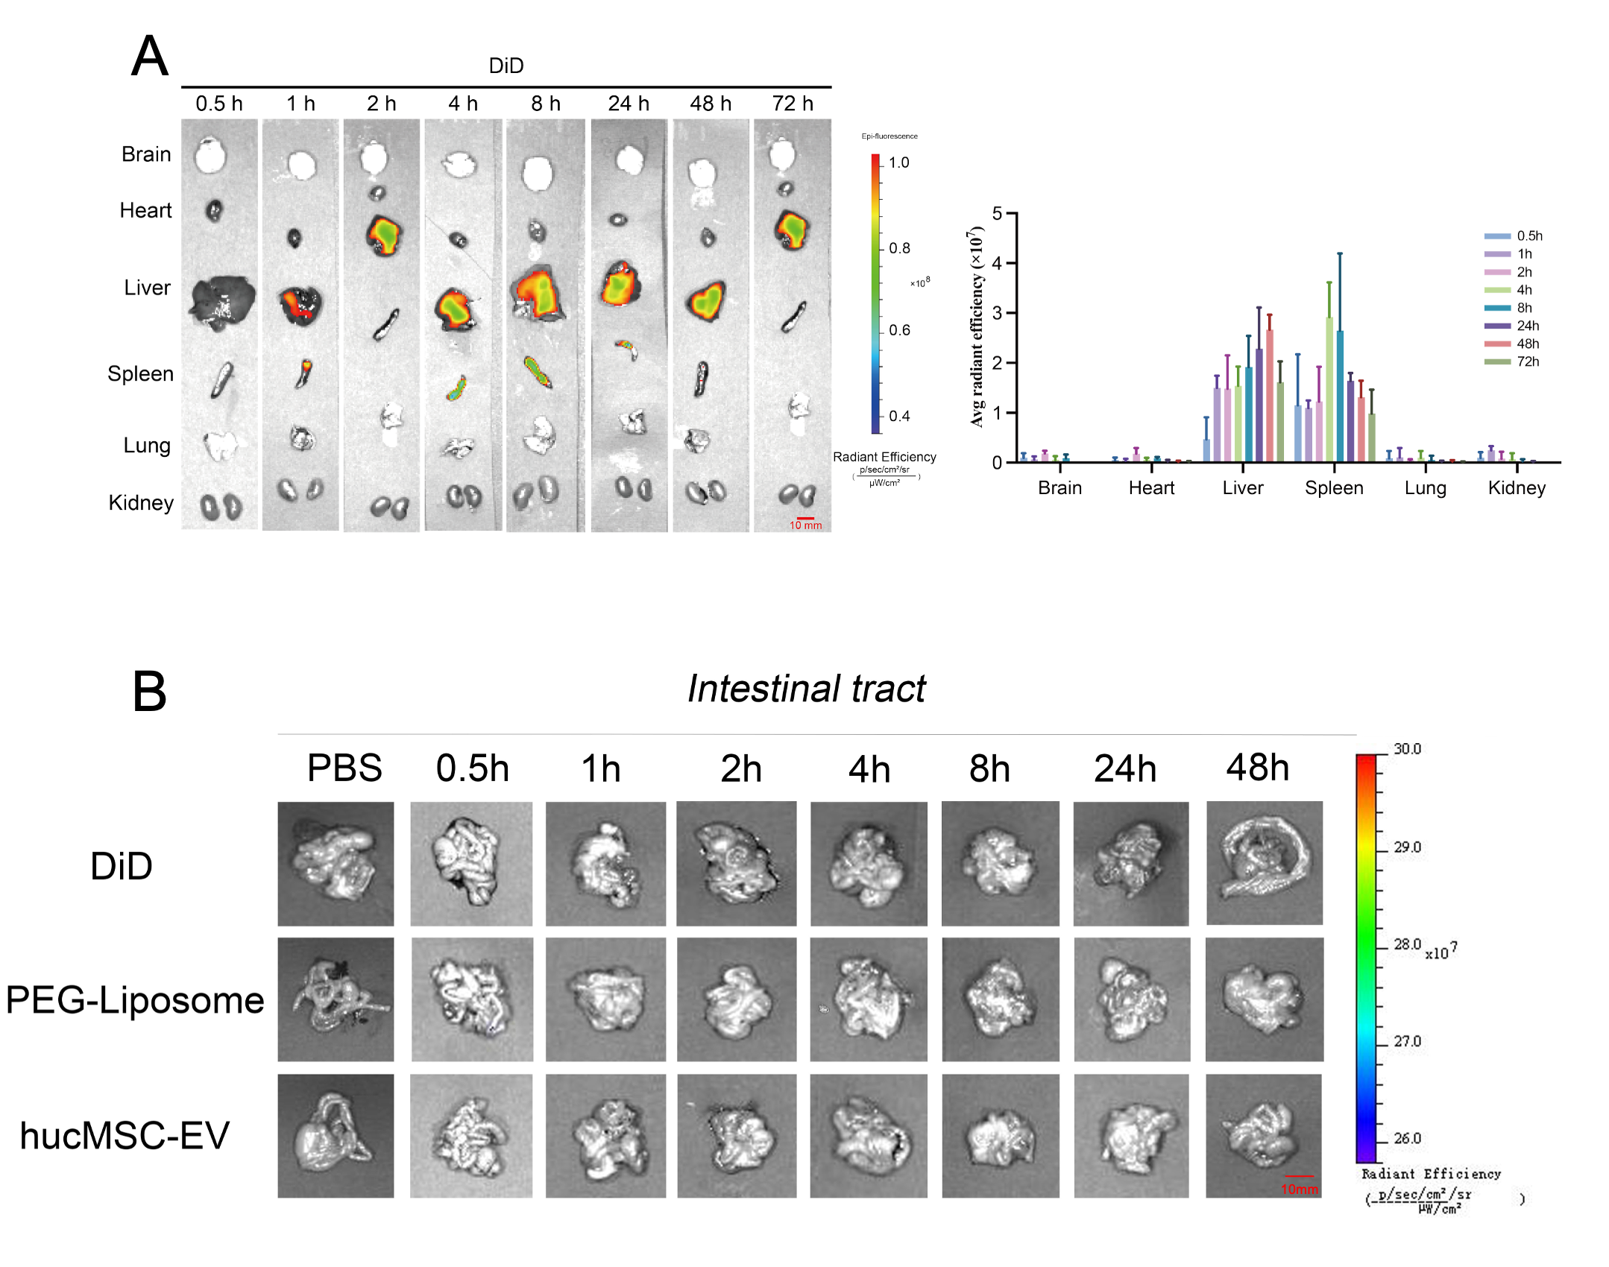
Figure S3. Fluorescence distribution imaging in the DiD group and the imaging of the gastrointestinal tract organs. (A) Fluorescence distribution imaging and fluorescence intensity analysis of each organ in the DiD group. Scale bar shows 10 mm, n = 4. (B) Fluorescence distribution imaging of the gastrointestinal tract organs in the DiD-labelled PEG-Liposome group and DiD-labelled hucMSC-Exo group. Scale bar shows 10 mm. Data are expressed as the mean ± SD.

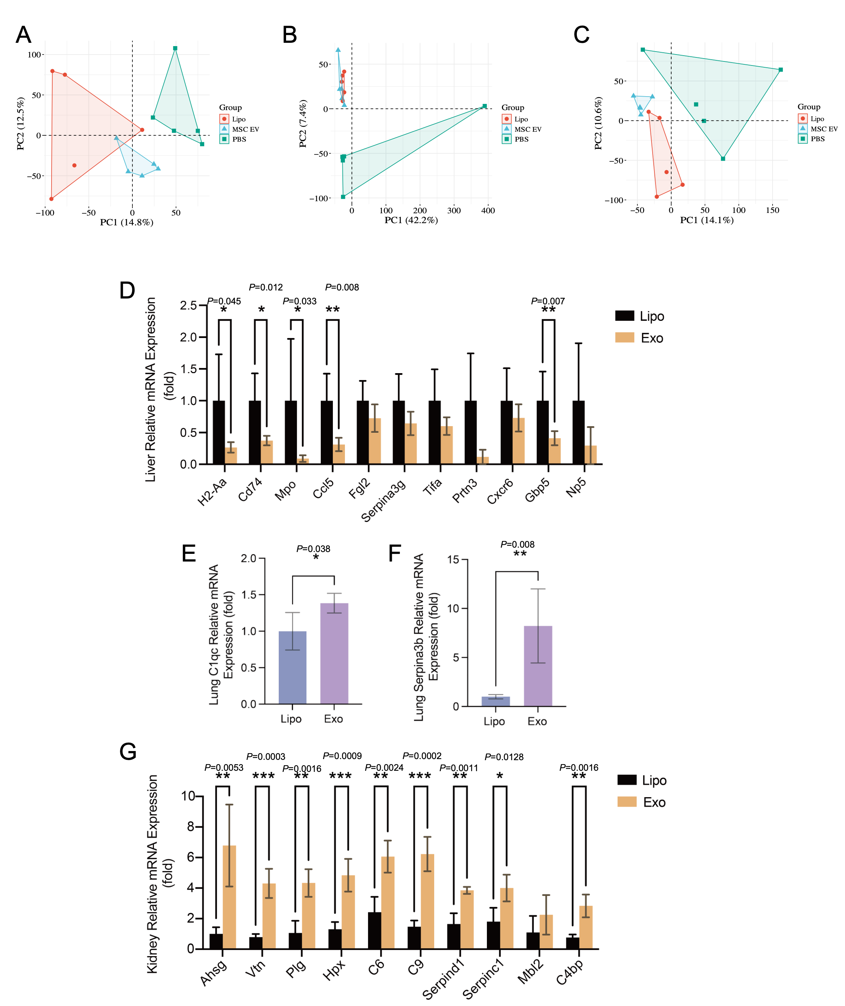
Figure S4. PCA plot performed on each group. The PCA plot shows the distribution of liver (A), lung (B), and kidney (C) samples in a reduced-dimensional space, where each data point represents an observation in the dataset. The X and Y axes of the plot represent the first two principal components, which capture the maximum variability in the data. The blue, red, and green colours, respectively, represent PEG-Liposomes, hucMSC-Exos, and PBS. (D) mRNA expression of H2-Aa, Cd74, MPO, Ccl5, Fgl2, Serpina3g, Tifa, Prtn3, Cxcr6, Gbp5, and Np5 by RT-qPCR in liver tissues of the PEG-Liposome group and hucMSC-Exo group. n = 4. (E, F) mRNA expression of C1qc (E) and Serpina3b (F) in lung tissues of PEG-Liposome group and hucMSC-Exo group. n = 4. (unpaired Student’s t test). (G) mRNA expression of Ahsg, Vtn, Plg, Hpx, C6, C9, Serpinad1, Serpinc1, Mbl2 and C4bp by RT-qPCR in kidney tissues of the PEG-Liposome group and hucMSC-Exo group. n = 4. Data are expressed as the mean ± SD. Statistical analysis was performed using unpaired Student’s t test *p< 0.05, **p< 0.01, *** p< 0.001, **** p< 0.0001.

