Supporting information for

Regenerative potential of extracellular vesicles from endometrial mesenchymal stem cells for modulating fibrosis and wound healing

Fang-Yu Lin^{1,2}, Xiao-Tong Tan², Chih-Ming Pan², Chien-Chu Huang^{5,6,7}, Wan-Ling Chiang², Che-Kai Chang², Wu-Chou Lin^{5,6}, Chiung-Yi Yeh^{1,5,6}, Yu-Chuan Lin², Ting-Hsun Lin², Der-Yang Cho^{1,2,3,4}, and Shao-Chih Chiu^{1,2,3}

¹Graduate Institute of Biomedical Sciences, China Medical University, Taichung, Taiwan, R.O.C.;
²Translational Cell Therapy Center, China Medical University Hospital, Taichung, Taiwan, R.O.C.;
³Drug Development Center, China Medical University, Taichung, Taiwan, R.O.C.;
⁴Department of Neurosurgery, China Medical University Hospital, Taichung, Taiwan, R.O.C.;
⁵Department of Obstetrics and Gynecology, China Medical University Hospital, Taichung, Taiwan, R.O.C.
⁶Department of Medicine, School of Medicine, China Medical University Hospital, Taichung, Taiwan, R.O.C.
⁷Center for immune-Oncology, National Cancer Institute, National Institutes of Health, Bethesda, MD, U.S.A.

Fang-Yu Lin, Xiao-Tong Tan and Chih-Ming Pan contributed equally to this work

Correspondence to:
Shao-Chih Chiu (s-cchiu@outlook.com) and Der-Yang Cho (dycho@tool.caaumed.org.tw)

Supporting figures

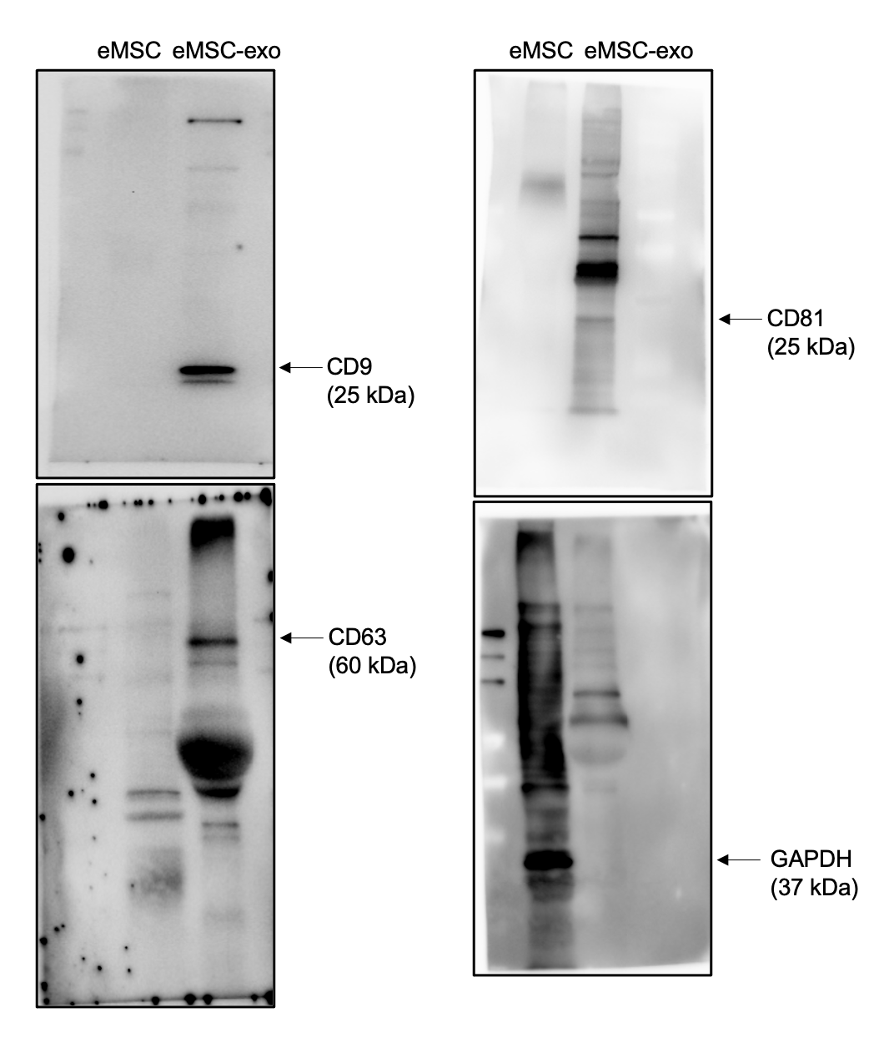

Supplementary figure 1. Full-length blots.
Full length blots of Figure 1F.

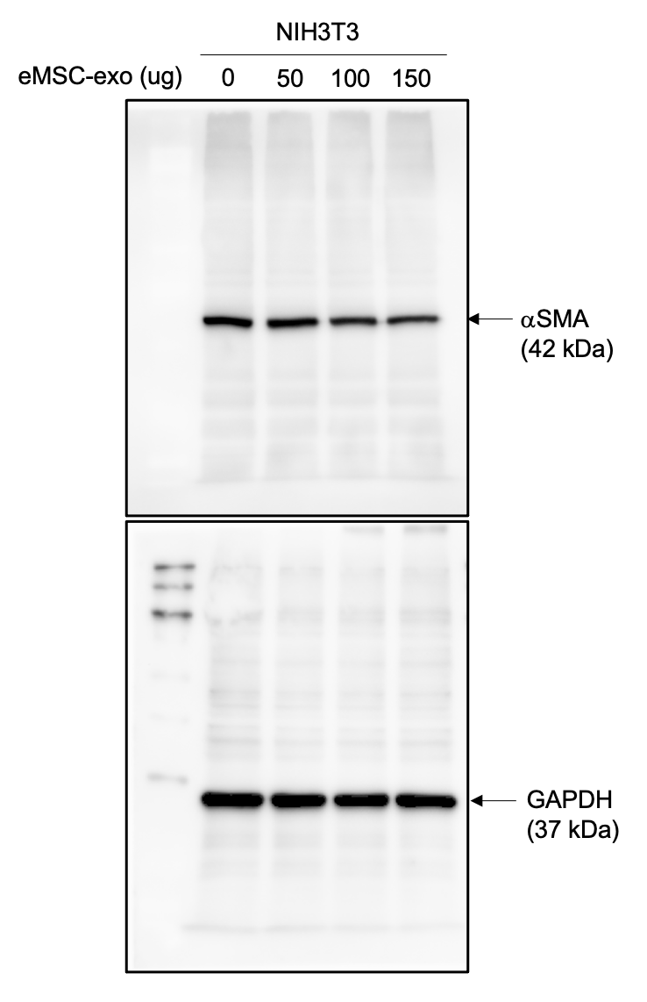

Supplementary figure 2. Full-length blots.
Full length blots of Figure 5A.

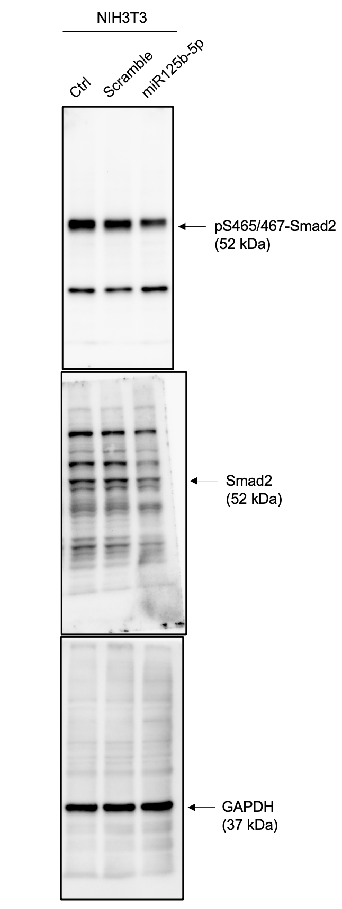

Supplementary figure 3. Full-length blots.
Full length blots of Figure 6C.
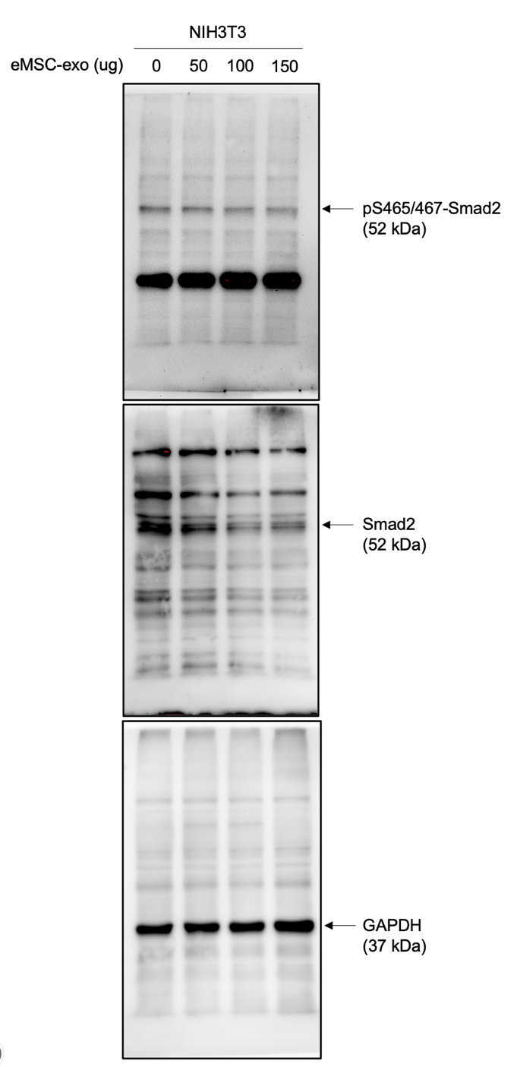

Supplementary figure 4. Full-length blots.
Full length blots of Figure 6E.

