Appendix

Manufacturer information of materials
Name | Manufacturer information
α-Minimum essential medium | Thermo Fisher Scientific Inc., Waltham, MA, USA
Alizarin Red | Alfa Aesar, Ward Hill, MA, USA
cDNA synthesis kit | iScript-cDNA Synthesis Kit; Bio-Rad Laboratories Inc., Hercules, CA, USA
Cell and tissue staining kit | Super Sensitive™ Polymer-HRP Detection Kit; Bio-Genex Laboratories, Fremont, CA, USA
CCK8 assay | Cell Counting Kit-8; Dojindo Laboratories, Japan
DAPI | 4',6-diamidino-2-phenylindole; Abcam Inc., Waltham, MA, USA
Dexamethasone | Standard Chem & Pharm Co., Ltd., Tainan City, Taiwan
FcR blocker | Innovex, Lincoln, RI, USA
Fetal bovine serum | Thermo Fisher Scientific Co., Waltham, MA, USA
Formaldehyde | Merck KGaA, Darmstadt, Germany
Master Mix | Thermo Fisher Scientific Co., Waltham, MA, USA
Oil Red O | Alfa Aesar, Ward Hill, MA, USA
PEDOT:PSS | Clevios™ PH1000, Heraeus Epurio GmbH, Germany
Penicillin–streptomycin | Thermo Fisher Scientific Co., Waltham, MA, USA
Polyclonal antibody for BSP | Thermo Fisher Scientific Co., Waltham, MA, USA
Monoclonal antibody for CD31 | Abcam Limited, Cambridge, UK
Polyclonal antibody for K-10 | Thermo Fisher Scientific Co., Waltham, MA, USA
RNA isolation kit | RNeasy Mini Kit; QIAGEN GmbH, Hilden, Germany
RUNX2 | RUNX family transcription factor 2; Abcam Inc., Waltham, MA, USA
Sodium hydroxide | Honeywell Research Chemicals, Charlotte, NC, USA
Sprague-Dawley rat | BioLASCO Taiwan Co. Ltd., Taipei, Taiwan
Titanium mesh | Huang-Liang Biomed Tech Co. Ltd., Kaohsiung, Taiwan
Thumbtack screws | Huang-Liang Biomed Tech Co. Ltd., Kaohsiung, Taiwan
Xylazine | Rompun 20; Bayer Animal Health, Monheim, Germany
Zolazepam-tiletamine | Zoletil 50; Virbac, Cedex, France
*Materials not listed in the table were all from Sigma-Aldrich, St Louis, MO, USA.

Manufacturer information of equipment
Name | Manufacturer information
Confocal microscope | LSM880; Carl Zeiss Microscopy GmbH, Munich, Germany
Confocal Raman microscope | In Via; Renishaw plc., Gloucestershire, United Kingdom
DC power generator | Good Will Instrument Co., Ltd., New Taipei, Taiwan
Digital imaging system | AxioCam ICc5; Carl Zeiss Microscopy GmbH, Munich, Germany
ELISA reader | Biotek Synergy^{HT} microplate reader; Agilent Technologies Inc., Santa Clara, CA, USA
Flow cytometer | BD LSRFortessa™, BD Biosciences, San Jose, CA, USA
Flow cytometry analytical software | BD FACSDiva™ Software, BD Biosciences, San Jose, CA, USA
Image analysis software | ImagePro Plus 7.0
ImageJ | NIH, Bethesda, MA, USA
Light microscope (in vitro experiments) | CKX41; Olympus Co., Tokyo, Japan
Light microscope (in vivo experiments) | Leica DM500; Leica Microsystems, Wetzlar, Germany
Mechanical tester | TA.XTplusC Texture Analyser, Stable Micro Systems Ltd., Surrey, United Kingdom
Micro-CT image analysis softwares | CTAn, CTVol, and NRecon; Bruker Corp., Kontich, Belgium
Micro-CT scanner | SkyScan1176; Bruker Corp., Kontich, Belgium
Multimeter | Keithley 2100, Tektronix, USA
Real-time PCR system | StepOnePlus; Thermo Fisher Scientific Co., Waltham, MA, USA
SEM | Nova NanoSEM 230, Thermo Fisher Scientific
Statistical software | GraphPad Prism®; GraphPad Software Inc., San Diego, CA, USA
UV machine | UT-500UV, Univex, Taiwan
UV-Vis spectrophotometer | Cary 300nc; Agilent Technologies, USA

The information of the antibodies, isotype controls and markers of flow cytometry.
Antibody | Secondary antibody | Fluorophore | Catalog No.
Surface markers
anti-rat CD73 | anti-mouse (2Ab) for CD73 | BV421 | 551123 & 563846
anti-rat CD90 |  | PE | 551401
anti-rat CD45 |  | PE-Cy7 | 561588
anti-rat CD11b |  | APC | 562102
anti-rat RT1A |  | BV421 | 744855
Anti-rat RT1B |  | Alexa Fluor® 647 | 562223
Isotype antibody
iso CD73 | anti-mouse (2Ab) for CD73 | BV421 | 557273 & 563846
iso CD90 |  | PE | 550617
iso CD45 |  | PE-Cy7 | 557872
iso CD11b |  | APC | 562140
iso RT1A |  | BV421 | 562603
iso RT1B |  | Alexa Fluor® 647 | 557714
Viability marker
7-Aminoactinomycin D |  | 7-AAD | 559925
*All products mentioned in the table were purchased from BD Biosciences.

Formulations of medium
Medium | Formulation
Growth medium | DMEM supplemented with 10% FBS, 1% penicillin/streptomycin, and 1 ng/ml fibroblast growth factor-2
Adipoinductive medium | DMEM supplemented with 10% FBS, 1% penicillin/streptomycin, 500 µM 3-isobutyl-1-methylxanthine, 1 µM dexamethasone, 10 µM insulin and 200 µM indomethacin
Chondroinductive medium | DMEM supplemented 1% FBS, 1% PSA, 10 ng mL⁻¹ transforming growth factor beta-1, 50 mM L-ascorbic acid-2-phosphate and 6.25 mg mL⁻¹ insulin
Osteoinductive medium | DMEM supplemented with 10% FBS, 1% penicillinestreptomycin,10 nM dexamethasone, 50 µM ascorbic acid 2-phosphate, and 10 µM β-glycerophosphate

The conditions of realtime PCR
cDNA mixed with the Taqman probes and Master Mix to achieve a volume of 30 μl, and realtime PCR was performed using a realtime PCR system under the following conditions: hot-start enzyme activation at 95 °C for 3 minutes, followed by 40 cycles of denaturation at 95 °C for 10 seconds and 60°C for 40 seconds.

The sequence information of PCR primers
 | Forward sequence | Reverse sequence
COLA1 | 5’-TGTTCGTGGTTCTCAGGGTAG-3’ | 5’-ACTGGTACATCAGTGGTGCAG-3’
RUNX2 | 5’-CTTCACAAATCCTCCCCAAG-3’ | 5’-TGCTTGAAGGTGCTGAGTGA-3’
ALP | 5’-ATGGGATGGGTGTCTCCACA-3’ | 5’-CCACGAAGGGGAACTTGTC-3’
OCN | 5’-CACTCCTCGCCCTATTGGC-3’ | 5’-CCCTCCTGCTTGGACACAAAG-3’

The protocol of the immunohistochemical staining
The immunohistochemical staining was performed using a cell and tissue staining kit following the manufacturer’s instruction. In brief, antigens and epitopes were unmasked by incubation with 0.05% trypsin/EDTA for 20 minutes at room temperature. To eliminate endogenous peroxidase activity, the sections were immersed in 3% H₂O₂ for 10 minutes. After blocking of non-specific binding with serum, the sections were incubated overnight at 4°C with the rabbit polyclonal anti-BSP (1:200 dilution), rabbit monoclonal anti-CD31 (1:200 dilution), or rabbit polyclonal anti-K-10 (1:200 dilution). The sections were subsequently incubated with the corresponding biotinylated secondary antibodies for 1 hour at room temperature. The color was developed by 3,3-diaminobenzidine, and sections were counterstained with hematoxylin.

The outcome of gross observation on specimens for the preliminary assessment (n=3/treatment/time point; data is presented as mean±standard deviation).
 | Day 4 |  |  | Day 7 |  |  | Day 14
 | Wound size (cm²) | Feret’s diameter (cm) | Wound size (cm²) |  | Feret’s diameter (cm) | Wound size (cm²) |  | Feret’s diameter (cm)
Untreated control | 2.40±0.08 | 1.89±0.02 | 1.38±0.35 |  | 1.45±0.19 | 0.53±0.17 |  | 1.04±0.19
GelMA alone | 2.42±0.19 | 1.97±0.05 | 1.33±0.12 |  | 1.56±0.06 | 0.51±0.06 |  | 1.00±0.05
GelMA with ES | 2.49±0.17 | 2.00±0.08 | 1.43±0.25 |  | 1.57±0.21 | 0.51±0.12 |  | 1.16±0.24
GelMA-rADSCs | 2.37±0.25 | 1.93±0.09 | 1.12±0.22 |  | 1.36±0.24 | 0.43±0.16 |  | 1.08±0.32
GelMA-rADSCs with ES | 2.47±0.14 | 1.99±0.06 | 1.14±0.23 |  | 1.39±0.16 | 0.49±0.10 |  | 1.05±0.07
GelMA/PEDOT:PSS-rADSCs with ES | 2.45±0.12 | 1.97±0.07 | 1.08±0.19 |  | 1.34±0.20 | 0.47±0.07 |  | 1.03±0.11
As the GelMA alone GelMA with ES groups showed similar progress of wound size and Feret’s diameter reduction as the untreated control group, to reduce the number of animal use, the untreated control (Con), GelMA-rADSCs (GM-SC), GelMA-rADSCs with ES (GM-SE), andGelMA/PEDOT:PSS-rADSCs with ES (PG-SE) groups were chosen to investigate the promotive effect of rADSCs and ES in this study.

The exact sample size of in vivo assessments
Due to technical failure, 0-2 specimens in each group were lost and were not included in the statistical analysis. Hence, the exact sample size of each in vivo assessment was reported in below table.
Parameters | Con | GM-SC | GM-SE | PG-SE
Wound area | 7 | 6 | 7 | 6
Feret’s diameter | 7 | 6 | 7 | 6
Collagen/muscle ratio | 7 | 6 | 7 | 6
Distance of K10 edges | 7 | 6 | 7 | 6
Density of microvessels | 6 | 5 | 5 | 5
New bone area | 6 | 5 | 6 | 5

Appendix Figure 1. (A) Flowchart of hydrogel manufacture. (B) Timeline of the animal study. (C) Wound healing model. Cutaneous wounds were created bilaterally on the back of each rat (upper panel), and ES was transmitted across the wounds using copper foil (lower panel). (D) Osteogenesis model. Two suprabony regenerative spaces were created using a molded titanium mesh fixed on the calvaria of a rat (upper panel), and ES was transmitted by connecting to the titanium screws at both ends (lower panel).
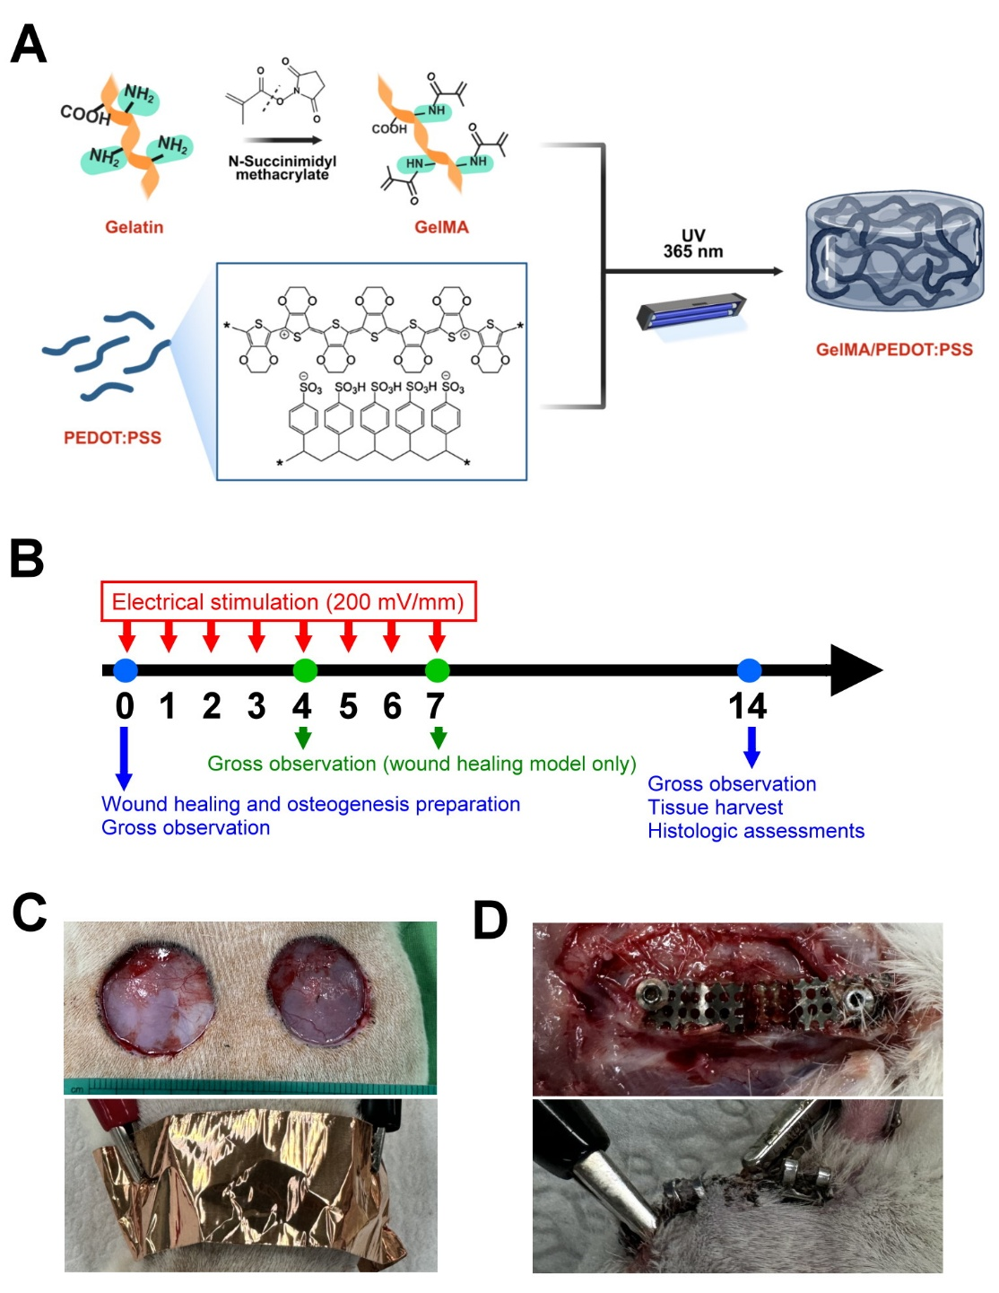
Appendix Figure 2. The representative histologic sections of the wound healing model with Masson’s trichrome staining on day 4. Due to large wound dimension (20 mm width), the areas of wound peripheries and center are chosen to show. The arrows indicate the edge of the cutaneous wound. (magnification: 49x; scale bar: 1 mm).
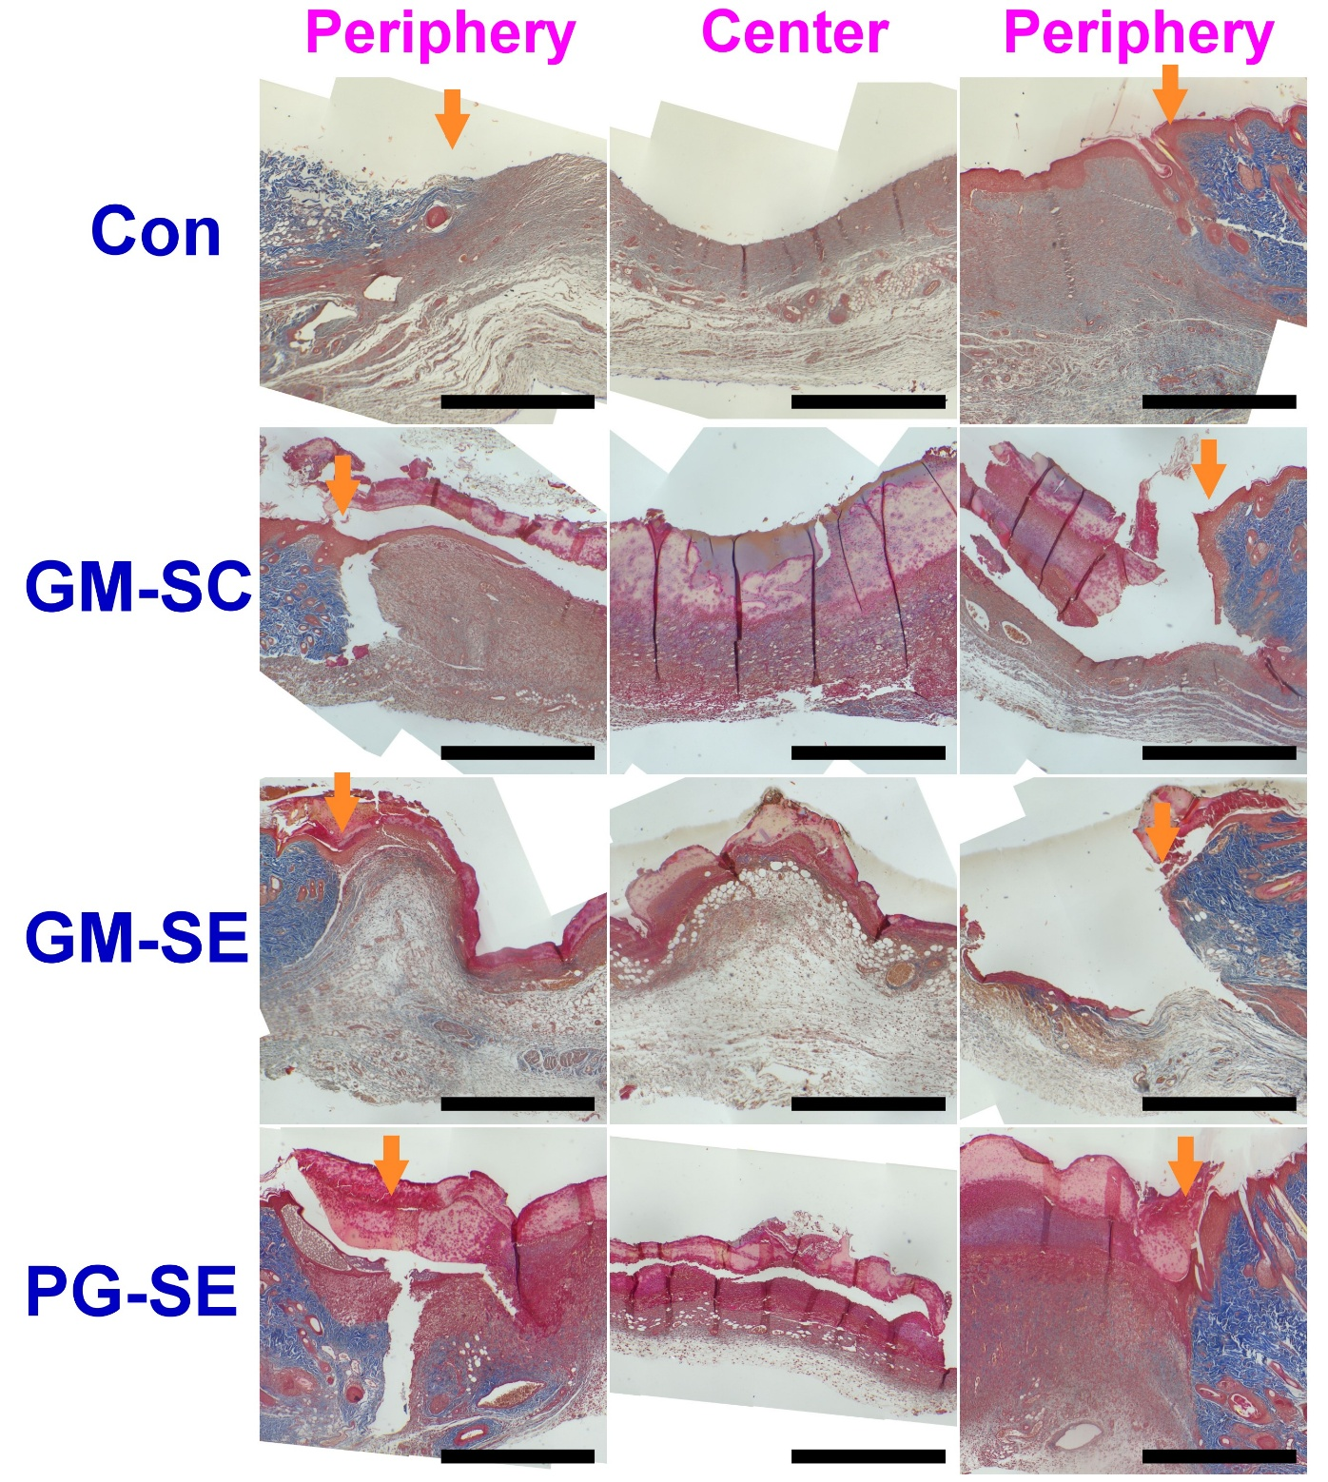

Appendix Figure 3. The representative histologic sections of the suprabony osteogenesis model with hematoxylin and eosin staining on day 4. The arrows indicate the edge of the suprabony housing bounded by a titanium mesh. (magnification: 49x; scale bar: 1 mm).
