Supplementary 2: Sorting efficiency of magnetic-activated cell sorting (MACS) and in vitro osteogenic and chondrogenic differentiation.
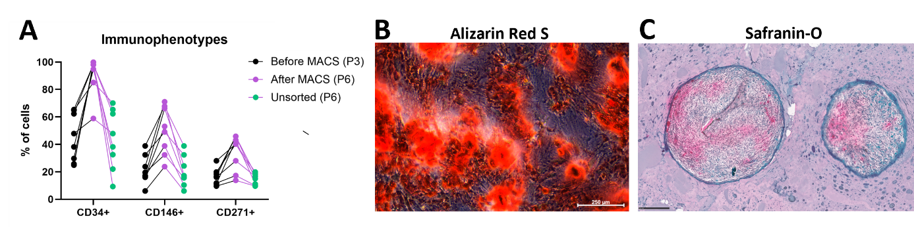
(A) MFAT-derived stem cell immunophenotype in percentages before and after MACS with lines connecting paired samples. Graph shows MFAT-derived stem cells positive for CD34, CD146, and CD271 on their cell surface before MACS (passage 3, P3), after MACS (passage 6, P6) and in unsorted MFAT-derived stem cells (P6). (B) Representative image showing osteogenic differentiation capacity of the enriched stem cells with calcium deposits visualized using Alizarin Red S staining. Image is taken at 10x magnification and size bar shows 250 µm. (C) Representative image showing chondrogenic differentiation capacity of the enriched stem cells evidenced by red/pink proteoglycan depositions in the pellets visualized by Safranin-O staining. Image is taken at 15x magnification and size bar shows 250 µm. *Flow cytometric gating strategy and full MACS and differentiation data are as previously reported by us [1].

References
1. Bagge J, Mahmood H, Janes J, Vomstein K, Blønd L, Hölmich LR, et al. Chondrogenic and Osteogenic In Vitro Differentiation Performance of Unsorted and Sorted CD34 + , CD146 + , and CD271 + Stem Cells Derived from Microfragmented Adipose Tissue of Patients with Knee Osteoarthritis. J Clin Med. 2025;14.

