Additional file 2. Progeny genotyping protocols relating to Additional file 1.

- Gonadal sex and FCG PCR
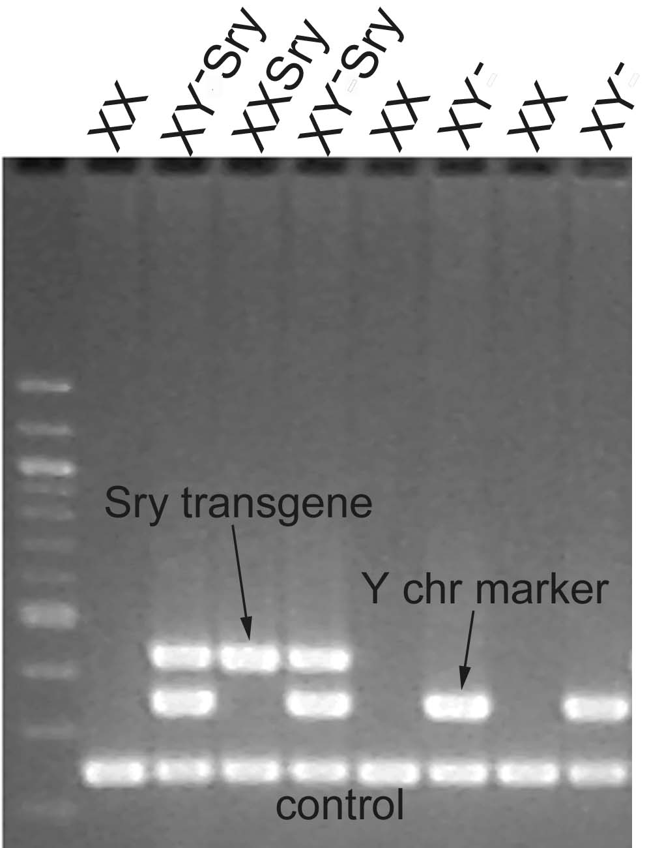
The first step for each cross is to assess the gonadal sex. Trained staff can determine this by examination of the anogenital distance soon after birth. For males, important further information can be gained from assessing testis size and fertility status (see the extensive literature relating to FCG mice). However, there is a reliable gonadal sex PCR that is applicable to all the crosses in Additional file 1. This utilizes PCRs for multiple Ssty copies on the Y chromosome long arm, the testis-determining gene Sry, and Myog (on chromosome 1) as a control (Additional Figure 1). In, for example, for the cross XX x XY*, the PCR for the Y chromosome marker Ssty is sufficient to identify gonadal males. However, in crosses involving the FCG Y⁻ that lacks Sry, it is necessary to also include Sry primers to detect the autosomally located Sry transgene. In practice it will be easiest to always run the triplex PCR, but bear in mind that the multiple copy Sry transgene in FCG males gives a much stronger band than endogenous Sry (see Figure 1 in [51]). This PCR utilizes the following conditions: 95ºC for 4 min, followed by 35 cycles of 94ºC for 45 sec, 58ºC for 30 sec and 72ºC for 1 min, with a final extension at 72ºC for 5 min.

Additional Figure 1. Gel image of products from triplex genomic PCR to distringuish genotypes of the Four Core Genotypes. The three bands correspond to the Sry transgene (which determines male gonadal sex), the Y chromosome marker to detect presence of the Y chromosome, and myogenin autosomal gene which check that the PCR reaction worked. Size ladder is 100bp.

List of primers
Gene | Primer ID | Primer sequence | Amplicon  size
Ssty | Ssty-F | CTGGAGCTCTACAGTGATGA | 342bp
Ssty | Ssty-R | CAGTTACCAATCAACACATCAC | 342bp
Sry | Sry-F | AGCCCTACAGCCACATGATA | 420bp
Sry | Sry-R | GTCTTGCCTGTATGTGATGG | 420bp
Myog | Om1a¹ | TTACGTCCATCGTGGACAGCAT | 246bp
Myog | Om1b¹ | TGGGCTGGGTGTTAGTCTTAT | 246bp
¹The Myogenin PCR using Om1 primers (see [110]) is a positive control that the PCR worked.

- NPX qPCR
The second step is to identify the NPX dosage. The quantitative real time genomic PCR (qPCR) presented here is designed to distinguish between NPX dosage and the dosage of the minute NPX+ segment present in the Y* and Y*^{X} chromosomes (Additional Figure 2).
In order to discriminate between the different genotypes, a qPCR test has been developed using two X-linked genes: Prdx4, present only on the X chromosome, and Amelx located very close to the pseudo-autosomal region and thus present on the X, Y* and Y*^{X} chromosomes. An autosomal gene Myogenin (Myog, chromosome 1) is used for normalization of each Prdxa and Amelx PCR. The primers used are listed below.

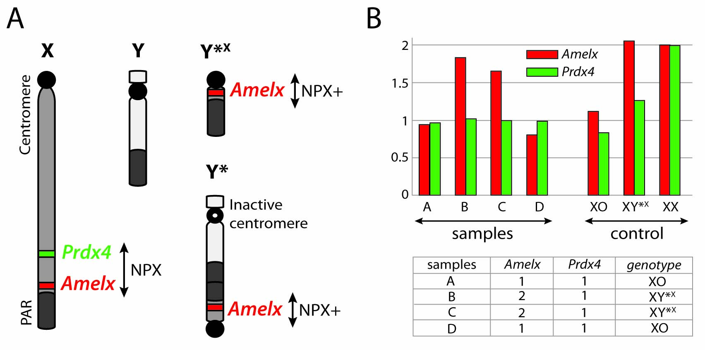
Additional Figure 2. Illustration of quantitative genomic PCR to distinguish between NPX dosage and dosage of the minute + segment of NPX (see Figure 3 and Table 3). A. The chromosomal diagrams show the location of the NPX gene Pdrx4 and NPX+ segment gene Amelx. B. An example of an experimental outcome showing expression levels of the two genes in progeny of XY* fathers. An autosomal gene Myogenin (Myog, chromosome 1) is used for normalization of each Prdxa and Amelx PCR (not shown).
List of primers
Gene | Primer ID | Primer sequence | Amplicon  size
Prdx4 | Prdx4-F | CATGATATCCACTGAAAGCTAC | 82bp
Prdx4 | Prdx4-R | GAGACAGTGTATCTATCCCTG | 82bp
Amelx | Amelx-F | GTTGGGTTGGAGTCATGGAG | 162bp
Amelx | Amelx-R | GGCTGCACCACCAAATCATC | 162bp
Myog¹ | Om1a² | TTACGTCCATCGTGGACAGCAT | 246bp
Myog¹ | Om1b² | TGGGCTGGGTGTTAGTCTTAT | 246bp
¹Atr is an alternative that is claimed to be superior for normalization (see [74]). ²See [110])

The genomic DNA can be prepared from as little tissue as an ear biopsy. We recommend DNA extraction to be followed by a purification step using, for instance, a phenol/chloroform protocol. The qPCR is performed according to the manufacturer’s instructions (see for example qPCR reagents SensiMix SYBR Lo-Rox as used by [73], or Power SYBR Green PCR Master Mix [74]). All reactions should be carried out in triplicate per assay and Myog included on every plate for normalization. We recommend using XY (1NPX) as the reference control, and known XY* (1NPX, 1NPX+), and XX (2NPX) samples in order to monitor the quality of your qPCR. A qPCR from a study that required XO and XY*^{X} mice [73] is shown in Additional Figure 2. A more relevant recent study provides a detailed protocol that was designed to identify a wider range of genotypes including XXY*^{X} [74]. This study utilized Atr on chromosome 9 for normalization rather than Myog.
The formula used to analyze raw data is a classic 2^(-ΔΔCT) [111]. Briefly, for each sample, the mean Ct for Myog is subtracted from the mean Ct for Prdx4 or Amelx (ΔCT). Then the ΔCT of the reference DNA is subtracted from the ΔCT of samples (ΔΔCT). The formula 2^(- ΔΔCT) will then give an approximate copy number between 1 and 2. The copy number of the reference DNA will arbitrarily be set at 1. If the reference DNA is XX, we recommend multiplying the 2^(- ΔΔCT) by 2 in order to help data interpretation. Based on previous experience, data between 0.6 and 1.2 are considered 1 copy, and data between 1.6 and 2.2 are considered 2. To better distinguish between XY*^{X} and XXY*^{X} it would be possible to use fluorescent in situ hybridization (FISH) to count number of X chromosomes in interphase lymphocytes using the kit Kreatech KI-30505 RAB9B (XqF1). An alternative strategy would be to check for the Xist expression associated with two Xs (see [72]). The NPX qPCR can be utilized for all the progeny of the crosses listed in Additional file 1. The predicted NPX dosages are tabulated below including those for the recommended XY, XY* and XX controls.

Genotypes | Gonadal sex | Prdx4 copies  (NPX) | Amelx copies  (NPX and NPX+) | Myog copies  (Chromosome 1)
Controls
1,1,2 - XY | M | 1 | 1 | 2
1,2,2 - XY* | M | 1 | 2 | 2
2,2,2 - XX | F | 2 | 2 | 2
A: XX x XY*
[XO rare] | F | 1 | 1 | 2
XY*^{X} | F | 1 | 2 | 2
XX | F | 2 | 2 | 2
XY* | M | 1 | 2 | 2
XX^{Y*} | M | 2 | 2 | 2
C: XY*^{X} x XY
[XO rare] | F | 1 | 1 | 2
XY*^{X} | F | 1 | 2 | 2
XX | F | 2 | 2 | 2
XXY*^{X} | F | 2 | 3 | 2
D: XXY*^{X} x XY⁻Sry
XY⁻Sry | M | 1 | 1 | 2
XXSry | M | 2 | 2 | 2
XXY*^{X}Sry | M | 2 | 3 | 2
XY⁻Y*^{X}Sry | M | 1 | 2 | 2
B: XY⁻Y*^{X}Sry x XX
[XO rare] | M or F | 1 | 1 | 2
XY⁻ | M or F | 1 | 1 | 2
XY*^{X} | M or F | 1 | 2 | 2
XX | M or F | 2 | 2 | 2
XXY*^{X} | M of F | 2 | 3 | 2
XY⁻Y*^{X} | M or F | 1 | 2 | 2
XXY⁻ | M or F | 2 | 2 | 2

