Sex DNA methylation differences of B cell chronic lymphocytic leukemia

Table S1. Samples for RNA-Seq analysis and replication of DNA methylation.
Study | CLL Female | CLL Male | Control Female | Control Male
EGAD00010000254 | 51 | 88 | 6 | 8 | 450K DNA  methylation
EGAD00010000871 | 65 | 98 | 3 | 4 | 450K DNA  methylation
EGAD00001000258 | 29 | 58 | 0 | 0 | RNA-Seq
GSE66117 | 21 | 26 | 0 | 0 | RNA-Seq
GSE16921 | 0 | 0 | 17 | 24 | RNA-Seq

Table S2. CLL subgroups of this study classified by Querios et al.
 | U-CLL | I-CLL | M-CLL
CLL Female | 9 | 5 | 15
CLL Male | 7 | 3 | 9

Table S3. Normal B cells subtypes samples from Kulis et al.
 | CD19+ | CD5+ NBC | NBC | csMBC | ncsMBC
Female | 6 | 2 | 2 | 2 | 2
Male | 8 | 1 | 1 | 1 | 1

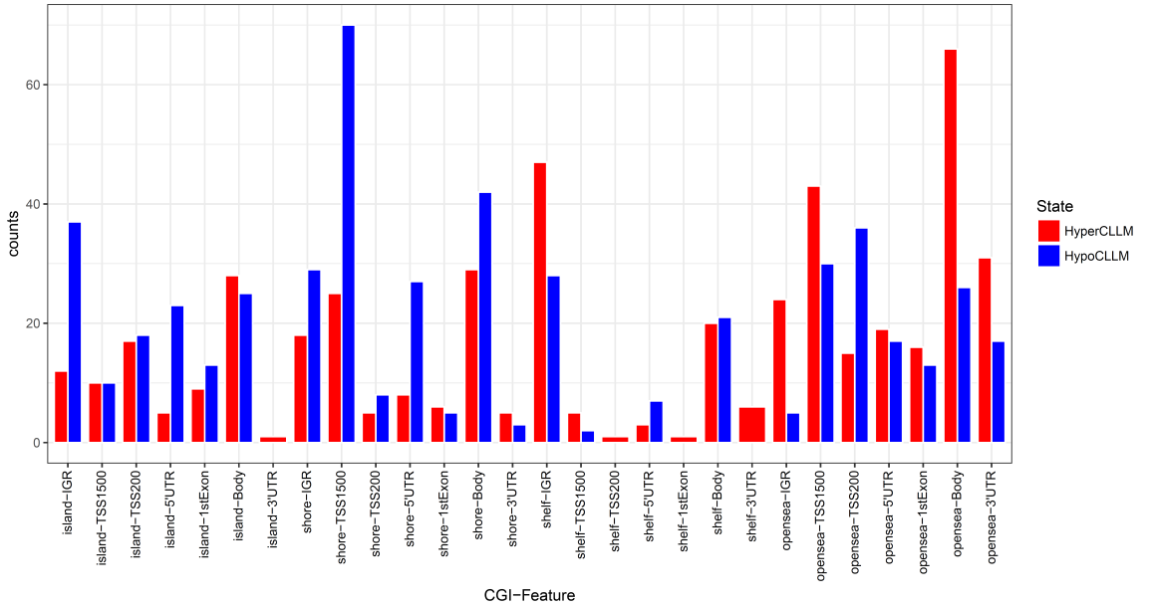
Figure S1. Sex-related X chromosomal DMPs stratified by gene features and CpG features.
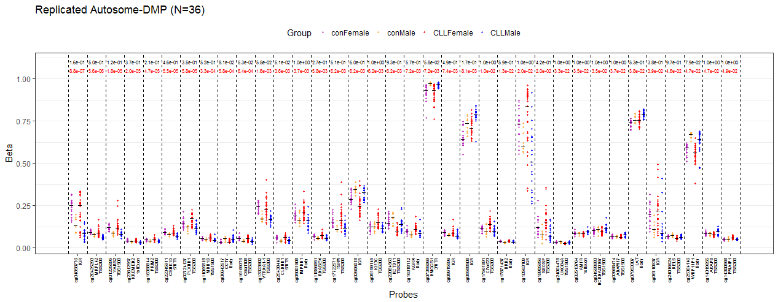
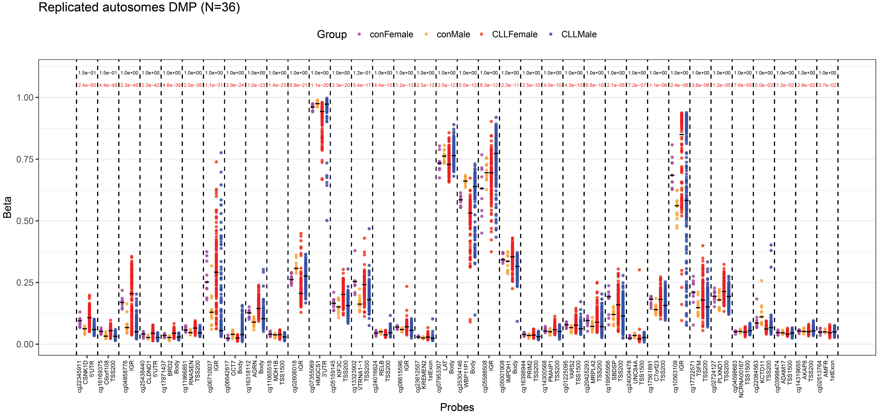

Figure S2a. Thirty-six replicated autosomal DMPs. Upper panel showed the 36 DMPs in our data; lower panel showed the 36 DMPs in EGA data. Black bar indicated medians β value. Q-values were listed at the top, controls were colored in black and CLL were in red.

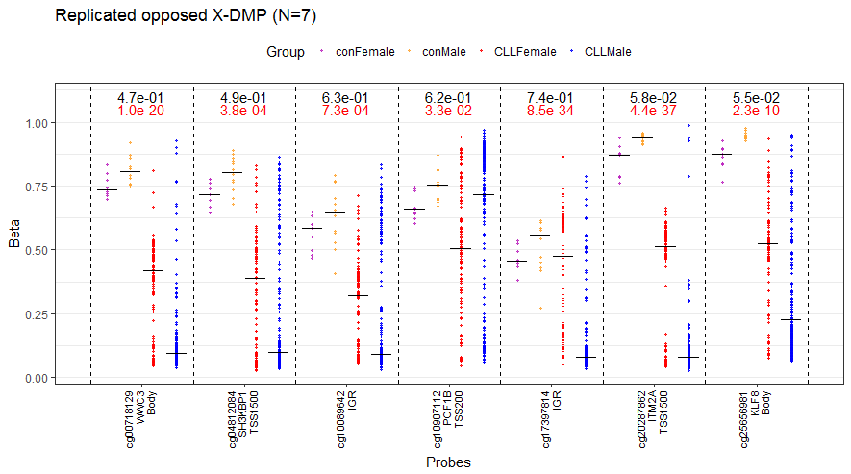
Figure S2b. The 7 X chromosomal DMPs of figure 2d in EGA data.

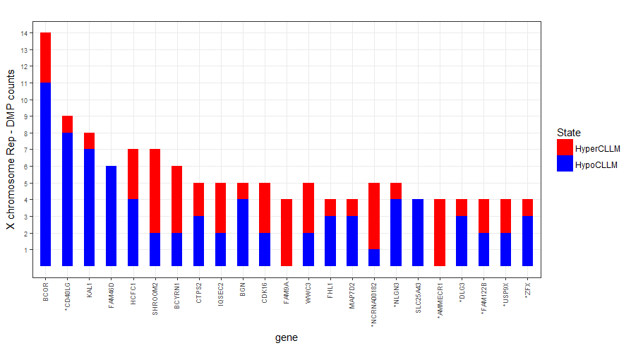
Figure S2c. Genes with numbers of X chromosomal DMPs >= 4 in EGA data. Numbers of DMPs were showed in y-axis. Genes of which all probes could be replicated were marked with “*”.
Figure S3a. CLL sex-related DEGs. By pooling the RNA-Seq data, we detected 94 significant genes between sex of CLL, and 54 significant genes between sex of controls, but no significant genes in the interaction term(Diff). The 83 (80+3) genes were considered as DEGs.

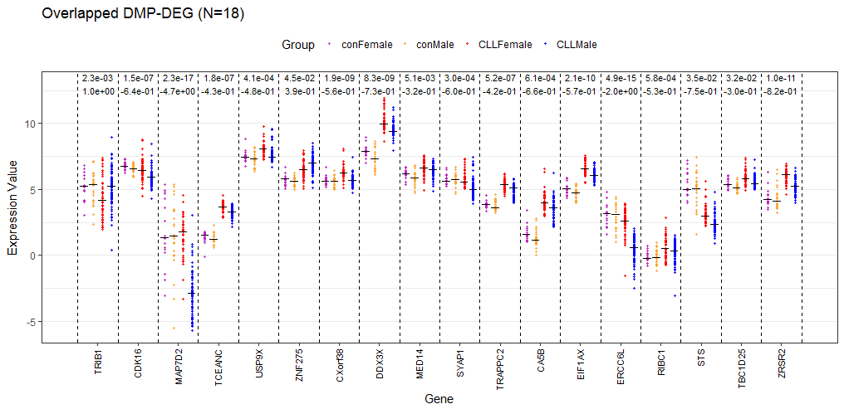
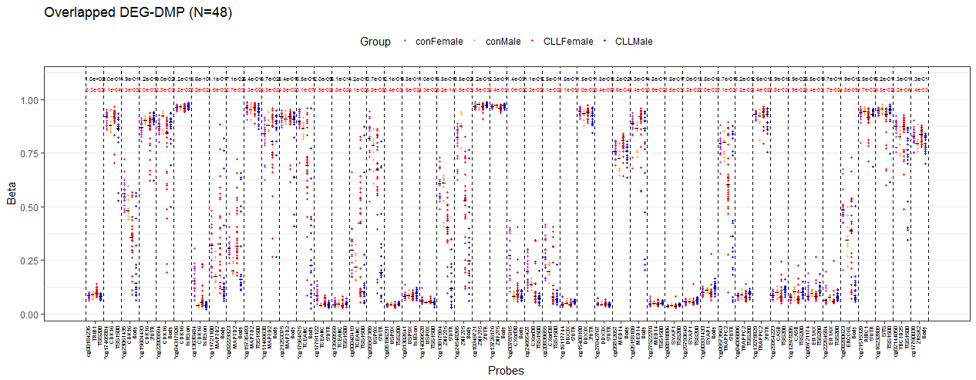
Figure S3b. The 18 DNAm-DEGs and their DMPs. Upper panel, 18 DEGs overlapped with DMPs covered genes. Q-value and log₂FG were showed in the top of each genes. Lower panel, the 48 DMPs overlapped with DEGs.

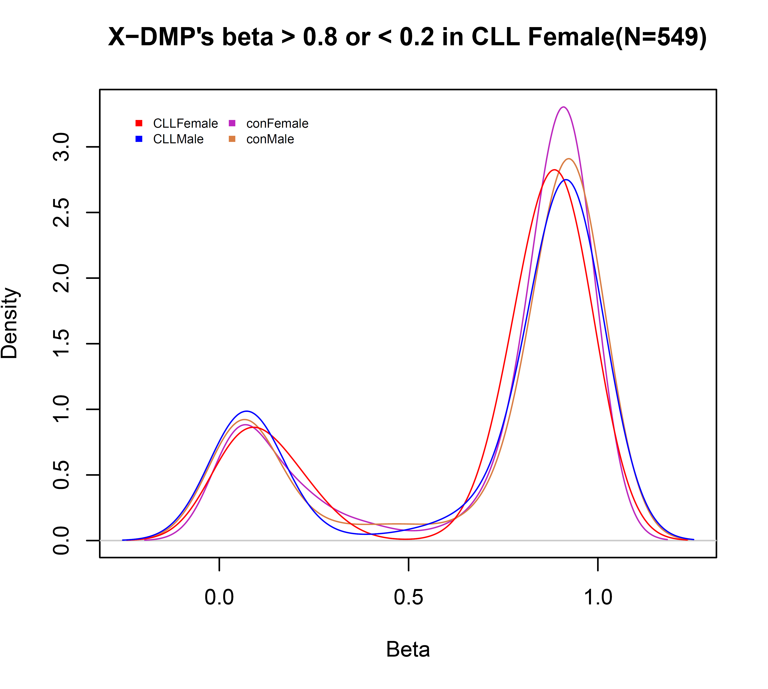
Figure S4a. There were 549 X chromosomal DMPs with median β < 0.2 or median β > 0.8 in CLL females. This figure showed the density of these DMPs’ mean β value.

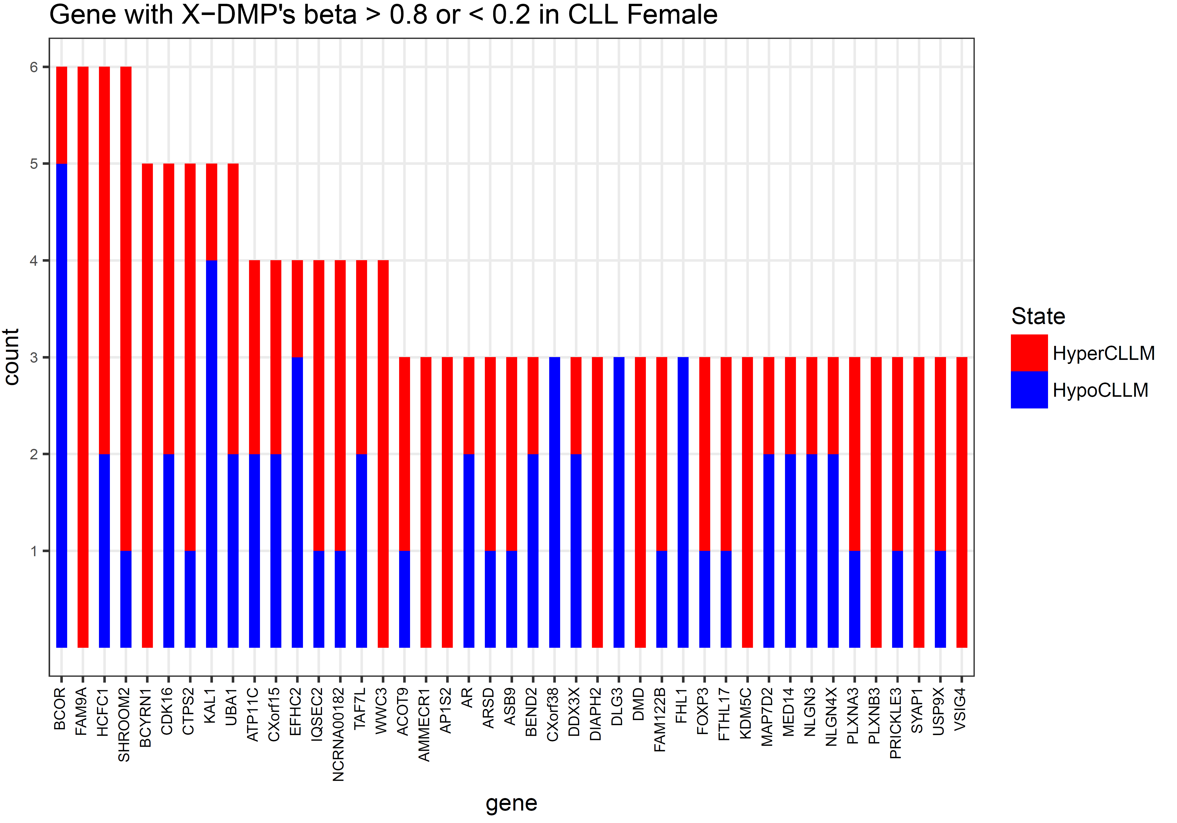
Figure S4b. Genes with at least 3 DMPs in Figure S4a (N=43).

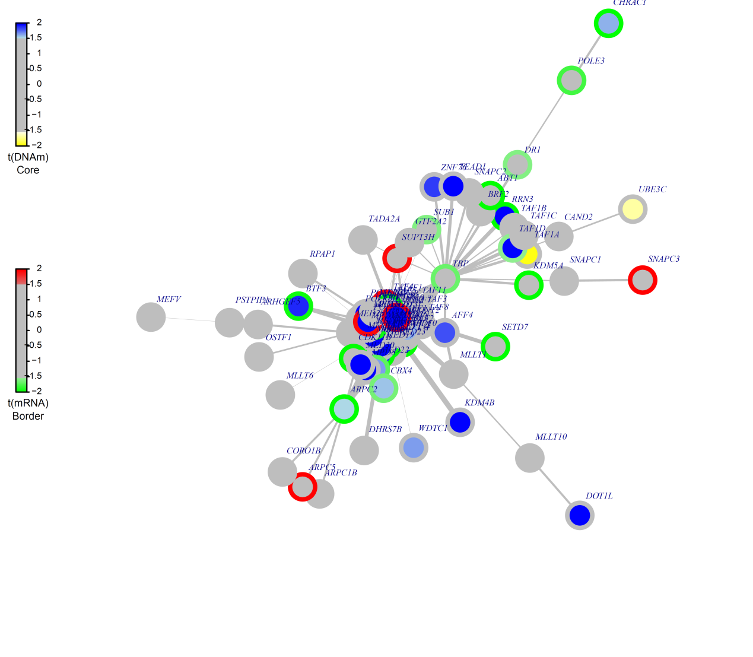
Figure S5. MED14 hotspot detected by FEM algorithm. T-statistic of DNA methylation was colored in blue or yellow inside the circle, and t- statistic of expression was colored in red or green outside the circle.

