Supplemental Material
Sex Differences in Soluble Prorenin Receptor in Patients with Type 2 Diabetes
*Bruna Visniauskas¹; *Danielle Y. Arita¹, Carla B. Rosales¹; Mohammed A. Feroz¹; Christina Luffman¹; Michael J. Accavitti¹; Gabrielle Dawkins¹; Jennifer Hong¹; Andrew C. Curnow¹; Tina K. Thethi^{2,3}; John J. Lefante⁴; Edgar A. Jaimes⁵; Franck Mauvais-Jarvis^{2,6,7}; Vivian A. Fonseca^{2,6}; Minolfa C. Prieto^{1,8}

(*) These authors contributed equally to this work as co-first authors

¹Department of Physiology, Tulane University School of Medicine, New Orleans, LA, USA.
²Department of Medicine, Endocrinology Division, Tulane University School of Medicine, New Orleans, LA, USA.
³AdventHealth, Translational Research Institute, Orlando, FL, USA
⁴Department of Biostatistics and Data Science, School of Public Health and Tropical Medicine, New Orleans, LA, USA.
⁵Renal Service, Memorial Sloan Kettering Cancer Center, New York, NY, USA.
⁶Southeast Louisiana Veterans Healthcare System New Orleans, LA, USA.
⁷Tulane Center of Excellence in Sex-Based Biology & Medicine, New Orleans, LA, USA.
⁸Tulane Hypertension and Renal Center of Excellence, Tulane University School of Medicine New Orleans, LA, USA.

* These authors contributed equally to this work as co-first authors

Supplementary Figure S1. Renin activity in urine by moderate loss of kidney function, hypertension (HTN) and albumin/creatinine (ACR: urine albumin to creatinine ratio). Data are expressed as mean ± Standard error of the mean (SEM). *P = 0.001 different from control group, † P<0.001 different from group 2 (type 2 diabetes and HTN), ‡ different from group 3 (type 2 diabetes, HTN and ACR).

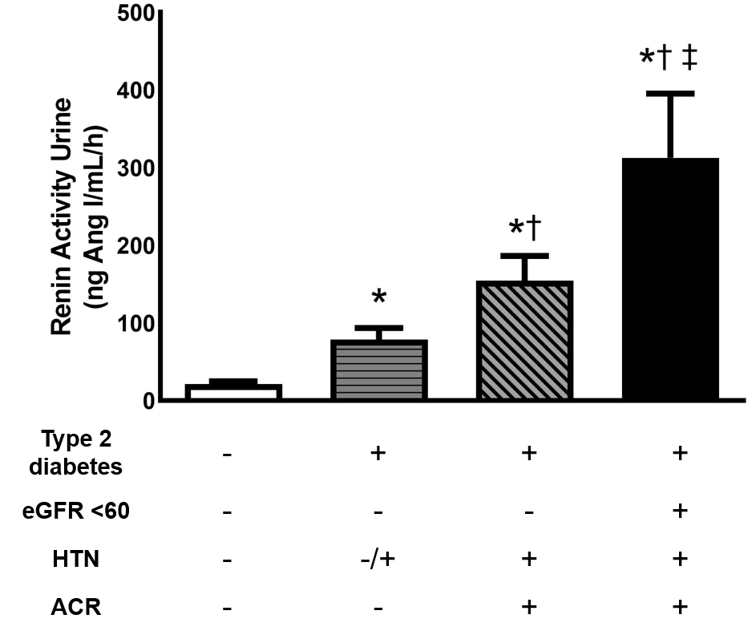

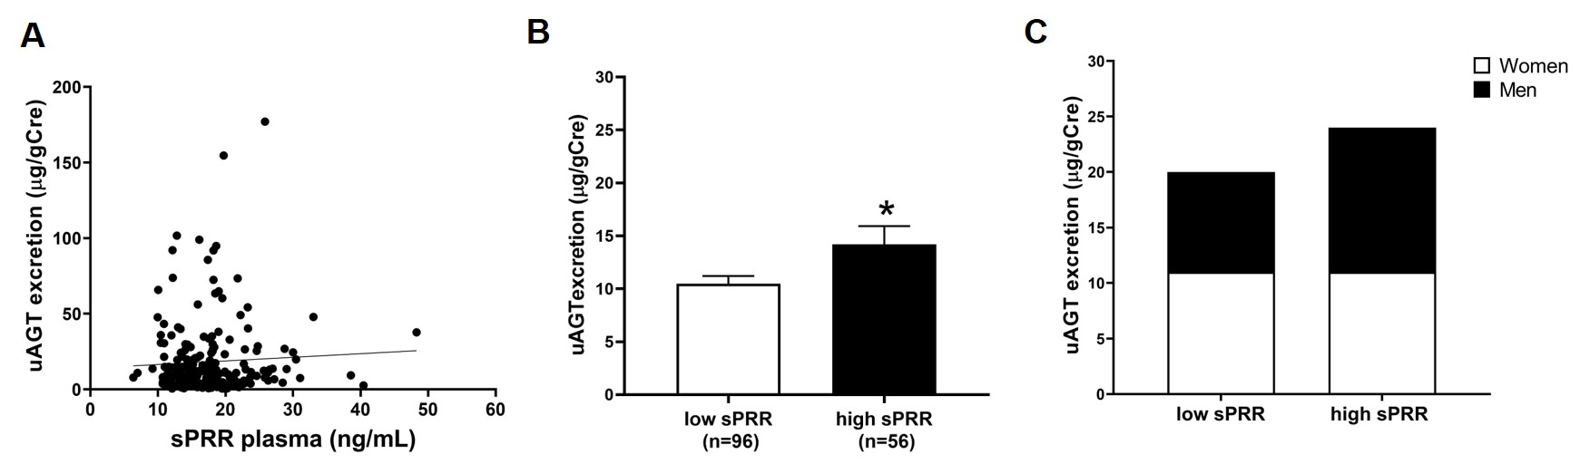
Supplementary Figure S2. (A) Correlation between soluble prorenin receptor (sPRR) levels and urinary angiotensinogen (uAGT) excretion (r = 0.05; P = 0.42). Data are expressed as mean ± SEM. Comparisons of uAGT between low (≤16 ng/mL) and high (≥19 ng/mL) levels of sPRR in patients with diabetes (B) and by gender (C). (C) *P < 0.02. (D) Men P = 0.03 and Women P = 0.73.

