Additional file 1

Sex differences in the association between cardiovascular diseases and dementia subtypes: a prospective analysis of 464 616 UK Biobank participants

Authors
Caiyun Dong, Chunmiao Zhou, Chunying Fu, Wenting Hao, Akihiko Ozaki, Nipun Shrestha, Salim S. Virani, Shiva Raj Mishra, Dongshan Zhu

Correspondence
Dongshan Zhu,
Department of Epidemiology, School of Public Health, Cheeloo College of Medicine, Shandong University, Jinan, China
44 Wenhuaxi Road, Jinan 250012, Shandong, China.
Email: dongshan.zhu@uq.net.au

List
Table S1: Sex-specific hazard ratios (HRs) between cardiovascular disease and dementia subtypes (CVD events occurred at least three years before dementia): sensitivity analysis

Table S2: Sex-specific hazard ratios (HRs) between cardiovascular disease and dementia subtypes (CVD events occurred at least five years before dementia): sensitivity analysis

Table S3: Sex differences in the association between body mass index (BMI) and dementia separated by obesity onset relative to dementia

Table S4: Characteristics of participants by sex in baseline

Figure S1: Sex differences in the association between cardiovascular diseases (CVD) and dementia by educational years.

Figure S2: Sex differences in the association between cardiovascular diseases (CVD) and dementia by number of leisure activities.

Figure S3: Sex differences in the association between cardiovascular diseases (CVD) and dementia by body mass index (BMI).

Figure S4: Sex differences in the association between cardiovascular diseases (CVD) and dementia by smoking status.

Figure S5: Sex differences in the association between cardiovascular diseases (CVD) and dementia by physical activities.

Figure S6: Sex differences in the association between cardiovascular diseases (CVD) and dementia by diabetes status.

Figure S7: Sex differences in the association between cardiovascular diseases (CVD) and dementia by hypertension status.
Additional Tables
TABLE S1. Sex-specific hazard ratios (HRs) between cardiovascular disease and dementia subtypes (CVD events occurred at least three years before dementia): sensitivity analysis*
Dementia | Sex | Did not experience any CVD event | Experienced any CVD | Only experienced CHD | Only experienced stroke | Only experienced heart failure
All-cause dementia | All participants | Reference | 1.83 (1.71, 1.96) | 1.68 (1.52, 1.85) | 2.37 (2.05, 2.75) | 0.73 (0.60, 0.88)
All-cause dementia | Female | Reference | 1.86 (1.65, 2.09) | 1.80 (1.52, 2.14) | 2.40 (1.91, 3.02) | 0.62 (0.44, 0.87)
All-cause dementia | Male | Reference | 1.70 (1.56, 1.86) | 1.52 (1.35, 1.71) | 2.24 (1.86, 2.71) | 0.75 (0.59, 0.95)
All-cause dementia | Ratio of HR (Female/Male) |  | 1.15 (1.07, 1.24) | 1.25 (1.13, 1.39) | 1.12 (0.97, 1.31) | 0.85 (0.69, 1.05)
Alzheimer's disease | All participants | Reference | 1.44 (1.28, 1.62) | 1.50 (1.28, 1.75) | 1.48 (1.12, 1.95) | 0.46 (0.32, 0.67)
Alzheimer's disease | Female | Reference | 1.69 (1.41, 2.02) | 1.93 (1.50, 2.47) | 1.44 (0.93, 2.23) | 0.46 (0.26, 0.84)
Alzheimer's disease | Male | Reference | 1.26 (1.08, 1.46) | 1.25 (1.03, 1.53) | 1.44 (1.00, 2.06) | 0.44 (0.27, 0.71)
Alzheimer's disease | Ratio of HR (Female/Male) |  | 1.43 (1.27, 1.61) | 1.63 (1.39, 1.91) | 1.06 (0.80, 1.41) | 1.11 (0.75, 1.63)
Vascular Dementia | All participants | Reference | 2.81 (2.46, 3.21) | 2.01 (1.66, 2.45) | 5.01 (4.00, 6.27) | 0.84 (0.57, 1.24)
Vascular Dementia | Female | Reference | 2.31 (1.82, 2.94) | 1.94 (1.34, 2.79) | 4.13 (2.78, 6.14) | 0.71 (0.35, 1.43)
Vascular Dementia | Male | Reference | 2.80 (2.38, 3.29) | 1.89 (1.50, 2.38) | 5.24 (3.98, 6.91) | 0.87 (0.55, 1.39)
Vascular Dementia | Ratio of HR (Female/Male) |  | 0.86 (0.75, 0.99) | 1.05 (0.84, 1.30) | 0.82 (0.64, 1.04) | 0.84 (0.55, 1.29)
* All HRs were adjusted for age at last follow up, race/ethnicity, educational years, income level, physical activity level, leisure activities, body mass index (BMI), smoking status, diabetes status, hypertension and APOE.

TABLE S2. Sex-specific hazard ratios (HRs) between cardiovascular disease and dementia subtypes (CVD events occurred at least five years before dementia): sensitivity analysis *
Dementia | Sex | Did not experience any CVD event | Experienced any CVD | Only experienced CHD | Only experienced stroke | Only experienced heart failure
All-cause dementia | All participants | Reference | 1.74 (1.62, 1.87) | 1.65 (1.50, 1.82) | 2.34 (2.02, 2.71) | 0.44 (0.34, 0.57)
All-cause dementia | Female | Reference | 1.74 (1.55, 1.97) | 1.74 (1.46, 2.07) | 2.37 (1.88, 2.98) | 0.34 (0.21, 0.54)
All-cause dementia | Male | Reference | 1.63 (1.49, 1.78) | 1.51 (1.34, 1.70) | 2.20 (1.82, 2.66) | 0.48 (0.36, 0.64)
All-cause dementia | Ratio of HR (Female/Male) |  | 1.13 (1.05, 1.21) | 1.22 (1.10, 1.36) | 1.13 (0.97, 1.31) | 0.73 (0.55, 0.97)
Alzheimer's disease | All participants | Reference | 1.37 (1.22, 1.54) | 1.46 (1.25, 1.71) | 1.42 (1.07, 1.88) | 0.28 (0.17, 0.45)
Alzheimer's disease | Female | Reference | 1.59 (1.32, 1.92) | 1.84 (1.43, 2.37) | 1.44 (0.93, 2.23) | 0.25 (0.11, 0.57)
Alzheimer's disease | Male | Reference | 1.20 (1.03, 1.40) | 1.24 (1.02, 1.51) | 1.34 (0.93, 1.95) | 0.29 (0.16, 0.52)
Alzheimer's disease | Ratio of HR (Female/Male) |  | 1.40 (1.25, 1.58) | 1.57 (1.34, 1.85) | 1.13 (0.85, 1.52) | 0.93 (0.56, 1.55)
Vascular Dementia | All participants | Reference | 2.73 (2.39, 3.12) | 2.00 (1.64, 2.43) | 5.01 (4.00, 6.27) | 0.56 (0.35, 0.90)
Vascular Dementia | Female | Reference | 2.24 (1.75, 2.85) | 1.94 (1.35, 2.79) | 4.13 (2.78, 6.14) | 0.45 (0.18, 1.08)
Vascular Dementia | Male | Reference | 2.73 (2.32, 3.21) | 1.86 (1.48, 2.35) | 5.24 (3.98, 6.91) | 0.60 (0.34, 1.05)
Vascular Dementia | Ratio of HR (Female/Male) |  | 0.85 (0.74, 0.98) | 1.06 (0.85, 1.32) | 0.82 (0.64, 1.04) | 0.77 (0.45, 1.31)
* All HRs were adjusted for age at last follow up, race/ethnicity, educational years, income level, physical activity level, leisure activities, body mass index (BMI), smoking status, diabetes status, hypertension and APOE.

TABLE S3. Sex differences in the association between body mass index (BMI) and dementia separated by obesity onset relative to dementia
Subgroup | Dementia | Total of number | Hazard ratio | Low | High | HR (95% CI) | p-value
obesity onset relative to dementia onset (<=10 years)
Men+BMI<25 | 579 | 12743 | 1.000 | 1.000 | 1.000 | Reference
Men+BMI 25-29.9 | 960 | 24968 | 0.719 | 0.644 | 0.802 | 0.71 (0.64, 0.80) | <.0001
Men+BMI>=30 | 608 | 13996 | 0.698 | 0.615 | 0.792 | 0.69 (0.61, 0.79) | <.0001
Women+BMI<25 | 654 | 21695 | 1.000 | 1.000 | 1.000 | Reference
Women+BMI 25-29.9 | 693 | 20223 | 0.927 | 0.827 | 1.039 | 0.92 (0.82, 1.03) | 0.1948
Women+BMI>=30 | 493 | 13608 | 0.799 | 0.699 | 0.913 | 0.79 (0.69, 0.91) | 0.001
obesity onset relative to dementia onset (>10 years)
Men+BMI<25 | 259 | 43705 | 1.000 | 1.000 | 1.000 | Reference
Men+BMI 25-29.9 | 508 | 85691 | 0.928 | 0.790 | 1.090 | 0.92 (0.79, 1.09) | 0.3639
Men+BMI>=30 | 328 | 42822 | 0.902 | 0.750 | 1.084 | 0.90 (0.75, 1.08) | 0.2719
Women+BMI<25 | 370 | 84928 | 1.000 | 1.000 | 1.000 | Reference
Women+BMI 25-29.9 | 412 | 78229 | 1.008 | 0.868 | 1.170 | 1.00 (0.86, 1.17) | 0.919
Women+BMI>=30 | 289 | 49483 | 0.814 | 0.681 | 0.973 | 0.81 (0.68, 0.97) | 0.0237
Note

TABLE S4. Characteristics of participants by sex in baseline
Characteristics | Female |  | Male |  | N
Characteristics | N | % | N | % | N
Race/ethnicity | 238337 | 54.05 | 202585 | 45.95 | 440922
White
Non-White | 12702 | 53.61 | 10992 | 46.39 | 23694
Education level (years) | 123198 | 53.84 | 105640 | 46.16 | 228838
<=10
11-12 | 32043 | 57.51 | 23678 | 42.49 | 55721
>12 | 95798 | 53.2 | 84259 | 46.8 | 180057
Physical activity level | 58731 | 55.56 | 46983 | 44.44 | 105714
Light
Moderate | 104697 | 56.17 | 81692 | 43.83 | 186389
High | 87611 | 50.79 | 84902 | 49.21 | 172513
Income level (£) | 62171 | 59.53 | 42274 | 40.47 | 104445
Less than 18,000
18,000 to 30,999 | 63515 | 55.75 | 50418 | 44.25 | 113933
31,000 to 51,999 | 63624 | 52.73 | 57045 | 47.27 | 120669
Greater than 52,000 | 61729 | 49.16 | 63840 | 50.84 | 125569
No. of leisure activities | 71202 | 54.17 | 60232 | 45.83 | 131434
No
One | 106456 | 52.55 | 96131 | 47.45 | 202587
Two or more | 73381 | 56.19 | 57214 | 43.81 | 130595
Body mass index (kg/m²) | 1915 | 79.86 | 483 | 20.14 | 2398
Underweight<18.5
Normal [18.5,25.0) | 99463 | 64.98 | 53595 | 35.02 | 153058
Overweight [25.0,30.0) | 92208 | 46.52 | 106022 | 53.48 | 198230
Obese>=30 | 57453 | 51.79 | 53477 | 48.21 | 110930
Smoking status | 149590 | 58.74 | 105060 | 41.26 | 254650
Never
Past | 79538 | 49.07 | 82545 | 50.93 | 162083
Current | 21911 | 45.76 | 25972 | 54.24 | 47883
Diabetes status | 242292 | 55.01 | 198185 | 44.99 | 440477
No
Yes | 8747 | 36.24 | 15392 | 63.76 | 24139
Hypertension status | 188417 | 56.07 | 147600 | 43.93 | 336017
No
Yes | 62622 | 48.7 | 65977 | 51.3 | 128599
APOE | 59321 | 52.5 | 53672 | 47.5 | 112993
no apoE4
one apoE4 | 186677 | 54.54 | 155616 | 45.46 | 342293
two apoE4 | 5041 | 54.03 | 4289 | 45.97 | 9330
Note

Additional Figures
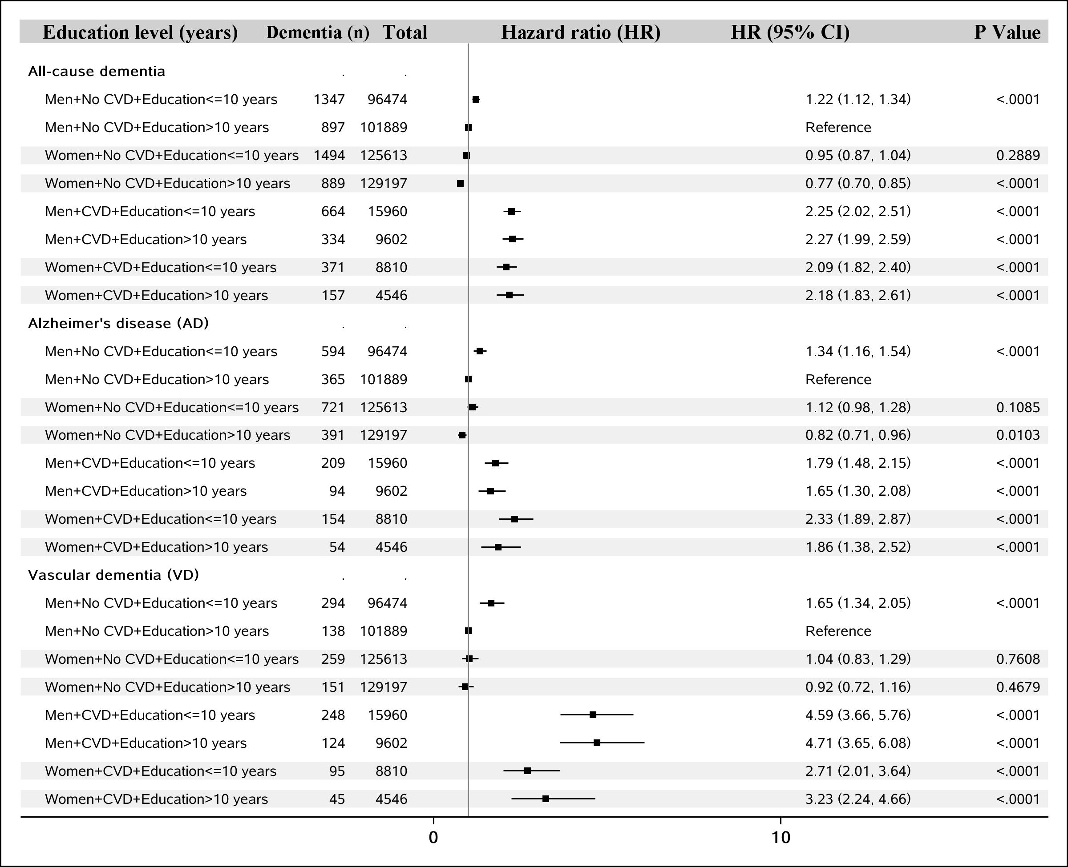
FIGURE S1: Sex differences in the association between cardiovascular diseases (CVD) and dementia by educational years.
All HRs were adjusted for age at baseline, race/ethnicity, educational years, income level, physical activity level, leisure activities, body mass index (BMI), smoking status, diabetes status, hypertension status and APOE.

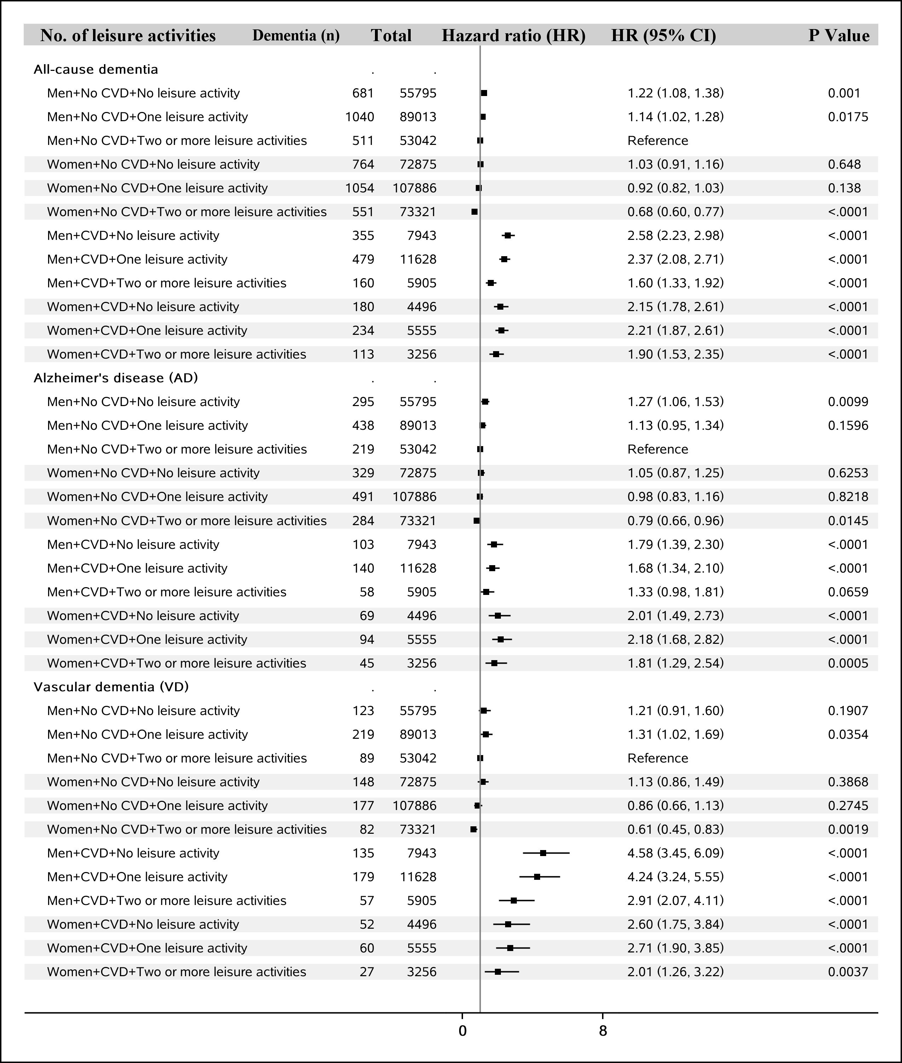
FIGURE S2: Sex differences in the association between cardiovascular diseases (CVD) and dementia by number of leisure activities.
All HRs were adjusted for age at baseline, race/ethnicity, educational years, income level, physical activity level, leisure activities, body mass index (BMI), smoking status, diabetes status, hypertension status and APOE.

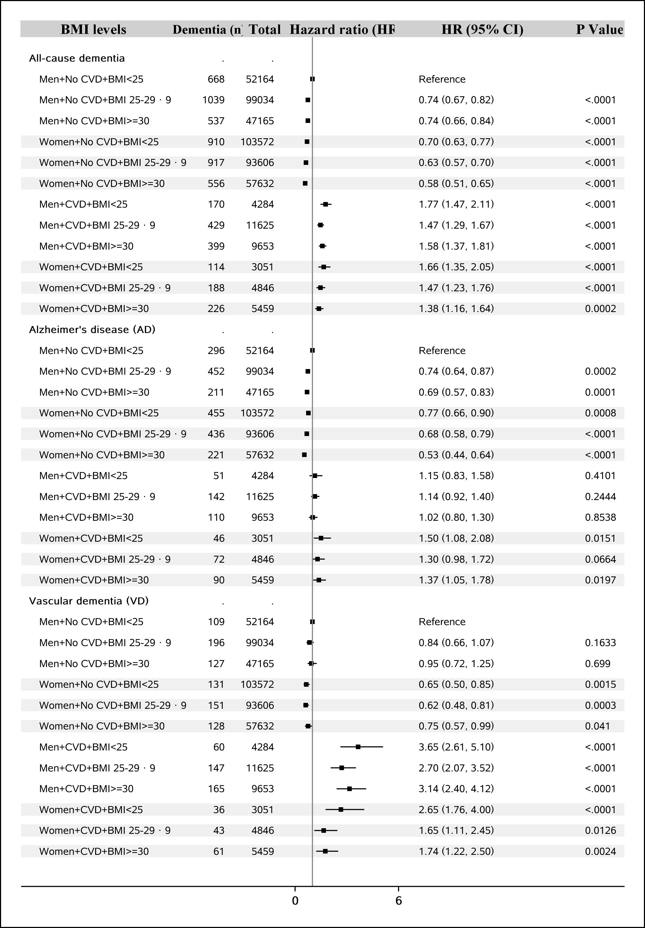
FIGURE S3: Sex differences in the association between cardiovascular diseases (CVD) and dementia by body mass index (BMI).
All HRs were adjusted for age at baseline, race/ethnicity, educational years, income level, physical activity level, leisure activities, body mass index (BMI), smoking status, diabetes status, hypertension status and APOE.

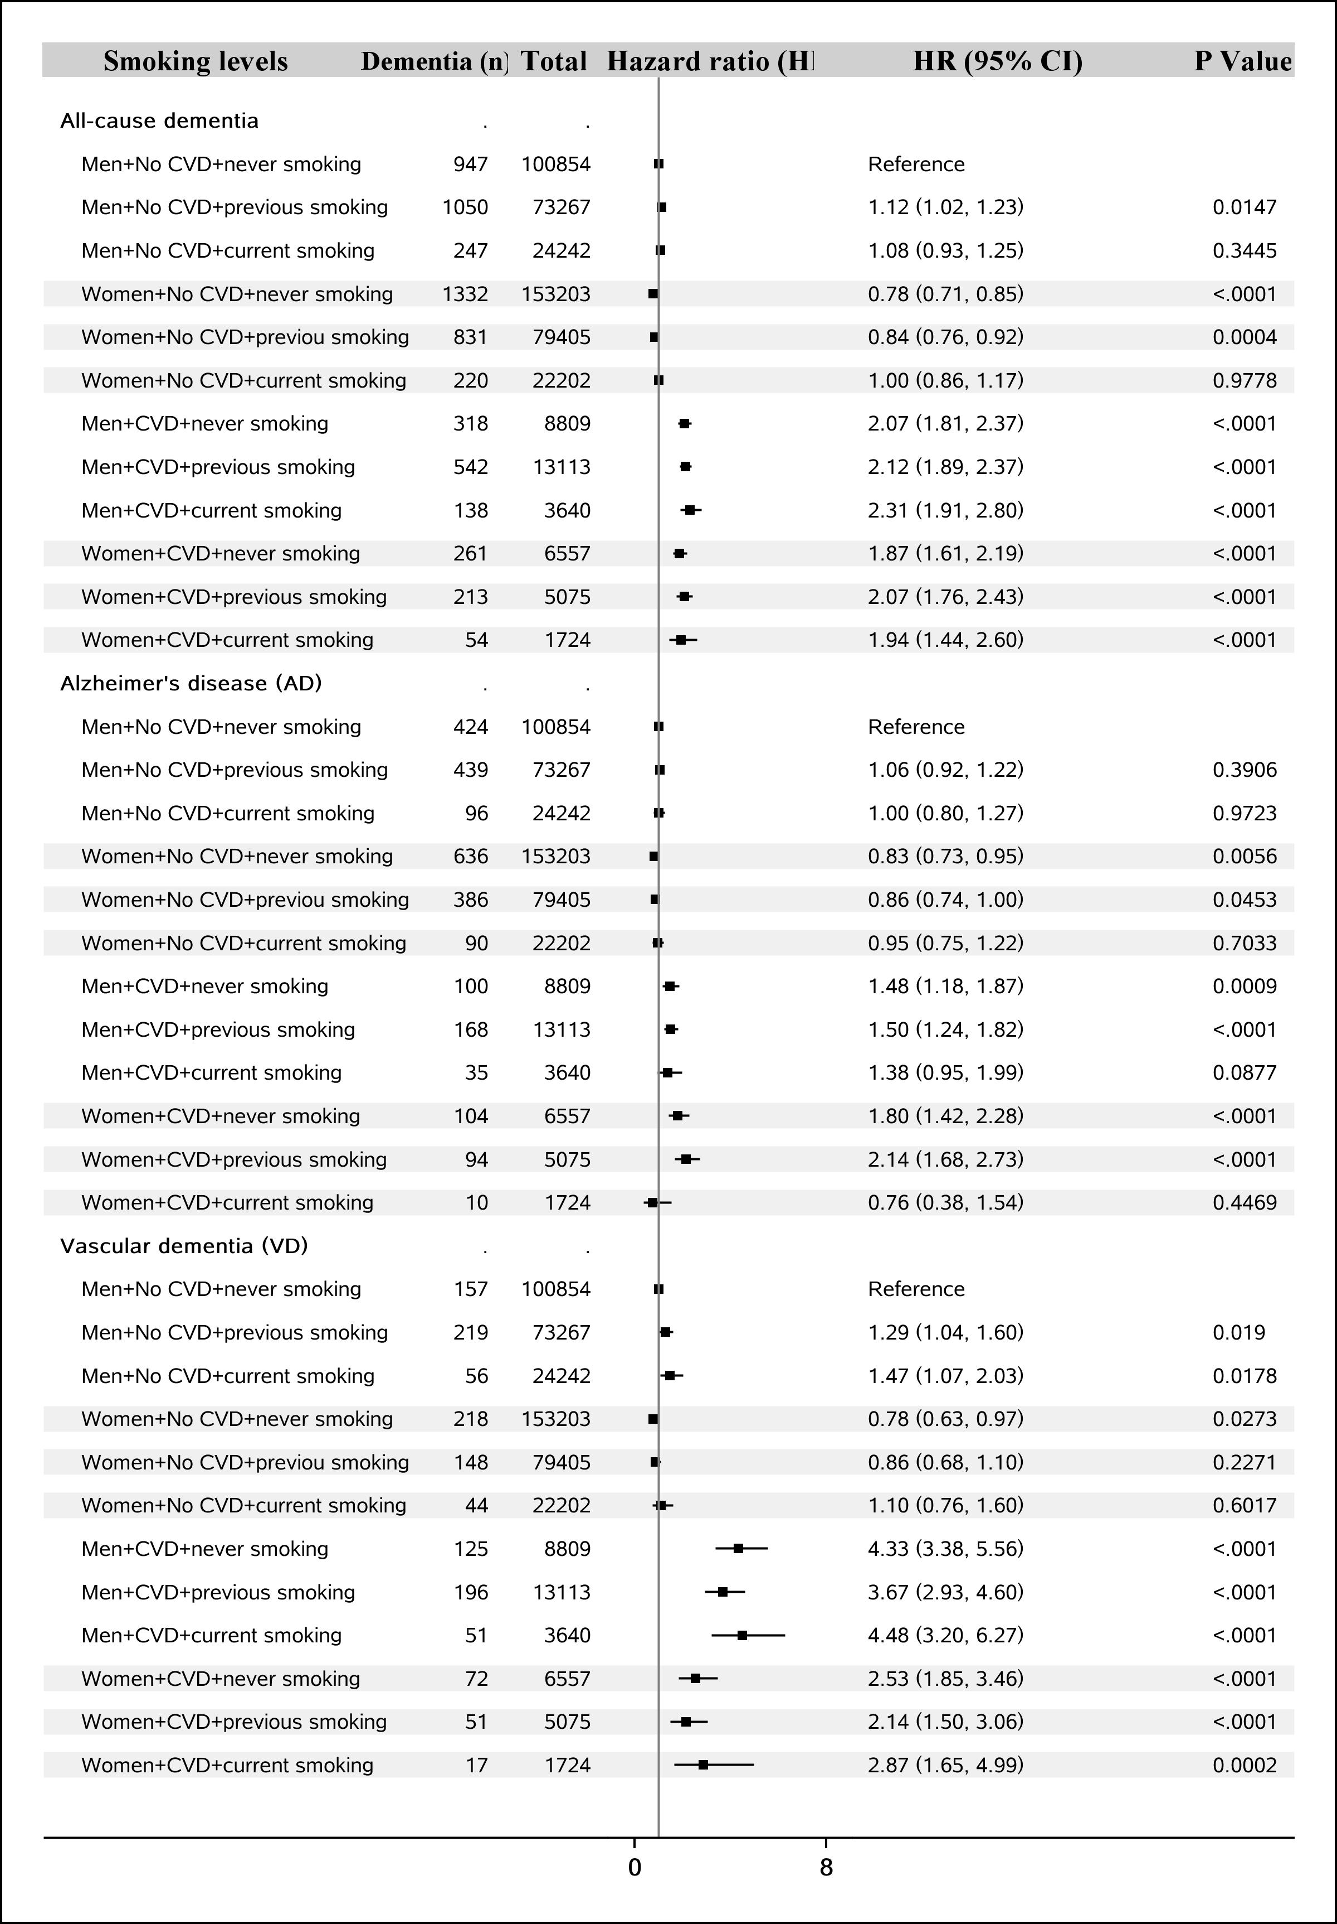
FIGURE S4: Sex differences in the association between cardiovascular diseases (CVD) and dementia by smoking status.
All HRs were adjusted for age at baseline, race/ethnicity, educational years, income level, physical activity level, leisure activities, body mass index (BMI), smoking status, diabetes status, hypertension status and APOE.

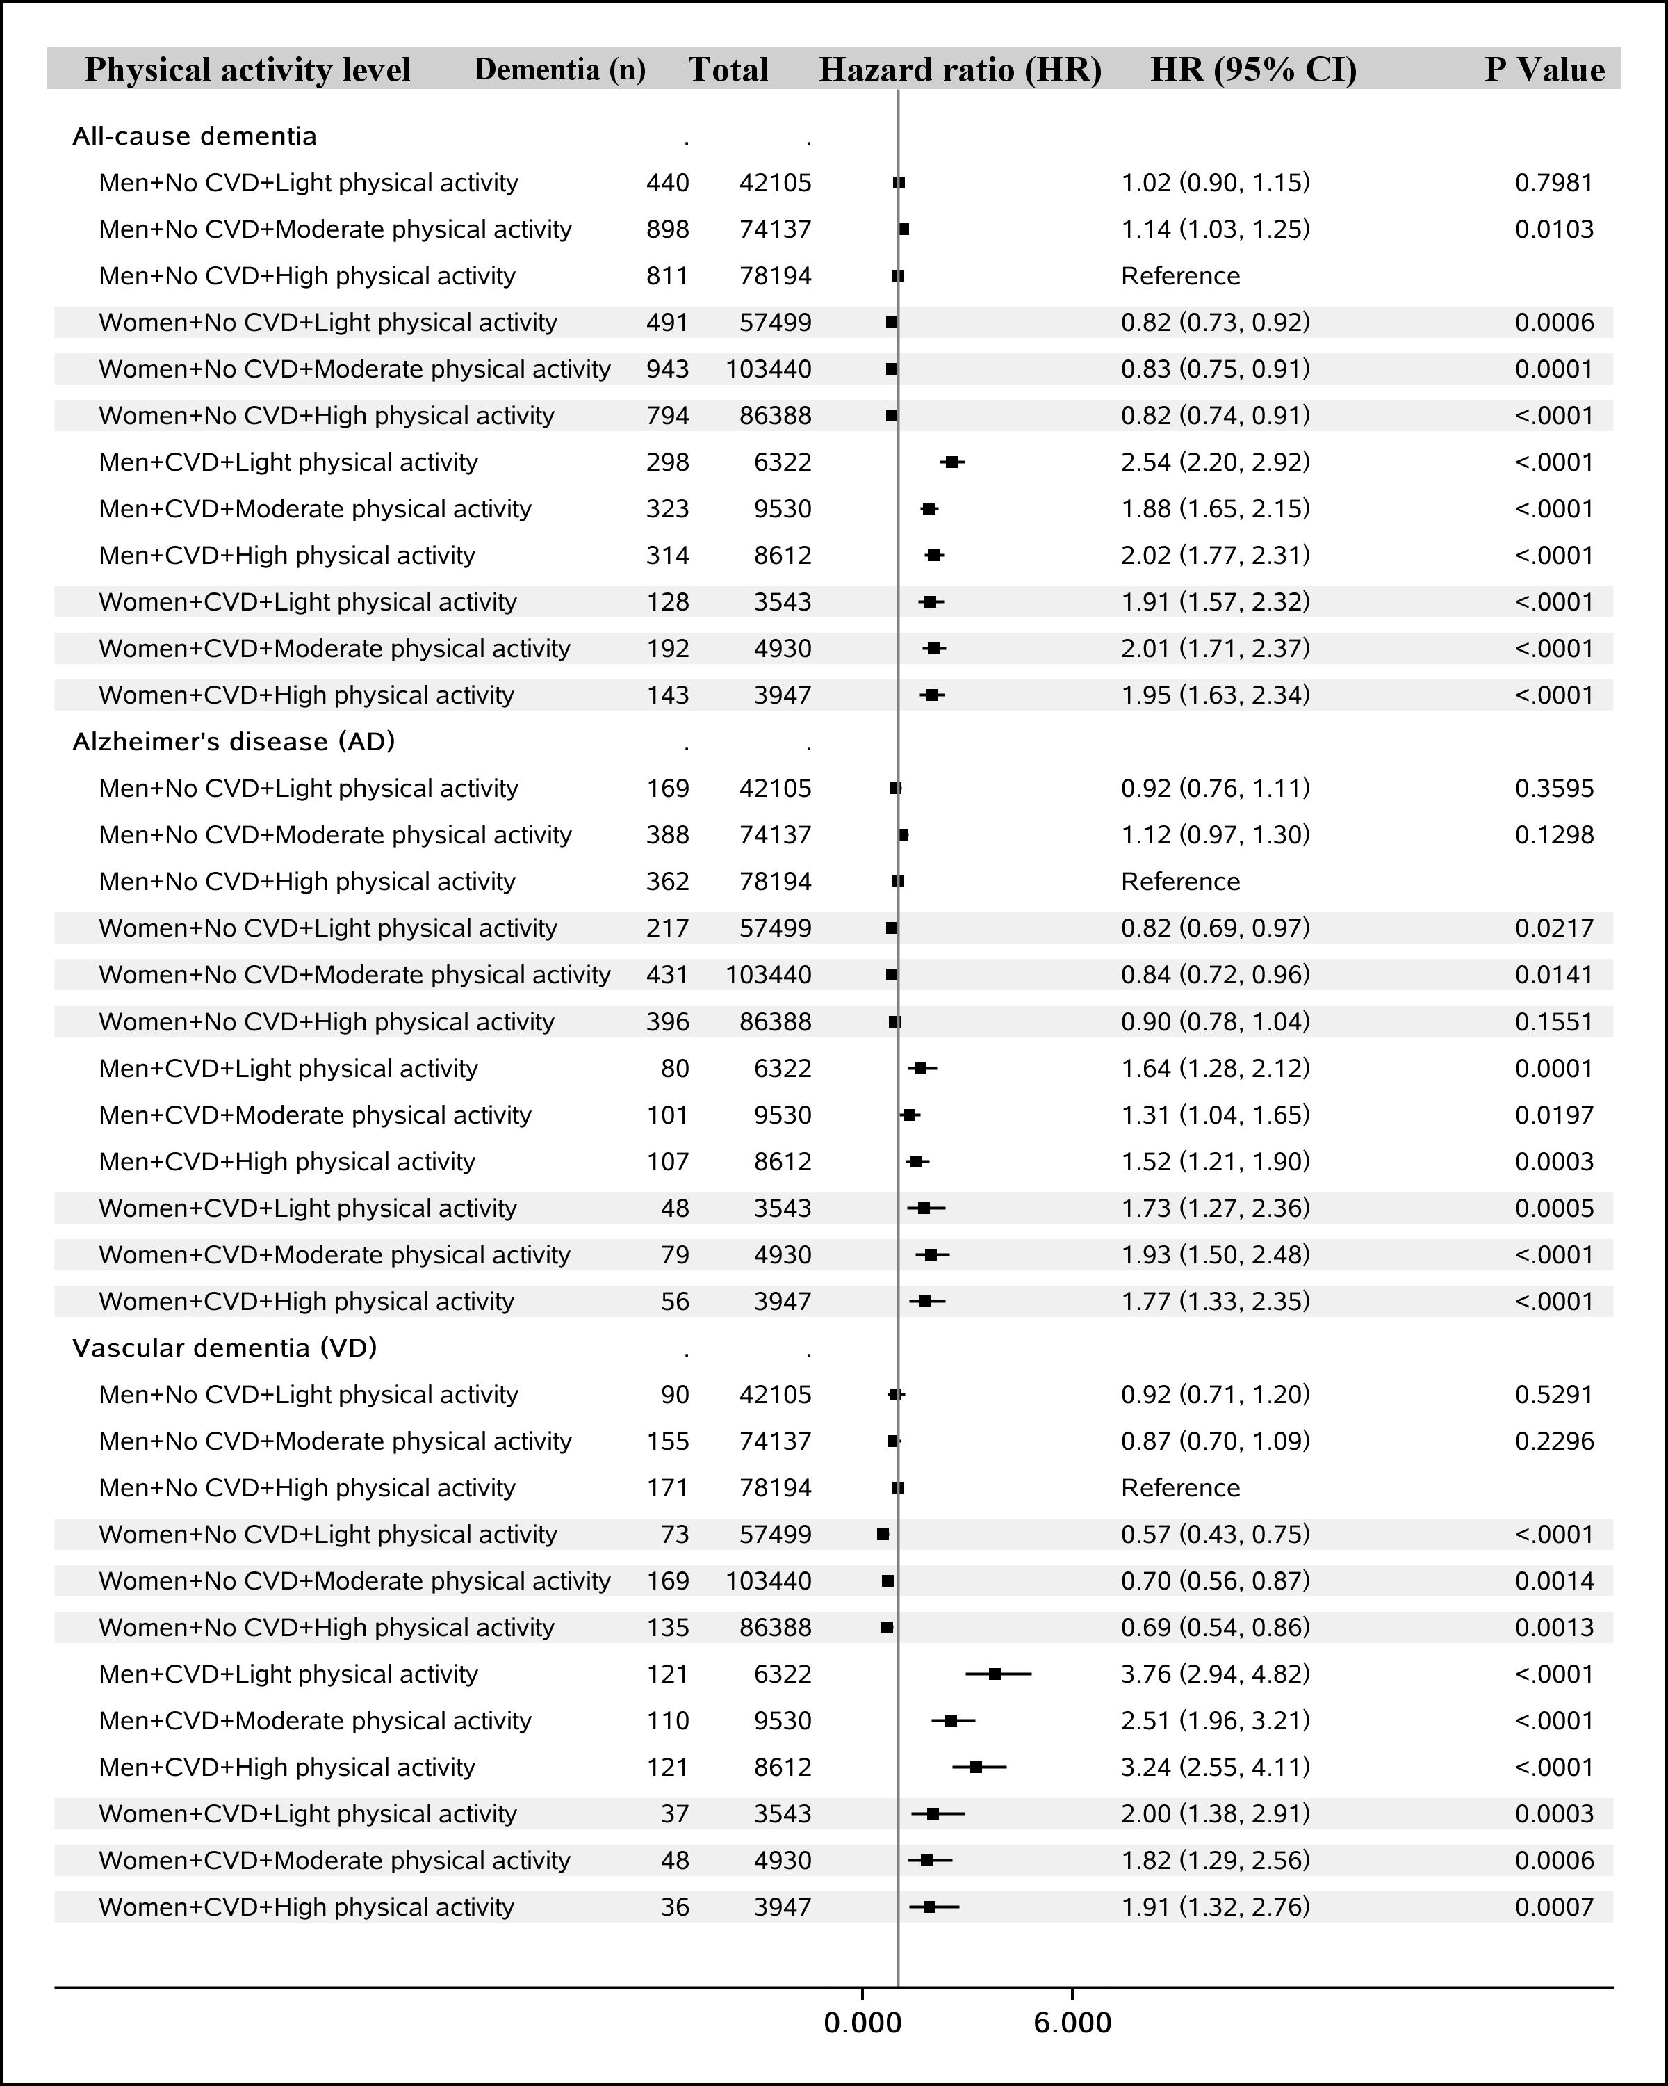
FIGURE S5: Sex differences in the association between cardiovascular diseases (CVD) and dementia by physical activities.
All HRs were adjusted for age at baseline, race/ethnicity, educational years, income level, physical activity level, leisure activities, body mass index (BMI), smoking status, diabetes status, hypertension status and APOE.

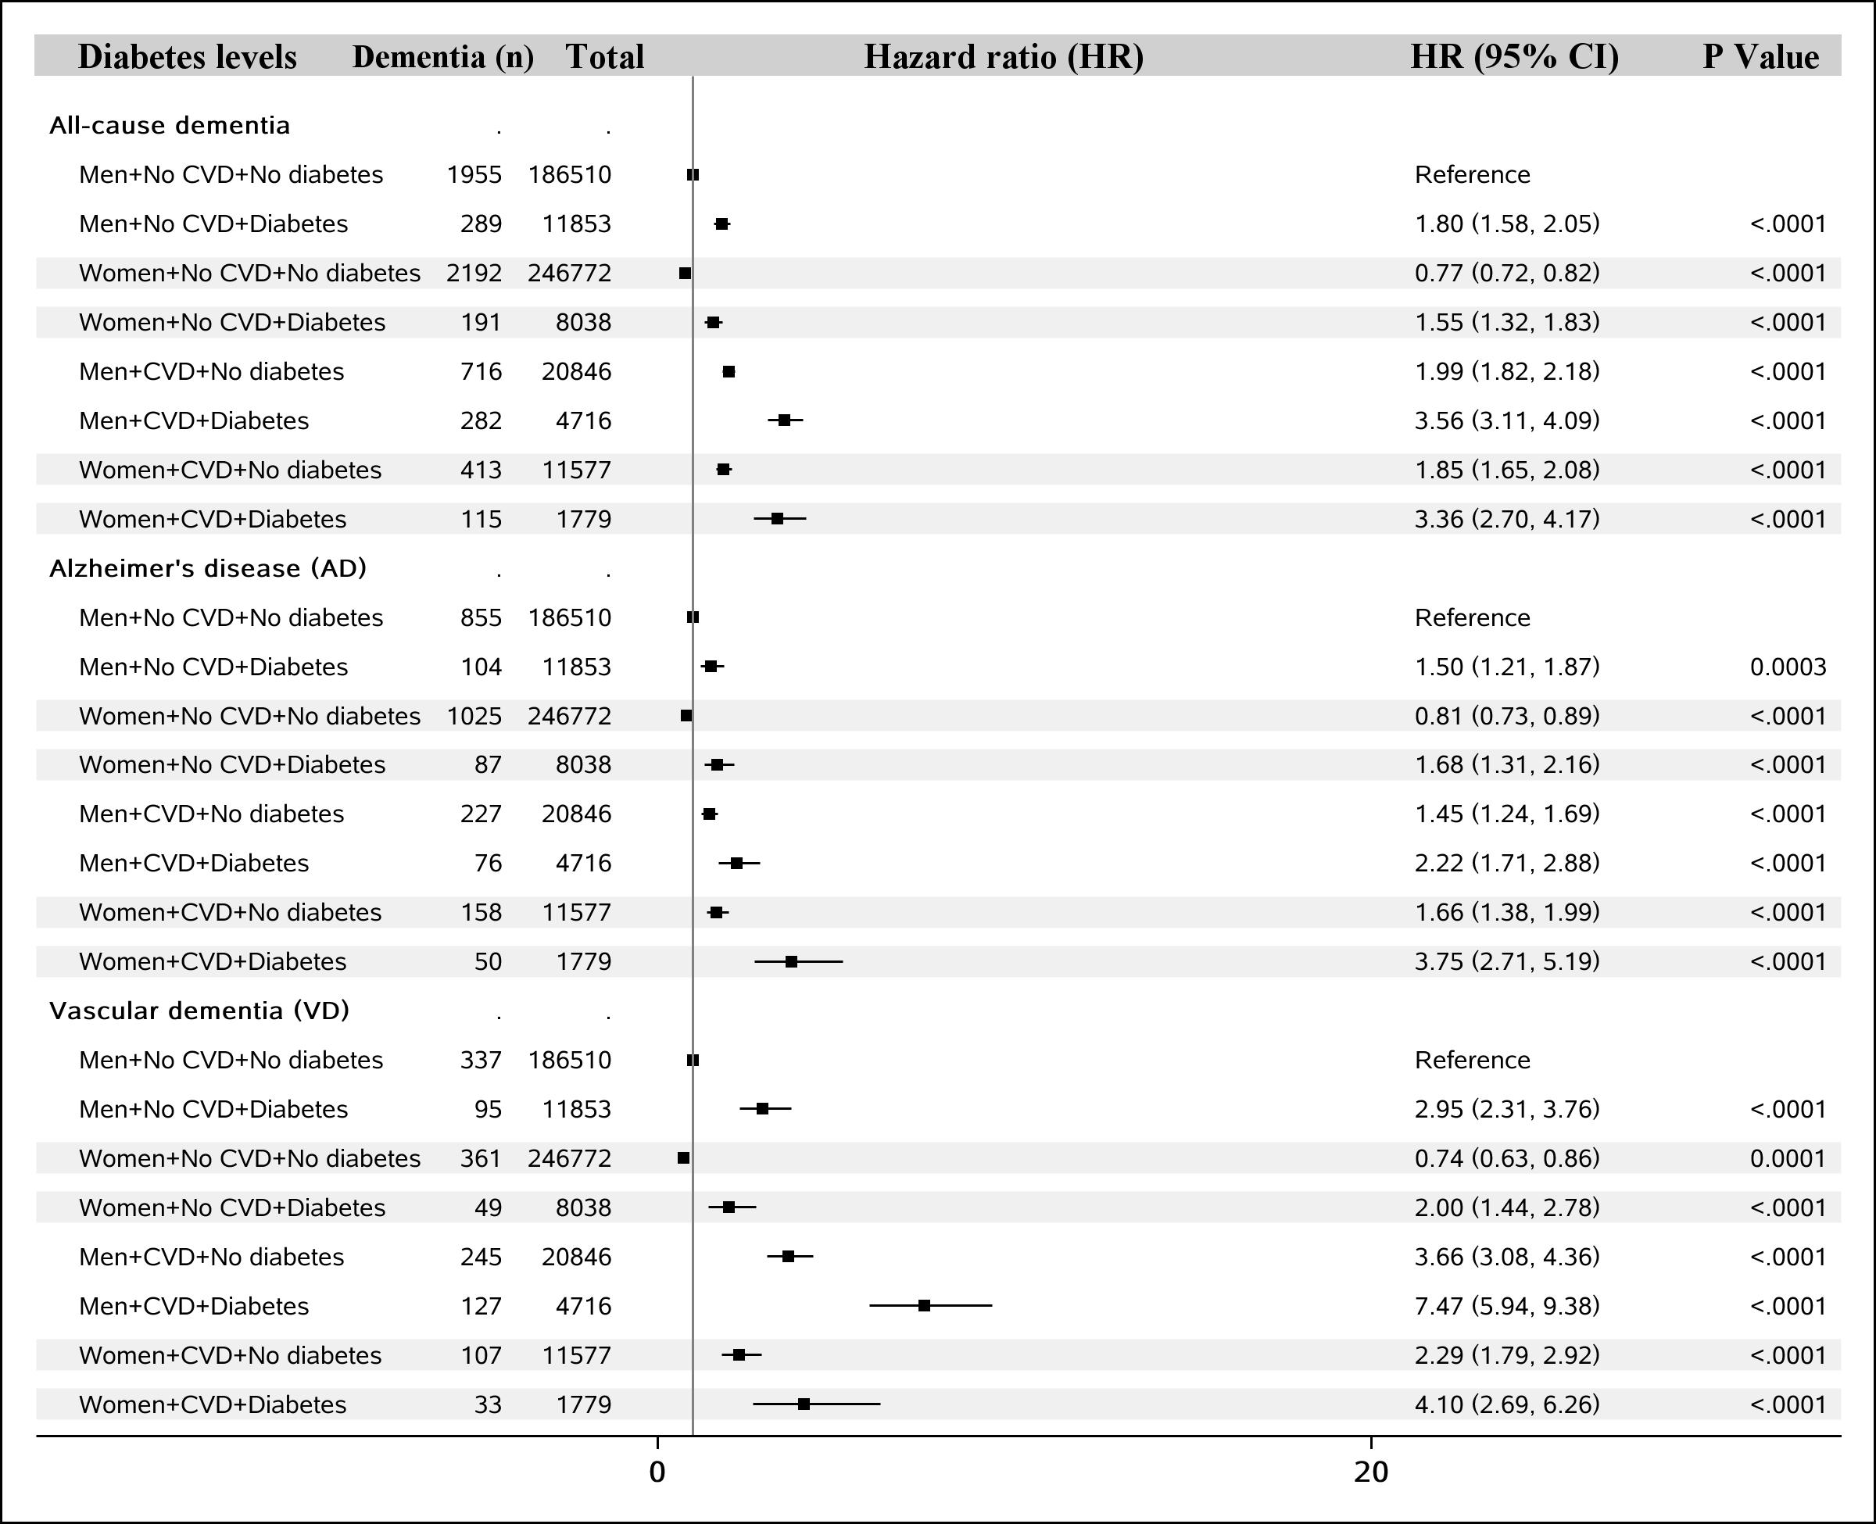
FIGURE S6: Sex differences in the association between cardiovascular diseases (CVD) and dementia by diabetes status.
All HRs were adjusted for age at baseline, race/ethnicity, educational years, income level, physical activity level, leisure activities, body mass index (BMI), smoking status, diabetes status, hypertension status and APOE.

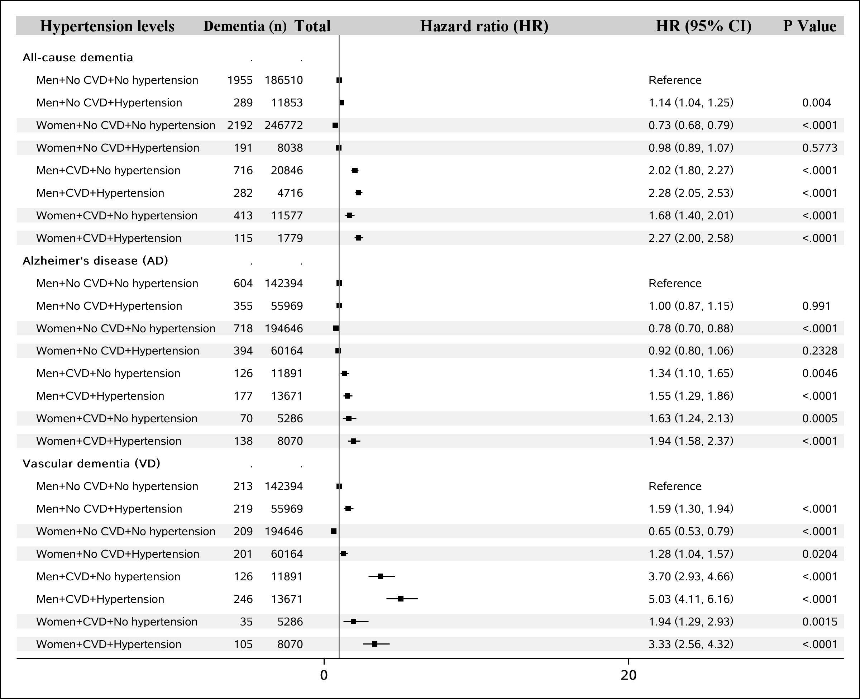
FIGURE S7: Sex differences in the association between cardiovascular diseases (CVD) and dementia by hypertension status.
All HRs were adjusted for age at baseline, race/ethnicity, educational years, income level, physical activity level, leisure activities, body mass index (BMI), smoking status, diabetes status, hypertension status and APOE.

