Genetic hypogonadal mouse model reveals niche-specific influence of reproductive axis and sex on intestinal microbial communities

This additional data file contains:
Additional Tables 1-3
Additional Figures 1-7

Fixed Effect | p value |  | Df | SumOfSqs | R2 | F
Section | 0.0001 |  | 2 | 464289 | 0.1953 | 70.5253
Sample Type | 0.0001 |  | 2 | 110964 | 0.0467 | 16.8554
Sex | 0.0134 |  | 1 | 8017 | 0.0034 | 2.4355
Genotype | 0.0004 |  | 1 | 14102 | 0.0060 | 4.2840
Sex:Genotype | 0.0065 |  | 1 | 9119 | 0.0038 | 2.7702
Sex:Sample Type | 0.5466 |  | 2 | 5900 | 0.0025 | 0.8962
Genotype:Sample Type | 0.8430 |  | 2 | 4946 | 0.0021 | 0.7514
Sex:Section | 0.2070 |  | 2 | 7614 | 0.0032 | 1.1566
Genotype:Section | 0.0473 |  | 2 | 10197 | 0.0043 | 1.5489
Sample Type:Section | 0.0002 |  | 2 | 27763 | 0.0117 | 4.2172
Sex:Genotype:Sample Type | 0.2931 |  | 2 | 7019 | 0.0030 | 1.0662
Sex:Genotype:Section | 0.2066 |  | 2 | 7542 | 0.0032 | 1.1457
Sex:Sample Type:Section | 0.6726 |  | 2 | 5424 | 0.0023 | 0.8240
Genotype:Sample Type:Section | 0.8259 |  | 2 | 4993 | 0.0021 | 0.7585
Sex:Genotype:Sample Type:Section | 0.2861 |  | 2 | 7064 | 0.0030 | 1.0730
Residual |  |  | 511 | 1682031 | 0.7076
Total |  |  | 538 | 2376984 | 1
Table S1 | Location, sex and hpg genotype affect compositional differences between samples. P values, degrees of freedom (DF), sum of squares (SumOFSqs), R2, and F statistics from mixed-effect model PERMANOVA for effects of section, sample type (lumen vs. mucosa), sex, and hpg genotype. P values < 0.05 shown in bold.

Fixed Effect | Duodenum |  | Ileum |  | Cecum
 | P value | R2 | P value | R2 | P value | R2
Sample Type | 0.0001 | 0.0811 | 0.0001 | 0.0512 | 0.0014 | 0.0173
Sex | 0.1687 | 0.0079 | 0.0198 | 0.0150 | 0.0745 | 0.0103
Genotype | 0.0016 | 0.0175 | 0.0257 | 0.0139 | 0.0182 | 0.0122
Sex:Genotype | 0.1587 | 0.0080 | 0.1146 | 0.0093 | 0.0105 | 0.0134
Sex:Sample Type | 0.0723 | 0.0095 | 0.9800 | 0.0023 | 0.9097 | 0.0033
Genotype:Sample Type | 0.1964 | 0.0075 | 0.0864 | 0.0102 | 0.9172 | 0.0033
Sex:Genotype:Sample Type | 0.1752 | 0.0078 | 0.1977 | 0.0079 | 0.9905 | 0.0019

Table S2. R2 and p values from mixed-effect PERMANOVAs for unweighted UniFrac distances. P values < 0.05 shown in bold.

Fixed Effect | Bacteroidaceae | Clostridiaceae | Deferribacteraceae | Eggerthellaceae | Lachnospiraceae
Sample Type | 1.158E-04 | 1.053E-01 | 1.067E-06 | 1.447E-25 | 2.709E-03
Section | 1.068E-79 | 0.000E+00 | 3.456E-50 | 1.279E-22 | 6.520E-36
Genotype | 0.7974 | 0.5403 | 0.3247 | 0.0033 | 0.7974
Sex*Genotype | 0.7119 | 0.7475 | 0.9501 | 0.7119 | 0.7119
Genotype*Section | 0.0056 | 0.5062 | 0.5062 | 0.3226 | 0.6400
Sample Type*Section | 1.267E-03 | 1.267E-03 | 1.271E-01 | 2.005E-08 | 7.914E-04
Sex*Genotype*Sample Type*Section | 0.4384 | 0.2403 | 0.2403 | 0.0712 | 0.0715
Fixed Effect | Lactobacillaceae | Muribaculaceae | Oscillospiraceae | Rikenellaceae | Ruminococcaceae
Sample Type | 2.504E-53 | 8.330E-30 | 1.870E-01 | 1.695E-03 | 0.1382
Section | 2.472E-173 | 5.422E-22 | 6.587E-39 | 9.833E-114 | 4.912E-27
Genotype | 0.1031 | 1.627E-05 | 0.9377 | 0.5142 | 0.5142
Sex*Genotype | 0.8381 | 0.0401 | 0.7119 | 0.7119 | 0.7119
Genotype*Section | 0.6400 | 0.0056 | 0.9392 | 0.0056 | 0.6400
Sample Type* Section | 2.602E-19 | 8.596E-15 | 4.180E-02 | 1.480E-02 | 1.942E-03
Sex*Genotype*Sample Type*Section | 0.0712 | 0.0124 | 0.1690 | 0.2403 | 0.2403
Table S3 | Effect of section, sample type, sex, or hpg genotype on top 10 most abundant bacterial families clr-transformed abundances. FDR-corrected p values shown for linear mixed-effect model. Fixed effects were section*sample type*sex*hpg. Non-significant interactions were removed. P values < 0.05 shown in bold.

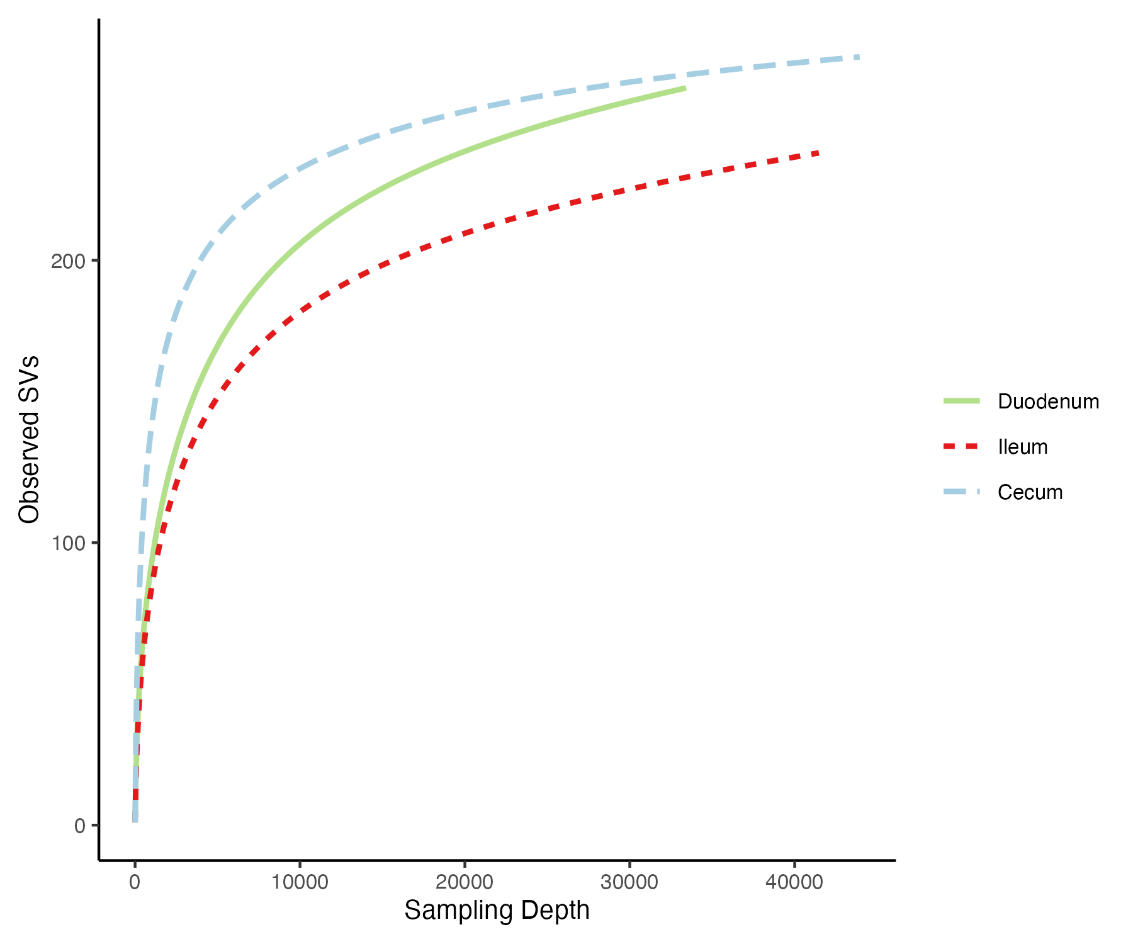
Figure S1 | Rarefaction curves by intestinal section. A Duodenum, B Ileum, and C Cecum.

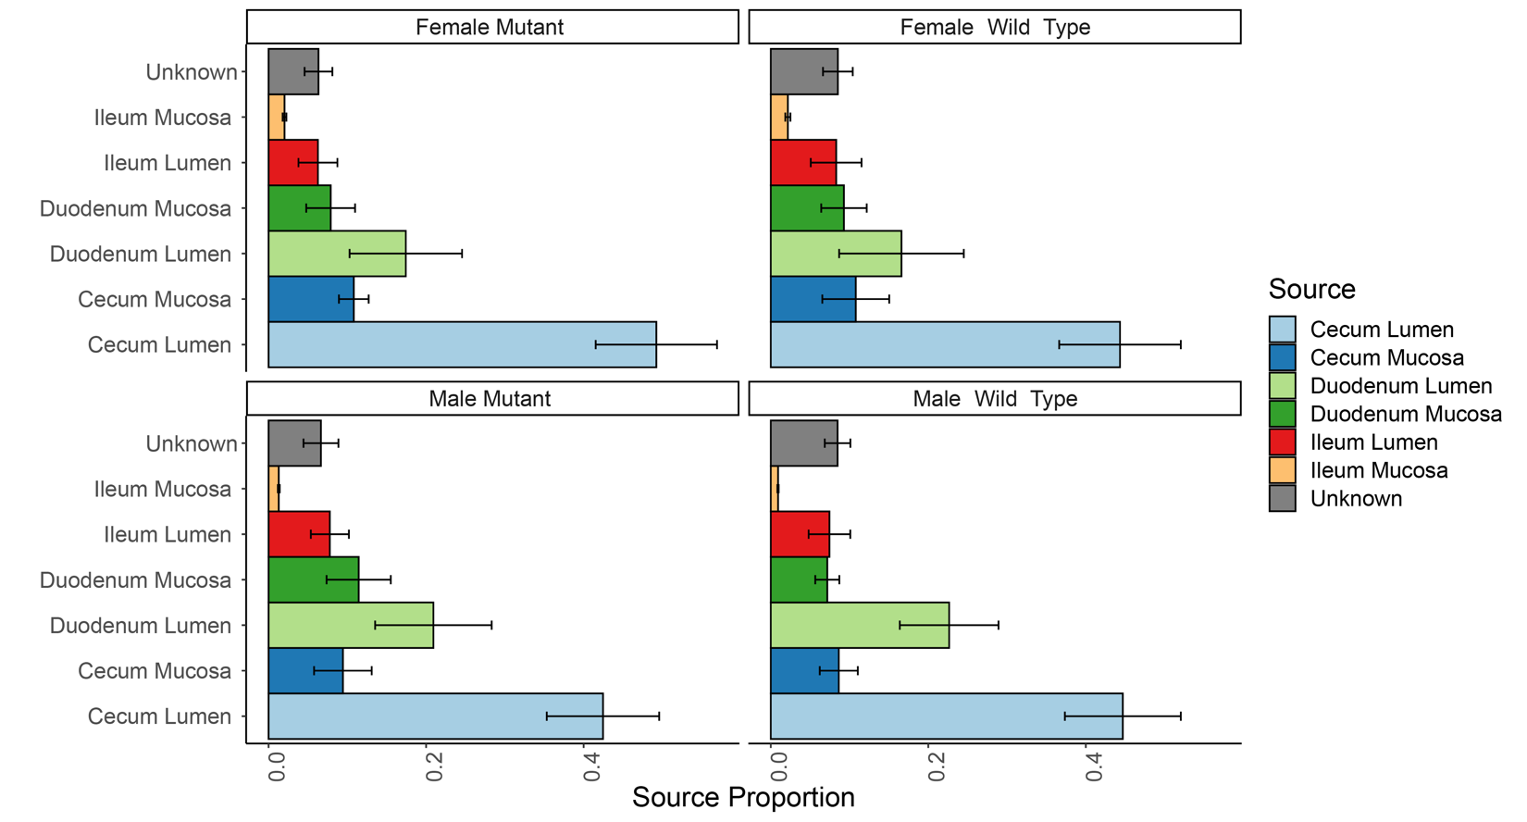
Figure S2 |Source contribution to feces by hpg genotype and sex. 95% confidence intervals shown for SourceTracker source proportions of feces (sink) samples by sex and hpg genotype.

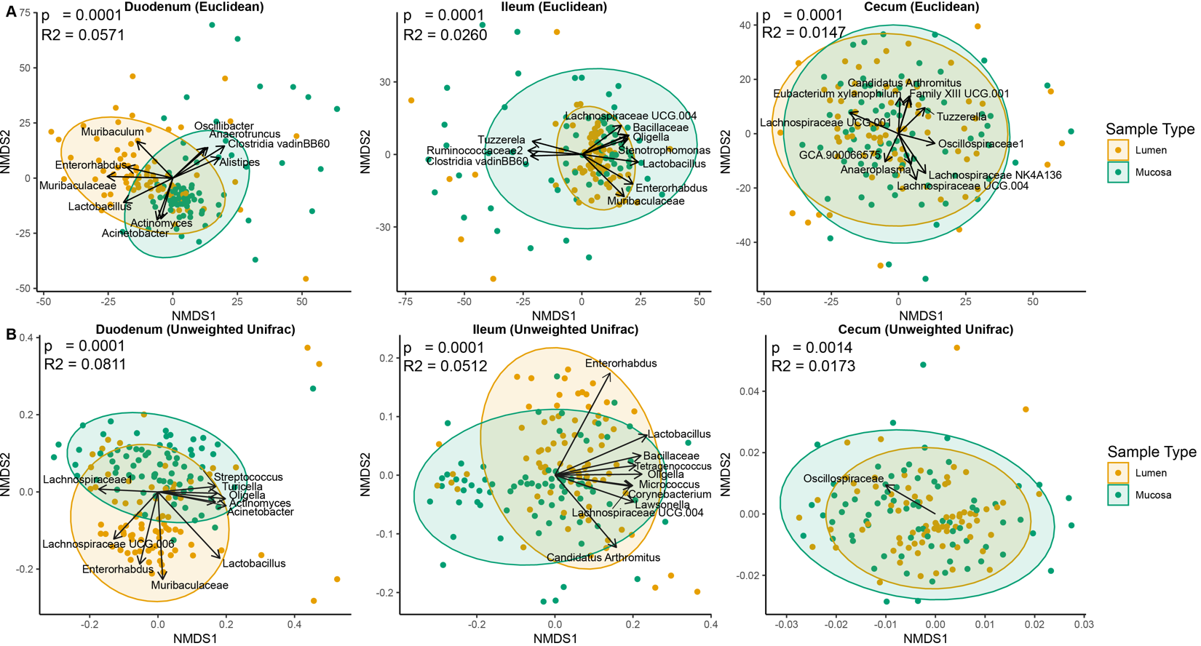
Figure S3 | Beta diversity differences between lumen and mucosa. A NMDS orientation plots of Euclidean distances comparing lumen and mucosa in the duodenum, ileum, and cecum. B NMDS plots of unweighted UniFrac distances for the duodenum, ileum, and cecum. The clr-transformed counts of genera were fit to each ordination and arrows are the vector average of the genus. Genera shown had the top 10 R² values of significant genera fit to the ordination (FDR-corrected p values < 0.05 determined by permutation test).

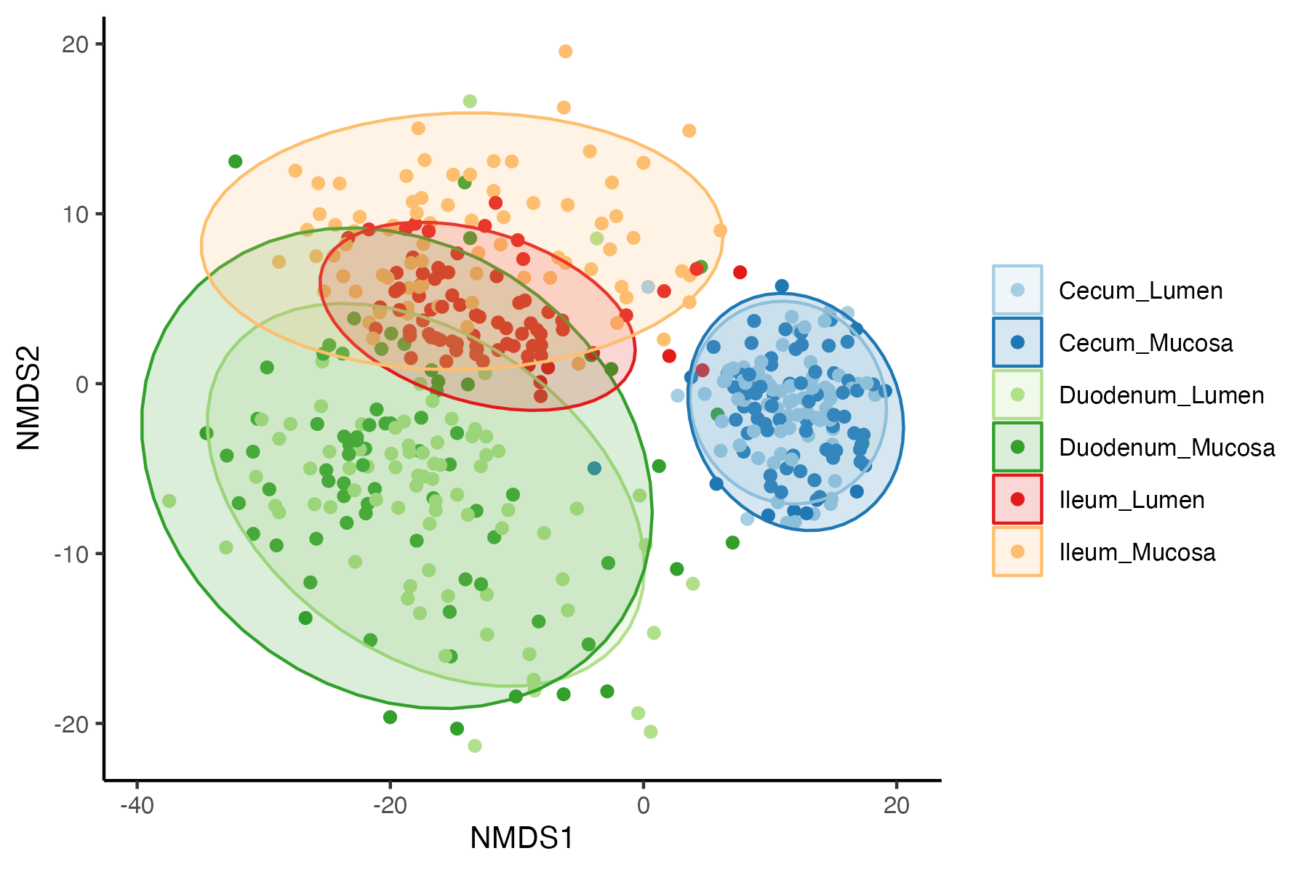
Figure S4 | NMDS ordination of Euclidean distances based on bacterial family abundances for each intestinal environment.

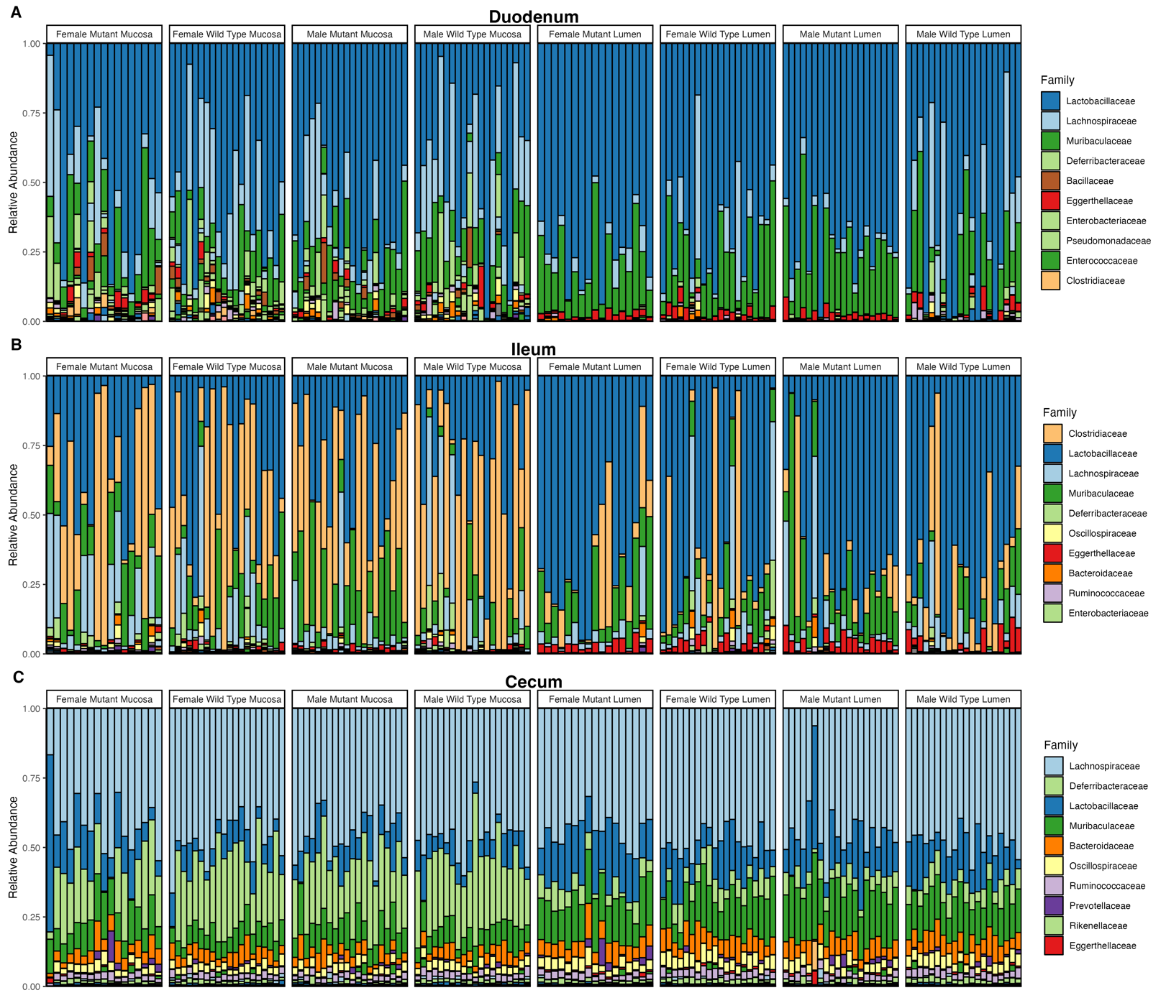
Figure S5 |Family relative abundance for each individual sample. Relative abundance of each family for A duodenum, B ileum, and C cecum. Each bar represents a mouse intestinal sample.

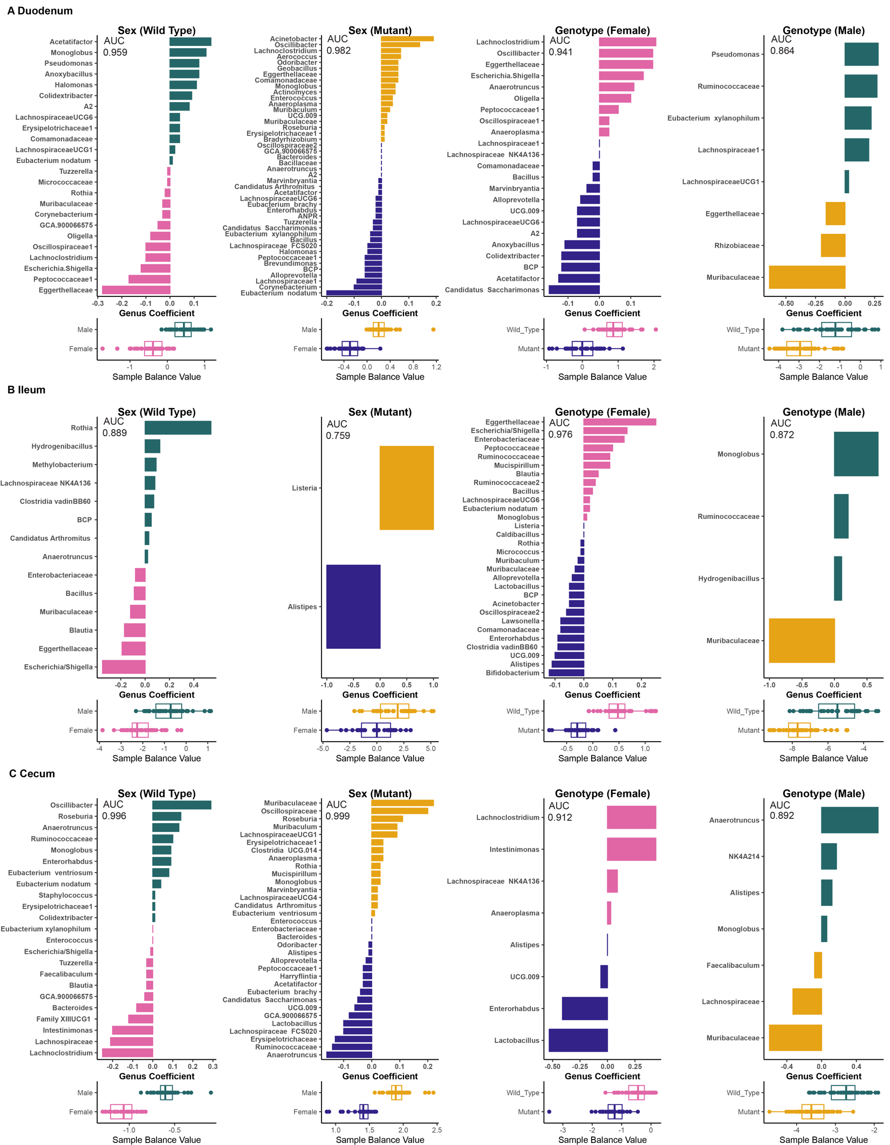
Figure S6 | Strength and complexity of genus-level balance models. Sex differences in wild-type and mutant mice and hpg genotype differences in female and male mice in the A duodenum, B ileum, and C cecum. AUC (area under the curve) indicates the model strength (AUC of 1 indicates a model with perfect predictive value). Abbreviations: ANPR genus: Allorhizobium /Neorhizobium/Pararhizobium/Rhizobium genus group. BCP genus: Burkholderia/Caballeronia/Paraburkholderi genus group.

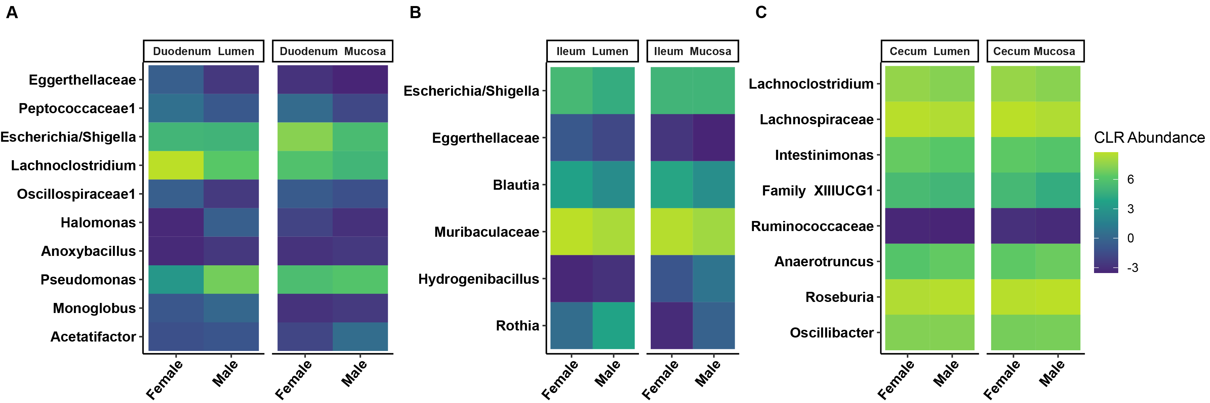
Figure S7| Relative abundance of genera in hpg wild-type balance differs by sample type. Heatmaps comparing genera abundances between wild-type sexes separating lumen and mucosa for the A duodenum, B ileum, and C cecum.

