Additional file 1: Figure S1. The distribution of RV-starter cells of the LHb in males
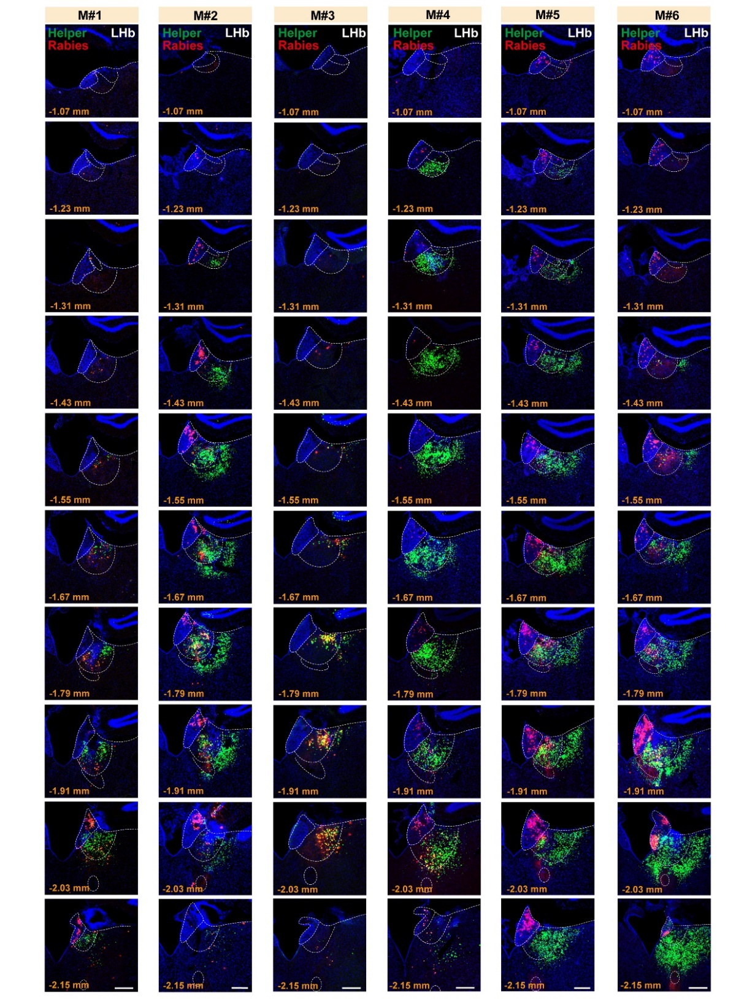Fluorescent images showing the spatial distribution of RV-starter cells from each sample (row) of males along the anterior (top) – posterior (bottom) axis. dsRed and EGFP co-labeled cells representing RV-starter cells. Scale bar = 200 μm.

