Additional file 2: Figure S2. The distribution of RV-starter cells of the LHb in females
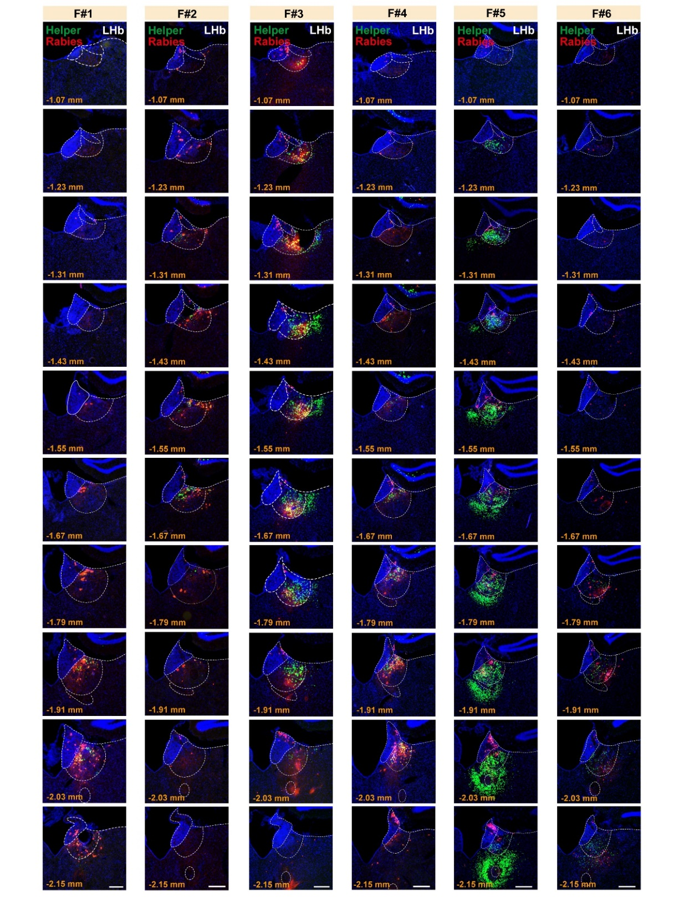
Fluorescent images showing the spatial distribution of RV-starter cells from each sample (row) of females along the anterior (top) – posterior (bottom) axis. dsRed and EGFP co-labeled cells representing RV-starter cells. Scale bar = 200 μm.

