Additional file 5: Figure S5. Whole-brain connections of the LHb^{vGlut2} neurons.
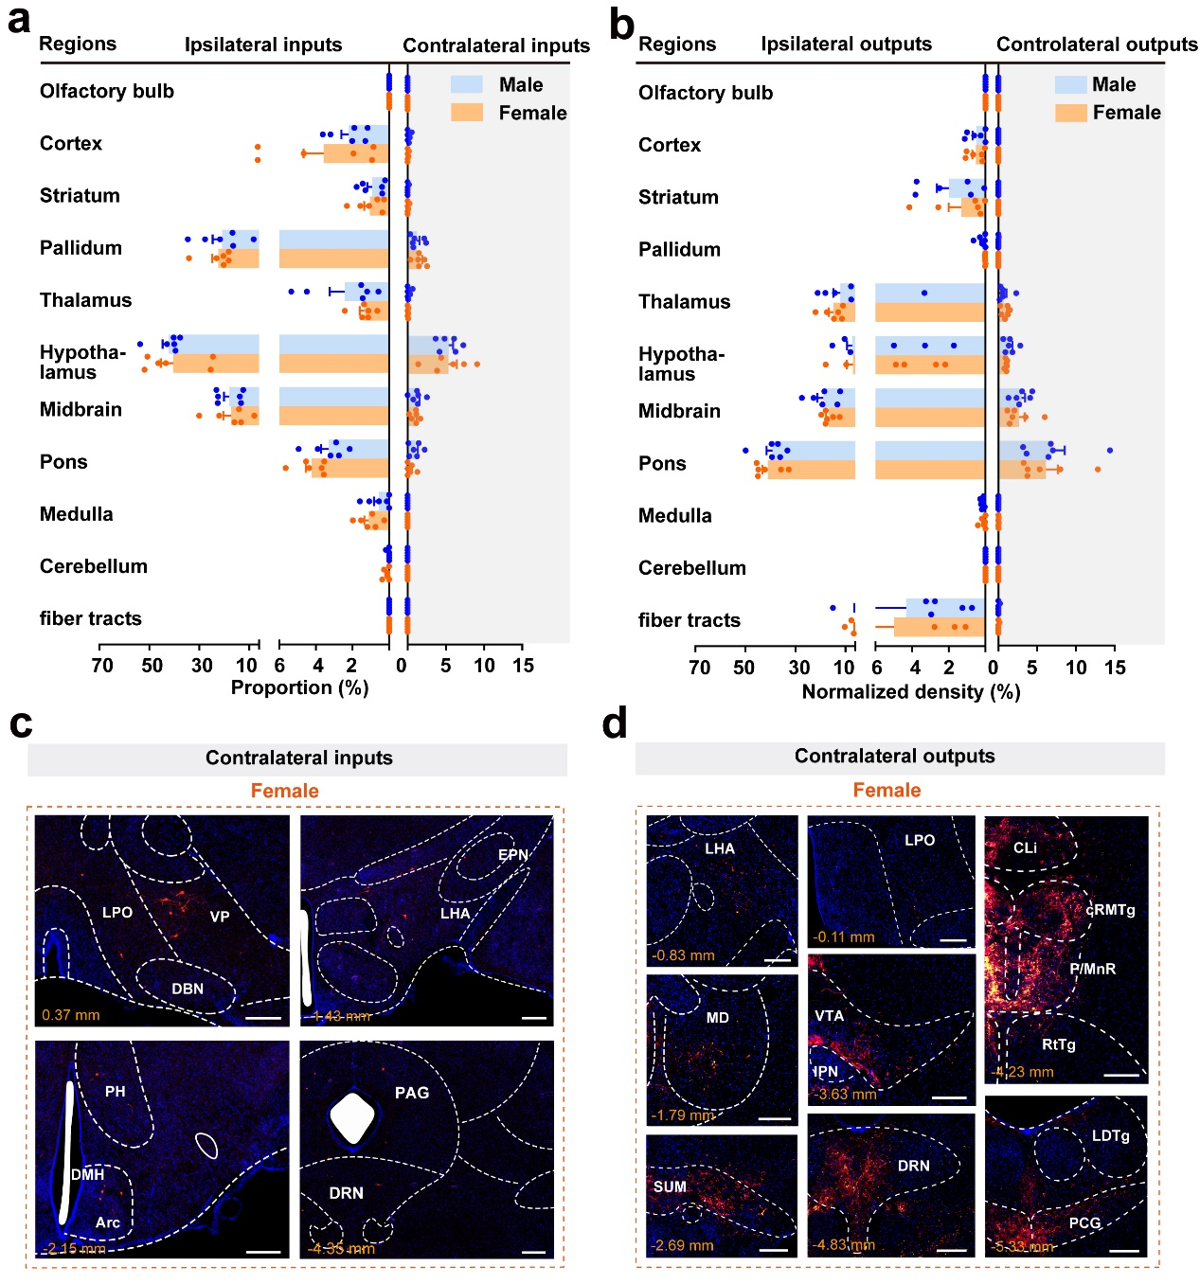
(a, b) The proportion or density of inputs (a) and outputs (b) in the ipsilateral and contralateral side of 11 brain regions. Data are shown as mean ± s.e.m., n = 6. (c, d) Representative image showing contralateral inputs (c) or outputs (d) brain regions of the LHb^{vGlut2} neurons. Scale bars = 200 μm.

