Additional file 8: Figure S8. Output cluster of LHb^{vGlut2} neurons according to the presynaptic bouton size, number, and occupied area. 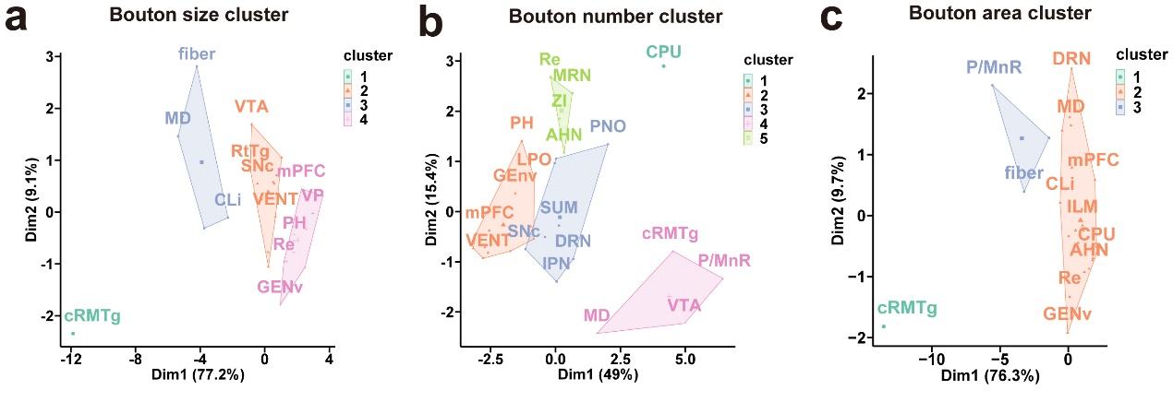
(a-c) Output brain subregions cluster of the LHb^{vGlut2} neurons according to the presynaptic bouton size (a), number (b), and occupied area (c).

