Additional file 9: Figure S9. Connection pattern of output and input of LHb^{vGlut2} neurons in male and female mice.
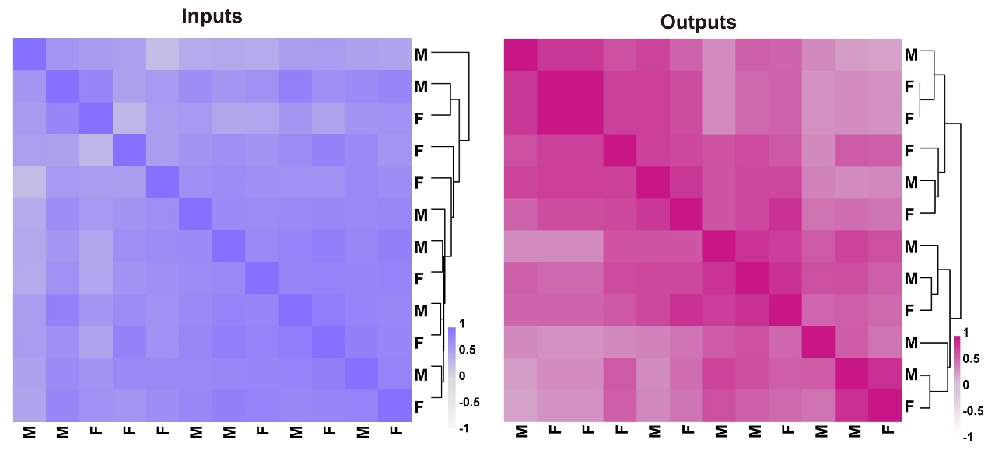
(a-b) Input (a) and output (b) pattern of male and female mice.

