Supplemental Information
Key Resources Table
REAGENT or RESOURCE | SOURCE | IDENTIFIER
Diet
Chow | Laboratory Rodent Diet | Cat# 3005659-220
High Fat Diet | Research Diets Inc. | Cat#D12492
Antibodies
Biotin anti-mouse CD45 Antibody | BioLegend | Cat# 103103
Biotin anti-mouse CD11b | BioLegend | Cat# 133307
Biotin anti-mouse CD90.2 (Thy1.2) Antibody | BioLegend | Cat# 105304
Biotin anti-mouse CD45R/B220 | BioLegend | Cat# 133307
Biotin anti-mouse CD19 Antibody | BioLegend | Cat# 115503
Biotin anti-mouse CX3CR1 Antibody | BioLegend | Cat# 149018
Biotin anti-mouse Ly-6G Antibody | BioLegend | Cat# 47003
Biotin anti-mouse Ly-6C Antibody | BioLegend | Cat# 47003
Biotin anti-mouse F4/80 Antibody | BioLegend | Cat# 12305
Biotin anti-mouse I-A/I-E Antibody | BioLegend | Cat# 107603
Biotin anti-mouse CD64 (FcγRI) Antibody | BioLegend | Cat# 139318
Biotin anti-mouse CD49b Antibody | BioLegend | Cat# 108903
Biotin anti-mouse TER-119 Antibody | BioLegend | Cat# 116203
Biotin anti-mouse CD11c Antibody | BioLegend | Cat# 117303
Purified anti-mouse CD127 Antibody | BioLegend | Cat# 158203
Purified anti-mouse CD117 Antibody | BioLegend | Cat# 105801
Biotin anti-mouse Ly-6A/E Antibody | BioLegend | Cat# 122504
Biotin anti-mouse CD135 Antibody | BioLegend | Cat# 135307
Biotin anti-mouse CD48 Antibody | BioLegend | Cat# 103409
Biotin anti-mouse CD150 Antibody | BioLegend | Cat# 115907
Anti-mouse CD34 Monoclonal Antibody | eBioscience (Thermo Fischer) | Cat# 14034182
Biotin anti-mouse CD16/32 Antibody | BioLegend | Cat# 101303
Biotin anti-mouse CD115 Antibody | BioLegend | Cat# 135507
Anti-mouse BrdU Monoclonal Antibody | eBioscience  (Thermo Fisher) | Cat# 11507142
Anti-mouse feeder cell antibody | Miltenyi Biotec | Cat# 130120166
Biotin anti-mouse Podoplanin Antibody | BioLegend | Cat# 127403
Biotin anti-mouse CD31 Antibody | BioLegend | Cat# 102404
Chemicals, peptides, and recombinant proteins
Acetic Acid
Insulin | Thermo Fischer | Cat# 12585014
Glucose | Sigma | Cat# G8769-100ML
Phenol‒chloroform
Diethylpyrocarbonate (DEPC) water
RBC lysis buffer | BioLegend | Cat# 420301
Collagenase from Clostridium histolyticum,  Type I | Sigma Aldrich | Cat# C0130-1G
Collagenase from Clostridium histolyticum  XI | Sigma Aldrich | Cat# C7657-100MG
Deoxyribonuclease I from bovine pancreas | Sigma Aldrich | Cat# D4513-1VL
Hyaluronidase from bovine testes | Sigma Aldrich | Cat# H3506-100MG
Live/Dead Blue | Thermo Fischer | Cat# L23105
Albumin bovine, fraction V, ≥98% | MP BIOMEDICALS | SKU: 0216006991
UltraPure™ 0.5 M EDTA, pH 8.0 | Thermo Fisher | Cat# 15575020
Critical commercial assays
cDNA reverse transcription kit | Applied Biosystems | Cat# 4368814
PCR SYBR green master mix | Diagenode
Next GEM Single cell 3’GEX Reagent kit | 10x Genomics | Cat# 1000092
Experimental models: Organisms/strains
C57BL/6J | The Jackson Laboratory | Stock #: 000664
Software and algorithms
EthoVision XT software | Noldus | https://www.noldus.com/ethovision-xt
CalR software | Mina et al. | RRID: SCR_015849  https://CalRapp.org
FlowJo software | BD Biosciences | RRID:SCR_008520
Cell Ranger v3.0.2 software | 10x Genomics | N/A
pySCENIC | github.com/aertslab/pySCENIC | doi:10.1038/nmeth.4463
GRNBoost2 | Arboreto framework | doi: 10.1093/bio  informatics/bty916
GraphPad Prism | GraphPad Software | RRID:SCR_002798
Other
High Fat Diet (60%kCal fat) | Research Diets | N/A
Chow Diet (3%kCal fat) | Research Diets | N/A
Fear Conditioning Chambers | Med Associates | N/A
Open field light gradient box | Nagai et al. | N/A
Glucometer | AlphaTrack 2 | N/A
Metabolic Chamber-Comprehensive Lab Animal Monitoring System (CLAMS) | Columbus Instruments | N/A
Applied Biosystem (ABI) qPCR machine | Thermo Fischer | QuantStudio 6 Flex System
100 µm cell strainer
FACS Machine
Singulator instrument | S2 Genomics | https://s2genomics.com/singulator-100/
10x Chromium platform | 10x Genomics | https://www.10xgenomics.com/platforms/chromium

Primer Targets
gWAT
Target | Forward Primer Sequence | Reverse Primer Sequence
Collagen type I alpha 1 chain (COL1A1) | GCTCCTCTTAGGGGCCACT | CCACGTCTCACCATTGGGG
Collagen type III alpha 1 chain (COL3a1) | CTGTAACATGGAAACTGGGGAAA | CCATAGCTGAACTGAAAACCACC
Collagen type IV alpha 1 chain (COL4A1) | TCCGGGAGAGATTGGTTTCC | CTGGCCTATAAGCCCTGGT
Collagen type V alpha 1 chain (COL5A1) | CTCCAACACCTCCAATCCAG | GTCCTCCAATCCCCTCAAAG
Collagen type VI alpha 1 chain (COL6A1) | CTGCTGCTACAAGCCTGCT | CCCCATAAGGTTTCAGCCTCA
Collagen type XIV alpha 1 chain (COL14A1) | TTTGGCGGCTGCTTGTTTC | CGCTTTTGTTGCAGTGTTCTG
Collagen type XV alpha 1 chain (COL15A1) | CCCATTACCCTCGTCTGTGTC | CTGAAGAAGGTCGGTGGGATG
Collagen type XVI alpha 1 chain (COL16A1) | GAGAGCGAGGATACACTGGC | CTGGCCTTGAAATCCCTGG
Interleukin 6 (IL-6) | GCTACCAAACTGGATATAATCAGGA | CCAGGTAGCTATGGTACTCCAGAA
Monocyte chemoattractant protein 1 (MCP-1) | CATCCACGTGTTGGCTCA | GATCATCTTGCTGGTGAATGA
Tumor necrosis factor alpha (TNF-) | TCTTCTCATTCCTGCTTGTGG | GGTCTGGGCCATAGAACTGA
Interleukin 1 beta (IL-1) | AGAAGCTGTGGCAGCTACCTG | GGAAAAGAAGGTGCTCATGTCC
Interleukin 10 receptor subunit alpha (IL-10R) | GCGTGACTCTGAAAGCAATG | TGAGAACTTCCGGATGGAAA
Interleukin 12 subunit p40 (IL-12p40) | ACCTGCCCAACTGCCGAGGA | CTGCCGTGCTTCCAACGCCA
Interleukin 12 subunit p35 (IL-12p35) | CTTAGCCAGTCCCGAAACCT | TTGCTGCCGTGTGATGTCT
Interferon gamma (IFN-) | TTGCCAAGTTTGAGGTCAACAAC | CGAATCAGCAGCGACTTCTT
Interleukin 17F (IL-17F) | CAGGGAGAGCTTCATCTGTGT | GCTGAGCTTTGAGGGATGAT
Interleukin 17A (IL-17A | CCCAGGAAGACATACTCAGAAGAAAA | GCAAGTCCCAACATCAACAG
Interleukin 23 subunit p19 (IL-23p19) | TCCCTACTAGGACTCAGCCAAC | TGGGCATCTGTTGGGTGT
Glucose transporter 1 (GLUT1)
  TCAACACGGCCTTCACTG
  CACGATGCTCAGATAGGACATC
Glucose transporter 2 (GLUT2)
  TGTGCTGCTGGATAAATTCGCCTG
  AACCATGAACCAAGGGATTGGACC
Glucose transporter 3 (GLUT3)
  TTCTGGTCGGAATGCTCTTC
  AATGTCCTCGAAAGTCCTGC
Glucose transporter 4 (GLUT4)
  GTAACTTCATTGTCGGCATGG
  AGCTGAGATCTGGTCAAACG
Activating transcription factor 4 (ATF4) | GATGGGTTCTCCAGCGACAAG | CCGGAAAAGGCATCCTCCTTC
C/EBP homologous protein (CHOP) | GCTGTGGTAGTGAGCTGTTGCA | CACAGCCCAGGTATGGAATCA
X-box binding protein 1 (XBP1) | GAACACGCTTGGGAATGGACAC | AGAAAGGGAGGCTGGTAAGGAAC
G protein-coupled receptor 78 (GPR78) | GTCTGCTTCGTGTCTCCTCCTG | TCCTCCTTCTTGTCCTCCTCCTC

Liver
Target | Forward Primer Sequence | Reverse Primer Sequence
Interleukin 6 (IL-6) | GCTACCAAACTGGATATAATCAGGA | CCAGGTAGCTATGGTACTCCAGAA
Monocyte chemoattractant protein 1 (MCP-1) | CATCCACGTGTTGGCTCA | GATCATCTTGCTGGTGAATGA
Tumor necrosis factor alpha (TNF-) | TCTTCTCATTCCTGCTTGTGG | GGTCTGGGCCATAGAACTGA
Interleukin 1 beta (IL-1) | AGAAGCTGTGGCAGCTACCTG | GGAAAAGAAGGTGCTCATGTCC
Interleukin 10 receptor subunit alpha (IL-10R) | GCGTGACTCTGAAAGCAATG | TGAGAACTTCCGGATGGAAA
Interleukin 12 subunit p40 (IL-12p40) | ACCTGCCCAACTGCCGAGGA | CTGCCGTGCTTCCAACGCCA
Interleukin 12 subunit p35 (IL-12p35) | CTTAGCCAGTCCCGAAACCT | TTGCTGCCGTGTGATGTCT
Interferon gamma (IFN-) | TTGCCAAGTTTGAGGTCAACAAC | CGAATCAGCAGCGACTTCTT
Interleukin 17F (IL-17F) | CAGGGAGAGCTTCATCTGTGT | GCTGAGCTTTGAGGGATGAT
Interleukin 17A (IL-17A | CCCAGGAAGACATACTCAGAAGAAAA | GCAAGTCCCAACATCAACAG
Interleukin 23 subunit p19 (IL-23p19) | TCCCTACTAGGACTCAGCCAAC | TGGGCATCTGTTGGGTGT
Glucose transporter 1 (GLUT1) | TCAACACGGCCTTCACTG | CACGATGCTCAGATAGGACATC
Glucose transporter 2 (GLUT2) | TGTGCTGCTGGATAAATTCGCCTG | AACCATGAACCAAGGGATTGGACC
Glucose transporter 3 (GLUT3) | TTCTGGTCGGAATGCTCTTC | AATGTCCTCGAAAGTCCTGC
Glucose transporter 4 (GLUT4) | GTAACTTCATTGTCGGCATGG | AGCTGAGATCTGGTCAAACG
Activating transcription factor 4 (ATF4) | GATGGGTTCTCCAGCGACAAG | CCGGAAAAGGCATCCTCCTTC
C/EBP homologous protein (CHOP) | GCTGTGGTAGTGAGCTGTTGCA | CACAGCCCAGGTATGGAATCA
X-box binding protein 1 (XBP1) | GAACACGCTTGGGAATGGACAC | AGAAAGGGAGGCTGGTAAGGAAC
G protein-coupled receptor 78 (GPR78) | GTCTGCTTCGTGTCTCCTCCTG | TCCTCCTTCTTGTCCTCCTCCTC
Mfibronectin | AAACTCGACGCTCCCACTAACCTC | CTTCTCCTGCCGCAACTACTGTGA
Transforming growth factor beta 1 (TGF1) | CTCCCGTGGCTTCTAGTGC | GCCTTAGTTTGGACAGGATCTG
Fibronectin 1 (FN1) | GATGTCCGAACAGCTATTTACCA | CCTTGCGACTTCAGCCACT
Stearoyl-coenzyme A desaturase 1 (SCD1) | TTCCCTCCTGCAAGCTCTAC | CAGAGCGCTGGTCATGTAGT
Fatty acid synthase (FASN) | TGCTCCCAGCTGCAGGC | GCCCGGTAGCTCTGGGTGTA
Sterol regulatory element binding protein 1C (SREBP1C) | GGAGCCATGGATTGCACATT | GGCCCGGGAAGTCACTGT

Supplementary Figures

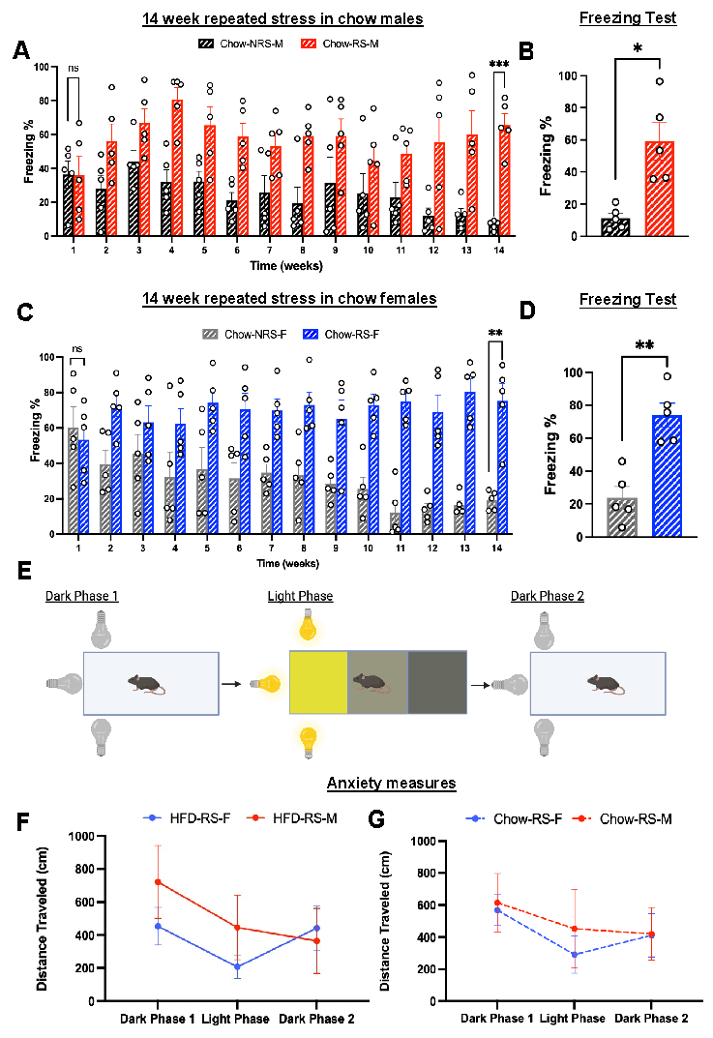
Supplemental Fig 1. Chow fed mice extinguish fear memory and while neither diet nor repeated shocks have an effect on anxiety-like phenotypes. A. Percent freezing of chow–fed male mice during 14 weeks of RS/NRS treatment (n=5; two-way ANOVA, F1,112 =89.76; ****p<0.0001) (post hoc comparison at week 14, N=5; Sidak’s multiple comparison test, ***p<0.001). B. Freezing percentage in chow-fed male mice during freezing test conducted after 14 weeks (n=5, two-tailed paired t test; t=3.586, *p<0.05). C. Percent freezing of chow–fed female mice after 14 weeks of RS/NRS treatment (n=5; two-way ANOVA, F1,112 =161.1; ****p<0.0001) (post hoc comparison, n=5; Sidak’s multiple comparison test, **p<0.01). D. Freezing percentage in chow-fed female mice during freezing test conducted after 14 weeks (n=5, two-tailed paired t test; t=4.771, **p<0.01). E. Experimental design of an open field light-gradient task. F. Average distance travelled during the three phases of the behavioral task in HFD fed RS female and male mice (N=5, Two way ANOVA, F_{1,24} = 1.1, p=0.29). G. Average distance travelled during the three phases of the behavioral task in chow-fed RS male and female mice (N=5, Two way ANOVA, F_{1,24} = 0.33, p=0.57).
Sup. Fig. 2. HFD has no effect on insulin tolerance or food consumption. A. Week 14 plasma glucose levels during the ITT test after 4 hours of fasting in HFD mice (n=5,two-way ANOVA, F_{3,87} = 1.037, p=0.38). AUC graphs from 14-week ITT tests of HFD mice (n=5, one-way ANOVA, F _{3,15}=0.189, p=0.902). B. Week 14 plasma glucose levels during the ITT test following 4 hours of fasting in chow-fed mice (n=5, two-way ANOVA, F _{3,96}=112.1, ****p<0.0001) (post hoc comparison, N=4/5, Tukey’s multiple comparison tests, p<0.05). AUC graphs from 14-week ITT tests chow-fed mice (n=5, one-way ANOVA; F _{3,16}=1.103, ****p<0.0001) (post hoc comparison, n=5; Tukey’s multiple comparison test, p<0.05). (*Compares No repeated Shock F vs No repeated Shock M, #Compares No repeated shock F to Repeated Shock M, +Compares Repeated shock F to No repeated Shock M, %Compares Repeated shock F to Repeated Shock M). C. Total food consumption of HFD-fed mice over 60 hours in the metabolic chamber (n=4/5; one-way ANOVA, p>0.05). D. Total food consumption of chow-fed mice in the metabolic chamber over 60 hours (n=5; one-way ANOVA, p>0.05).
Supplemental Fig. 3. Sex and acute stress effects on mice that are fed chow/HFD. A. Energy expenditure (EE) (kCal/hr) of HFD-fed female and male mice during 60 hours of metabolic chamber housing (n=5, One way ANOVA, p>0.05). B. Energy expenditure (EE) (kCal/hr) of chow-fed female and male mice during 60 hours of metabolic chamber housing (N=5, One way ANOVA, p>0.05) C. Respiratory exchange ratio (RER) in HFD-fed female and male mice (N=5, One way ANOVA, p>0.05) D. RER in chow-fed female and male (N=4,5, One way ANOVA, p>0.05) E. Pedestrian locomotion (m) in HFD-fed female and male mice (N=5, One way ANOVA, **p<0.01) (Post hoc comparison, Tukey’s multiple comparison test, p<0.05). F. Pedestrian locomotion (m) in chow-fed female and male mice (N=5, One way ANOVA, **p<0.01) (Post hoc comparison, Tukey’s multiple comparison test, p<0.05).

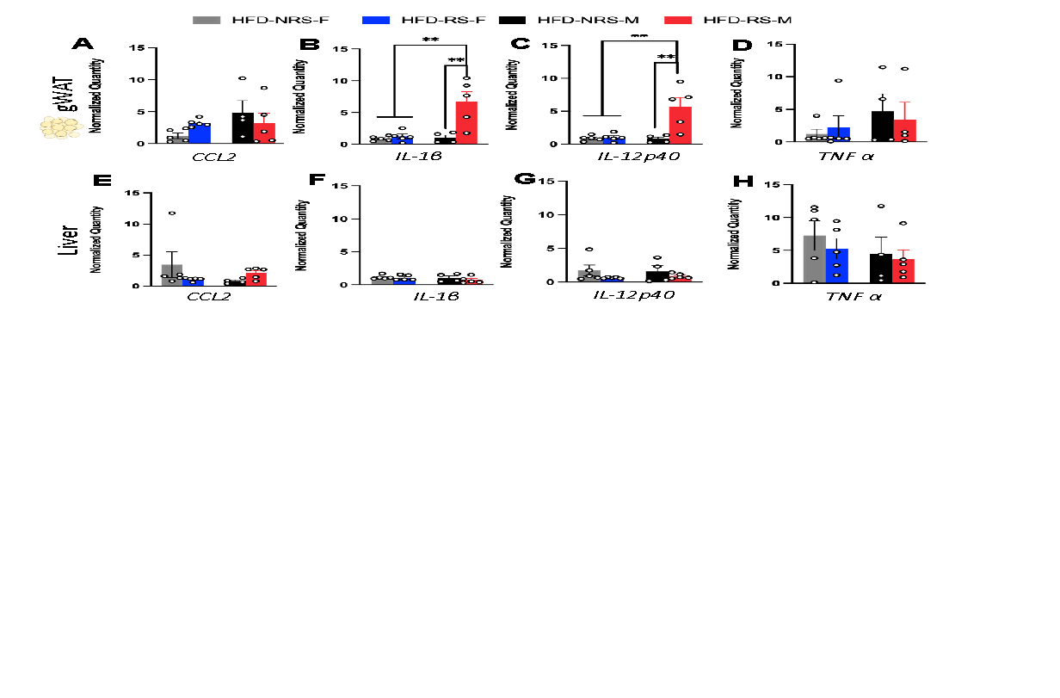
Supplemental Fig 4. HFD induces upregulation of inflammatory markers in the peripheral tissue. A. Normalized quantification of CCL2 gene expression in gWAT of HFD fed animals (n=9, two way ANOVA, F_{1,15} = 2.248, p=0.1545) B. Quantification of pro-inflammatory cytokine IL-1β in gWAT of HFD mice (N=9, two way ANOVA, F_{1,15} = 9.796 &11.08 respectively, **p<0.01) (Post hoc comparison, N=4/5, Tukey’s multiple comparison test, **p<0.01). C. Quantification of cytokine IL-12p40 in gWAT of HFD fed mice (n=9/10, two way ANOVA, F_{1,15} = 9.796 & 11.08 respectively, *p<0.05 & **p<0.01 respectively) (Post hoc comparison, n=4/5, Tukey’s multiple comparison test, **p<0.01). D. Quantification of TNF α levels in HFD fed animals in the gWAT(n=9, two way ANOVA, p=0.26). E,F,G &H. Quantification of CCL2, IL-1β, IL-12p40 or TNF α gene expression levels in liver of HFD-fed animals (N=9, two way ANOVA, p<0.05).
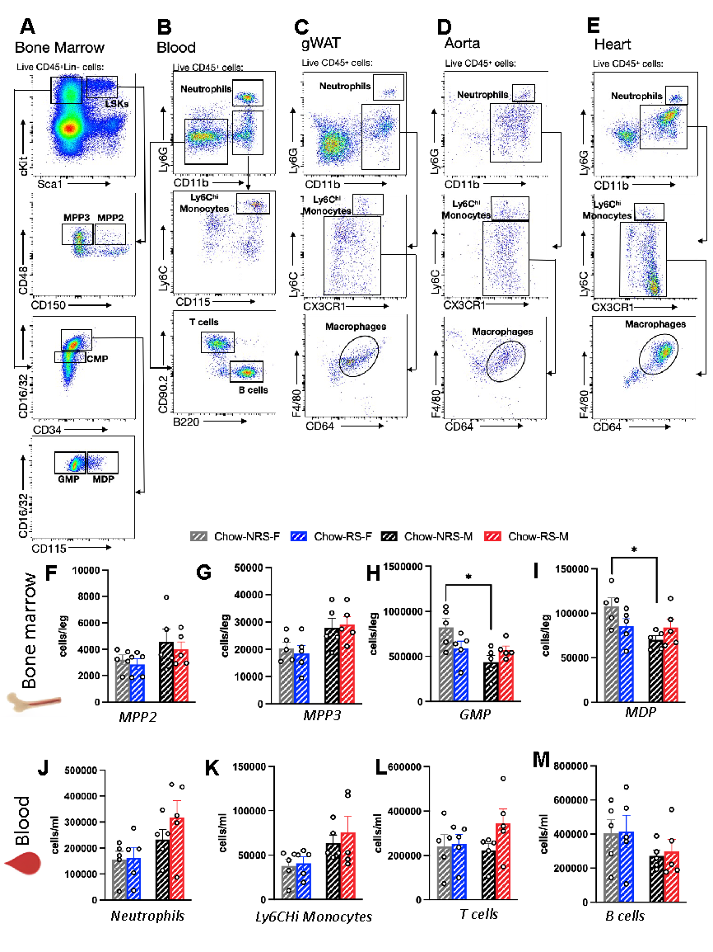
Supplemental Fig. 5 Chow diet has minimal effects on peripheral myeloid lineage cells and inflammatory markers. A-E. Gating strategies for flow cytometric data analysis. F. FACS analysis and further quantification of MPP2 cells in the BM of HFD (n=10, two way ANOVA, F_{1,16} = 4.007, p=0.06). G. Quantification of MPP3 cells in the BM of chow-fed animals (n=10, two way ANOVA, F_{1,16} = 9.504, p=0.07) H. Quantification of GMPs in BM of chow fed animals (n=10, two way ANOVA, F_{1,16} = 7.478, *p<0.05) (Post hoc comparison, n=5, Tukey’s multiple comparison test,* p<0.05). I. Quantification of MDPs in the BM of chow animals (N=10, two way ANOVA, F_{1,16} = 5.604, *p<0.05) (Post hoc comparison, N=5, Tukey’s multiple comparison test,* p<0.05). J. Quantification of neutrophil levels in the blood of chow fed mice (N=9, two way ANOVA, F_{1,16} = 6.46, p=0.02) (Post hoc comparison, N=5, Tukey’s multiple comparison test, p>0.05). K. Quantification of Ly6CHi monocytes in the blood of chow fed mice (n=10, two way ANOVA, F_{1,16} = 6.46, *p<0.05) (Post hoc comparison, N=5, Tukey’s multiple comparison test, p>0.05). L. Quantification of T cells in the blood of chow-fed animals (n=9, two way ANOVA, F_{1,16} = 0.581, p=0.45). M. Quantification of B cells in the blood of chow-fed animals (n=10, two way ANOVA, F_{1,16} = 2.77, p=0.16).

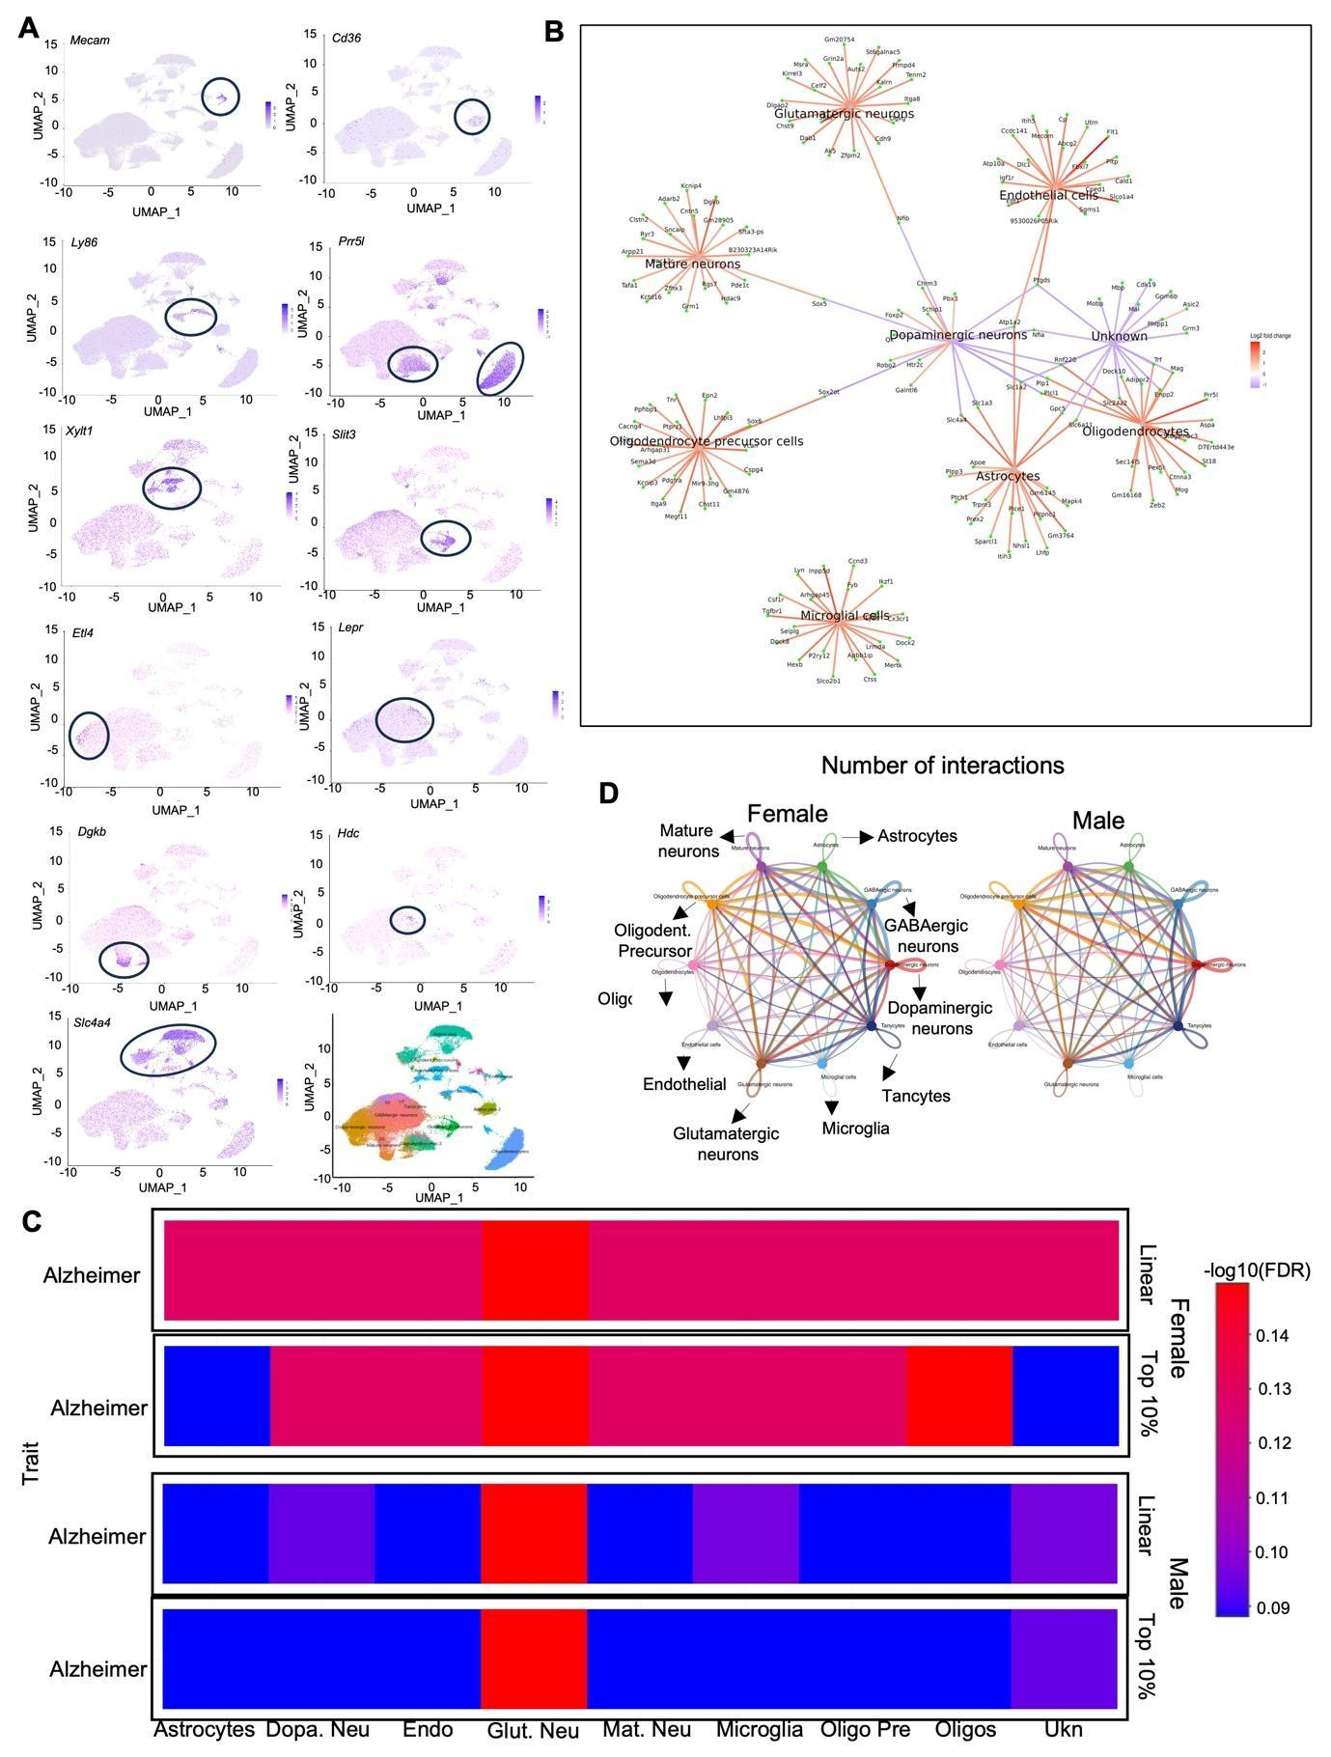
Supplemental Fig. 6. scRNA-seq from VMH show celltype specific gene expression, cellular interaction and GWAS phenotype in males and females. A. The UMAP plot depicts the distribution of annotated clusters from the combined dataset based on indicated marker genes. B. Analysis of cell-type-specific feature genes and shared gene connections within labeled clusters. C. A GWAS study reveals Alzheimer traits associated with differentially expressed genes (DEGs) in male and female mice across specified cell types. D. The interactome illustrates the number of interactions between cell types, derived from ligand-receptor interactions in males and females.

