Supplementary Information

Sex differences in the human brain related to visual motion perception
Dong-Yu Liu^{1#}, Ming Li^{2#}, Juan Yu³, Yuan Gao¹, Xiaotong Zhang^{4, 5}, Dewen Hu², Georg Northoff⁶, Xue Mei Song^{1, 3, 4 *}, Junming Zhu^{1, 4*}

*Correspondence: dr.zhujunming@zju.edu.cn, songxuemei@zju.edu.cn.

This PDF file includes:
Figures S1 to S5
Table S1

Supplementary Figures and Legends

Fig. S1 No sex differences in the signal change percentage of bilateral MT+.
There were no significant sex differences (P = 0.21) in the signal change percentage of bilateral MT+ for males (0.06 ± 0.01, n = 14) and females (0.05 ± 0.01, n = 14).

Fig. S2 No sex differences in the duration thresholds of large stimulus.
There were no significant differences (P = 0.29) of duration thresholds in large stimulus for males (4.94 ± 0.12ms, n = 30) compared to females (5.22 ± 0.22ms, n = 31). The thick dashed line represents the median and the thin dashed line represents the quartiles. Two-sample 𝑡-test, ns: no significance.

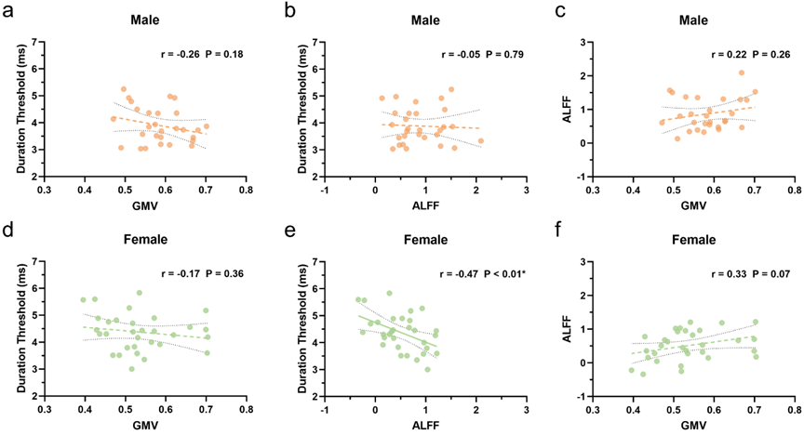

Fig. S3 Correlations among inter-individual’s variables of left MT+ GMV, ALFF in slow 3 and ST within the male and female groups.
(a) No significant correlation between duration thresholds of small stimuli (ST values) and the GMV values of left MT+ in the male group. (b) No significant correlation between ST values and the ALFF values in slow 3 frequency band in left MT+ in the male group. (c) No significant correlation between left MT+ GMV and ALFF slow 3 values in the male group. (d) No significant correlation between duration thresholds of small stimuli (ST values) and the GMV values of left MT+ in the female group. (e) A significant negative correlation between ST values and the ALFF values in slow 3 frequency band in left MT+ in the female group. (f) No significant correlation between left MT+ GMV and ALFF slow 3 values in the female group.

Fig. S4 No significant of sex differences in FCs of MT+ and amygdala.
(a) There were no significant differences in FC values of left MT+ and right amygdala (P = 0.73) and FC values of left MT+ and left amygdala (P = 0.57). (b) There were no significant differences in FC values of right MT+ and right amygdala (P = 0.29) and FC values of right MT+ and left amygdala (P = 0.80).

Fig. S5 No significant of sex differences in FCs of MT+ and contralateral amygdala subregions
- There were no significant differences in FC values of left MT+ and right CM subregion of amygdala (P = 0.44), FC values of left MT+ and right LB subregion of amygdala (P = 0.62), and FC values of left MT+ and right SF subregion of amygdala (P = 0.39). (b) There were no significant differences in FC values of right MT+ and left CM subregion of amygdala (P = 0.11), FC values of right MT+ and left LB subregion of amygdala (P = 0.86), and FC values of right MT+ and left SF subregion of amygdala (P = 0.27).

Table S1. Descriptive statistics (Mean ± SD) of demographic information

 |  | Male |  | Female |  | P value
Cohort 1 |  | N=17 |  | N=16 |  | –
Age (years) |  | 25.00±2.35 |  | 23.00±2.15 |  | 0.02
Education (years) |  | 17.24±2.86 |  | 16.81±1.84 |  | 0.73
Cohort 2 |  | N=30 |  | N=32 |  | –
Age (years) |  | 23.07±2.06 |  | 23.25±2.46 |  | 0.76
Education (years) |  | 17.07±2.06 |  | 17.25±2.46 |  | 0.76
Differences in age and education were analyzed using two-sample t-test.

