Sex-specific difference on anxiety- and depressive-like behavior in Neuronal growth regulator 1-knockout mice

So Rok Lee¹, Eunji Yoon², Sooyeon Baek¹, Jin Gyeom Kim^{1,5}, Jong-Oh Kim³, Su-In Yoon^{1, 2}, Soojin Lee⁴, Jin Ah Cho^{1, 5, *}

Supplementary Table. S1 Target genes and primer sequences for mouse RT-qPCR
Gene | Primer | Sequence (5′→3′)
Bdnf | forward | TGA GTC TCC AGG ACA GCA AA
Bdnf | reverse | GCC TTC ATG CAA CCG AAG TA
Muc2 | forward | GCC TGT TTG ATA GCT GCT ATG TGC C
Muc2 | reverse | GTT CCG CCA GTC AAT GCA GAC AC
Occludin | forward | ACC CGA AGA AAG ATG CAT CG
Occludin | reverse | CAT AGT CAG ATG GGG GTG GA
Claudin-2 | forward | CCT TCG GGA CTT CTA CTC GC
Claudin-2 | reverse | TCA CAC ATA CCC AGT CAG GC
Zo-1 | forward | AAG AAA AAA GAA TGC ACA GAG TTG TT
Zo-1 | reverse | GAA ATC GTG CTG ATG TGC CA
Gapdh | forward | ACA ACT TTG GCA TTG TGG AA
Gapdh | reverse | GAT GCA GGG ATG ATG TTC TG

Supplementary Table. S2 Target genes and primer sequences for mouse RT-PCR
Gene | Primer | Sequence (5′→3′) | Base Pair (bp)
Xbp1 | forward | GAG TCC GCA GCA GGT G | Xbp1u:171
 | reverse | GTG TCA GAG TCC ATG GGA | Xbp1s:145
Chop | forward | CAC ATC CCA AAG CCC TCG CTC TC | 286
Chop | reverse | TGC TTG GTG CAG GCT GAC CAT | 286
Gapdh | forward | T CAC TGC CAC CCA GAA GAC TG | 147
Gapdh | reverse | ATG CCA GTG AGC TTC CCG TTC AG | 147

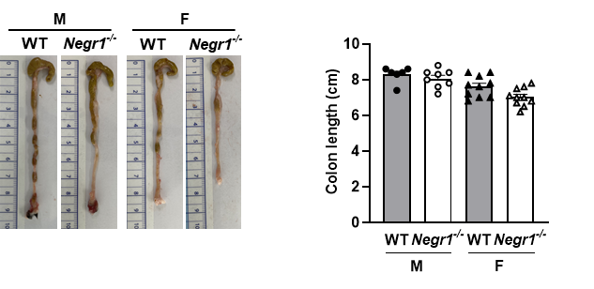
Supplementary Figure. S1 Negr1^{−/−} mice have colon lengths comparable to those of WT mice. Representative colon length image (left) and colon lengths for all samples (right). Two-way ANOVA was used to assess group main effects and interactions. Data are presented as mean ± SEM. M, males; F, females.

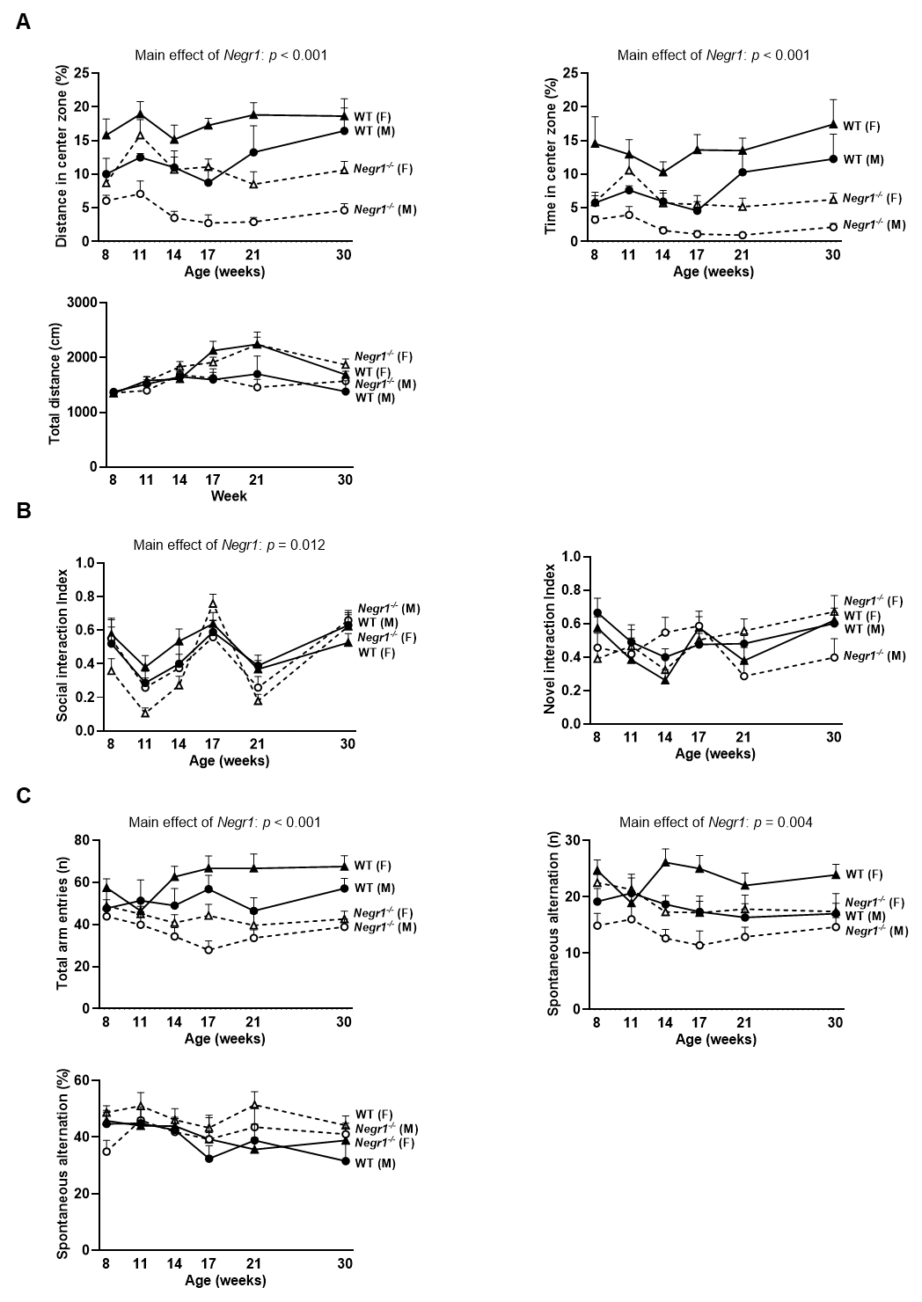

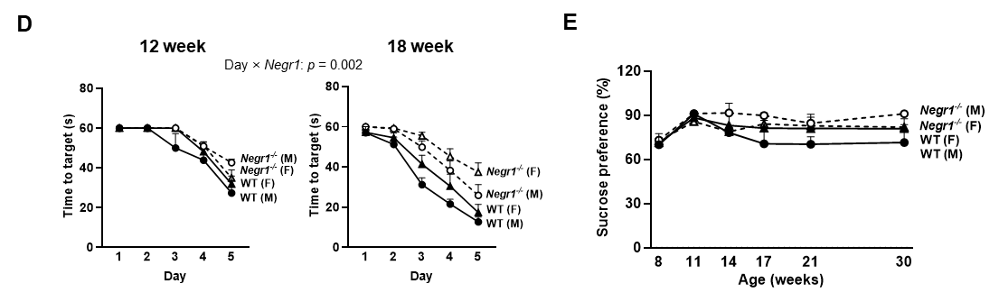Supplementary Figure. S2 Negr1^{−/−} mice exhibit behavioral phenotypes common to both sexes. Behavioral tests (OFT, 3-SIT, Y-maze and SPT) at weeks 8, 11, 14, 17, 21, and 30 across all groups. A. Evaluation of anxiety-like behavior using the OFT. B. Evaluation of social interaction and social novelty using the 3-SIT. C. Evaluation of short-term spatial memory using the Y-maze. D. Evaluation of spatial learning using the MWM at 12 and 18 weeks. E. Evaluation of anhedonia using the SPT. RM-ANOVA was used to assess group main effects and interactions, with Sidak’s post hoc comparisons. Data are presented as mean ± SEM. M, males; F, females.

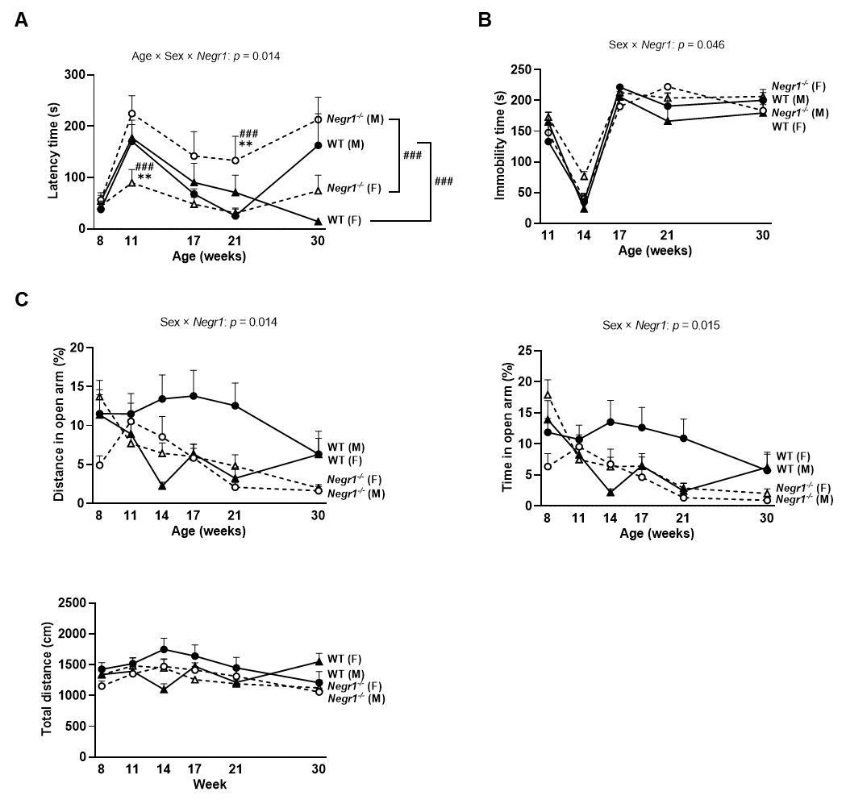
Supplementary Figure. S3 Negr1^{−/−} mice exhibit sex-specific behavioral phenotypes. A. Evaluation of fear learning using the PAT at 8, 11, 17, 21, and 30 weeks. B. Evaluation of depressive-like using the TST at 11, 14, 17, 21, and 30 weeks. C. Evaluation of anxiety-like using the EPM at 8, 11, 14, 17, 21, and 30 weeks. Male vs. female comparisons: ### p < 0.001. WT vs. Negr1–/– comparisons: ** p < 0.01. Data are presented as mean ± SEM. M, males; F, females.

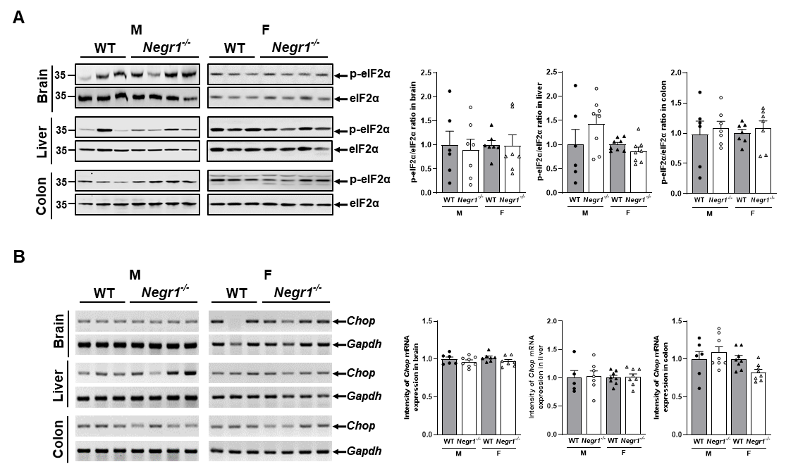
Supplementary Figure. S4 Negr1^{−/−} mice exhibit no sex-specific changes in eIF2α–CHOP related ER stress responses. A. p-eIF2α protein expression in the brain, liver, and colon measured by Western blot. Normalization to p-eIF2α/eIF2α ratios in brain, liver and colon. B. Chop mRNA expression in the brain, liver, and colon measured by RT-PCR. Protein and mRNA expression were quantified using ImageJ. Two-way ANOVA was used to assess group main effects and interactions. Data are presented as mean ± SEM. M, males; F, females.

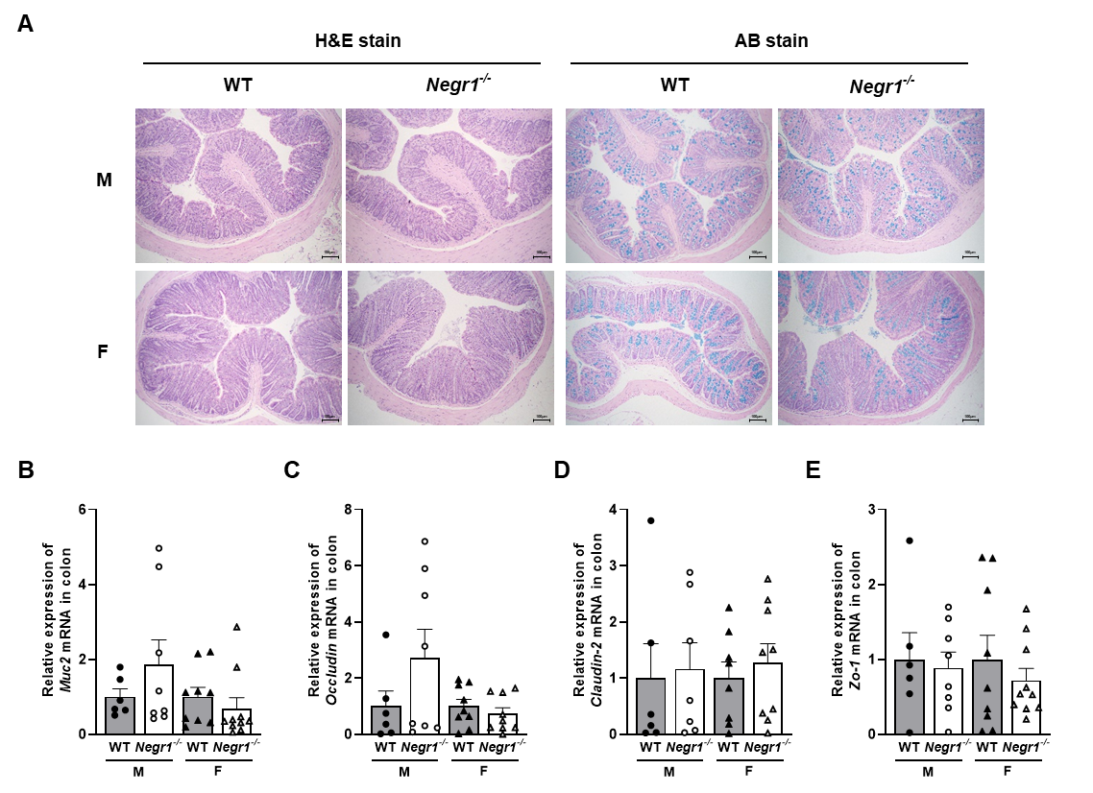
Supplementary Figure. S5 Negr1^{−/−} mice exhibit no sex-specific differences in colon structure or tight-junction expression. A. Representative H&E and AB staining of the colon. Scale bar =100 μm. B-E. Muc2, Occludin, Claudin-2, Zo-1 mRNA expression in colon measured by RT-qPCR. Two-way ANOVA was used to assess group main effects and interactions. Data are presented as mean ± SEM. M, males; F, females.

