 | TableS1.Lifetime risks(%) of developing and dying from PUD in 1990 and 2021,male
Location |  | LRDE(95% CI) |  | AAPC,1990-2021 | LRDY(95% CI) |  | AAPC,1990-2021
 |  | 1990 | 2021 | AAPC,1990-2021 | 1990 | 2021 | AAPC,1990-2021
Global |  | 4.99(4.98-5.01) | 3.21(3.20,3.22) | -1.43 (-1.53, -1.33) | 0.79(0.78,0.79) | 0.34(0.34,0.34) | -2.73 (-2.86, -2.60)
High SDI |  | 4.87(4.84-4.91) | 3.77(3.73,3.82) | -0.82 (-0.91, -0.74) | 0.53(0.52,0.53) | 0.22(0.22,0.23) | -2.84 (-3.32, -2.35)
High-middle SDI |  | 4.74(4.71-4.77) | 3.22(3.19,3.25) | -1.23 (-1.37, -1.09) | 0.58(0.57,0.59) | 0.31(0.30,0.31) | -2.11 (-2.42, -1.80)
Middle SDI |  | 5.55(5.52-5.57) | 3.27(3.25,3.28) | -1.71 (-1.83, -1.60) | 0.82(0.81,0.83) | 0.33(0.33,0.34) | -2.90 (-3.03, -2.77)
Low-middle SDI |  | 5.56(5.53-5.59) | 2.93(2.91,2.95) | -2.06 (-2.19, -1.93) | 1.25(1.24,1.26) | 0.44(0.44,0.44) | -3.31 (-3.52, -3.10)
Low SDI |  | 3.82(3.79-3.85) | 2.66(2.64,2.68) | -1.13 (-1.47, -0.79) | 1.04(1.02,1.05) | 0.47(0.46,0.48) | -2.66 (-3.08, -2.24)
Regional
Southern Latin America |  | 2.11(2.04-2.17) | 1.61(1.55,1.66) | -0.91 (-1.07, -0.75) | 0.45(0.42,0.48) | 0.18(0.16,0.20) | -2.88 (-3.87, -1.88)
Western Europe |  | 2.98(2.95-3.01) | 1.95(1.90,1.99) | -1.37 (-1.43, -1.30) | 0.57(0.56,0.59) | 0.21(0.21,0.22) | -3.25 (-3.76, -2.74)
High-income North America |  | 5.40(5.35-5.46) | 4.22(4.17,4.28) | -0.82 (-0.95, -0.68) | 0.32(0.31,0.33) | 0.12(0.11,0.12) | -3.20 (-3.69, -2.72)
Australasia |  | 3.78(3.62-3.93) | 1.99(1.85,2.13) | -2.07 (-2.21, -1.93) | 0.71(0.65,0.78) | 0.19(0.16,0.21) | -4.16 (-4.88, -3.44)
High-income Asia Pacific |  | 6.60(6.45-6.75) | 5.42(5.10,5.74) | -0.65 (-0.87, -0.43) | 0.61(0.59,0.64) | 0.24(0.23,0.25) | -2.91 (-3.19, -2.64)
Caribbean |  | 3.42(3.28-3.55) | 2.30(2.20,2.40) | -1.17 (-1.42, -0.92) | 0.92(0.86,0.98) | 0.39(0.36,0.41) | -2.88 (-3.41, -2.34)
Central Latin America |  | 3.33(3.26-3.39) | 1.61(1.59,1.64) | -2.49 (-2.68, -2.30) | 1.11(1.07,1.15) | 0.32(0.31,0.33) | -4.03 (-4.48, -3.57)
Tropical Latin America |  | 4.02(3.96-4.08) | 1.91(1.88,1.94) | -2.37 (-2.59, -2.15) | 0.60(0.57,0.62) | 0.30(0.29,0.31) | -2.21 (-2.48, -1.95)
Andean Latin America |  | 3.70(3.55-3.84) | 1.79(1.73,1.86) | -2.46 (-2.69, -2.23) | 1.12(1.04,1.20) | 0.20(0.18,0.21) | -5.72 (-6.39, -5.05)
Central Sub-Saharan Africa |  | 2.49(2.42-2.57) | 2.17(2.12,2.22) | -0.45 (-0.58, -0.32) | 0.62(0.58,0.65) | 0.43(0.40,0.45) | -1.26 (-1.48, -1.03)
Eastern Sub-Saharan Africa |  | 2.63(2.59-2.66) | 2.34(2.31,2.37) | 0.12 (-0.06, 0.31) | 0.88(0.86,0.90) | 0.53(0.51,0.54) | -1.43 (-2.46, -0.38)
Southern Sub-Saharan Africa |  | 2.93(2.84-3.02) | 1.93(1.89,1.97) | -1.34 (-1.70, -0.98) | 0.55(0.50,0.59) | 0.24(0.23,0.25) | -2.66 (-2.92, -2.39)
Western Sub-Saharan Africa |  | 2.88(2.83-2.93) | 2.67(2.63,2.70) | -0.29 (-0.39, -0.19) | 0.57(0.55,0.59) | 0.33(0.32,0.34) | -1.77 (-2.07, -1.47)
North Africa and Middle East |  | 3.03(2.99-3.07) | 2.16(2.14,2.19) | -1.11 (-1.18, -1.03) | 0.63(0.61,0.65) | 0.20(0.20,0.21) | -3.70 (-3.90, -3.50)
South Asia |  | 6.32(6.29-6.36) | 2.89(2.88,2.91) | -2.50 (-2.66, -2.35) | 1.39(1.38,1.40) | 0.44(0.43,0.44) | -3.69 (-3.93, -3.46)
East Asia |  | 6.90(6.86-6.93) | 4.35(4.31,4.38) | -1.50 (-1.65, -1.34) | 0.86(0.85,0.87) | 0.38(0.37,0.38) | -2.66 (-2.95, -2.37)
Southeast Asia |  | 4.47(4.43-4.52) | 3.24(3.21,3.28) | -1.02 (-1.15, -0.88) | 0.73(0.71,0.74) | 0.37(0.36,0.37) | -2.13 (-2.31, -1.96)
Oceania(Expect Australasia) |  | 6.08(5.59-6.57) | 4.60(4.28,4.93) | -0.85 (-1.02, -0.67) | 0.96(0.80,1.11) | 0.49(0.43,0.56) | -2.05 (-2.25, -1.84)
Central Asia |  | 3.42(3.33-3.51) | 3.01(2.92,3.10) | -2.50 (-2.66, -2.35) | 0.55(0.52,0.58) | 0.40(0.38,0.42) | -1.20 (-1.72, -0.67)
Eastern Europe |  | 4.19(4.14-4.23) | 3.69(3.64,3.75) | -0.46 (-0.87, -0.05) | 0.49(0.48,0.50) | 0.47(0.46,0.48) | -0.07 (-0.78, 0.66)
Central Europe |  | 4.17(4.10-4.23) | 3.62(3.51,3.74) | -0.43 (-0.63, -0.23) | 0.61(0.59,0.62) | 0.46(0.44,0.47) | -0.92 (-1.28, -0.55)
LRDE=lifetime risk of developing(%); LRDY=lifetime risk of dying(%);CI = confidence interval;SDI:sociodemographic index

Table S2.Lifetime risks(%) of developing and dying from PUD in 1990 and 2021,female
Location | LRDE(95% CI) |  | AAPC,1990-2021 | LRDY(95% CI) |  | AAPC,1990-2021
Location | 1990 | 2021 | AAPC,1990-2021 | 1990 | 2021 | AAPC,1990-2021
Global | 4.37(4.36-4.39) | 3.21(3.20,3.23) | -1.00 (-1.10, -0.89) | 0.61(0.60,0.61) | 0.35(0.35,0.36) | -1.80 (-2.00, -1.60)
High SDI | 4.63(4.58-4.68) | 3.92(3.85,3.98) | -0.54 (-0.66, -0.42) | 0.53(0.52,0.53) | 0.23(0.23,0.23) | -2.69 (-2.91, -2.48)
High-middle SDI | 3.33(3.30-3.36) | 2.55(2.51,2.59) | -0.83 (-0.92, -0.73) | 0.34(0.33,0.34) | 0.26(0.26,0.27) | -0.85 (-1.36, -0.35)
Middle SDI | 4.84(4.81-4.86) | 3.02(3.00,3.04) | -1.51 (-1.68, -1.33) | 0.70(0.69,0.71) | 0.37(0.36,0.37) | -2.06 (-2.35, -1.77)
Low-middle SDI | 5.33(5.30-5.36) | 3.52(3.49,3.54) | -1.35 (-1.54, -1.16) | 0.97(0.96,0.98) | 0.51(0.51,0.52) | -2.05 (-2.25, -1.84)
Low SDI | 3.49(3.46-3.53) | 2.89(2.87,2.92) | -0.63 (-0.74, -0.52) | 0.86(0.85,0.88) | 0.55(0.54,0.56) | -1.48 (-1.89, -1.06)
Regional
Southern Latin America | 1.61(1.55-1.68) | 1.36(1.30,1.42) | -0.54 (-0.67, -0.41) | 0.29(0.27,0.32) | 0.16(0.14,0.17) | -1.84 (-2.91, -0.76)
Western Europe | 2.64(2.61-2.68) | 1.77(1.72,1.83) | -1.32 (-1.48, -1.16) | 0.56(0.55,0.57) | 0.21(0.20,0.21) | -3.17 (-3.36, -2.98)
High-income North America | 6.28(6.18-6.38) | 5.30(5.20,5.40) | -0.59 (-0.77, -0.40) | 0.35(0.34,0.36) | 0.13(0.12,0.13) | -3.20 (-3.96, -2.45)
Australasia | 4.13(3.93-4.33) | 2.01(1.81,2.20) | -2.31 (-2.43, -2.19) | 0.86(0.79,0.94) | 0.20(0.17,0.23) | -4.50 (-4.83, -4.17)
High-income Asia Pacific | 5.30(5.17-5.43) | 4.07(3.80,4.33) | -0.84 (-1.01, -0.66) | 0.67(0.65,0.70) | 0.24(0.23,0.25) | -3.29 (-3.76, -2.81)
Caribbean | 2.44(2.27-2.61) | 1.91(1.75,2.06) | -0.65 (-1.32, 0.02) | 0.54(0.49,0.59) | 0.27(0.25,0.30) | -1.86 (-2.24, -1.47)
Central Latin America | 3.20(3.13-3.27) | 1.73(1.71,1.76) | -1.97 (-2.14, -1.81) | 1.22(1.17,1.27) | 0.38(0.36,0.39) | -3.77 (-4.15, -3.39)
Tropical Latin America | 3.36(3.28-3.43) | 1.71(1.68,1.75) | -2.13 (-2.47, -1.78) | 0.44(0.41,0.46) | 0.26(0.25,0.27) | -1.67 (-2.13, -1.22)
Andean Latin America | 3.49(3.31-3.67) | 2.03(1.95,2.11) | -1.68 (-2.06, -1.31) | 0.95(0.87,1.03) | 0.24(0.22,0.26) | -4.50 (-5.11, -3.90)
Central Sub-Saharan Africa | 2.19(2.10-2.27) | 2.46(2.39,2.54) | 0.36 (0.31, 0.40) | 0.45(0.41,0.49) | 0.42(0.40,0.44) | -0.25 (-0.46, -0.04)
Eastern Sub-Saharan Africa | 1.64(1.60-1.67) | 1.59(1.56,1.62) | -0.13 (-0.32, 0.07) | 0.55(0.53,0.57) | 0.44(0.42,0.45) | -0.66 (-1.18, -0.13)
Southern Sub-Saharan Africa | 2.46(2.37-2.56) | 1.77(1.72,1.82) | -1.08 (-1.49, -0.67) | 0.60(0.54,0.65) | 0.29(0.28,0.31) | -2.37 (-2.72, -2.01)
Western Sub-Saharan Africa | 2.93(2.86-2.99) | 3.31(3.26,3.37) | 0.40 (0.33, 0.47) | 0.57(0.55,0.59) | 0.56(0.54,0.58) | -0.10 (-0.32, 0.12)
North Africa and Middle East | 3.14(3.09-3.19) | 2.72(2.67,2.77) | -0.49 (-0.64, -0.35) | 0.47(0.45,0.48) | 0.22(0.21,0.23) | -2.50 (-2.77, -2.23)
South Asia | 6.36(6.32-6.39) | 3.78(3.76,3.81) | -1.66 (-1.88, -1.45) | 1.21(1.20,1.23) | 0.59(0.59,0.60) | -2.32 (-2.50, -2.14)
East Asia | 5.64(5.61-5.68) | 3.40(3.36,3.44) | -1.64 (-1.71, -1.56) | 0.62(0.61,0.62) | 0.31(0.31,0.32) | -2.23 (-2.55, -1.91)
Southeast Asia | 4.25(4.21-4.30) | 3.08(3.04,3.13) | -0.95 (-1.36, -0.54) | 0.67(0.65,0.69) | 0.42(0.41,0.43) | -1.44 (-1.64, -1.23)
Oceania(Expect Australasia) | 5.15(4.60-5.71) | 4.59(4.17,5.01) | -0.33 (-0.45, -0.21) | 0.67(0.51,0.83) | 0.38(0.31,0.46) | -1.74 (-2.00, -1.47)
Central Asia | 2.18(2.09-2.28) | 2.48(2.37,2.59) | 0.40 (0.28, 0.52) | 0.23(0.21,0.25) | 0.28(0.26,0.30) | 0.58 (-0.09, 1.25)
Eastern Europe | 2.00(1.96-2.04) | 2.47(2.41,2.54) | 0.70 (0.38, 1.02) | 0.19(0.18,0.20) | 0.36(0.36,0.37) | 2.08 (1.52, 2.64)
Central Europe | 3.59(3.47-3.70) | 3.55(3.34,3.76) | -0.01 (-0.11, 0.09) | 0.40(0.38,0.42) | 0.42(0.40,0.43) | 0.14 (-0.35, 0.63)
LRDE=lifetime risk of developing(%); LRDY=lifetime risk of dying(%);CI = confidence interval;SDI:sociodemographic index

Table S3.The gender ratio of global and regional lifetime risks of developing PUD from 1990 to 2021
year | location_name | gender_ratio
1990 | Global | 1.14(1.14-1.15)
1991 | Global | 1.15(1.14-1.15)
1992 | Global | 1.15(1.14-1.15)
1993 | Global | 1.14(1.14-1.15)
1994 | Global | 1.14(1.13-1.14)
1995 | Global | 1.14(1.13-1.15)
1996 | Global | 1.13(1.13-1.14)
1997 | Global | 1.13(1.12-1.13)
1998 | Global | 1.11(1.11-1.12)
1999 | Global | 1.10(1.10-1.11)
2000 | Global | 1.09(1.09-1.09)
2001 | Global | 1.09(1.08-1.09)
2002 | Global | 1.08(1.08-1.09)
2003 | Global | 1.08(1.07-1.09)
2004 | Global | 1.08(1.07-1.08)
2005 | Global | 1.07(1.07-1.08)
2006 | Global | 1.07(1.07-1.08)
2007 | Global | 1.07(1.06-1.07)
2008 | Global | 1.06(1.06-1.07)
2009 | Global | 1.06(1.06-1.07)
2010 | Global | 1.06(1.05-1.06)
2011 | Global | 1.05(1.05-1.06)
2012 | Global | 1.05(1.04-1.05)
2013 | Global | 1.05(1.04-1.05)
2014 | Global | 1.04(1.04-1.05)
2015 | Global | 1.04(1.03-1.05)
2016 | Global | 1.04(1.03-1.04)
2017 | Global | 1.03(1.03-1.04)
2018 | Global | 1.03(1.02-1.03)
2019 | Global | 1.02(1.02-1.03)
2020 | Global | 1.01(1.00-1.01)
2021 | Global | 1.00(0.99-1.00)
1990 | High SDI | 1.05(1.04-1.07)
1991 | High SDI | 1.06(1.04-1.07)
1992 | High SDI | 1.06(1.05-1.08)
1993 | High SDI | 1.06(1.05-1.08)
1994 | High SDI | 1.06(1.05-1.08)
1995 | High SDI | 1.06(1.05-1.08)
1996 | High SDI | 1.06(1.04-1.07)
1997 | High SDI | 1.05(1.03-1.06)
1998 | High SDI | 1.03(1.02-1.05)
1999 | High SDI | 1.02(1.00-1.03)
2000 | High SDI | 1.01(1.00-1.03)
2001 | High SDI | 1.01(1.00-1.03)
2002 | High SDI | 1.02(1.01-1.04)
2003 | High SDI | 1.04(1.02-1.05)
2004 | High SDI | 1.04(1.03-1.06)
2005 | High SDI | 1.04(1.03-1.06)
2006 | High SDI | 1.04(1.02-1.06)
2007 | High SDI | 1.04(1.02-1.06)
2008 | High SDI | 1.03(1.02-1.05)
2009 | High SDI | 1.03(1.01-1.05)
2010 | High SDI | 1.03(1.01-1.05)
2011 | High SDI | 1.03(1.01-1.05)
2012 | High SDI | 1.03(1.01-1.05)
2013 | High SDI | 1.02(1.00-1.05)
2014 | High SDI | 1.02(1.00-1.04)
2015 | High SDI | 1.01(0.99-1.04)
2016 | High SDI | 1.01(0.99-1.03)
2017 | High SDI | 1.00(0.97-1.02)
2018 | High SDI | 0.98(0.96-1.01)
2019 | High SDI | 0.98(0.95-1.00)
2020 | High SDI | 0.98(0.96-1.00)
2021 | High SDI | 0.96(0.94-0.99)
1990 | High-middle SDI | 1.42(1.41-1.44)
1991 | High-middle SDI | 1.42(1.41-1.44)
1992 | High-middle SDI | 1.42(1.40-1.43)
1993 | High-middle SDI | 1.41(1.39-1.43)
1994 | High-middle SDI | 1.41(1.39-1.42)
1995 | High-middle SDI | 1.40(1.39-1.42)
1996 | High-middle SDI | 1.40(1.39-1.42)
1997 | High-middle SDI | 1.41(1.39-1.42)
1998 | High-middle SDI | 1.40(1.38-1.42)
1999 | High-middle SDI | 1.39(1.37-1.40)
2000 | High-middle SDI | 1.37(1.35-1.39)
2001 | High-middle SDI | 1.36(1.34-1.37)
2002 | High-middle SDI | 1.35(1.33-1.36)
2003 | High-middle SDI | 1.33(1.32-1.35)
2004 | High-middle SDI | 1.31(1.30-1.33)
2005 | High-middle SDI | 1.30(1.29-1.32)
2006 | High-middle SDI | 1.31(1.29-1.32)
2007 | High-middle SDI | 1.31(1.29-1.32)
2008 | High-middle SDI | 1.31(1.29-1.33)
2009 | High-middle SDI | 1.31(1.29-1.33)
2010 | High-middle SDI | 1.31(1.29-1.33)
2011 | High-middle SDI | 1.31(1.29-1.33)
2012 | High-middle SDI | 1.30(1.28-1.32)
2013 | High-middle SDI | 1.30(1.28-1.32)
2014 | High-middle SDI | 1.29(1.27-1.31)
2015 | High-middle SDI | 1.29(1.27-1.31)
2016 | High-middle SDI | 1.28(1.26-1.30)
2017 | High-middle SDI | 1.28(1.26-1.30)
2018 | High-middle SDI | 1.28(1.25-1.30)
2019 | High-middle SDI | 1.27(1.25-1.29)
2020 | High-middle SDI | 1.26(1.23-1.29)
2021 | High-middle SDI | 1.26(1.24-1.29)
1990 | Middle SDI | 1.15(1.14-1.16)
1991 | Middle SDI | 1.15(1.14-1.16)
1992 | Middle SDI | 1.16(1.15-1.17)
1993 | Middle SDI | 1.16(1.15-1.17)
1994 | Middle SDI | 1.16(1.15-1.17)
1995 | Middle SDI | 1.16(1.15-1.17)
1996 | Middle SDI | 1.15(1.14-1.16)
1997 | Middle SDI | 1.14(1.13-1.15)
1998 | Middle SDI | 1.13(1.12-1.14)
1999 | Middle SDI | 1.13(1.12-1.14)
2000 | Middle SDI | 1.12(1.11-1.13)
2001 | Middle SDI | 1.12(1.11-1.13)
2002 | Middle SDI | 1.12(1.11-1.12)
2003 | Middle SDI | 1.11(1.10-1.12)
2004 | Middle SDI | 1.11(1.10-1.12)
2005 | Middle SDI | 1.11(1.10-1.12)
2006 | Middle SDI | 1.11(1.10-1.12)
2007 | Middle SDI | 1.11(1.10-1.12)
2008 | Middle SDI | 1.12(1.11-1.12)
2009 | Middle SDI | 1.12(1.11-1.13)
2010 | Middle SDI | 1.12(1.11-1.13)
2011 | Middle SDI | 1.12(1.11-1.13)
2012 | Middle SDI | 1.11(1.10-1.12)
2013 | Middle SDI | 1.11(1.10-1.12)
2014 | Middle SDI | 1.11(1.10-1.12)
2015 | Middle SDI | 1.11(1.10-1.12)
2016 | Middle SDI | 1.11(1.10-1.12)
2017 | Middle SDI | 1.10(1.09-1.11)
2018 | Middle SDI | 1.10(1.09-1.11)
2019 | Middle SDI | 1.10(1.09-1.11)
2020 | Middle SDI | 1.08(1.07-1.09)
2021 | Middle SDI | 1.08(1.07-1.09)
1990 | Low-middle SDI | 1.04(1.03-1.05)
1991 | Low-middle SDI | 1.04(1.03-1.05)
1992 | Low-middle SDI | 1.04(1.03-1.05)
1993 | Low-middle SDI | 1.03(1.02-1.04)
1994 | Low-middle SDI | 1.03(1.02-1.04)
1995 | Low-middle SDI | 1.03(1.02-1.03)
1996 | Low-middle SDI | 1.02(1.01-1.02)
1997 | Low-middle SDI | 1.00(0.99-1.01)
1998 | Low-middle SDI | 0.99(0.98-1.00)
1999 | Low-middle SDI | 0.98(0.97-0.98)
2000 | Low-middle SDI | 0.96(0.95-0.97)
2001 | Low-middle SDI | 0.95(0.94-0.96)
2002 | Low-middle SDI | 0.94(0.93-0.95)
2003 | Low-middle SDI | 0.93(0.92-0.94)
2004 | Low-middle SDI | 0.92(0.92-0.93)
2005 | Low-middle SDI | 0.92(0.92-0.93)
2006 | Low-middle SDI | 0.92(0.91-0.93)
2007 | Low-middle SDI | 0.91(0.90-0.92)
2008 | Low-middle SDI | 0.91(0.90-0.91)
2009 | Low-middle SDI | 0.90(0.89-0.91)
2010 | Low-middle SDI | 0.89(0.88-0.90)
2011 | Low-middle SDI | 0.89(0.88-0.89)
2012 | Low-middle SDI | 0.89(0.88-0.89)
2013 | Low-middle SDI | 0.89(0.88-0.89)
2014 | Low-middle SDI | 0.88(0.87-0.89)
2015 | Low-middle SDI | 0.88(0.87-0.89)
2016 | Low-middle SDI | 0.88(0.87-0.89)
2017 | Low-middle SDI | 0.87(0.87-0.88)
2018 | Low-middle SDI | 0.87(0.86-0.88)
2019 | Low-middle SDI | 0.87(0.86-0.88)
2020 | Low-middle SDI | 0.84(0.83-0.85)
2021 | Low-middle SDI | 0.83(0.82-0.84)
1990 | Low SDI | 1.09(1.08-1.11)
1991 | Low SDI | 1.10(1.09-1.12)
1992 | Low SDI | 1.11(1.10-1.13)
1993 | Low SDI | 1.11(1.10-1.13)
1994 | Low SDI | 1.05(1.04-1.06)
1995 | Low SDI | 1.11(1.10-1.12)
1996 | Low SDI | 1.10(1.09-1.11)
1997 | Low SDI | 1.09(1.07-1.10)
1998 | Low SDI | 1.07(1.06-1.09)
1999 | Low SDI | 1.06(1.05-1.08)
2000 | Low SDI | 1.06(1.04-1.07)
2001 | Low SDI | 1.05(1.04-1.07)
2002 | Low SDI | 1.05(1.04-1.07)
2003 | Low SDI | 1.05(1.03-1.06)
2004 | Low SDI | 1.04(1.02-1.05)
2005 | Low SDI | 1.03(1.02-1.04)
2006 | Low SDI | 1.03(1.01-1.04)
2007 | Low SDI | 1.02(1.00-1.03)
2008 | Low SDI | 1.01(1.00-1.02)
2009 | Low SDI | 1.00(0.99-1.02)
2010 | Low SDI | 1.00(0.99-1.01)
2011 | Low SDI | 0.99(0.98-1.01)
2012 | Low SDI | 1.00(0.98-1.01)
2013 | Low SDI | 0.99(0.98-1.00)
2014 | Low SDI | 0.99(0.97-1.00)
2015 | Low SDI | 0.98(0.97-0.99)
2016 | Low SDI | 0.97(0.96-0.98)
2017 | Low SDI | 0.96(0.95-0.98)
2018 | Low SDI | 0.96(0.95-0.97)
2019 | Low SDI | 0.96(0.94-0.97)
2020 | Low SDI | 0.93(0.91-0.94)
2021 | Low SDI | 0.92(0.91-0.93)

TableS4.The gender ratio of global and regional lifetime risks of dying PUD from1990 to 2021
year | location_name | gender ratio
1990 | Global | 1.30(1.28-1.31)
1991 | Global | 1.28(1.27-1.30)
1992 | Global | 1.28(1.27-1.30)
1993 | Global | 1.27(1.25-1.28)
1994 | Global | 1.25(1.24-1.26)
1995 | Global | 1.25(1.24-1.26)
1996 | Global | 1.25(1.23-1.26)
1997 | Global | 1.23(1.22-1.25)
1998 | Global | 1.23(1.22-1.24)
1999 | Global | 1.22(1.21-1.24)
2000 | Global | 1.21(1.19-1.23)
2001 | Global | 1.19(1.17-1.21)
2002 | Global | 1.16(1.15-1.17)
2003 | Global | 1.14(1.14-1.15)
2004 | Global | 1.14(1.12-1.15)
2005 | Global | 1.12(1.12-1.12)
2006 | Global | 1.09(1.08-1.10)
2007 | Global | 1.08(1.08-1.08)
2008 | Global | 1.07(1.06-1.08)
2009 | Global | 1.08(1.07-1.10)
2010 | Global | 1.08(1.06-1.09)
2011 | Global | 1.08(1.07-1.09)
2012 | Global | 1.04(1.03-1.06)
2013 | Global | 1.04(1.03-1.06)
2014 | Global | 1.04(1.03-1.06)
2015 | Global | 1.03(1.02-1.04)
2016 | Global | 1.02(1.01-1.04)
2017 | Global | 1.02(1.02-1.02)
2018 | Global | 1.01(1.00-1.02)
2019 | Global | 1.01(1.00-1.02)
2020 | Global | 0.97(0.97-0.97)
2021 | Global | 0.96(0.95-0.97)
1990 | High SDI | 1.00(0.99-1.01)
1991 | High SDI | 0.99(0.97-1.01)
1992 | High SDI | 0.97(0.95-0.99)
1993 | High SDI | 0.95(0.93-0.97)
1994 | High SDI | 0.96(0.93-0.99)
1995 | High SDI | 0.96(0.94-0.97)
1996 | High SDI | 0.95(0.92-0.97)
1997 | High SDI | 0.94(0.92-0.97)
1998 | High SDI | 0.97(0.94-0.99)
1999 | High SDI | 0.98(0.96-0.99)
2000 | High SDI | 0.95(0.93-0.97)
2001 | High SDI | 0.94(0.91-0.97)
2002 | High SDI | 0.95(0.91-0.99)
2003 | High SDI | 0.95(0.93-0.97)
2004 | High SDI | 0.92(0.90-0.94)
2005 | High SDI | 0.94(0.92-0.97)
2006 | High SDI | 0.94(0.92-0.96)
2007 | High SDI | 0.95(0.92-0.99)
2008 | High SDI | 0.97(0.94-0.99)
2009 | High SDI | 0.97(0.94-0.99)
2010 | High SDI | 0.95(0.91-0.99)
2011 | High SDI | 0.97(0.94-0.99)
2012 | High SDI | 0.97(0.94-0.99)
2013 | High SDI | 0.96(0.94-0.99)
2014 | High SDI | 1.00(0.97-1.03)
2015 | High SDI | 1.00(0.97-1.03)
2016 | High SDI | 1.00(0.97-1.03)
2017 | High SDI | 1.00(0.97-1.03)
2018 | High SDI | 1.00(0.97-1.03)
2019 | High SDI | 1.00(0.97-1.03)
2020 | High SDI | 0.98(0.96-1.00)
2021 | High SDI | 0.98(0.96-1.00)
1990 | High-middle SDI | 1.73(1.69-1.78)
1991 | High-middle SDI | 1.70(1.66-1.74)
1992 | High-middle SDI | 1.72(1.69-1.75)
1993 | High-middle SDI | 1.72(1.68-1.77)
1994 | High-middle SDI | 1.70(1.67-1.73)
1995 | High-middle SDI | 1.67(1.63-1.70)
1996 | High-middle SDI | 1.67(1.63-1.72)
1997 | High-middle SDI | 1.62(1.59-1.66)
1998 | High-middle SDI | 1.64(1.61-1.68)
1999 | High-middle SDI | 1.61(1.58-1.65)
2000 | High-middle SDI | 1.56(1.51-1.61)
2001 | High-middle SDI | 1.56(1.53-1.60)
2002 | High-middle SDI | 1.47(1.44-1.51)
2003 | High-middle SDI | 1.47(1.44-1.51)
2004 | High-middle SDI | 1.44(1.41-1.47)
2005 | High-middle SDI | 1.41(1.38-1.44)
2006 | High-middle SDI | 1.42(1.39-1.45)
2007 | High-middle SDI | 1.39(1.35-1.42)
2008 | High-middle SDI | 1.35(1.32-1.38)
2009 | High-middle SDI | 1.35(1.32-1.38)
2010 | High-middle SDI | 1.32(1.28-1.35)
2011 | High-middle SDI | 1.32(1.28-1.35)
2012 | High-middle SDI | 1.27(1.24-1.30)
2013 | High-middle SDI | 1.27(1.24-1.30)
2014 | High-middle SDI | 1.23(1.20-1.26)
2015 | High-middle SDI | 1.23(1.20-1.26)
2016 | High-middle SDI | 1.23(1.20-1.26)
2017 | High-middle SDI | 1.19(1.16-1.22)
2018 | High-middle SDI | 1.20(1.17-1.23)
2019 | High-middle SDI | 1.16(1.14-1.19)
2020 | High-middle SDI | 1.18(1.15-1.21)
2021 | High-middle SDI | 1.15(1.12-1.18)
1990 | Middle SDI | 1.17(1.15-1.20)
1991 | Middle SDI | 1.17(1.15-1.20)
1992 | Middle SDI | 1.16(1.14-1.18)
1993 | Middle SDI | 1.16(1.14-1.17)
1994 | Middle SDI | 1.14(1.12-1.16)
1995 | Middle SDI | 1.13(1.11-1.15)
1996 | Middle SDI | 1.13(1.10-1.15)
1997 | Middle SDI | 1.12(1.10-1.14)
1998 | Middle SDI | 1.11(1.09-1.13)
1999 | Middle SDI | 1.10(1.09-1.11)
2000 | Middle SDI | 1.10(1.09-1.12)
2001 | Middle SDI | 1.09(1.07-1.10)
2002 | Middle SDI | 1.09(1.07-1.10)
2003 | Middle SDI | 1.08(1.06-1.10)
2004 | Middle SDI | 1.08(1.06-1.10)
2005 | Middle SDI | 1.06(1.04-1.08)
2006 | Middle SDI | 1.03(1.01-1.05)
2007 | Middle SDI | 1.01(0.99-1.03)
2008 | Middle SDI | 1.02(1.00-1.03)
2009 | Middle SDI | 1.01(0.99-1.03)
2010 | Middle SDI | 1.02(1.00-1.03)
2011 | Middle SDI | 1.01(0.99-1.03)
2012 | Middle SDI | 0.98(0.96-1.00)
2013 | Middle SDI | 0.98(0.96-1.00)
2014 | Middle SDI | 0.98(0.96-1.00)
2015 | Middle SDI | 0.96(0.94-0.97)
2016 | Middle SDI | 0.98(0.96-1.00)
2017 | Middle SDI | 0.97(0.94-0.99)
2018 | Middle SDI | 0.94(0.92-0.97)
2019 | Middle SDI | 0.94(0.93-0.95)
2020 | Middle SDI | 0.93(0.91-0.94)
2021 | Middle SDI | 0.92(0.90-0.94)
1990 | Low-middle SDI | 1.29(1.27-1.31)
1991 | Low-middle SDI | 1.28(1.26-1.30)
1992 | Low-middle SDI | 1.26(1.24-1.28)
1993 | Low-middle SDI | 1.24(1.23-1.26)
1994 | Low-middle SDI | 1.23(1.21-1.25)
1995 | Low-middle SDI | 1.21(1.20-1.23)
1996 | Low-middle SDI | 1.21(1.19-1.22)
1997 | Low-middle SDI | 1.21(1.19-1.23)
1998 | Low-middle SDI | 1.18(1.16-1.20)
1999 | Low-middle SDI | 1.16(1.14-1.18)
2000 | Low-middle SDI | 1.15(1.13-1.17)
2001 | Low-middle SDI | 1.13(1.11-1.15)
2002 | Low-middle SDI | 1.10(1.08-1.12)
2003 | Low-middle SDI | 1.08(1.06-1.10)
2004 | Low-middle SDI | 1.04(1.03-1.06)
2005 | Low-middle SDI | 1.02(1.01-1.04)
2006 | Low-middle SDI | 0.98(0.96-1.00)
2007 | Low-middle SDI | 0.96(0.94-0.97)
2008 | Low-middle SDI | 0.94(0.93-0.96)
2009 | Low-middle SDI | 0.95(0.93-0.97)
2010 | Low-middle SDI | 0.97(0.95-0.98)
2011 | Low-middle SDI | 0.96(0.94-0.97)
2012 | Low-middle SDI | 0.95(0.93-0.97)
2013 | Low-middle SDI | 0.95(0.94-0.97)
2014 | Low-middle SDI | 0.97(0.95-0.98)
2015 | Low-middle SDI | 0.94(0.92-0.97)
2016 | Low-middle SDI | 0.94(0.93-0.95)
2017 | Low-middle SDI | 0.93(0.92-0.94)
2018 | Low-middle SDI | 0.94(0.92-0.96)
2019 | Low-middle SDI | 0.92(0.91-0.93)
2020 | Low-middle SDI | 0.88(0.86-0.89)
2021 | Low-middle SDI | 0.85(0.85-0.86)
1990 | Low SDI | 1.20(1.17-1.23)
1991 | Low SDI | 1.20(1.17-1.23)
1992 | Low SDI | 1.19(1.17-1.22)
1993 | Low SDI | 1.19(1.17-1.22)
1994 | Low SDI | 1.11(1.08-1.14)
1995 | Low SDI | 1.16(1.13-1.19)
1996 | Low SDI | 1.16(1.14-1.19)
1997 | Low SDI | 1.16(1.14-1.19)
1998 | Low SDI | 1.17(1.14-1.19)
1999 | Low SDI | 1.15(1.12-1.18)
2000 | Low SDI | 1.13(1.10-1.16)
2001 | Low SDI | 1.11(1.09-1.13)
2002 | Low SDI | 1.08(1.06-1.11)
2003 | Low SDI | 1.07(1.04-1.09)
2004 | Low SDI | 1.06(1.03-1.08)
2005 | Low SDI | 1.03(1.01-1.06)
2006 | Low SDI | 1.01(0.98-1.04)
2007 | Low SDI | 1.00(0.97-1.03)
2008 | Low SDI | 0.98(0.96-1.01)
2009 | Low SDI | 0.98(0.96-1.01)
2010 | Low SDI | 0.99(0.97-1.02)
2011 | Low SDI | 0.99(0.97-1.01)
2012 | Low SDI | 0.97(0.94-0.99)
2013 | Low SDI | 0.95(0.93-0.98)
2014 | Low SDI | 0.94(0.92-0.97)
2015 | Low SDI | 0.94(0.92-0.97)
2016 | Low SDI | 0.93(0.90-0.95)
2017 | Low SDI | 0.91(0.89-0.94)
2018 | Low SDI | 0.90(0.88-0.92)
2019 | Low SDI | 0.90(0.88-0.92)
2020 | Low SDI | 0.87(0.85-0.89)
2021 | Low SDI | 0.85(0.83-0.88)

TableS5.Lifetime risks (%) of developing and dying PUD within selected age intervals by sex in 2021
Sex | Brith to death | 40 to death | 50 to death | 60 to death | 70 to death
Developing
Both | 3.21(3.20,3.22) | 2.52(2.52,2.53) | 2.18(2.18,2.19) | 1.69(1.69,1.70) | 1.10(1.10,1.10)
Male | 3.21(3.20,3.22) | 2.49(2.49,2.50) | 2.10(2.09,2.10) | 1.55(1.54,1.55) | 0.93(0.92,0.93)
Female | 3.21(3.20,3.23) | 2.57(2.56,2.57) | 2.28(2.28,2.29) | 1.86(1.86,1.86) | 1.29(1.29,1.30)
Dying
Both | 0.35(0.34,0.35) | 0.33(0.33,0.33) | 0.32(0.32,0.32) | 0.29(0.29,0.29) | 0.23(0.23,0.23)
Male | 0.34(0.34,0.34) | 0.32(0.32,0.33) | 0.30(0.30,0.31) | 0.26(0.26,0.27) | 0.20(0.20,0.20)
Female | 0.35(0.35,0.36) | 0.34(0.34,0.34) | 0.33(0.33,0.34) | 0.31(0.31,0.31) | 0.26(0.26,0.27)

TableS6.Lifetime and cumulative (ages 0-74) risks (%) of developing PUD by region worldwide in 2021
Location | CR (95%CI) | Lifetime risk(95%CI) | Risk difference (95%CI) | p-value
Global | 3.64 (3.62,3.66) | 3.21(3.20,3.22) | 0.43 (0.39,0.47)* | ＜0.05
High SDI | 3.40 (3.37,3.44) | 3.85(3.81,3.88) | -0.45 (-0.55,-0.35)* | ＜0.05
High-middle SDI | 3.05 (3.01,3.08) | 2.89(2.87,2.92) | 0.16 (0.08,0.24)* | ＜0.05
Middle SDI | 3.54 (3.51,3.56) | 3.14(3.13,3.15) | 0.40 (0.35,0.45)* | ＜0.05
Low-middle SDI | 4.26 (4.22,4.30) | 3.20(3.18,3.21) | 1.06 (0.98,1.14)* | ＜0.05
Low SDI | 4.12 (4.06,4.18) | 2.75(2.74,2.77) | 1.37 (1.25,1.49)* | ＜0.05
Regional
Southern Latin America | 1.45 (1.35,1.55) | 1.48(1.44,1.53) | -0.03 (-0.24,0.18) | ＞0.05
Western Europe | 1.46 (1.42,1.50) | 1.86(1.83,1.89) | -0.40 (-0.50,-0.30)* | ＜0.05
High-income North America | 4.55 (4.49,4.62) | 4.76(4.71,4.80) | -0.21 (-0.36,-0.06)* | ＜0.05
Australasia | 1.42 (1.28,1.56) | 2.00(1.89,2.11) | -0.58 (-0.93,-0.23)* | ＜0.05
High-income Asia Pacific | 3.66 (3.57,3.75) | 4.78(4.57,5.00) | -1.12 (-1.58,-0.66)* | ＜0.05
Caribbean | 2.51 (2.34,2.68) | 2.11(2.02,2.20) | 0.40 (0.02,0.78)* | ＜0.05
Central Latin America | 1.79 (1.73,1.86) | 1.66(1.64,1.68) | 0.13 (-0.00,0.26) | ＞0.05
Tropical Latin America | 1.92 (1.85,1.99) | 1.81(1.79,1.83) | 0.11 (-0.03,0.25) | ＞0.05
Andean Latin America | 2.22 (2.07,2.37) | 1.89(1.84,1.94) | 0.33 (0.02,0.64)* | ＜0.05
Central Sub-Saharan Africa | 3.64 (3.45,3.82) | 2.30(2.25,2.34) | 1.34 (0.97,1.71)* | ＜0.05
Eastern Sub-Saharan Africa | 3.04 (2.95,3.14) | 1.97(1.95,1.99) | 1.07 (0.88,1.26)* | ＜0.05
Southern Sub-Saharan Africa | 3.24 (3.07,3.42) | 1.84(1.81,1.87) | 1.40 (1.05,1.75)* | ＜0.05
Western Sub-Saharan Africa | 4.37 (4.27,4.47) | 2.94(2.91,2.98) | 1.43 (1.22,1.64)* | ＜0.05
North Africa and Middle East | 2.85 (2.80,2.91) | 2.41(2.39,2.44) | 0.44 (0.32,0.56)* | ＜0.05
South Asia | 4.25 (4.21,4.29) | 3.30(3.28,3.32) | 0.95 (0.86,1.04)* | ＜0.05
East Asia | 3.96 (3.92,3.99) | 3.89(3.87,3.92) | 0.07 (-0.01,0.15)* | ＜0.05
Southeast Asia | 3.78 (3.72,3.84) | 3.16(3.13,3.19) | 0.62 (0.49,0.75)* | ＜0.05
Oceania | 6.68 (6.02,7.34) | 4.60(4.35,4.86) | 2.08 (0.69,3.47)* | ＜0.05
Central Asia | 3.46 (3.30,3.62) | 2.75(2.68,2.81) | 0.71 (0.37,1.05)* | ＜0.05
Eastern Europe | 3.92 (3.83,4.01) | 3.08(3.04,3.13) | 0.84 (0.64,1.04)* | ＜0.05
Central Europe | 3.99 (3.88,4.11) | 3.59(3.49,3.69) | 0.40 (0.10,0.70)* | ＜0.05
CR=Cumulative Risk
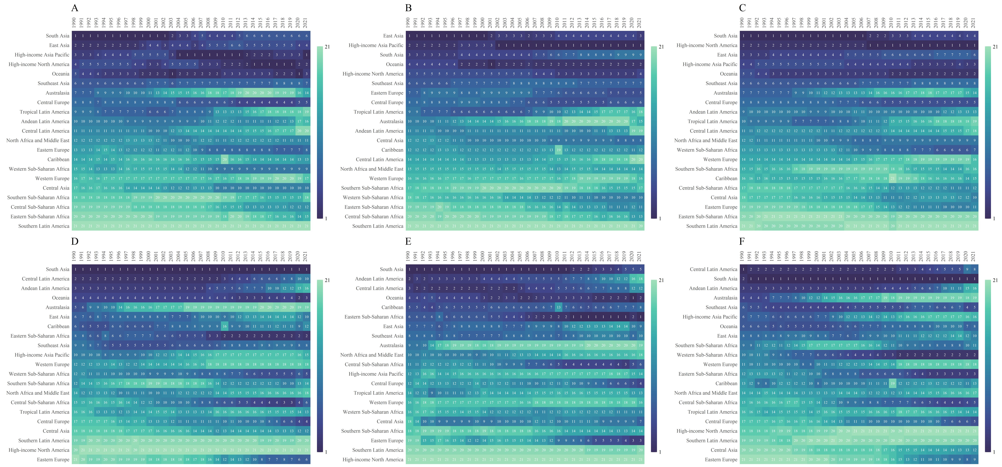
Fig.S1.Heatmap of the lifetime risk of developing and dying from PUD for the whole population,males and females from 1990 to 2021. A Lifetime risk of developing PUD in the whole population. B Lifetime risk of developing PUD in males. C Lifetime risk of developing PUD in females. D Lifetime risk of dying PUD in the whole population. E Lifetime risk of dying PUD in males. F Lifetime risk of dying PUD in females.
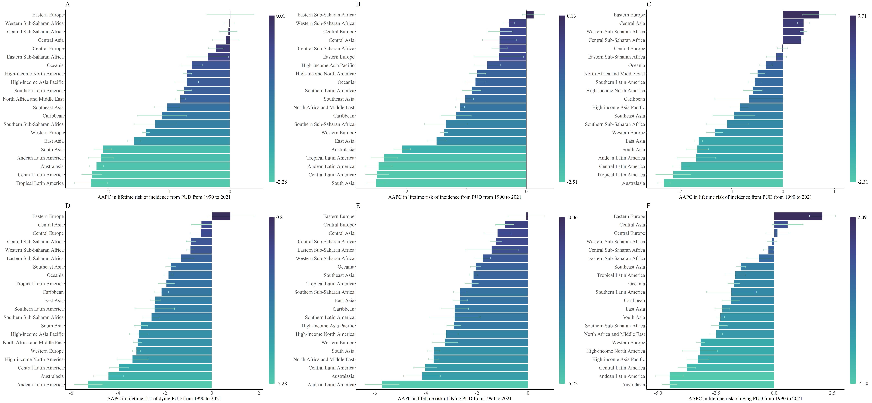
Fig.S2.AAPC in lifetime risk of developing and dying from PUD for the whole population,males and females from 1990 to 2021 A AAPC in lifetime risk of developing from PUD in the whole population. B AAPC in lifetime risk of developing from PUD in males. C AAPC in lifetime risk of developing from PUD in females. D AAPC in lifetime risk of dying from PUD in the whole population. E AAPC in lifetime risk of dying from PUD in males. F AAPC in lifetime risk of dying in females.

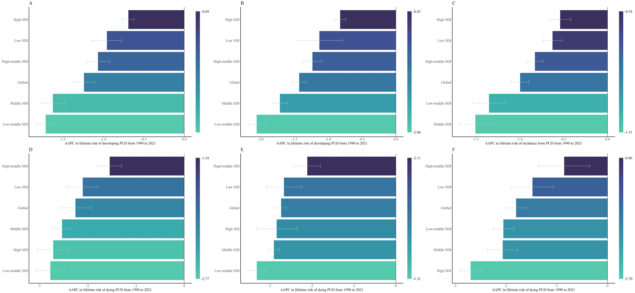
Fig.S3.AAPC in lifetime risk of developing and dying from PUD by SDI for the whole population,males and females from 1990 to 2021. A AAPC in lifetime risk of developing from PUD in the whole population. B AAPC in lifetime risk of developing from PUD in males. C AAPC in lifetime risk of developing from PUD in females. D AAPC in lifetime risk of dying from PUD in the whole population. E AAPC in lifetime risk of dying from PUD in males. F AAPC in lifetime risk of dying from PUD in females.
Fig.S4. Lifetime risks of developing and dying from PUD for the whole population,males and females by age at diagnosis in 2021. A Lifetime risk of developing PUD in the whole population. B Lifetime risk of developing PUD in males. C Lifetime risk of developing PUD in females. D Lifetime risk of dying PUD in the whole population. E Lifetime risk of dying PUD in males. F Lifetime risk of dying PUD in females.
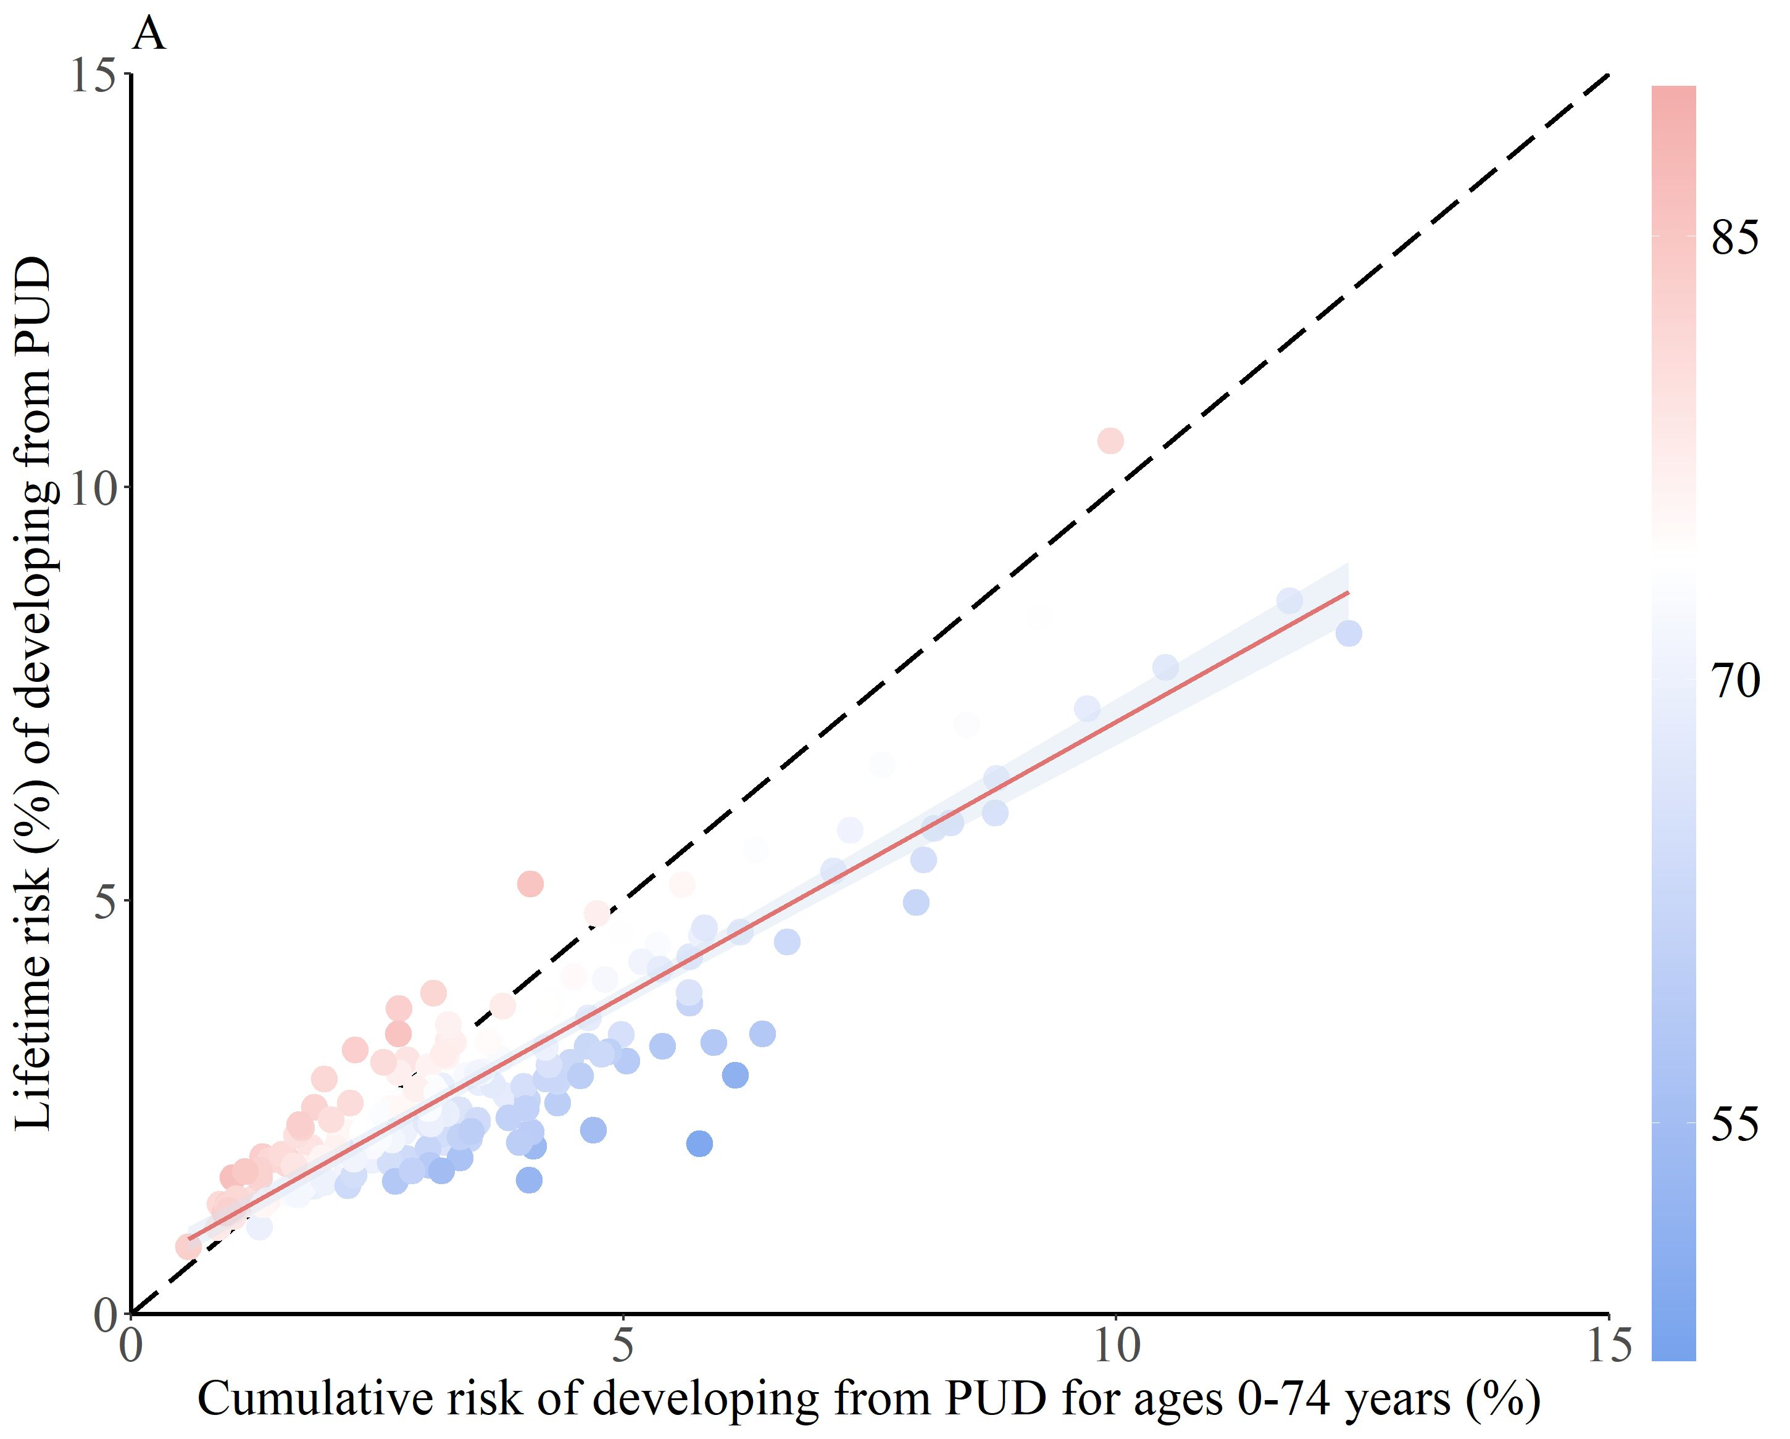
Fig.S5.Correlation between lifetime risk of developing PUD and traditional cumulative risk measure (ages 0-74 years) with both sexes combined.The red line indicates the fitted risks using quadratic regression with a 95% confidence interval; the short dash black line indicates the reference line where the risk estimations of two measures are equal; the color circles indicate the risks in different countries/regions with different life expectancy.

