Supplementary material for

Predicting Developmental Norms from Baseline Cortical Thickness in Longitudinal Studies

Philipp Seidel^{1,2,*}, Tobias Kaufmann^{1,2,3,#}, Thomas Wolfers^{1,2,4,#}

¹Department of Psychiatry and Psychotherapy, Tübingen Center for Mental Health, University of Tübingen, Germany
²German Center for Mental Health (DZPG), partner site Tübingen, Germany
³Centre for Precision Psychiatry, University of Oslo, Norway
⁴Institute for Psychology, Friedrich Schiller University Jena, Jena, Germany
#Shared senior authorship
*Corresponding author (E-Mail: philipp.seidel@med.uni-tuebingen.de)
Table of Contents
Figures 3
Tables 3
1. Excluding participants using Euler numbers 4
2. Sanity checks after preprocessing 6
3. Integrating Baseline Thickness Measures as Predictors for Norms in Longitudinal designs 8
4. Within subject differences of extreme z-scores 9
5. Longitudinal B-Norm models better predict cortical thickness at future time points than standard Age models 11
Mean standardized log loss (MSLL) 11
Explained Variance 13
Standardized mean squared error (SMSE) 17
Root mean squared error (RMSE) 19
Pearson’s correlation (real vs. predicted) 21
Skewness 23
Kurtosis 27
Bayesian Information Criteria (BIC) 31
Longitudinal normative plots for other baseline ages 33
Surface maps for males and 4-year females 34
6. Association with puberty scores 39
6.1. Adjusting for family structure in training- and test-set. 39
7. Validation of normative models using percentile shifts 42

Figures
Figure S 1 Before and-after exclusion of badly reconstructed Freesurfer data based on Euler numbers: training data. 5
Figure S 2 Before and-after exclusion of badly reconstructed Freesurfer data based on Euler numbers: test data 6
Figure S 3 Demographics for training and test set. 7
Figure S 4 Changes in cortical thickness and pubertal development across visits. 8
Figure S 5 Distribution of the ABCD ethnicities in the training (left) and test (right) datasets. 8
Figure S 6 Performance metrics for additional C-Norm models (using 2yr and a combination of baseline and 2yr data) 9
Figure S 7 Similarity of deviation scores across brain regions for all models. 10
Figure S 8 Example z-score distributions for participants with extrem deviations at baseline in C-Norm models 11
Figure S 9 Interaction plots for mean standardized log loss. 12
Figure S 10 Interaction plots for explained variance. 14
Figure S 11 ROI-wise difference (2year minus 4year) of explained variance for males. 16
Figure S 12 ROI-wise difference (2year minus 4year) explained variance for females. 17
Figure S 13 Interaction plots for standardized mean squared error. 18
Figure S 14 Interaction plots for root mean squared error. 20
Figure S 15 Interaction plots for Pearson’s correlation. 22
Figure S 16 Interaction plots for skewness. 24
Figure S 17 ROI-wise difference (2year minus 4year) for skewness for males. 26
Figure S 18 ROI-wise difference (2year minus 4year) for skewness for females 27
Figure S 19 Interactionplots for kurtosis. 28
Figure S 20 ROI-wise difference (2year minus 4year) for kurtosis for males 30
Figure S 21 ROI-wise difference (2year minus 4year) for kurtosis for females 31
Figure S 22 Interaction plots for Bayesian Information Criteria (BIC). 32
Figure S 23 Normative plots of additional baseline ages. 34
Figure S 24 ROI-wise performances for male C-Norms or B-Norms of 2-year and 4-year data. 35
Figure S 25 ROI-wise performances for female C-Norms or B-Norms of 4-year data. 36
Figure S 26 Association experiment: PDS with z - C-Norm. 40
Figure S 27. Comparing performance metrics between C- and B-Norm models using all-subs or family-adjusted data. 41
Figure S 28 Percentile shifts as indicators of individual level brain development and pubertal progress 44
Figure S 29 Validation of male normative models with percentile shifts and change in pubertal progress. 45

Tables
Table S 1 Mean standardized log loss statistics 12
Table S 2 Explained variance statistics 14
Table S 3 standardized mean squared error statistics 18
Table S 4 Root-mean squared error statistics 20
Table S 5 Pearson’s rho statistics 22
Table S 6 for skewness statistics 24
Table S 7 for Kurtosis Statistics 28
Table S 8 for BIC Statistics 32
Table S 9 Kurtosis values greater 10 in the 2- or 4-year follow-up test data for both males and females and the cross-sectional normative models (C-Norms) or longitudinal normative models (B-Norms). 37
Table S 10. Normalized Euclidean Distance between predicted norms of the test set using models trained with all participants and those trained adjusting for family structure. 42
Table S 11. Pearson’s correlation of p-values from “PDS~z” GLM association tests between models using all participants (as determined by preprocessing) and models trained with family-adjusted data.. 42

Excluding participants using Euler numbers
Training set: participants with only baseline- and 2-year follow-up data.
- Before

- After
Figure S 1 Before and-after exclusion of badly reconstructed Freesurfer data based on Euler numbers: training data.
Mean and standard deviations were computed using Euler numbers for each site individually. Participants whose Euler numbers exceeded 6*SD from the mean were excluded.

Test set: participants with baseline-, 2-year, and 4-year follow-up data.
- Before
- After
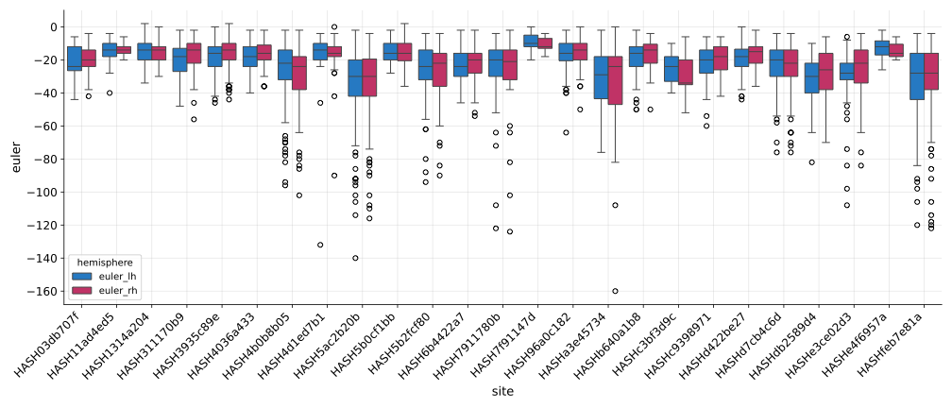
Figure S 2 Before and-after exclusion of badly reconstructed Freesurfer data based on Euler numbers: test data
Mean and standard deviations were computed using Euler numbers for each site individually. Participants whose Euler numbers exceeded 6*SD from the mean were excluded.

Sanity checks after preprocessing

- Age distributions
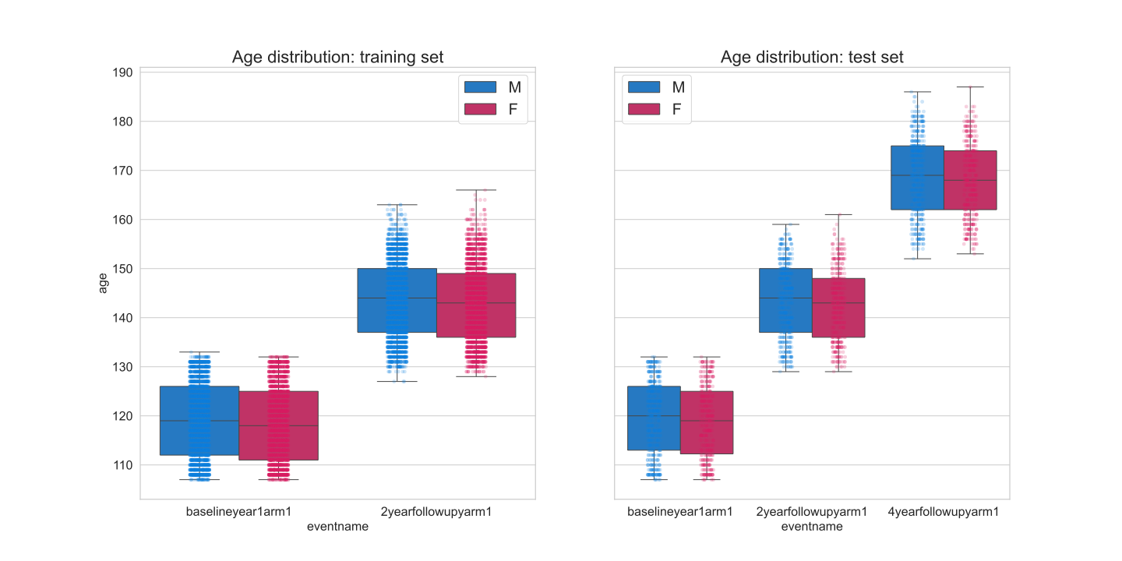
- BMI distributions
Figure S 3 Demographics for training and test set.
We found no discernable difference in age between males and females within timepoints (Panel A). Average body mass index increased slightly with age but was not statistically different between males and females.

We performed Welch’s t-tests to test for differences of baseline ages and BMI between the training and test dataset. These tests revealed no statistical differences for age (male: t(3522)=0.3876, p<0.7; female: t(3056)=-0.469, p<0.64) nor for BMI (male: t(3522)=-0.467, p<0.64; female: t(3056)=1.54, p<0.124).

A. Average cortical thickness for the train and test data
B. Puberty scores as rated by caregivers for the train and test data
Figure S 4 Changes in cortical thickness and pubertal development across visits.
Panel A) As was expected, we saw a decline in cortical thickness with increasing age. This expected decline was also more pronounced in females than in males at 4-year follow-up. Panel B) illustrates the changes in the pubertal development scale (PDS) as rated by the youth’s caregivers over time. As expected, we observed a stronger increase for females than for males. Although it should be noted that the menarche item is binary (i.e., either 1 or 4), which may explain the dramatic increase over males in the 2-year follow-up data.

A Welch’s t-test revealed a statistical difference between the baseline PDS mean scores between the training and test set in both males (t(3522)=-9.47, p<4.7e⁻²¹) and females (t(3056)=1.568, p<6.49e⁻¹⁴).

Distribution of males and females according to ethnicity
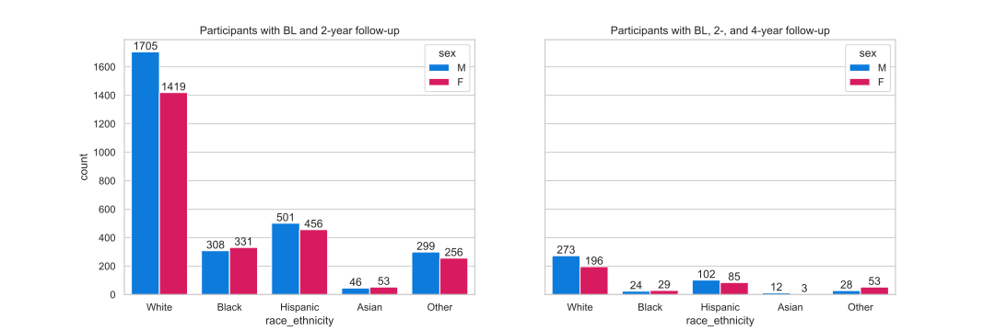
Figure S 5 Distribution of the ABCD ethnicities in the training (left) and test (right) datasets.

Integrating Baseline Thickness Measures as Predictors for Norms in Longitudinal designs

We additionally tested whether C-Norm models trained with only the 2-year data or a combination of baseline- and 2-year data of the training set yielded better results than the baseline age based C-Norm model reported in the main text. We performed this auxillary analyses to rule out a potential age bias in our C-Norm model.

For the C-Norm-2yr model, we used the 2-year data of the entire training dataset (N=5374; 2515 females) and tested the model on the 2- and 4-year follow-up data of the test dataset (N=805; 366 females).

For the C-Norm-bl+2yr model, we split the training dataset into halves for both the baseline and 2-year timepoints. We then used 50% of the baseline and 50% of the 2-year data and combined them again into a training, and a validation set. This approach extended the age range and potentially offered a fairer comparison to the B-Norm model which used the age at baseline and at a follow-up timepoint. Lastly, we applied the model to the 2- and 4-year data of the test set.

The results of this additional analysis revealed no difference in performance metrics for the C-Norm-2yr and C-Norm-bl+2yr models. The models also performed similarly to the C-Norm models from the main text (see Figure S6 below). These results suggested that training the C-Norm model on the 2-year data did not induce an age range bias compared to B-Norm models.

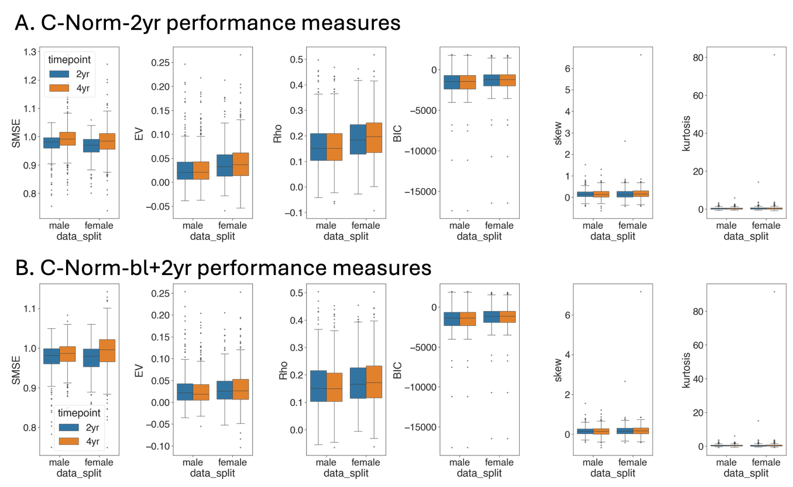
Figure S 6 Performance metrics for additional C-Norm models (using 2yr and a combination of baseline and 2yr data)
Performance measures for the two additional models showed no noticeable differences between one another and with the C-Norm models from the main analysis.

We further investigated the similarity of deviation scores (i.e., z-scores) as produced by each model. Deviation score patterns between the B-Norm and all C-Norm models were associated. The figure below shows Pearson’s Rho correlation values for the male (left) and female (right) models averaged across all 360 Glasser ROIs. What becomes immediately evident is the high correlation between all C-Norm models. While intra timepoint correlations were nearly identical, inter timepoint correlations were high (>0.8).
Correlations of deviation scores between the B- and C-Norm models were moderate within timepoint (Pearson’s rho ∼ 0.6) and weak between timepoints (Pearson’s rho ∼ 0.3).

Figure S 7 Similarity of deviation scores across brain regions for all models.
Average pairwise Pearson’s correlation coefficient averaged across all 360 Glasser ROIs. Each models deviation (i.e. z-) scores were pair-wise correlated with all other models and timepoints. Orange intensities correspond from lower (lighter) to larger (darker) correlations. As evident from the graphs, the similarity between the C-Norm models is markedly larger than between C- and B-Norm models. This suggests that our C-Norm model reported in the main text, does not show a significant age-range bias.

Within subject differences of extreme z-scores

Given the different natures of our models, where deviations from the norm in the C-Norm models indicate an unusual metric according to a population level as opposed to an unusual follow-up metric according to a baseline measure for the B-Norm model, we investigated whether deviation scores are consistent across these two models.
One can imagine different patterns of distributions such as:
- The distributions are completely different
- The distributions are highly overlapping
- The distributions overlap within models but differ between models. Here we would expect to see the z-score distributions for the C-Norm models to show peaks at the extremes and peaks around zero for the B-Norm models.

We first identified participants whose z-scores at baseline were smaller/larger than 1.96 in the C-Norm models. We then extracted the corresponding z-scores for both the 2- and 4-year follow-ups for the C- and B-Norm models and plotted these distributions (see Figure below).

We found overlap of participants with extreme z-scores to vary greatly. Though, looking at the example plots below, we observe pattern 3 to occur, which suggests that participants who flagged as extreme outliers on a population level during all stages of development must not or do not necessarily show unusual deviation from their own trajectory during their development. This effect suggests that B-Norm models could be especially interesting in longitudinal contexts, as these models may better identify disease related changes.

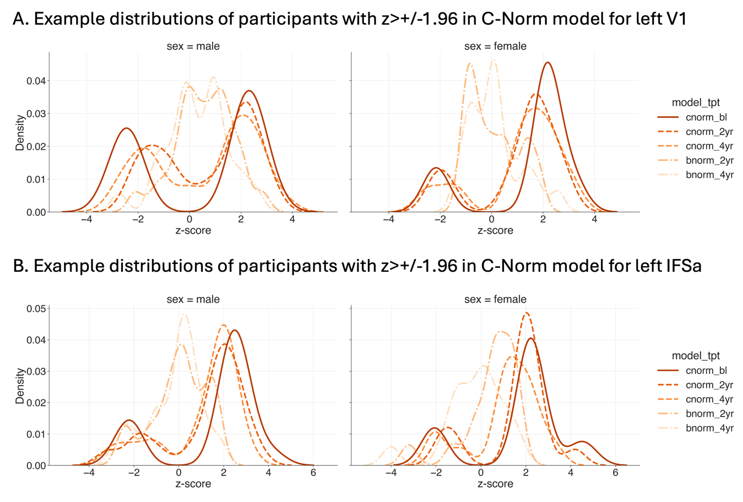
Figure S 8 Example z-score distributions for participants with extrem deviations at baseline in C-Norm models
Shown here are two examples for participants with extreme deviations (i.e., z>+/-1.96) at baseline according to C-Norm models that were not consistently flagged as outliers in the B-Norm models. The solid dark-orange line in this figure indicates the distribution of z-scores in the C-Norm model at baseline. The dashed and dash-dotted lines indicate the distributions of z-scores for the same participants in the C-Norm and B-Norm models at different timepoints, respectively. The distributions of the B-Norm models clearly show that despite being outliers with respect to the population level it does not mean that one changes abnormally from ones own trajectory during development or vice verca.

Longitudinal B-Norm models better predict cortical thickness at future time points than standard Age models

Mean standardized log loss (MSLL)
Figure S 9 Interaction plots for mean standardized log loss.
Note: We limited the y-axes to [-10, 150] as there were some extreme outliers that squished everything such that nothing was really visible.

Table S 1 Mean standardized log loss statistics
model | sex | timepoint | mean | sem
C-Norm | male | 2yr | 1,07E+10 | 6,33E+09
C-Norm | male | 4yr | 1,04E+10 | 6,14E+09
C-Norm | female | 2yr | 3,24E+10 | 1,59E+10
C-Norm | female | 4yr | 3,07E+10 | 1,51E+10
B-Norm | male | 2yr | 2,17E+09 | 1,57E+09
B-Norm | male | 4yr | 2,05E+09 | 1,49E+09
B-Norm | female | 2yr | 1,50E+09 | 9,36E+08
B-Norm | female | 4yr | 1,39E+09 | 8,68E+08

Repeated measures ANOVA for male models:
 | sum_sq (III) | df | df2 | F | PR(>F) | np2
model | 2.560779e+10 | 1.0 | 359 | 1.718 | 0.190697 | 0.004765
timepoint | 2.265690e+07 | 1.0 | 359 | 5.457 | 0.020039 | 0.014973
model×timepoint | 6.811265e+06 | 1.0 | 359 | 1.623 | 0.203473 | 0.004501

Pair-wise tests for male models:
 | model | A | B | T | dof | p-unc | hedges
model | - | C-Norm | B-Norm | 1.310995 | 359 | 0.190697 | 0.097760
timepoint | - | 2yr | 4yr | 2.336034 | 359 | 0.020039 | 0.004118
model×timepoint | C-Norm | 2yr | 4yr | 1.947903 | 359 | 0.052206 | 0.003277
model×timepoint | B-Norm | 2yr | 4yr | 1.393163 | 359 | 0.164433 | 0.003902

Repeated measures ANOVA for female models:
 | sum_sq (III) | df | df2 | F | PR(>F) | np2
model | 3.263640e+11 | 1.0 | 359 | 3.746042 | 0.053718 | 0.010327
timepoint | 2.687321e+08 | 1.0 | 359 | 4.658619 | 0.031560 | 0.012810
model×timepoint | 2.031492e+08 | 1.0 | 359 | 3.510597 | 0.061790 | 0.009684

Pair-wise tests for female models:
 | model | A | B | T | dof | p-unc | hedges
model | - | C-Norm | B-Norm | 1.935469 | 359 | 0.053718 | 0.144186
timepoint | - | 2yr | 4yr | 2.158383 | 359 | 0.031560 | 0.005852
model×timepoint | C-Norm | 2yr | 4yr | 2.023247 | 359 | 0.043788 | 0.005477
model×timepoint | B-Norm | 2yr | 4yr | 1.654231 | 359 | 0.098955 | 0.006576

Explained Variance
Figure S 10 Interaction plots for explained variance.

Table S 2 Explained variance statistics
model | sex | timepoint | mean | sem
C-Norm | male | 2yr | 0.024850 | 0.002010
C-Norm | male | 4yr | 0.021023 | 0.002010
C-Norm | female | 2yr | 0.026646 | 0.001956
C-Norm | female | 4yr | 0.025996 | 0.002306
B-Norm | male | 2yr | 0.642806 | 0.006439
B-Norm | male | 4yr | 0.627440 | 0.006757
B-Norm | female | 2yr | 0.639412 | 0.006537
B-Norm | female | 4yr | 0.626474 | 0.006523

Repeated measures ANOVA for male models:
 | sum_sq (III) | df | df2 | F | PR(>F) | np2
model | 134.918144 | 1.0 | 359 | 7855.030079 | 4.076e-246 | 0.956294
timepoint | 0.033154 | 1.0 | 359 | 51.245127 | 4.633e-12 | 0.124913
model×timepoint | 0.011983 | 1.0 | 359 | 25.864015 | 5.913e-07 | 0.067203

Pair-wise tests for male models:
 | model | A | B | T | dof | p-unc | hedges
model | - | C-Norm | B-Norm | -88.628608 | 359 | 4.076e-246 | -6.71640
timepoint | - | 2yr | 4yr | 7.158570 | 359 | 4.633e-12 | 0.148663
model×timepoint | C-Norm | 2yr | 4yr | 3.267979 | 359 | 1.187e-03 | 0.100236
model×timepoint | B-Norm | 2yr | 4yr | 7.015936 | 359 | 1.143e-11 | 0.122578
Repeated measures ANOVA for female models:
 | sum_sq (III) | df | df2 | F | PR(>F) | np2
model | 132.47644 | 1.0 | 359 | 8803.735267 | 1.226e-254 | 0.960820
timepoint | 0.016615 | 1.0 | 359 | 26.170219 | 5.100e-07 | 0.067945
model×timepoint | 0.013590 | 1.0 | 359 | 26.040458 | 5.430e-07 | 0.067630

Pair-wise tests for female models:
 | model | A | B | T | dof | p-unc | hedges
model | - | C-Norm | B-Norm | -93.828222 | 359 | 1.226e-254 | -6.68806
timepoint | - | 2yr | 4yr | 5.115684 | 359 | 5.100e-07 | 0.099989
model×timepoint | C-Norm | 2yr | 4yr | 0.612661 | 359 | 5.404e-01 | 0.015991
model×timepoint | B-Norm | 2yr | 4yr | 5.618100 | 359 | 3.876e-08 | 0.104307

ROI-wise differences males:
Figure S 11 ROI-wise difference (2year minus 4year) of explained variance for males.

ROI-wise differences females:
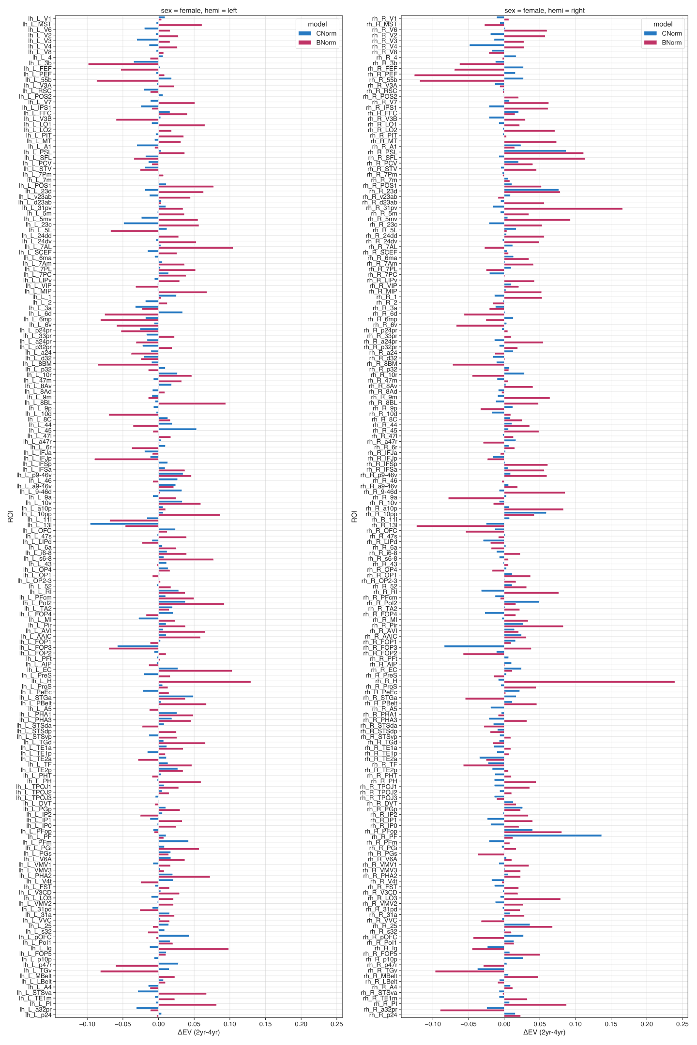
Figure S 12 ROI-wise difference (2year minus 4year) explained variance for females.

Standardized mean squared error (SMSE)
Figure S 13 Interaction plots for standardized mean squared error.

Table S 3 standardized mean squared error statistics
model | sex | timepoint | mean | sem
C-Norm | male | 2yr | 0.992541 | 0.002693
C-Norm | male | 4yr | 1.041071 | 0.006351
C-Norm | female | 2yr | 1.005893 | 0.002953
C-Norm | female | 4yr | 1.162099 | 0.009572
B-Norm | male | 2yr | 0.358037 | 0.006456
B-Norm | male | 4yr | 0.403665 | 0.007461
B-Norm | female | 2yr | 0.361767 | 0.006561
B-Norm | female | 4yr | 0.400521 | 0.006735

Repeated measures ANOVA for male models:
 | sum_sq (III) | df | df2 | F | PR(>F) | np2
model | 145.597865 | 1.0 | 359 | 7593.869315 | 1.347e-243 | 0.954859
timepoint | 0.797900 | 1.0 | 359 | 261.395531 | 1.464e-44 | 0.421337
model×timepoint | 0.000758 | 1.0 | 359 | 0.304499 | 5.814e-01 | 0.000847

Pair-wise tests for male models:
 | model | A | B | T | dof | p-unc | hedges
model | - | C-Norm | B-Norm | 87.142810 | 359 | 1.347e-243 | 5.883945
timepoint | - | 2yr | 4yr | -16.167731 | 359 | 1.464e-44 | -0.53849
model×timepoint | C-Norm | 2yr | 4yr | -10.733332 | 359 | 1.703e-23 | -0.52384
model×timepoint | B-Norm | 2yr | 4yr | -14.187876 | 359 | 1.389e-36 | -0.34434
Repeated measures ANOVA for female models:
 | sum_sq (III) | df | df2 | F | PR(>F) | np2
model | 177.840354 | 1.0 | 359 | 7577.073462 | 1.969e-243 | 0.954764
timepoint | 3.420820 | 1.0 | 359 | 602.006111 | 9.226e-79 | 0.626433
model×timepoint | 1.241548 | 1.0 | 359 | 220.320024 | 3.370e-39 | 0.380308

Pair-wise tests for female models:
 | model | A | B | T | dof | p-unc | hedges
model | - | C-Norm | B-Norm | 87.046387 | 359 | 1.969e-243 | 5.900791
timepoint | - | 2yr | 4yr | -24.535813 | 359 | 9.226e-79 | -0.98817
model×timepoint | C-Norm | 2yr | 4yr | -21.281107 | 359 | 1.364e-65 | -1.16110
model×timepoint | B-Norm | 2yr | 4yr | -12.919172 | 359 | 1.280e-31 | -0.30688

Root mean squared error (RMSE)
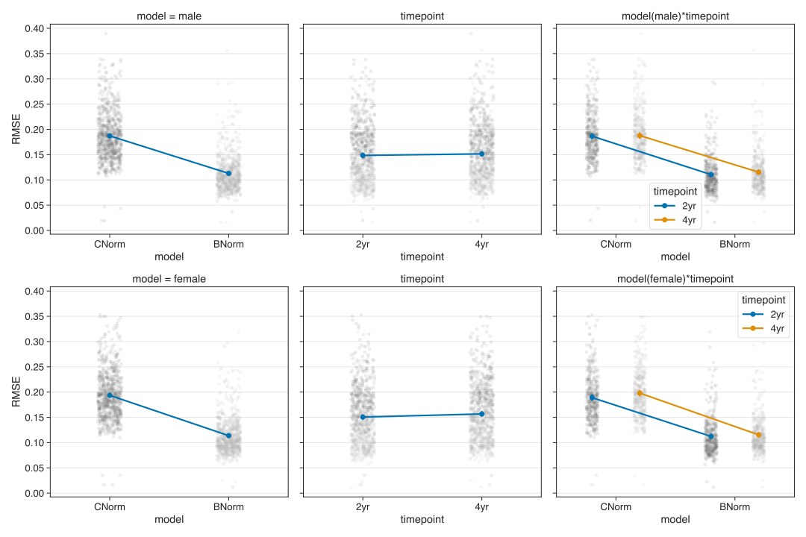
Figure S 14 Interaction plots for root mean squared error.

Table S 4 Root-mean squared error statistics
model | sex | timepoint | mean | sem
C-Norm | male | 2yr | 0.186527 | 0.002473
C-Norm | male | 4yr | 0.197752 | 0.002589
C-Norm | female | 2yr | 0.189054 | 0.002490
C-Norm | female | 4yr | 0.198061 | 0.002544
B-Norm | male | 2yr | 0.110464 | 0.001890
B-Norm | male | 4yr | 0.115337 | 0.002007
B-Norm | female | 2yr | 0.112266 | 0.002020
B-Norm | female | 4yr | 0.115331 | 0.001892

Repeated measures ANOVA for male models:
 | sum_sq (III) | df | df2 | F | PR(>F) | np2
model | 1.984116 | 1.0 | 359 | 2597.950827 | 1.883e-166 | 0.878591
timepoint | 0.003347 | 1.0 | 359 | 61.269798 | 5.644e-14 | 0.145787
model×timepoint | 0.001198 | 1.0 | 359 | 35.469328 | 6.177e-09 | 0.089917

Pair-wise tests for male models:
 | model | A | B | T | dof | p-unc | hedges
model | - | C-Norm | B-Norm | 50.970097 | 359 | 1.883e-166 | 1.740543
timepoint | - | 2yr | 4yr | -7.827503 | 359 | 5.644e-14 | -0.07525
model×timepoint | C-Norm | 2yr | 4yr | -2.565330 | 359 | 1.071e-02 | -0.02547
model×timepoint | B-Norm | 2yr | 4yr | -9.502101 | 359 | 3.011e-19 | -0.13162
Repeated measures ANOVA for female models:
 | sum_sq (III) | df | df2 | F | PR(>F) | np2
model | 2.290157 | 1.0 | 359 | 3154.581077 | 6.678e-180 | 0.897825
timepoint | 0.013117 | 1.0 | 359 | 169.514898 | 5.238e-32 | 0.320738
model×timepoint | 0.003177 | 1.0 | 359 | 55.945537 | 5.778e-13 | 0.134826

Pair-wise tests for female models:
 | model | A | B | T | dof | p-unc | hedges
model | - | C-Norm | B-Norm | 56.165657 | 359 | 6.678e-180 | 1.880078
timepoint | - | 2yr | 4yr | -13.019789 | 359 | 5.238e-32 | -0.14917
model×timepoint | C-Norm | 2yr | 4yr | -12.946247 | 359 | 1.006e-31 | -0.18840
model×timepoint | B-Norm | 2yr | 4yr | -5.996011 | 359 | 4.931e-09 | -0.08248

Pearson’s correlation (real vs. predicted)
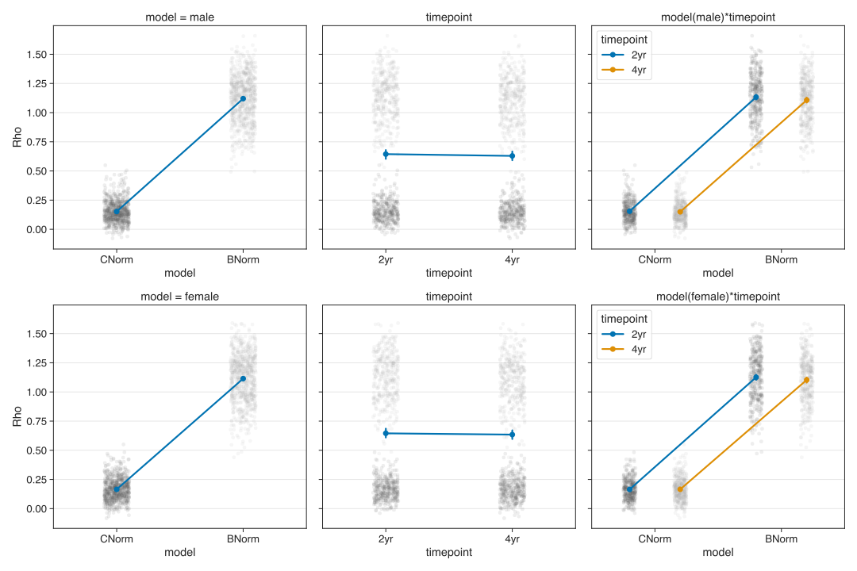
Figure S 15 Interaction plots for Pearson’s correlation.

Rho values were Fisher-z transformed before computing averages and before submitting to the rm-ANOVA.

Table S 5 Pearson’s rho statistics
model | sex | timepoint | mean | sem
C-Norm | male | 2yr | 0.151992 | 0.004744
C-Norm | male | 4yr | 0.147164 | 0.004723
C-Norm | female | 2yr | 0.162123 | 0.004587
C-Norm | female | 4yr | 0.162319 | 0.005068
B-Norm | male | 2yr | 0.800192 | 0.004052
B-Norm | male | 4yr | 0.791132 | 0.004186
B-Norm | female | 2yr | 0.796746 | 0.004320
B-Norm | female | 4yr | 0.789628 | 0.004265

Repeated measures ANOVA for male models:
 | sum_sq (III) | df | df2 | F | PR(>F) | np2
model | 149.712098 | 1.0 | 359 | 9634.944936 | 6.799e-261 | 0.964175
timepoint | 0.017338 | 1.0 | 359 | 27.024021 | 3.385e-07 | 0.070188
model×timepoint | 0.001617 | 1.0 | 359 | 3.275425 | 7.116e-02 | 0.009066

Pair-wise tests for male models:
 | model | A | B | T | dof | p-unc | hedges
model | - | C-Norm | B-Norm | -98.157755 | 359 | 6.799e-261 | -7.82574
timepoint | - | 2yr | 4yr | 5.198463 | 359 | 3.385e-07 | 0.125273
model×timepoint | C-Norm | 2yr | 4yr | 2.255272 | 359 | 2.741e-02 | 0.053695
model×timepoint | B-Norm | 2yr | 4yr | 6.872249 | 359 | 2.816e-11 | 0.116100

Repeated measures ANOVA for female models:
 | sum_sq (III) | df | df2 | F | PR(>F) | np2
model | 143.322695 | 1.0 | 359 | 10563.04810 | 2.484e-268 | 0.967131
timepoint | 0.004312 | 1.0 | 359 | 7.085329 | 8.121e-03 | 0.019354
model×timepoint | 0.004814 | 1.0 | 359 | 9.475281 | 2.242e-03 | 0.025715

Pair-wise tests for female models:
 | model | A | B | T | dof | p-unc | hedges
model | - | C-Norm | B-Norm | -102.77669 | 359 | 2.484e-268 | -7.40653
timepoint | - | 2yr | 4yr | 2.661828 | 359 | 8.121e-03 | 0.054651
model×timepoint | C-Norm | 2yr | 4yr | -0.096233 | 359 | 9.233e-01 | -0.00213
model×timepoint | B-Norm | 2yr | 4yr | 4.958425 | 359 | 1.098e-06 | 0.087302

Skewness
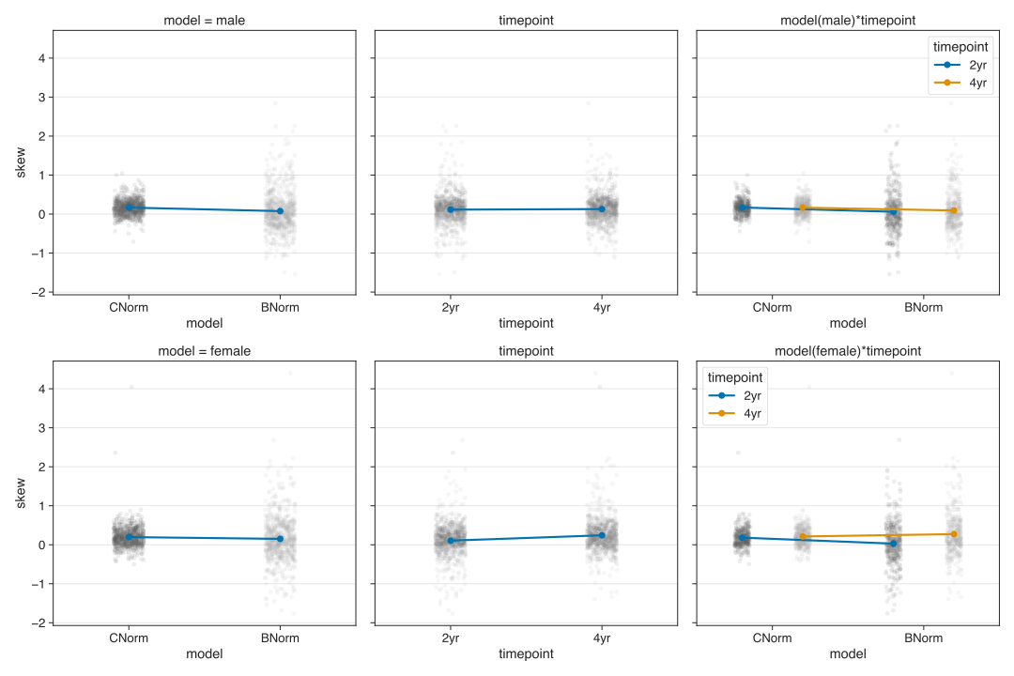
Figure S 16 Interaction plots for skewness.

We found more variance in skewness values for B-Norms (mean±SEM, 2-year: 0.0587±0.542, 4-year:0.092±0.497) than for C-Norms (2-year: 0.169±0.188, 4-year:0.165±0.209) in males. That is, our rm-ANOVA corroborated only the difference between the Age and longitudinal B-Norm models (sum of squares(SS)=2.997, F_{1,359}=15.619, p<9.3e⁻⁵, ${}^{2}$=0.041). For the female models, we found the lowest and highest average skewness for the 2-year follow-up data (0.029±0.573) and 4-year follow-up data (0.273±0.591) of the longitudinal B-Norm model, albeit again with larger variance than for the standard Age models (2-year=0.183±0.239; 4-year=0.213±0.302). As can be seen by the differential differences between the 2-year and 4-year follow-up in the longitudinal B-Norm models and the Age models, our rm-ANOVA revealed a statistically significant interaction effect of MODEL×TIMEPOINT (SS=4.134, F_{1,359}=47.58, p<2.39e⁻¹¹, ${}^{2}$=0.117). Post-hoc tests are available in the supplements.

Table S 6 for skewness statistics
model | sex | timepoint | mean | sem
C-Norm | male | 2yr | 0.168878 | 0.009897
C-Norm | male | 4yr | 0.164945 | 0.011034
C-Norm | female | 2yr | 0.182953 | 0.012586
C-Norm | female | 4yr | 0.212620 | 0.015939
B-Norm | male | 2yr | 0.058715 | 0.028601
B-Norm | male | 4yr | 0.092619 | 0.026188
B-Norm | female | 2yr | 0.029373 | 0.030232
B-Norm | female | 4yr | 0.273383 | 0.031180

Repeated measures ANOVA for male models:

 | sum_sq (III) | df | df2 | F | PR(>F) | np2
model | 2.997198 | 1.0 | 359 | 15.618609 | 0.000093 | 0.041692
timepoint | 0.080848 | 1.0 | 359 | 0.911024 | 0.340485 | 0.002531
model×timepoint | 0.128851 | 1.0 | 359 | 2.072432 | 0.150854 | 0.005740

Pair-wise tests for male models:
 | model | A | B | T | dof | p-unc | hedges
model | - | C-Norm | B-Norm | 3.952039 | 359 | 0.000093 | 0.266040
timepoint | - | 2yr | 4yr | -0.954476 | 359 | 0.340485 | -0.04946
model×timepoint | C-Norm | 2yr | 4yr | 0.570844 | 359 | 0.568462 | 0.019757
model×timepoint | B-Norm | 2yr | 4yr | -1.205536 | 359 | 0.228790 | -0.06510

Repeated measures ANOVA for female models:
 | sum_sq (III) | df | df2 | F | PR(>F) | np2
model | 0.775350 | 1.0 | 359 | 3.959325 | 4.737e-02 | 0.010908
timepoint | 6.740953 | 1.0 | 359 | 43.002270 | 1.907e-10 | 0.106970
model×timepoint | 4.134840 | 1.0 | 359 | 47.583383 | 2.389e-11 | 0.117032

Pair-wise tests for female models:
 | model | A | B | T | dof | p-unc | hedges
model | - | C-Norm | B-Norm | 1.989805 | 359 | 4.737e-02 | 0.121346
timepoint | - | 2yr | 4yr | -6.55761 | 359 | 1.907e-10 | -0.37040
model×timepoint | C-Norm | 2yr | 4yr | -2.71135 | 359 | 7.022e-03 | -0.10876
model×timepoint | B-Norm | 2yr | 4yr | -6.94649 | 359 | 1.767e-11 | -0.41834

ROI-wise differences males:
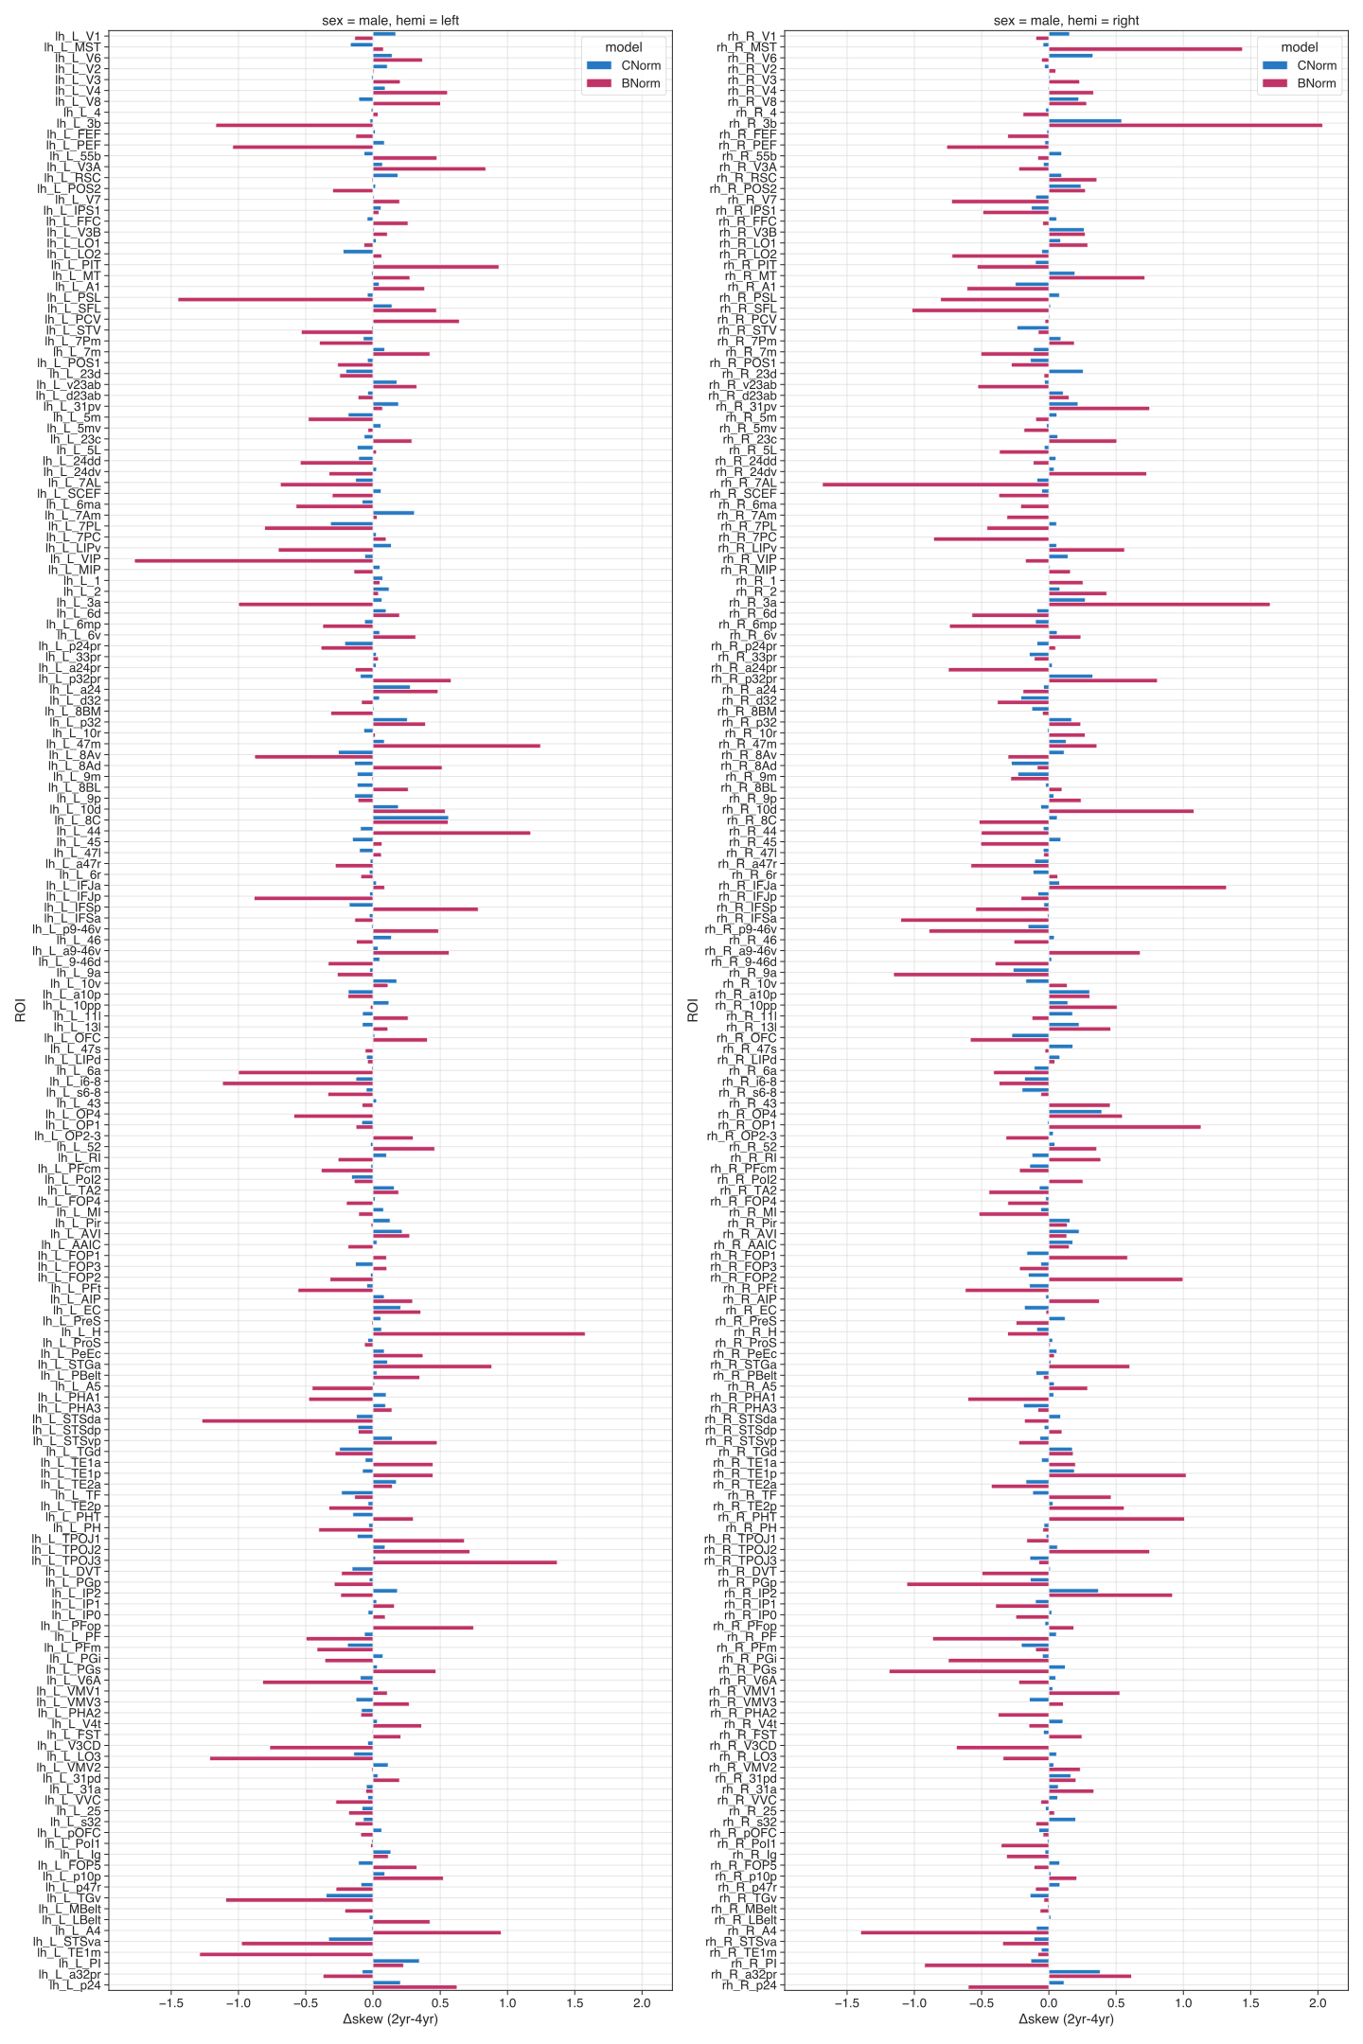
Figure S 17 ROI-wise difference (2year minus 4year) for skewness for males.

ROI-wise differences females:
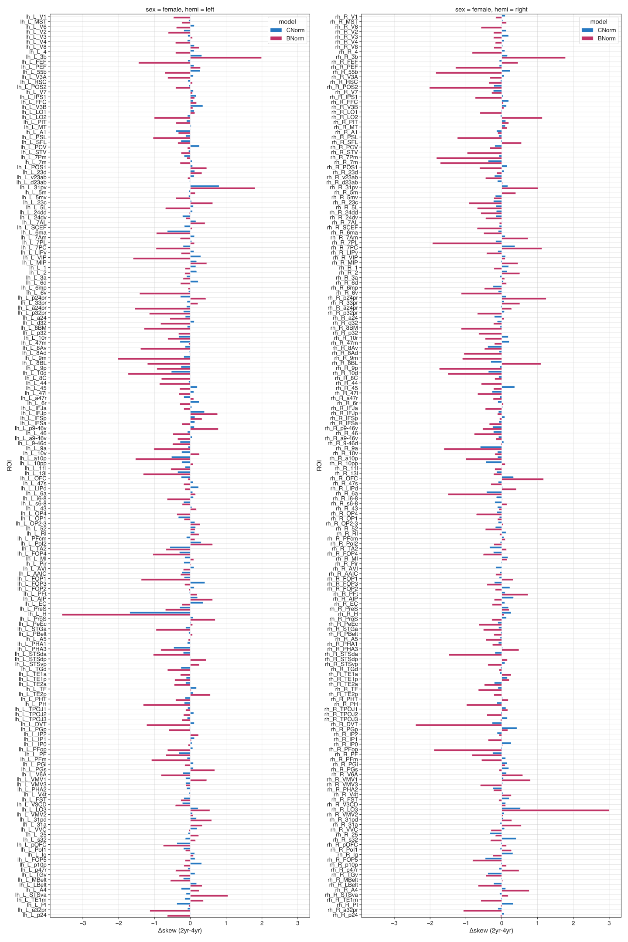
Figure S 18 ROI-wise difference (2year minus 4year) for skewness for females

Kurtosis
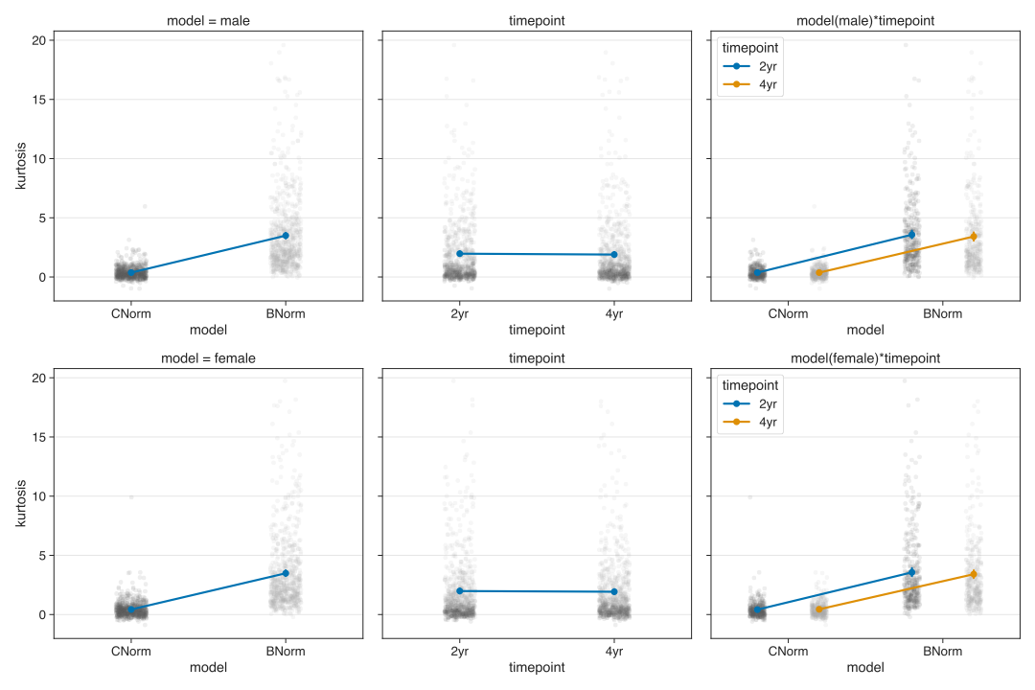
Figure S 19 Interactionplots for kurtosis.

As can be easily seen in the last row in panel A of Figure 1 of the main text, excess kurtosis was generally much larger in the longitudinal B-Norm models than in the C-Norm models, irrespective of sex and timepoint. We obtained lower kurtosis for the longitudinal B-Norm models in the 4-year follow-up data of the males compared to the 2-year follow-up data (2year-4year=0.2044).. This effect is somewhat reverse in the female Age models (2year-4year=-0.127). However, our rm-ANOVAs revealed no statistical effect of TIMEPOINT (males: SS=3.828, F_{1,359}=2.241, p<0.135, ${}^{2}$=0.0062; females: SS=0.298, F_{1,359}=0.046, p<0.829, ${}^{2}$=0.00013) or the MODEL×TIMEPOINT interaction (males: SS=3.69, F_{1,359}=2.36, p<0.125, ${}^{2}$=0.0065; females: SS=3.45, F_{1,359}=1.462, p<0.227, ${}^{2}$=0.00406).

Table S 7 for Kurtosis Statistics
model | sex | timepoint | mean | sem
C-Norm | male | 2yr | 0.371731 | 0.026005
C-Norm | male | 4yr | 0.369859 | 0.028927
C-Norm | female | 2yr | 0.414015 | 0.038817
C-Norm | female | 4yr | 0.541394 | 0.102754
B-Norm | male | 2yr | 3.624436 | 0.166718
B-Norm | male | 4yr | 3.420059 | 0.175922
B-Norm | female | 2yr | 3.610992 | 0.177697
B-Norm | female | 4yr | 3.541184 | 0.211235

Repeated measures ANOVA for male models:
 | sum_sq (III) | df | df2 | F | PR(>F) | np2
model | 3575.394208 | 1.0 | 359 | 403.233441 | 1.163e-60 | 0.529016
timepoint | 3.828481 | 1.0 | 359 | 2.241535 | 1.352e-01 | 0.006205
model×timepoint | 3.690724 | 1.0 | 359 | 2.364916 | 1.249e-01 | 0.006544

Pair-wise tests for male models:
 | model | A | B | T | dof | p-unc | hedges
model | - | C-Norm | B-Norm | -20.080673 | 359 | 1.163e-60 | -1.46689
timepoint | - | 2yr | 4yr | 1.497176 | 359 | 1.352e-01 | 0.061387
model×timepoint | C-Norm | 2yr | 4yr | 0.080621 | 359 | 9.357e-01 | 0.003584
model×timepoint | B-Norm | 2yr | 4yr | 1.539696 | 359 | 1.245e-01 | 0.062786

Repeated measures ANOVA for female models:
 | sum_sq (III) | df | df2 | F | PR(>F) | np2
model | 3455.992461 | 1.0 | 359 | 419.236080 | 2.769e-62 | 0.538700
timepoint | 0.298301 | 1.0 | 359 | 0.046851 | 8.287e-01 | 0.000130
model×timepoint | 3.499407 | 1.0 | 359 | 1.462770 | 2.272e-01 | 0.004058

Pair-wise tests for female models:
 | model | A | B | T | dof | p-unc | hedges
model | - | C-Norm | B-Norm | -20.475255 | 359 | 2.769e-62 | -1.29035
timepoint | - | 2yr | 4yr | -0.216451 | 359 | 8.287e-01 | -0.01250
model×timepoint | C-Norm | 2yr | 4yr | -1.645627 | 359 | 1.007e-01 | -0.08634
model×timepoint | B-Norm | 2yr | 4yr | 0.337934 | 359 | 7.356e-01 | 0.018830

ROI-wise differences males:
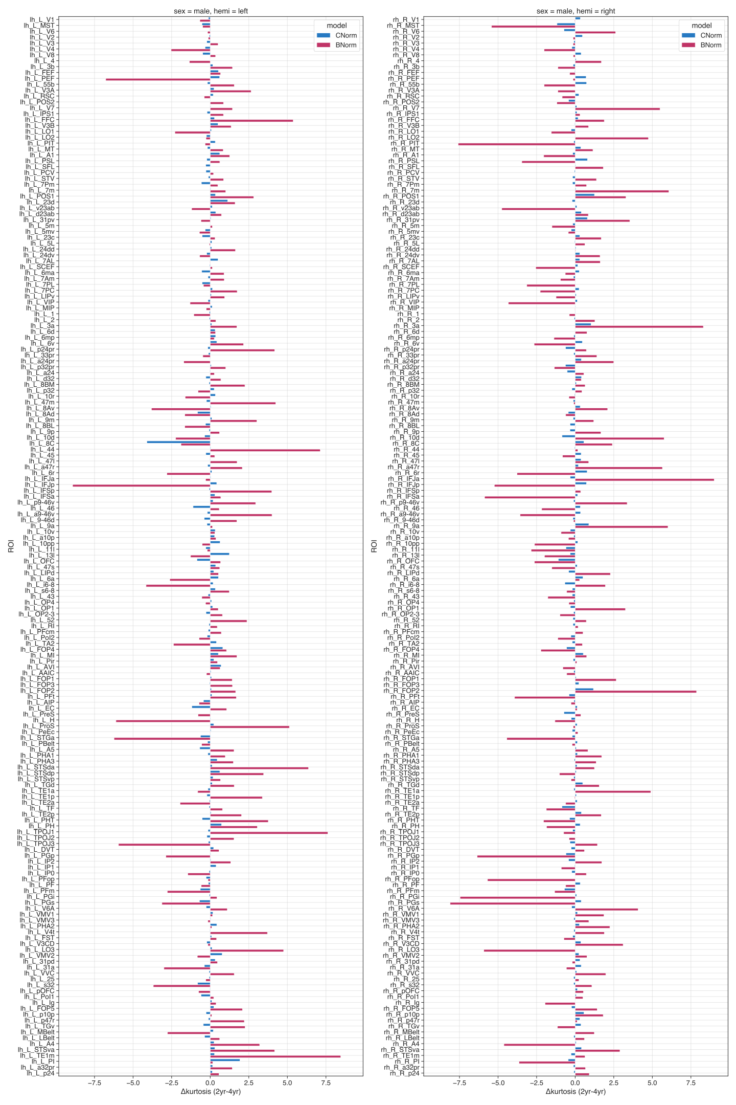
Figure S 20 ROI-wise difference (2year minus 4year) for kurtosis for males

ROI-wise differences females:
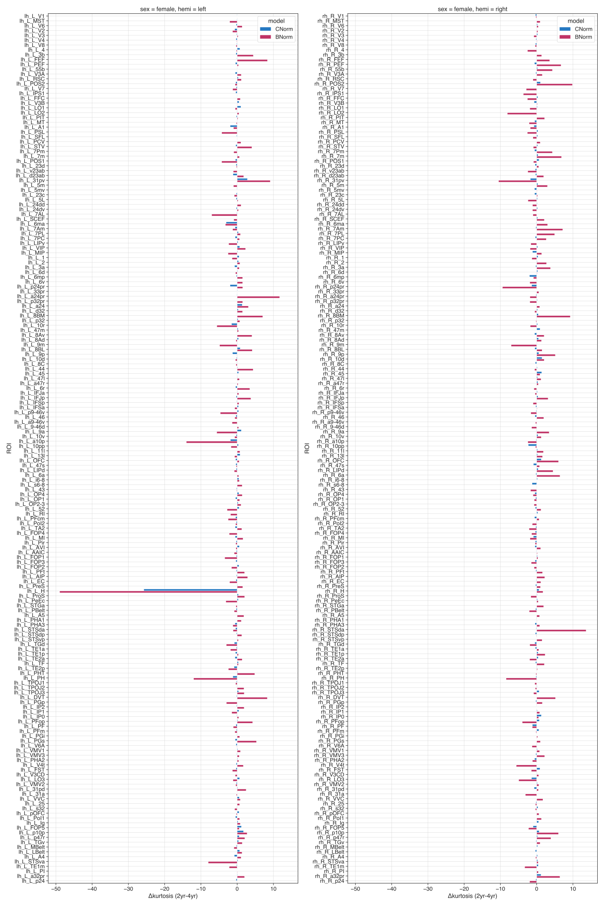
Figure S 21 ROI-wise difference (2year minus 4year) for kurtosis for females

Bayesian Information Criteria (BIC)
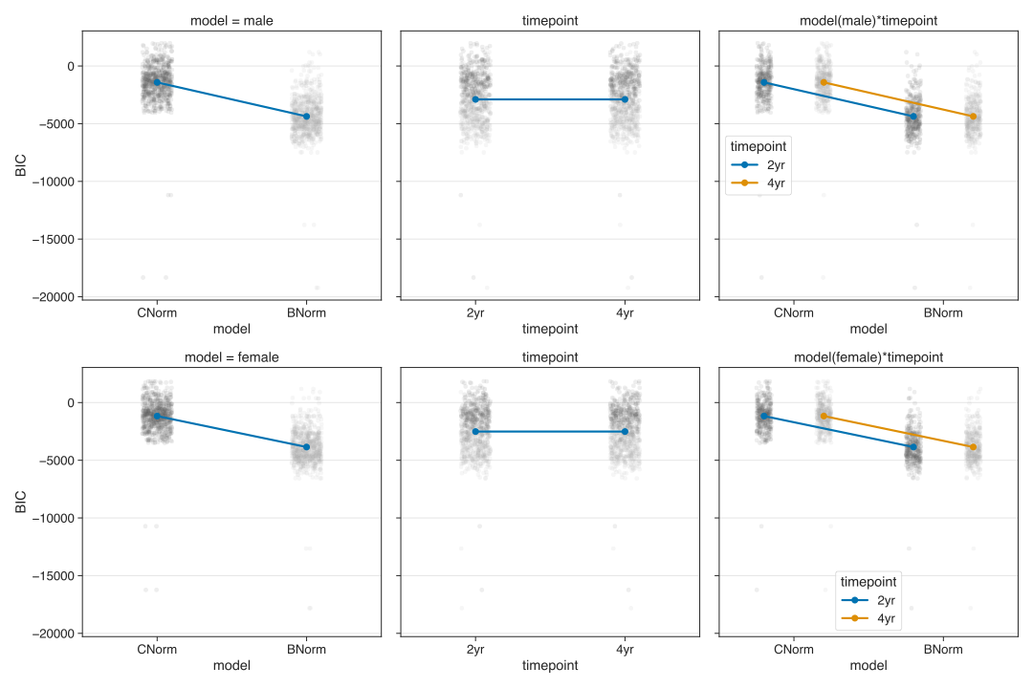
Figure S 22 Interaction plots for Bayesian Information Criteria (BIC).

Table S 8 for BIC Statistics
model | sex | timepoint | mean | sem
C-Norm | male | 2yr | -1418.224590 | 86.843136
C-Norm | male | 4yr | -1418.224590 | 86.843136
C-Norm | female | 2yr | -1168.022447 | 77.588938
C-Norm | female | 4yr | -1168.022447 | 77.588938
B-Norm | male | 2yr | -4368.158769 | 92.116311
B-Norm | male | 4yr | -4368.158769 | 92.116311
B-Norm | female | 2yr | -3853.867853 | 82.764235
B-Norm | female | 4yr | -3853.867853 | 82.764235

Repeated measures ANOVA for male models:
 | sum_sq (III) | df | df2 | F | PR(>F) | np2
model | 3.132760e+09 | 1.0 | 359 | 4423.606452 | 6.033e-204 | 0.924936
timepoint | 0 | 1.0 | 359 | NaN | NaN | NaN
model×timepoint | 0 | 1.0 | 359 | NaN | NaN | NaN

Pair-wise tests for male models:
 | model | A | B | T | dof | p-unc | hedges
model | - | C-Norm | B-Norm | 66.510198 | 359 | 6.033e-204 | 1.734978
timepoint | - | 2yr | 4yr | NaN | 359 | NaN | NaN
model×timepoint | C-Norm | 2yr | 4yr | NaN | 359 | NaN | NaN
model×timepoint | B-Norm | 2yr | 4yr | NaN | 359 | NaN | NaN

Repeated measures ANOVA for female models:
 | sum_sq (III) | df | df2 | F | PR(>F) | np2
model | 2.596956e+09 | 1.0 | 359 | 4435.001523 | 3.935e-204 | 0.925115
timepoint | 0 | 1.0 | 359 | NaN | NaN | NaN
model×timepoint | 4.768372e-07 | 1.0 | 359 | -359.00 | 1 | -inf

Pair-wise tests for female models:
 | model | A | B | T | dof | p-unc | hedges
model | - | C-Norm | B-Norm | 66.595807 | 359 | 3.935e-204 | 1.762796
timepoint | - | 2yr | 4yr | NaN | 359 | NaN | NaN
model×timepoint | C-Norm | 2yr | 4yr | NaN | 359 | NaN | NaN
model×timepoint | B-Norm | 2yr | 4yr | NaN | 359 | NaN | NaN

Longitudinal normative plots for other baseline ages
A Baseline age 114 months  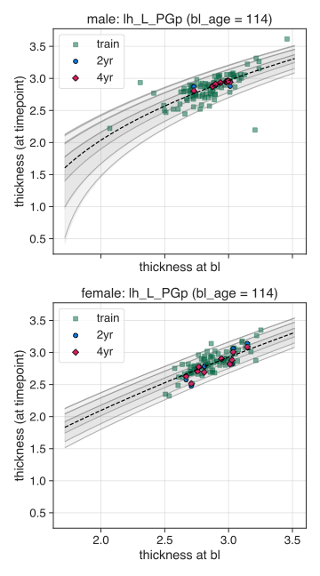 | B Baseline age 120 months  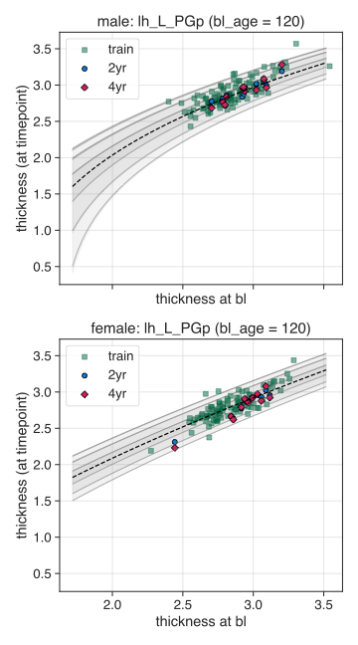
Figure S 23 Normative plots of additional baseline ages.
For each baseline age the B-Norm models require to generate their own specific normative plots.

Surface maps for males and 4-year females
Males:
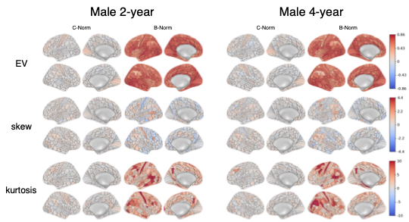
Figure S 24 ROI-wise performances for male C-Norms or B-Norms of 2-year and 4-year data.
The first two columns correspond to the lateral and medial views of the C-Norms, the last two to the B-Norms for the male data of the 2-year (left) and 4-year (right) timepoints. Warmer colors indicate more explained variance, positive skewness or kurtosis; colder colors indicate negative skewness or kurtosis.

Females:
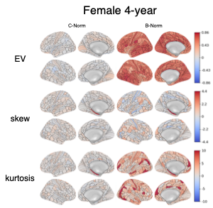
Figure S 25 ROI-wise performances for female C-Norms or B-Norms of 4-year data.
The first two columns correspond to the lateral and medial views of the C-Norms, the last two to the B-Norms for the female data of the 4-year (right) timepoint. Warmer colors indicate more explained variance, positive skewness or kurtosis; colder colors indicate negative skewness or kurtosis.

Table S 9 Kurtosis values greater 10 in the 2- or 4-year follow-up test data for both males and females and the cross-sectional normative models (C-Norms) or longitudinal normative models (B-Norms).
TIMEPOINTS
(KURTOSIS)
ROI | sex | model | 2yr | 4yr
lh_L_31pv | female | B-Norm | 11,76290842 | 2,629781958
lh_L_3b | female | B-Norm | 10,71668255 | 6,247540803
lh_L_3b | male | B-Norm | 12,96071984 | 11,51556182
lh_L_7AL | female | B-Norm | 3,8794104 | 10,90371176
lh_L_7m | male | B-Norm | 16,5975464 | 15,59198511
lh_L_8Av | male | B-Norm | 12,75218943 | 16,56447492
lh_L_9a | female | B-Norm | 8,682803201 | 14,30709845
lh_L_9m | female | B-Norm | 9,373430277 | 14,231347
lh_L_DVT | female | B-Norm | 10,33011033 | 2,00732272
lh_L_FEF | female | B-Norm | 11,31489956 | 2,940819297
lh_L_FFC | male | B-Norm | 10,91524634 | 5,536031908
lh_L_H | female | C-Norm | 9,901031485 | 35,64663669
lh_L_H | female | B-Norm | 1,603037042 | 50,58707693
lh_L_H | male | B-Norm | 4,75407098 | 10,86558246
lh_L_IFJp | male | B-Norm | 1,148044584 | 10,06856346
lh_L_PEF | male | B-Norm | 12,19898004 | 18,97121604
lh_L_PGp | female | B-Norm | 14,65411217 | 17,62042069
lh_L_PGs | female | B-Norm | 15,368533 | 10,03059332
lh_L_PH | female | B-Norm | 1,598953809 | 13,62981184
lh_L_PHA2 | male | B-Norm | 12,39759022 | 12,29477535
lh_L_PHT | female | B-Norm | 10,00917361 | 5,149083075
lh_L_PHT | male | B-Norm | 10,46510435 | 6,701237315
lh_L_STGa | female | B-Norm | 13,50325382 | 13,848643
lh_L_STGa | male | B-Norm | 5,76363991 | 11,99852562
lh_L_STV | male | B-Norm | 11,3317584 | 10,4647438
lh_L_TE1m | male | B-Norm | 11,49994023 | 3,038578396
lh_L_TPOJ1 | male | B-Norm | 21,84947433 | 14,22164634
lh_L_TPOJ2 | male | B-Norm | 19,59594667 | 18,05174349
lh_L_V4t | male | B-Norm | 15,26645785 | 11,55654298
lh_L_a10p | female | B-Norm | 1,152343017 | 15,18718302
lh_L_a24pr | female | B-Norm | 13,31379949 | 1,574931428
lh_L_a9-46v | female | B-Norm | 9,597011301 | 11,01125166
lh_L_i6-8 | male | B-Norm | 9,296803167 | 13,45465258
rh_R_10d | male | B-Norm | 10,24066773 | 4,475485798
rh_R_31pv | female | B-Norm | 1,025028563 | 11,54680956
rh_R_3a | male | B-Norm | 11,95140229 | 3,644869905
rh_R_3b | female | B-Norm | 10,37805138 | 8,997568492
rh_R_3b | male | B-Norm | 14,52870512 | 15,6496683
rh_R_44 | female | B-Norm | 11,58053834 | 12,17725787
rh_R_7Am | female | B-Norm | 20,5133387 | 13,30165131
rh_R_7PL | female | B-Norm | 12,45543568 | 7,488820253
rh_R_7m | female | B-Norm | 10,99658638 | 4,125820033
rh_R_9a | female | B-Norm | 11,62209824 | 8,178718571
rh_R_9m | female | B-Norm | 4,09637938 | 11,14340854
rh_R_A4 | male | B-Norm | 5,586119388 | 10,20693123
rh_R_DVT | female | B-Norm | 11,28552972 | 6,078333548
rh_R_FOP2 | male | B-Norm | 10,05838288 | 2,190422599
rh_R_IFJa | male | B-Norm | 16,74052749 | 7,729798258
rh_R_LO2 | male | B-Norm | 10,78944139 | 6,03952023
rh_R_LO3 | female | B-Norm | 13,05455982 | 18,00750931
rh_R_LO3 | male | B-Norm | 4,249035663 | 10,17218253
rh_R_MIP | female | B-Norm | 10,11372778 | 8,724604533
rh_R_PFop | female | B-Norm | 6,515904078 | 10,50034521
rh_R_PGi | male | B-Norm | 7,918783911 | 15,38134528
rh_R_PGp | female | B-Norm | 17,66814705 | 16,1002063
rh_R_PGp | male | B-Norm | 10,51179197 | 16,86733645
rh_R_PGs | female | B-Norm | 18,15842994 | 17,13469829
rh_R_PGs | male | B-Norm | 8,571392677 | 16,6776718
rh_R_PH | female | B-Norm | 6,453859626 | 14,89600601
rh_R_PIT | male | B-Norm | 9,164982121 | 16,75270585
rh_R_POS2 | female | B-Norm | 12,82487944 | 2,946550829
rh_R_PSL | male | B-Norm | 7,035369014 | 10,49655466
rh_R_STSda | female | B-Norm | 19,7429093 | 6,102572361
rh_R_p24pr | female | B-Norm | 0,929161114 | 10,36833111

Association with puberty scores

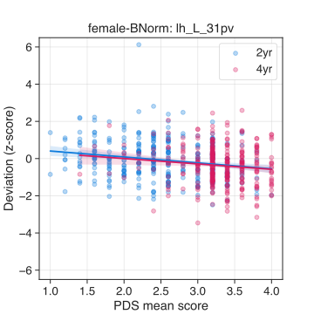 | 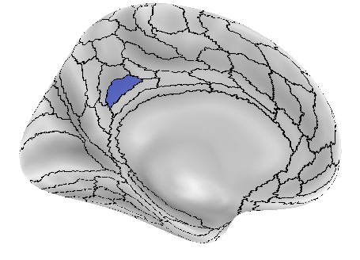
Figure S 26 Association experiment: PDS with z - C-Norm.
Area 31pv of the left hemisphere yielded a significant association effect at the 2-year follow-up (t=-3.985, p<0.0244) between mean PDS scores and the z (i.e., deviation scores) as obtained from the female C-Norm model. Left panel shows the scatter plot with regression lines. Colors correspond to either the 2-year (blue) or 4-year (red) data. Right panel shows the location of area 31pv.

Adjusting for family structure in training- and test-set.
We performed the same analysis as in the main text, however adjusting for family relationships before training the C- and B-Norm models. We opted for this auxillary analysis because the ABCD dataset has high proportions of siblings/twins.
Before training, we removed all participants from the training set that had a familial relationship with participants in the test set. If there were family relations in the test set, we randomly chose one of the siblings to remain in the test set. This resulted in 37 and 26 less males (new N=402) and females (new N=340) respectively.

Interestingly, we did not find the previously reported associations in the reported areas (see main text). Significance values increased to 0.0965 for the left 31pv and to 0.0636 for the left LO2, IFSa, PoI2 and LO3.
Given these results we briefly investigated the “family-adjusted” models for performance and difference in predicted norms compared to the “all-subs” models. We further tested whether the statistics (e.g., p-values) for the association analysis (“PDS ~ z”) was markedly different between the “all-subs” and “family-adjusted” models.

    - Differences in performance
Similar to the analysis of performance measures in the main text we investigated whether adjusting for family structure leads to differences in performance measures. Looking at the similar structures in the graphs below, we opted to not do the extra statistics because the patterns between the “all-subs” and “family-adjusted” models appears largely identical.
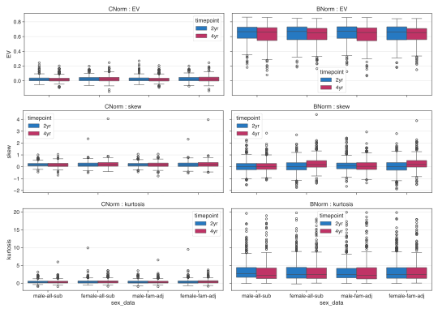
Figure S 27. Comparing performance metrics between C- and B-Norm models using all-subs or family-adjusted data.
Each panel depicts one of three performance measures for the models using all- or family-adjusted subjects (denoted as <sex>-all-sub or <sex>-fam-adj on the x-axis respectively). From top to bottom: explained variance (EV), skew, and kurtosis for both models (columns).As is evident from the pattern of the box plots, we do not see any marked effect of adjusting for family relationships in the training or test set.

    - Differences in predicted norms
We evaluated whether adjusting for family-relationship yields differences between the norms within each of the C- and B-Norm models. To do so, we loaded the predicted values (yhat) of the test set and used the PCNtoolkit to warp them (since our model uses the SinArcsin warp; see Methods in the main text).
For each model (C-Norm and B-Norm), we computed the normalized Euclidean distance between the predicted values obtained using the all-subject data and those obtained using the family-adjusted data.We repeated this process for all 360 Glasser regions.
Normalized Euclidean Distance values indicated high overlap between C- and B-Norm model norms suggesting that adjusting for family structure had likely no effect on model parameters (see table below).

Table S 10. Normalized Euclidean Distance between predicted norms of the test set using models trained with all participants and those trained adjusting for family structure.
 |  | Normalized Euclidean Distance
Sex | Model | Min | Max | Mean  (across ROIs) | Std  (across ROIs)
Male | C-Norm | 0.00241 | 0.00984 | 0.00079 | 0.00069
Male | B-Norm | 0.00014 | 0.01117 | 0.00061 | 0.00075
female | C-Norm | 0.00020 | 0.06120 | 0.00098 | 0.00331
female | B-Norm | 0.00013 | 0.02385 | 0.00064 | 0.00129

    - Potential sample size problem?
We performed a correlation analysis to assess whether a drop in sample sizes potentially affected our significant ROIs. We used Pearson's correlation across all ROIs of -log10-transformed p-values for each of the conditions (i.e., for each sex specific model for each timepoint) of the "all-subs" test set and the "family-adjusted" test set. The correlations can be seen in the table below.
Interestingly, we observed lowes correlations for the 2-year follow-up data for male B-Norm models. Importantly, the correlations for the female B-Norm models of the 4-year follow-up data (which showed most marginally significant results) were almost perfectly correlated.

Table S 11. Pearson’s correlation of p-values from “PDS~z” GLM association tests between models using all participants (as determined by preprocessing) and models trained with family-adjusted data..
Sex | Model | Timepoint | Pearson’s rho
male | CNorm | 2yr | 0.877
male | CNorm | 4yr | 0.914
male | BNorm | 2yr | 0.778
male | BNorm | 4yr | 0.934
female | CNorm | 2yr | 0.960
female | CNorm | 4yr | 0.959
female | Bnorm | 2yr | 0.955
female | Bnorm | 4yr | 0.979

Validation of normative models using percentile shifts
As a final validation step, similar to longitudinal changes used in pediatrics, we validated our normative models by categorizing participants into three groups based on percentile shifts between the 2-year and 4-year follow-up data: negative (zDiff < -1), stable (-1 < zDiff < 1), and positive (zDiff > 1), with zDiff representing the change in ROI-specific z-scores over time. For each ROI, participants were assigned to one of these groups, and a Kruskal-Wallis test was conducted to assess group differences in ΔPDS scores (4-year minus 2-year). No group differences survived multiple comparison correction using the Benjamini-Hochberg procedure (male: min p-uncorrected=0.001142, p-corrected=0.2723 for right PFop in the B-Norms; female: min p-uncorrected=0.001286, p-corrected=0.4526 for left PHA2 in the C-Norms). Nevertheless, regions showing uncorrected p-values < 0.05 are displayed in Figure 4 for the female C-Norms (left) and B-Norms (right), along with corresponding boxplots of delta PDS scores for the most notable ROIs (TGv and PHA2 in the C-Norms; p24pr and PHA2 in the B-Norms, all left hemisphere). Of note, due to insufficient sample sizes within deviation groups, Kruskal-Wallis tests could not be performed in the following regions of the female C-Norms: MT, VMV1, and L31a (left hemisphere), and TE1a, PHT, PH, TPOJ1, VMV1, VMV2, and TE1m (right hemisphere). Figure S24 shows a similar graph for the male models.

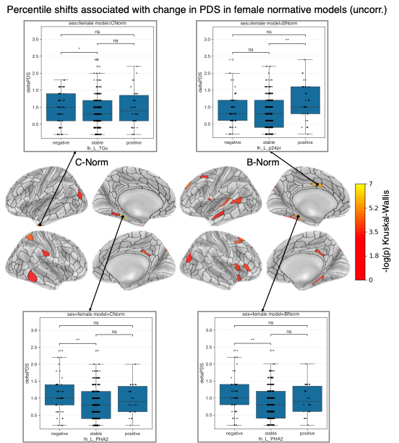
Figure S 28 Percentile shifts as indicators of individual level brain development and pubertal progress
Uncorrected significant -log-transformed p-values of a Kruskal-Wallis test plotted on the surface brain for female C-Norms (left) and B-Norms (right). Arrows connecting ROIs with boxplots indicate the two largest effects for an area in the left temporal pole (TGv) and left peri-hippocampal area PHA2 for the C-Norms or for parts of the left cingulate cortex (area p24pr) and area PHA2 for the B-Norms. The boxplots show delta PDS scores across the three groups: negative (zDiff < -1), stable (-1 < zDiff < 1), and positive (zDiff > 1). Black dots represent individual participants. Asterisks above connecting boxes indicate the significance of pair-wise Dunn’s tests (n.s.: p>0.05, *: p<0.05, **: p<0.01).

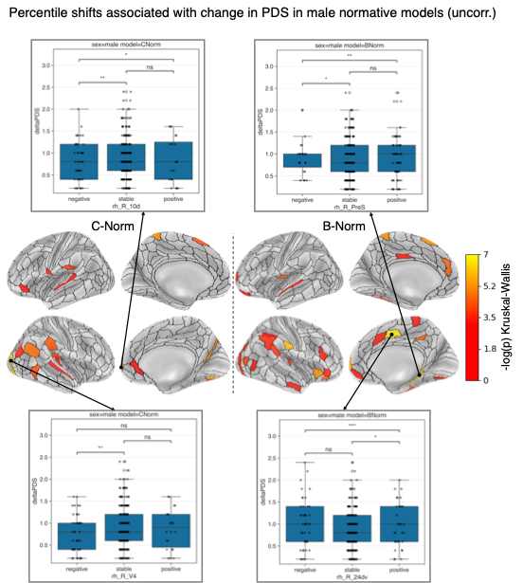
Figure S 29 Validation of male normative models with percentile shifts and change in pubertal progress.
Uncorrected significant -log-transformed p-values of a Kruskal-Wallis test plotted on the surface brain for male C-Norms (left) and B-Norms (right). Arrows connecting ROIs with boxplots indicate the two largest effects for an area in the right visual (V4) and frontal cortex (10d) for the C-Norms or for a section of the left frontal cortex (area p24pr) and the presubiculum (PreS) for the B-Norms. The boxplots show delta PDS scores across the three groups: negative (zDiff < -1), stable (-1 < zDiff < 1), and positive (zDiff > 1). Black dots represent individual participants. Asterisks above connecting boxes indicate the significance of pair-wise Dunn’s tests (n.s.: p>0.05, *: p<0.05, **: p<0.01).
sss

