Supplemental Material
Table S1. Fit Statistics for latent class models
Model | Parameters | LL | AIC | BIC | aBIC | Entropy | χ² (p) | G² (p)
1-Class | 5 | -14319.08 | 28648.15 | 28680.63 | 28664.75 | 1.00 | 2889.77 (<0.001) | 304.01 (<0.001)
2-Class | 11 | -10589.82 | 21201.64 | 21273.10 | 21238.15 | 0.85 | 847.92 (<.001) | 550.46 (0.03)
3-Class | 17 | -5016.44 | 10066.87 | 10164.76 | 10110.75 | 0.79 | 255.44 (<.001) | 175.73 (<.001)
4-Class | 23 | -4935.76 | 9917.53 | 10049.97 | 9976.89 | 0.77 | 12.61 (0.14) | 14.38 (0.04)
5-Class | 29 | -4929.08 | 9916.16 | 10083.15 | 9991.01 | 0.78 | 0.84 (0.36) | 0.60 (0.25)
Notes. LL: Loglikelihood; AIC: Akaike Information Criterion; BIC: Bayesian Information Criteria; aBIC: Adjusted BIC; χ ²: Pearson Chi-Square; G²: Likelihood Ratio Chi-Square. p: significance level. Bolded class represents the final solution.

Table S2. Father presence across time by class
 |  | Birth | Year 1 | Year 3 | Year 5 | Year 9
Class | n | % | % | % | % | %
Consistently absent | 1812 | 6.2 | 1.6 | 1.5 | 2.0 | 16.0
Early absence/Later presence | 398 | 20.5 | 9.8 | 53.6 | 95.6 | 92.3
Early presence/Later absence | 846 | 67.7 | 65.6 | 40.5 | 21.4 | 44.6
Consistently present | 1842 | 75.6 | 95.7 | 96.6 | 100.0 | 96.4
Notes. n: sample size. %: percentage

Table S3. Results of multiple mediation analysis for social comparisons of puberty
Direct effect | β (SE) | t | p | LLCI, ULCI
Girls’ social comparisons of puberty (age 9)
Class 1: Consistently absent
Child BMI | -0.183 (0.158) | -1.155 | 0.248 | -0.493, 0.127
Material Hardship | -0.066 (0.038) | -1.726 | 0.084 | -0.140, 0.008
Depression | -0.158 (0.043) | -3.671 | 0.000 | -0.242, -0.074
Class 2: Early absence/Later presence
Child BMI | 0.024 (0.342) | 0.070 | 0.944 | -0.646, 0.694
Material Hardship | 0.067 (0.088) | 0.769 | 0.442 | -0.105, 0.239
Depression | -0.250 (0.085) | -2.939 | 0.003 | -0.417, -0.083
Class 3: Early presence/Later absence
Child BMI | -0.234 (0.222) | -1.056 | 0.291 | -0.669, 0.201
Material Hardship | -0.047 (0.060) | -0.783 | 0.434 | -0.165, 0.071
Depression | -0.166 (0.086) | -1.929 | 0.054 | -0.335, 0.003
Class 4: Consistently present
Child BMI | -0.067 (0.144) | -0.467 | 0.641 | -0.349, 0.215
Material Hardship | 0.024 (0.042) | 0.562 | 0.574 | -0.058, 0.106
Depression | -0.170 (0.059) | -2.892 | 0.004 | -0.286, -0.054
Girls’ social comparisons of puberty (age 15)
Class 1: Consistently absent
Child BMI | 0.029 (0.143) | 0.203 | 0.839 | -0.251, 0.309
Material Hardship | 0.035 (0.036) | 0.973 | 0.330 | -0.036, 0.106
Depression | -0.120 (0.043) | -2.798 | 0.005 | -0.204, -0.036
Class 2: Early absence/Later presence
Child BMI | 0.775, (0.380) | 2.042 | 0.041 | 0.030, 1.520
Material Hardship | 0.138 (0.092) | 1.488 | 0.137 | -0.042, 0.318
Depression | -0.149 (0.107) | -1.390 | 0.165 | -0.359, 0.061
Class 3: Early presence/Later absence
Child BMI | -0.035 (0.221) | -0.159 | 0.874 | -0.468, 0.398
Material Hardship | 0.002 (0.064) | 0.039 | 0.969 | -0.123, 0.127
Depression | -0.074 (0.088) | -0.849 | 0.396 | -0.246, 0.098
Class 4: Consistently present
Child BMI | -0.174 (0.132) | -1.319 | 0.187 | -0.433, 0.085
Material Hardship | 0.007 (0.038) | 0.175 | 0.861 | -0.067, 0.081
Depression | -0.104 (0.054) | -1.932 | 0.053 | -0.210, 0.002
Boys’ social comparisons for puberty at age 9
Class 1: Consistently absent
Child BMI | 0.174 (0.175) | 0.995 | 0.320 | -0.169, 0.517
Material Hardship | 0.036 (0.040) | 0.903 | 0.367 | -0.042, 0.114
Depression | -0.144 (0.046) | -3.121 | 0.002 | -0.234, -0.054
Class 2: Early absence/Later presence
Child BMI | 0.069 (0.536) | 0.129 | 0.897 | -0.982, 1.120
Material Hardship | -0.141 (0.188) | -0.753 | 0.451 | -0.509, 0.227
Depression | -0.251 (0.211) | -1.194 | 0.233 | -0.665, 0.163
Class 3: Early presence/Later absence
Child BMI | -0.391 (0.273) | -1.434 | 0.151 | -0.926, 0.144
Material Hardship | 0.025 (0.076) | 0.325 | 0.745 | -0.124, 0.174
Depression | -0.227 (0.086) | -2.638 | 0.008 | -0.396, -0.058
Class 4: Consistently present
Child BMI | -0.232 (0.163) | -1.426 | 0.154 | -0.551, 0.087
Material Hardship | -0.023 (0.049) | -0.458 | 0.647 | -0.119, 0.073
Depression | -0.250 (0.060) | -4.157 | 0.001 | -0.368, -0.132
Boys’ social comparisons for puberty at age 15
Class 1: Consistently absent
Child BMI | 0.090 (0.137) | 0.652 | 0.514 | -0.178, 0.358
Material Hardship | -0.019 (0.034) | -0.553 | 0.581 | -0.086, 0.048
Depression | -0.022 (0.041) | -0.551 | 0.581 | -0.102, 0.058
Class 2: Early absence/Later presence
Child BMI | 0.629 (0.348) | 1.809 | 0.071 | -0.053, 1.311
Material Hardship | 0.199 (0.094) | 2.124 | 0.034 | 0.015, 0.383
Depression | -0.118 (0.110) | -1.067 | 0.286 | -0.334, 0.098
Class 3: Early presence/Later absence
Child BMI | -0.167 (0.193) | -0.864 | 0.387 | -0.545, 0.211
Material Hardship | -0.039 (0.052) | -0.753 | 0.451 | -0.141, 0.063
Depression | -0.139 (0.069) | -2.020 | 0.043 | -0.274, -0.004
Class 4: Consistently present
Child BMI | -0.297 (0.105) | -2.830 | 0.005 | -0.503, -0.091
Material Hardship | -0.006 (0.033) | -0.176 | 0.860 | -0.071, 0.059
Depression | -0.011 (0.049) | -0.228 | 0.820 | -0.107, 0.085
Notes. Bolded rows are significant at p < .05 for ease of interpretation. All direct effects on the outcome (social comparisons of puberty at age 9 and 15) are depicted. There were no significant indirect effects. β:unstandardized beta value. SE: Standard error. t: t-value. p: significance level. LLCI: Lower limit confidence interval. ULCI: Upper limit confidence interval.
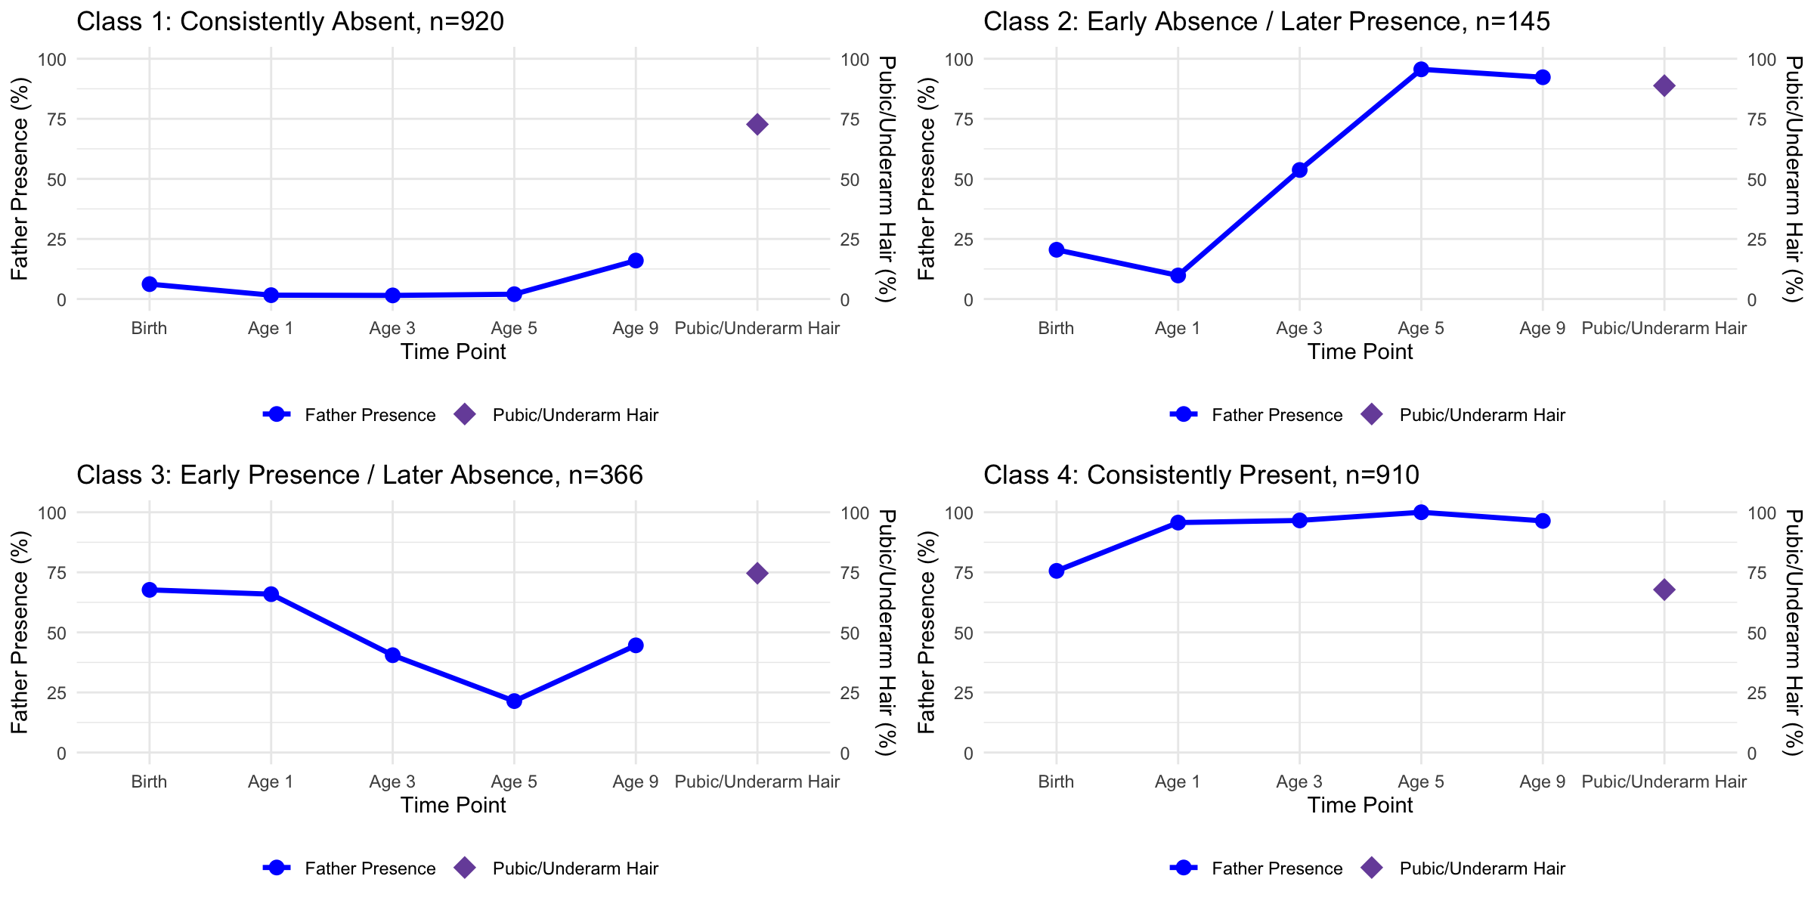
72.7%
88.8%
74.6%
67.8%
Figure S1. Father Presence and Girls’ Pubic and Underarm Hair Growth at Age 9. The relationship between father presence across five time points (birth, ages 1, 3, 5, and 9) and girls’ pubic and underarm hair growth at age 9 for each latent class. The solid blue line indicates the percent of fathers present across time points, the purple diamond marker represents the estimated percentage of individuals within each latent class who experienced pubic and underarm hair growth at age 9. A.) 72.7% of girls in the consistent absent class reported pubic and underarm hair at year 9. B.) 88.8% of girls in the early absence/later presence class reported pubic and underarm hair at year 9. C.) 74.6% of girls in the early presence/later absence class reported pubic and underarm hair at year 9. D.) 67.8% of girls in the consistently present class reported pubic and underarm hair at year 9. Subscripts represent significant differences between latent classes. ¹ = significantly different from the consistently absent class. ² = significantly different from the early absence/later presence class. ³ = significantly different from the early presence/later absence class. ⁴ = significantly different from the consistently present class. * p < .05, ** p < .01, *** p < .001

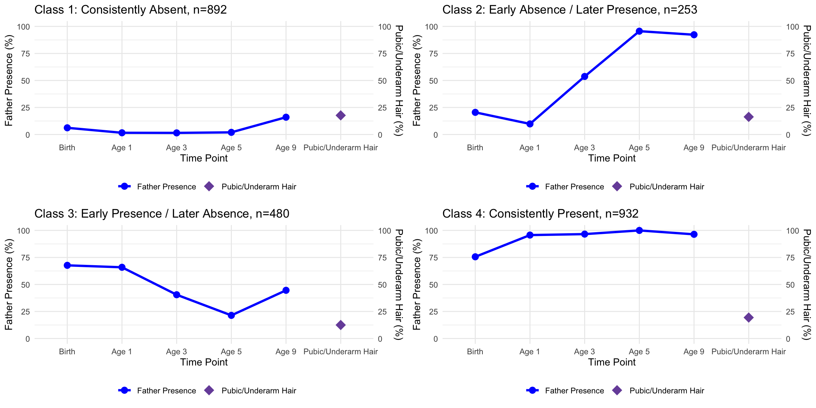
17.7%
16.3%
12.5%
19.4%
Figure S2. Father Presence and Boys’ Pubic and Underarm Hair Growth at Age 9. The relationship between father presence across five time points (birth, ages 1, 3, 5, and 9) and boys’ pubic and underarm hair at age 9 for each latent class. The solid blue line indicates the percent of fathers present across time points, the purple diamond marker represents the estimated percentage of individuals within each latent class who experienced pubic and underarm hair at age 9. A.) 17.7% of boys in the consistent absent class reported pubic and underarm hair at year 9. B.) 16.3% of boys in the early absence/later presence class reported pubic and underarm hair at year 9. C.) 12.5% of boys in the early presence/later absence class reported pubic and underarm hair at year 9. D.) 19.4% of boys in the consistently present class reported pubic and underarm hair at year 9. Subscripts represent significant differences between latent classes. ¹ = significantly different from the consistently absent class. ² = significantly different from the early absence/later presence class. ³ = significantly different from the early presence/later absence class. ⁴ = significantly different from the consistently present class. * p < .05, ** p < .01, *** p < .001

