Supplementary Material
Content

- Supplementary Tables
- Supplementary Table 1: Socioeconomic characteristics of the estimation, internal validation, and external validation cohort stratified by sex.
  - Supplementary Table 2: Correlation between gender-related variables within the estimation cohort.
  - Supplementary Table 3: Principal component analysis.
  - Supplementary Table 4: Mean and median gender scores by sex across cohorts
  - Supplementary Table 5: Logistic regression coefficients of gender-related factors associated with biological sex performed in the estimation set.
  - Supplementary Table 6: Association between biological sex and individual items from the gender score with cardiometabolic and health conditions
  - Supplementary Table 7: Association between individual items from the gender score with cardiometabolic and health conditions stratified by sex

- Supplementary Figures
  - Supplementary Figure 1: Gender-related questions included in the questionnaire.
  - Supplementary Figure 2: Flowchart providing an overview of the estimation and validation data sets.
  - Supplementary Figure 3: Violin plots of gender score distribution by sex across datasets
Supplementary Table 1: Socioeconomic characteristics of the estimation, internal validation, and external validation cohort stratified by sex. SD, standard deviation; BEM score, measure used to assess gender roles.

Gender-Related Variables | Estimation set (n = 1,882) |  |  | Internal validation set (n = 808) |  |  | External validation set (n = 337)
Gender-Related Variables | Male  (n = 1,026) | Female  (n = 856) | p-value | Male  (n = 441) | Female  (n = 367) | p-value | Male  (n = 158) | Female  (n = 179) | p-value
Education |  |  | 0.59 |  |  | 0.37 |  |  | 0.22
No education qualification (%) | 61 (5.9) | 50 (5.8) |  | 21 (4.8) | 18 (4.9) |  | 5 (3.2) | 6 (3.4)
Primary education (%) | 55 (5.4) | 59 (6.9) |  | 25 (5.7) | 31 (8.4) |  | 11 (7.0) | 15 (8.4)
Secondary education or vocational degree (%) | 403 (39.3) | 332 (38.8) |  | 174 (39.5) | 150 (40.9) |  | 80 (50.6) | 107 (59.8)
University or technical college degree (%) | 507 (49.4) | 415 (48.5) |  | 221 (50.1) | 168 (45.8) |  | 62 (39.2) | 51 (28.5)
Marital status |  |  | 0.52 |  |  | 0.028 |  |  | 0.067
married/partnership (%) | 700 (68.2) | 572 (66.8) |  | 320 (72.6) | 240 (65.4) |  | 121 (76.6) | 121 (67.6)
living alone (%) | 326 (31.8) | 284 (33.2) |  | 121 (27.4) | 127 (34.6) |  | 37 (23.4) | 58 (32.4)
Income |  |  | <0.001 |  |  | <0.001 |  |  | <0.001
Earns highest income in household (%) | 717 (69.9) | 365 (42.6) |  | 300 (68.0) | 138 (37.6) |  | 109 (69.0) | 85 (47.5)
Earns lowest income in household (%) | 166 (16.2) | 349 (40.8) |  | 72 (16.3) | 167 (45.5) |  | 17 (10.8) | 63 (35.2)
Equal between partners (%) | 143 (13.9) | 142 (16.6) |  | 69 (15.6) | 62 (16.9) |  | 32 (20.3) | 31 (17.3)
Main person responsible for household work |  |  | <0.001 |  |  | <0.001 |  |  | <0.001
No (%) | 334 (32.6) | 108 (12.6) |  | 151 (34.2) | 47 (12.8) |  | 43 (27.2) | 18 (10.1)
Yes (%) | 318 (31.0) | 481 (56.2) |  | 125 (28.3) | 207 (56.4) |  | 45 (28.5) | 113 (63.1)
Equal distribution between partners (%) | 374 (36.5) | 267 (31.2) |  | 165 (37.4) | 113 (30.8) |  | 70 (44.3) | 48 (26.8)
Average domestic stress level (score 0 - 10) – Mean (SD) | 3.0 (2.0) | 3.7 (2.3) | <0.001 | 3.0 (1.8) | 3.9 (2.5) | <0.001 | 2.8 (1.8) | 3.3 (2.2) | 0.034
Main responsibility for childcare/care of family members (min 1 - max 6) – mean (SD) | 1.7 (2.1) | 1.8 (2.3) | 0.13 | 1.6 (2.1) | 2.1 (2.3) | 0.005 | 1.5 (1.9) | 1.7 (2.1) | 0.56
BEM score (overall) | 5.0 (0.9) | 4.9 (0.9) | 0.006 | 5.0 (1.0) | 4.9 (0.9) | 0.19 | 4.9 (0.8) | 4.9 (0.9) | 0.65
I am someone who …
(min 1 – max 7) – mean (SD)
…defends his own opinion. | 5.4 (1.3) | 5.5 (1.4) | 0.39 | 5.5 (1.4) | 5.5 (1.4) | 0.87 | 5.3 (1.3) | 5.5 (1.3) | 0.30
…has leadership qualities. | 5.2 (1.4) | 4.8 (1.6) | <0.001 | 5.1 (1.5) | 4.8 (1.5) | 0.004 | 5.1 (1.2) | 4.8 (1.5) | 0.026
…is independent. | 5.6 (1.4) | 5.7 (1.4) | 0.12 | 5.6 (1.4) | 5.7 (1.4) | 0.22 | 5.5 (1.4) | 5.7 (1.3) | 0.18
…is willing to take risks. | 4.6 (1.6) | 4.3 (1.6) | <0.001 | 4.6 (1.6) | 4.2 (1.6) | 0.002 | 4.7 (1.6) | 4.5 (1.4) | 0.31
…is positive. | 5.5 (1.4) | 5.5 (1.4) | 0.96 | 5.4 (1.4) | 5.6 (1.4) | 0.073 | 4.5 (1.4) | 4.8 (1.7) | 0.020
…is assertive. | 5.3 (1.3) | 5.2 (1.3) | 0.19 | 5.2 (1.4) | 5.2 (1.3) | 0.76 | 5.3 (1.2) | 5.3 (1.2) | 0.56
…has a strong personality. | 5.4 (1.3) | 5.4 (1.4) | 0.64 | 5.4 (1.4) | 5.4 (1.3) | 0.63 | 5.2 (1.2) | 5.4 (1.2) | 0.19
…is ready to take a stand. | 5.5 (1.3) | 5.3 (1.4) | 0.012 | 5.5 (1.3) | 5.4 (1.3) | 0.39 | 5.5 (1.2) | 5.6 (1.2) | 0.31
…is energetic. | 4.8 (1.5) | 4.8 (1.6) | 0.74 | 4.8 (1.5) | 4.7 (1.5) | 0.29 | 4.8 (1.4) | 4.9 (1.4) | 0.35
…is aggressive. | 2.6 (1.4) | 2.3 (1.4) | <0.001 | 2.6 (1.5) | 2.3 (1.4) | 0.001 | 2.8 (1.5) | 2.5 (1.4) | 0.040
Self-assessment of gender identity (scale 1–7; 1 = predominantly traits traditionally labelled as masculine, 7 = predominantly traits traditionally labelled as feminine), mean (SD) | 2.4 (1.4) | 5.5 (1.3) | <0.001 | 2.3 (1.4) | 5.5 (1.3) | <0.001 | 2.1 (1.1) | 5.5 (1.6) | <0.001

Supplementary Table 2: Correlation between gender-related variables within the estimation cohort (n=1,882). Correlation coefficient for each variable is presented. BEM score, measure used to assess gender roles.

(n = 1,882) | Education | Marital status | Income | Main person responsible for household work | Average domestic stress level | Main responsibility for childcare/care of family members | …defends his own opinion. | …has leadership qualities | …is independent | …is willing to take risks | …is positive. | …is assertive. | …has a strong personality. | …is ready to take a stand. | …is energetic.
Education | 1
Marital status | -0.0122 | 1
Income | -0.0500 | -0.2881 | 1
Main person responsible for household work | 0.1167 | -0.2214 | 0.2374 | 1
Average domestic stress level | -0.0615 | -0.0758 | 0.0535 | 0.0097 | 1
Main responsibility for childcare/care of family members | -0.1041 | -0.2502 | 0.0634 | 0.0258 | 0.3234 | 1
Personal characteristics according to BEM score.
I am someone who…
…defends his own opinion. | 0.0624 | -0.0427 | -0.0029 | 0.0142 | -0.0434 | 0.0439 | 1
…has leadership qualities. | 0.1683 | -0.0728 | -0.0875 | 0.0621 | -0.0493 | 0.0334 | 0.4618 | 1
…is independent. | 0.1876 | 0.0573 | -0.0918 | 0.0624 | -0.1226 | -0.0347 | 0.4235 | 0.3781 | 1
…is willing to take risks. | 0.1132 | 0.0457 | -0.0725 | -0.0137 | -0.0353 | -0.0208 | 0.2908 | 0.3489 | 0.3883 | 1
…is positive. | 0.0659 | -0.0300 | -0.0299 | 0.0599 | -0.1540 | 0.0568 | 0.3016 | 0.3147 | 0.3767 | 0.3459 | 1
…is assertive. | 0.0462 | -0.0223 | -0.0566 | 0.0189 | -0.0785 | 0.0371 | 0.5289 | 0.5193 | 0.4147 | 0.3755 | 0.4460 | 1
…has a strong personality. | 0.0523 | -0.0349 | -0.0214 | 0.0453 | -0.0435 | 0.0535 | 0.5267 | 0.5451 | 0.4549 | 0.3618 | 0.4553 | 0.6877 | 1
…is ready to take a stand. | 0.1444 | -0.0284 | -0.0526 | 0.0280 | -0.0808 | 0.0457 | 0.5631 | 0.5580 | 0.4599 | 0.3756 | 0.4026 | 0.6187 | 0.6784 | 1
…is energetic. | 0.0491 | -0.0110 | -0.0540 | 0.0028 | 0.0566 | 0.0878 | 0.4008 | 0.3823 | 0.3044 | 0.3672 | 0.3026 | 0.4403 | 0.4996 | 0.4909 | 1
…is aggressive. | -0.0031 | -0.0393 | -0.0240 | -0.0171 | 0.1477 | 0.0707 | 0.0661 | 0.0928 | -0.0841 | 0.1381 | -0.1369 | 0.0592 | 0.0787 | 0.0684 | 0.2688

Supplementary Table 3: Principal component analysis (PCA). PCA performed on the estimation cohort (n=1,882), with factor loadings for ten principal components (PCs) presented. The PCs are ranked according to the variance they capture. A total of 13 gender-related variables were found to load onto the 10 retained PCs, with the identified factors highlighted in bold.

Gender-related factors | Principal Components (PCs)
Gender-related factors | 1 | 2 | 3 | 4 | 5 | 6 | 7 | 8 | 9 | 10
Education | -0.0049 | 0.0043 | 0.0096 | -0.0179 | 0.0081 | -0.0058 | 0.9824 | 0.0063 | -0.0087 | -0.0113
Marital status | 0.0072 | -0.0065 | 0.0239 | -0.0489 | 0.0817 | 0.8763 | -0.0063 | -0.0795 | -0.0174 | -0.1181
Income | 0.0133 | -0.0132 | 0.0082 | -0.0019 | 0.0369 | -0.0574 | 0.0082 | 0.9471 | 0.0045 | -0.0528
Main person responsible for household work | -0.0065 | 0.0167 | 0.0134 | -0.0257 | 0.0144 | -0.0123 | -0.0087 | 0.0035 | 0.9855 | -0.0164
Domestic stress level | -0.0044 | -0.0352 | -0.0539 | 0.0511 | 0.9343 | 0.0613 | 0.0097 | 0.0366 | 0.0175 | 0.0761
Main responsibility for childcare/care of family members | 0.0031 | 0.0308 | 0.0769 | -0.0836 | 0.1053 | -0.1222 | -0.0180 | -0.0718 | -0.0278 | 0.8610
BEM score (overall)
I am someone who …
(min 1 – max 7) – mean (SD)
…defends his own opinion. | 0.5310 | -0.0166 | -0.3187 | -0.0237 | -0.0872 | 0.0438 | -0.0562 | 0.1166 | -0.0542 | 0.1189
…has leadership qualities. | 0.3587 | -0.0169 | 0.0118 | 0.0263 | 0.1678 | -0.3295 | 0.0660 | -0.2533 | 0.0270 | -0.2638
…is independent. | 0.3097 | -0.2259 | -0.3090 | 0.4513 | -0.1911 | 0.2112 | 0.0773 | 0.0024 | 0.1292 | 0.2844
…is willing to take risks. | -0.0483 | 0.0869 | 0.1084 | 0.8606 | 0.0890 | -0.0772 | -0.0376 | -0.0036 | -0.0561 | -0.1100
…is positive. | -0.0258 | -0.1574 | 0.7442 | 0.1365 | -0.1297 | 0.0467 | 0.0263 | 0.0208 | 0.0350 | 0.1347
…is assertive. | 0.3626 | -0.0009 | 0.2558 | -0.0655 | 0.0562 | -0.0490 | -0.0894 | -0.0343 | -0.0204 | -0.1259
…has a strong personality. | 0.3855 | 0.0313 | 0.2516 | -0.0934 | 0.0721 | 0.0088 | -0.0554 | 0.0228 | 0.0157 | -0.0768
…is ready to take a stand. | 0.4196 | 0.0337 | 0.1003 | -0.0754 | 0.0002 | -0.0059 | 0.0757 | 0.0053 | -0.0349 | -0.0209
…is energetic. | 0.1827 | 0.4380 | 0.2725 | 0.0112 | -0.0020 | 0.2086 | 0.0436 | 0.0962 | 0.0028 | 0.1364
…is aggressive. | -0.0245 | 0.8482 | -0.1201 | 0.0633 | -0.0482 | -0.0277 | 0.0022 | -0.0305 | 0.0277 | 0.0127

Supplementary Table 4. Sex-specific distribution of the composite gender score across study cohorts. Mean (standard deviation) and median (interquartile range) values of the gender score are shown separately for males and females in the estimation, internal validation, and external validation cohorts. The mean difference between males and females with corresponding 95% confidence intervals is reported. The gender score ranges from 0 to 100, with higher values indicating a greater expression of traits historically labelled as feminine and lower values indicating traits historically labelled as masculine.

 |  | Male | Female | Mean difference (95%CI)
Estimation set | Mean (SD) | 35.3 (20.6) | 59.1 (22.3) | -23.8 (-25.7, -21.8)
Estimation set | Median (IQR) | 37.4 (16.6-50.4) | 56.3 (45.3-77.6)
Internal validation set | Mean (SD) | 34.6 (21.3) | 61.9 (22.0) | -27.2 (-30.2, -24.2)
Internal validation set | Median (IQR) | 35.6 (14.9-49.2) | 60.0 (46.8-83.0)
External validation set | Mean (SD) | 32.7 (20.7) | 57.1 (21.9) | -24.4 (-29.0, -19.8)
External validation set | Median (IQR) | 30.0 (15.3-48.0) | 55.5 (44.2-74.1)

Supplementary Table 5: Logistic regression coefficients of gender-related factors associated with biological sex performed in the estimation set (n = 1,882). A full model derived from the principal component analysis( PCA) as well as a reduced model, containing only factors showing significant associations with biological sex in the full model, are presented. BEM score, measure used to assess gender roles. AIC, Akaike information criterion. BIC, Bayesian information criterion.

Gender-related factors | Full model derived from PCA |  | Reduced model
 | Coefficient estimate | p-value | Coefficient estimate | p-value
Intercept | -3.372 |  | -2.963
Education
No education qualification | Reference
Primary education | 0.435 | 0.164
Secondary education or vocational degree | 0.305 | 0.208
University or technical college degree | 0.331 | 0.168
Marital status
married/partnership | Reference
living alone | -0.041 | 0.759
Income
Earns highest income in household | Reference |  | Reference
Earns lowest income in household | 2.110 | <0.001 | 2.092 | <0.001
Equal between partners | 1.191 | <0.001 | 1.184 | <0.001
Main person responsible for household work
No | Reference |  | Reference
Yes | 2.200 | <0.001 | 2.197 | <0.001
Equal distribution between partners | 0.956 | <0.001 | 0.965 | <0.001
Main responsibility for childcare/care of family members | -0.032 | 0.248
Average domestic stress level (score 0 - 10) | 0.144 | <0.001 | 0.134 | <0.001
BEM score (overall)
I am someone who …
(min 1 – max 7) – mean (SD)
…defends his own opinion. | 0.107 | 0.029 | 0.117 | 0.015
…is independent. | 0.176 | <0.001 | 0.192 | <0.001
…is willing to take risks. | -0.144 | <0.001 | -0.120 | 0.002
…is positive. | 0.052 | 0.262
…is ready to take a stand. | -0.149 | 0.007 | -0.109 | 0.036
…is energetic. | 0.067 | 0.121
…is aggressive. | -0.137 | 0.001 | -0.133 | 0.001
AIC | 2,122.45 |  | 2,115.86
BIC | 2,222.17 |  | 2,176.80
ROC | 0.780 |  | 0.776

 | Diabetes |  | Hypertension |  | Dyslipidemia |  | Obesity  (BMI > 30kg/m²) |  | Known coronary artery disease |  | Previous stroke/TIA
 | OR [95%CI] | p-value | OR [95%CI] | p-value | OR [95%CI] | p-value | OR [95%CI] | p-value | OR [95%CI] | p-value | OR [95%CI] | p-value
Female sex | 0.29 [0.18, 0.45] | <0.001 | 0.58 [0.45, 0.75] | <0.001 | 0.57 [0.42, 0.79] | <0.001 | 0.69 [0.53, 0.89] | 0.005 | 0.23 [0.11, 0.45] | <0.001 | 0.16 [0.05, 0.50] | 0.001
Income
Earns highest income in household | Reference |  | Reference |  | Reference |  | Reference |  | Reference |  | Reference
Earns lowest income in household | 1.10 [0.72, 1.67] | 0.660 | 0.62 [0.47, 0.84] | 0.002 | 0.57 [0.40, 0.82] | 0.002 | 0.82 [0.62, 1.09] | 0.175 | 0.51 [0.27, 0.96] | 0.037 | 0.64 [0.24, 1.71] | 0.375
Equal between partners | 0.83 [0.47, 1.44] | 0.502 | 0.92 [0.66, 1.29] | 0.637 | 0.90 [0.61, 1.34] | 0.612 | 0.87 [0.61, 1.23] | 0.430 | 1.00 [0.52, 1.91] | 0.999 | 2.05 [0.73, 5.74] | 0.173
Main person responsible for household work
No | Reference |  | Reference |  | Reference |  | Reference |  | Reference |  | Reference
Yes | 0.80 [0.52, 1.23] | 0.302 | 0.80 [0.60, 1.06] | 0.126 | 0.51 [0.36, 0.73] | <0.001 | 0.91 [0.68, 1.23] | 0.549 | 0.35 [0.20, 0.62] | <0.001 | 0.70 [0.32, 1.55] | 0.379
Equal distribution between partners | 0.75 [0.49, 1.16] | 0.200 | 0.76 [0.57, 1.02] | 0.063 | 0.65 [0.47, 0.92] | 0.013 | 0.79 [0.59, 1.07] | 0.133 | 0.44 [0.26, 0.75] | 0.003 | 0.21 [0.07, 0.59] | 0.003
Average domestic stress level (score 0-10) | 1.12 [1.04, 1.21] | 0.003 | 0.97 [0.92, 1.02] | 0.229 | 1.00 [0.94, 1.07] | 0.930 | 1.07 [1.01, 1.12] | 0.014 | 1.00 [0.90, 1.12] | 0.959 | 1.00 [0.84, 1.19] | 0.968
I am someone who …
(min 1 – max 7) – mean (SD)
…defends his own opinion. | 1.04 [0.90, 1.21] | 0.609 | 1.00 [0.91, 1.10] | 0.995 | 0.89 [0.80, 1.00] | 0.049 | 1.04 [0.94, 1.15] | 0.428 | 0.90 [0.75, 1.09] | 0.283 | 0.82 [0.63, 1.07] | 0.151
…is independent. | 0.91 [0.79, 1.04] | 0.162 | 0.88 [0.81, 0.97] | 0.009 | 0.89 [0.80, 0.99] | 0.035 | 0.87 [0.79, 0.95] | 0.003 | 1.01 [0.84, 1.20] | 0.940 | 0.77 [0.59, 1.00] | 0.054
…is willing to take risks. | 0.88 [0.78, 0.98] | 0.026 | 0.89 [0.83, 0.96] | 0.003 | 0.96 [0.87, 1.05] | 0.379 | 0.94 [0.87, 1.02] | 0.131 | 0.87 [0.75, 1.01] | 0.070 | 1.06 [0.84, 1.33] | 0.622
…is ready to take a stand. | 0.98 [0.83, 1.15] | 0.778 | 1.05 [0.95, 1.17] | 0.341 | 0.96 [0.85, 1.09] | 0.547 | 1.04 [0.93, 1.16] | 0.499 | 0.96 [0.78, 1.18] | 0.684 | 1.32 [0.96, 1.83] | 0.091
…is aggressive. | 1.04 [0.92, 1.16] | 0.556 | 1.02 [0.95, 1.10] | 0.550 | 1.00 [0.91, 1.10] | 0.975 | 1.04 [0.96, 1.12] | 0.331 | 1.05 [0.91, 1.22] | 0.502 | 0.68 [0.51, 0.92] | 0.012
Supplementary Table 6. Association between biological sex and individual items from the gender score (derived from principal component analysis) with cardiometabolic (A) and health conditions (B). OR, odds ratio; CI, confidence interval; SD, standard deviation; BMI, body mass index; TIA, transient ischemic attack; COPD, chronic obstructive pulmonary disease; HIV, human immunodeficiency virus. Significant associations are highlighted in bold, while non-significant associations are presented in light grey.
A

B | Immune system disorders (e.g., autoimmune diseases) |  | Psychiatric diseases |  | Pulmonary diseases (e.g., asthma, COPD, pulmonary hypertension) |  | Bone diseases (e.g., osteoporosis) |  | Infectious diseases (e.g., HIV, hepatitis)
 | OR [95%CI] | p-value | OR [95%CI] | p-value | OR [95%CI] | p-value | OR [95%CI] | p-value | OR [95%CI] | p-value
Female sex | 1.90 [1.38, 2.61] | <0.001 | 1.82 [1.00, 3.34] | 0.052 | 1.39 [1.02, 1.89] | 0.037 | 2.15 [1.12, 4.14] | 0.021 | 0.95 [0.52, 1.72] | 0.862
Income
Earns highest income in household | Reference |  | Reference |  | Reference |  | Reference |  | Reference
Earns lowest income in household | 0.78 [0.55, 1.11] | 0.167 | 0.82 [0.44, 1.56] | 0.551 | 0.82 [0.58, 1.15] | 0.248 | 1.17 [0.58, 2.37] | 0.66 | 0.31 [0.13, 0.73] | 0.007
Equal between partners | 0.85 [0.55, 1.31] | 0.462 | 0.95 [0.42, 2.16] | 0.903 | 1.02 [0.67, 1.56] | 0.911 | 1.86 [0.81, 4.25] | 0.143 | 0.84 [0.38, 1.87] | 0.673
Main person responsible for household work
No | Reference |  | Reference |  | Reference |  | Reference |  | Reference
Yes | 1.60 [1.04, 2.45] | 0.033 | 0.59 [0.30, 1.17] | 0.134 | 0.89 [0.62, 1.29] | 0.54 | 2.04 [0.86, 4.83] | 0.105 | 0.80 [0.41, 1.56] | 0.516
Equal distribution between partners | 1.55 [1.00, 2.41] | 0.049 | 0.62 [0.30, 1.27] | 0.193 | 0.75 [0.51, 1.10] | 0.142 | 1.17 [0.47, 2.95] | 0.732 | 0.62 [0.30, 1.28] | 0.196
Average domestic stress level (score 0-10) | 0.99 [0.93, 1.06] | 0.8 | 1.12 [1.01, 1.25] | 0.04 | 1.05 [0.99, 1.11] | 0.126 | 0.82 [0.70, 0.95] | 0.007 | 0.95 [0.83, 1.08] | 0.398
I am someone who …
(min 1 – max 7) – mean (SD)
…defends his own opinion. | 0.95 [0.84, 1.07] | 0.365 | 1.18 [0.93, 1.49] | 0.182 | 0.95 [0.84, 1.07] | 0.405 | 1.07 [0.84, 1.36] | 0.576 | 0.96 [0.76, 1.21] | 0.72
…is independent. | 0.88 [0.78, 0.99] | 0.04 | 0.82 [0.66, 1.01] | 0.06 | 0.99 [0.88, 1.11] | 0.813 | 0.77 [0.61, 0.96] | 0.022 | 0.95 [0.76, 1.19] | 0.678
…is willing to take risks. | 0.94 [0.85, 1.03] | 0.199 | 0.99 [0.83, 1.19] | 0.93 | 1.06 [0.96, 1.16] | 0.271 | 0.92 [0.76, 1.12] | 0.400 | 0.94 [0.79, 1.13] | 0.533
…is ready to take a stand. | 1.06 [0.92, 1.21] | 0.43 | 0.93 [0.73, 1.19] | 0.573 | 1.02 [0.89, 1.16] | 0.821 | 0.94 [0.73, 1.22] | 0.647 | 1.09 [0.84, 1.41] | 0.534
…is aggressive. | 1.10 [1.00, 1.21] | 0.06 | 0.88 [0.72, 1.07] | 0.19 | 1.15 [1.05, 1.26] | 0.003 | 0.98 [0.80, 1.21] | 0.871 | 1.17 [0.99, 1.38] | 0.068

Supplementary Table 7. Association between individual items from the gender score (derived from principal component analysis) with cardiometabolic (A) and health conditions (B) stratified by biological sex. OR, odds ratio; CI, confidence interval; SD, standard deviation; BMI, body mass index; TIA, transient ischemic attack; COPD, chronic obstructive pulmonary disease; HIV, human immunodeficiency virus. Significant associations are highlighted in bold, while non-significant associations are presented in light grey.

A | Diabetes |  | Hypertension |  | Dyslipidemia |  | Obesity  (BMI > 30kg/m²) |  | Known coronary artery disease |  | Previous stroke/TIA
A | Female | Male | Female | Male | Female | Male | Female | Male | Female | Male | Female | Male
Income
Earns highest income in household | Reference |  | Reference |  | Reference |  | Reference |  | Reference |  | Reference
Earns lowest income in household | 0.91  [0.40, 2.07] | 1.17  [0.72, 1.92] | 0.90  [0.58, 1.41] | 0.51  [0.34, 0.78] | 0.80  [0.45, 1.45] | 0.49  [0.30, 0.79] | 1.04  [0.69, 1.57] | 0.68  [0.45, 1.03] | 2.16 [0.39,11.98] | 0.37  [0.17, 0.80] | 0.29  [0.02, 4.60] | 0.72  [0.25, 2.04]
Equal between partners | 0.92  [0.31, 2.71] | 0.74  [0.38, 1.44] | 1.41  [0.80, 2.47] | 0.77  [0.51, 1.17] | 1.49  [0.72, 3.06] | 0.74  [0.45, 1.21] | 0.92  [0.52, 1.62] | 0.87  [0.55, 1.36] | 3.38 [0.48,23.77] | 0.87  [0.43, 1.77] | 4.72 [0.37,60.16] | 1.84  [0.60, 5.66]
Main person responsible for household work
No | Reference |  | Reference |  | Reference |  | Reference |  | Reference |  | Reference
Yes | 0.98  [0.31, 3.06] | 0.80  [0.50, 1.30] | 1.43  [0.75, 2.73] | 0.67  [0.48, 0.94] | 0.80  [0.38, 1.66] | 0.43  [0.28, 0.65] | 1.67  [0.88, 3.15] | 0.77  [0.54, 1.10] | 0.71  [0.13, 3.96] | 0.32  [0.17, 0.59] | 0.48  [0.04, 5.88] | 0.68  [0.29, 1.60]
Equal distribution between partners | 1.33  [0.40, 4.46] | 0.69  [0.43, 1.12] | 1.05  [0.52, 2.12] | 0.75  [0.54, 1.04] | 0.69  [0.31, 1.57] | 0.68  [0.47, 0.98] | 1.48  [0.75, 2.93] | 0.66  [0.46, 0.94] | 0.71  [0.11, 4.62] | 0.42  [0.24, 0.74] | N/A | 0.25  [0.09, 0.70]
Average domestic stress level (score 0-10) | 1.18  [1.03, 1.36] | 1.09  [1.00, 1.20] | 0.98  [0.90, 1.06] | 0.96  [0.89, 1.03] | 1.00  [0.90, 1.11] | 1.00  [0.92, 1.08] | 1.07  [0.99, 1.15] | 1.07  [0.99, 1.14] | 0.96  [0.74, 1.26] | 1.00  [0.89, 1.13] | 0.90  [0.58, 1.39] | 1.01  [0.84, 1.22]
I am someone who …
(min 1 – max 7)
…defends his own opinion. | 1.30  [0.92, 1.82] | 0.98  [0.83, 1.16] | 0.91  [0.78, 1.07] | 1.04  [0.92, 1.18] | 0.88  [0.72, 1.07] | 0.90  [0.78, 1.03] | 1.06  [0.90, 1.24] | 1.03  [0.90, 1.17] | 1.16  [0.66, 2.05] | 0.87  [0.72, 1.06] | 0.86  [0.37, 1.99] | 0.82  [0.62, 1.10]
…is independent. | 0.78  [0.59, 1.04] | 0.94  [0.81, 1.10] | 0.96  [0.82, 1.13] | 0.86  [0.76, 0.96] | 0.89  [0.73, 1.09] | 0.89  [0.79, 1.02] | 0.92  [0.79, 1.07] | 0.84  [0.75, 0.95] | 0.72  [0.44, 1.18] | 1.06  [0.88, 1.29] | 0.58  [0.25, 1.32] | 0.80  [0.60, 1.06]
…is willing to take risks. | 0.80  [0.63, 1.02] | 0.91  [0.79, 1.03] | 0.91  [0.80, 1.04] | 0.89  [0.81, 0.97] | 0.90  [0.76, 1.06] | 0.99  [0.89, 1.11] | 0.94  [0.83, 1.07] | 0.95  [0.86, 1.05] | 0.83  [0.54, 1.27] | 0.88  [0.75, 1.04] | 1.13  [0.56, 2.25] | 1.05  [0.83, 1.34]
…is ready to take a stand. | 1.13  [0.82, 1.56] | 0.93  [0.77, 1.12] | 0.94  [0.79, 1.12] | 1.12  [0.98, 1.28] | 0.98  [0.78, 1.21] | 0.95  [0.81, 1.11] | 0.94  [0.80, 1.12] | 1.10  [0.95, 1.27] | 1.34  [0.74, 2.44] | 0.91  [0.73, 1.13] | 1.18  [0.47, 2.96] | 1.35  [0.95, 1.91]
…is aggressive. | 0.96  [0.74, 1.24] | 1.05  [0.92, 1.20] | 1.00  [0.87, 1.15] | 1.03  [0.94, 1.13] | 0.96  [0.80, 1.15] | 1.01  [0.91, 1.13] | 1.12  [0.99, 1.26] | 0.99  [0.90, 1.09] | 0.99  [0.63, 1.55] | 1.06  [0.90, 1.24] | 0.92  [0.43, 1.96] | 0.65  [0.47, 0.90]

B | Immune system disorders (e.g., autoimmune diseases) |  | Psychiatric diseases |  | Pulmonary diseases (e.g., asthma, COPD, pulmonary hypertension) |  | Bone diseases (e.g., osteoporosis) |  | Infectious diseases (e.g., HIV, hepatitis) |  | Immune system disorders (e.g., autoimmune diseases)
B | Female | Male | Female | Male | Female | Male | Female | Male | Female | Male | Female | Male
Income
Earns highest income in household | Reference |  | Reference |  | Reference |  | Reference |  | Reference |  | Reference
Earns lowest income in household | 0.88  [0.57, 1.37] | 0.69  [0.36, 1.34] | 0.59  [0.27, 1.29] | 1.32  [0.48, 3.65] | 0.27  [0.04, 1.72] | 6.59 [0.91,47.68] | 1.03  [0.66, 1.62] | 0.63  [0.36, 1.13] | 0.99  [0.43, 2.30] | 1.50  [0.36, 6.22] | 0.31  [0.09, 0.99] | 0.36  [0.11, 1.23]
Equal between partners | 1.18  [0.68, 2.06] | 0.50  [0.24, 1.06] | 0.49  [0.15, 1.62] | 1.98  [0.63, 6.20] | 2.94 [0.51,16.89] | N/A | 1.11  [0.61, 2.02] | 0.98  [0.54, 1.76] | 1.45  [0.50, 4.19] | 2.82 [0.72,11.05] | 0.35  [0.07, 1.72] | 1.33  [0.52, 3.37]
Main person responsible for household work
No | Reference |  | Reference |  | Reference |  | Reference |  | Reference |  | Reference
Yes | 2.21  [1.06, 4.61] | 1.25  [0.70, 2.23] | 0.68  [0.25, 1.81] | 0.49  [0.16, 1.46] | 1.30 [0.14,12.03] | 1.07 [0.08,14.74] | 1.27  [0.67, 2.43] | 0.68  [0.42, 1.12] | 1.96  [0.54, 7.10] | 2.16  [0.61, 7.58] | 2.10 [0.26,17.02] | 0.67  [0.30, 1.48]
Equal distribution between partners | 1.86  [0.85, 4.05] | 1.55  [0.89, 2.67] | 0.78  [0.26, 2.33] | 0.51  [0.19, 1.36] | N/A | 1.58 [0.21,11.73] | 0.89  [0.44, 1.82] | 0.72  [0.45, 1.15] | 1.49  [0.38, 5.88] | 0.74  [0.19, 2.85] | 1.61 [0.17,14.82] | 0.54  [0.24, 1.22]
Average domestic stress level (score 0-10) | 0.98  [0.91, 1.07] | 1.00  [0.89, 1.11] | 1.08  [0.94, 1.24] | 1.22  [1.02, 1.46] | 1.01  [0.77, 1.32] | 0.90  [0.54, 1.48] | 1.02  [0.94, 1.11] | 1.08  [0.98, 1.18] | 0.80  [0.67, 0.95] | 0.86  [0.65, 1.14] | 0.96  [0.80, 1.15] | 0.94  [0.78, 1.12]
I am someone who …
(min 1 – max 7)
…defends his own opinion. | 0.96  [0.82, 1.13] | 0.91  [0.75, 1.10] | 1.16  [0.85, 1.59] | 1.26  [0.86, 1.84] | 1.27  [0.67, 2.41] | 0.67  [0.35, 1.26] | 0.95  [0.80, 1.12] | 0.94  [0.79, 1.11] | 1.13  [0.83, 1.55] | 1.00  [0.69, 1.47] | 0.93  [0.63, 1.37] | 0.97  [0.73, 1.29]
…is independent. | 0.87  [0.74, 1.02] | 0.91  [0.76, 1.08] | 0.74  [0.56, 0.98] | 0.92  [0.67, 1.28] | 0.51  [0.29, 0.90] | 1.04  [0.52, 2.11] | 1.11  [0.92, 1.33] | 0.91  [0.77, 1.07] | 0.65  [0.49, 0.87] | 0.99  [0.68, 1.44] | 1.23  [0.81, 1.88] | 0.86  [0.66, 1.12]
…is willing to take risks. | 0.93  [0.82, 1.06] | 0.95  [0.82, 1.11] | 1.01  [0.79, 1.28] | 0.96  [0.72, 1.27] | 1.12  [0.71, 1.79] | 0.98  [0.54, 1.78] | 1.04  [0.91, 1.19] | 1.08  [0.94, 1.24] | 0.89  [0.70, 1.14] | 0.98  [0.71, 1.37] | 0.98  [0.73, 1.32] | 0.93  [0.75, 1.16]
…is ready to take a stand. | 1.09  [0.91, 1.30] | 1.01  [0.81, 1.24] | 1.02  [0.74, 1.38] | 0.82  [0.56, 1.21] | 1.10  [0.60, 2.04] | 1.40  [0.61, 3.24] | 1.09  [0.90, 1.32] | 0.94  [0.78, 1.14] | 1.14  [0.81, 1.60] | 0.68  [0.45, 1.03] | 0.87  [0.58, 1.31] | 1.22  [0.88, 1.71]
…is aggressive. | 1.06  [0.93, 1.20] | 1.15  [0.99, 1.33] | 0.86  [0.66, 1.13] | 0.88  [0.65, 1.19] | 1.10  [0.70, 1.74] | 1.08  [0.58, 2.02] | 1.15  [1.01, 1.31] | 1.15  [1.01, 1.30] | 1.01  [0.79, 1.30] | 0.92  [0.64, 1.32] | 1.36  [1.03, 1.78] | 1.08  [0.88, 1.34]

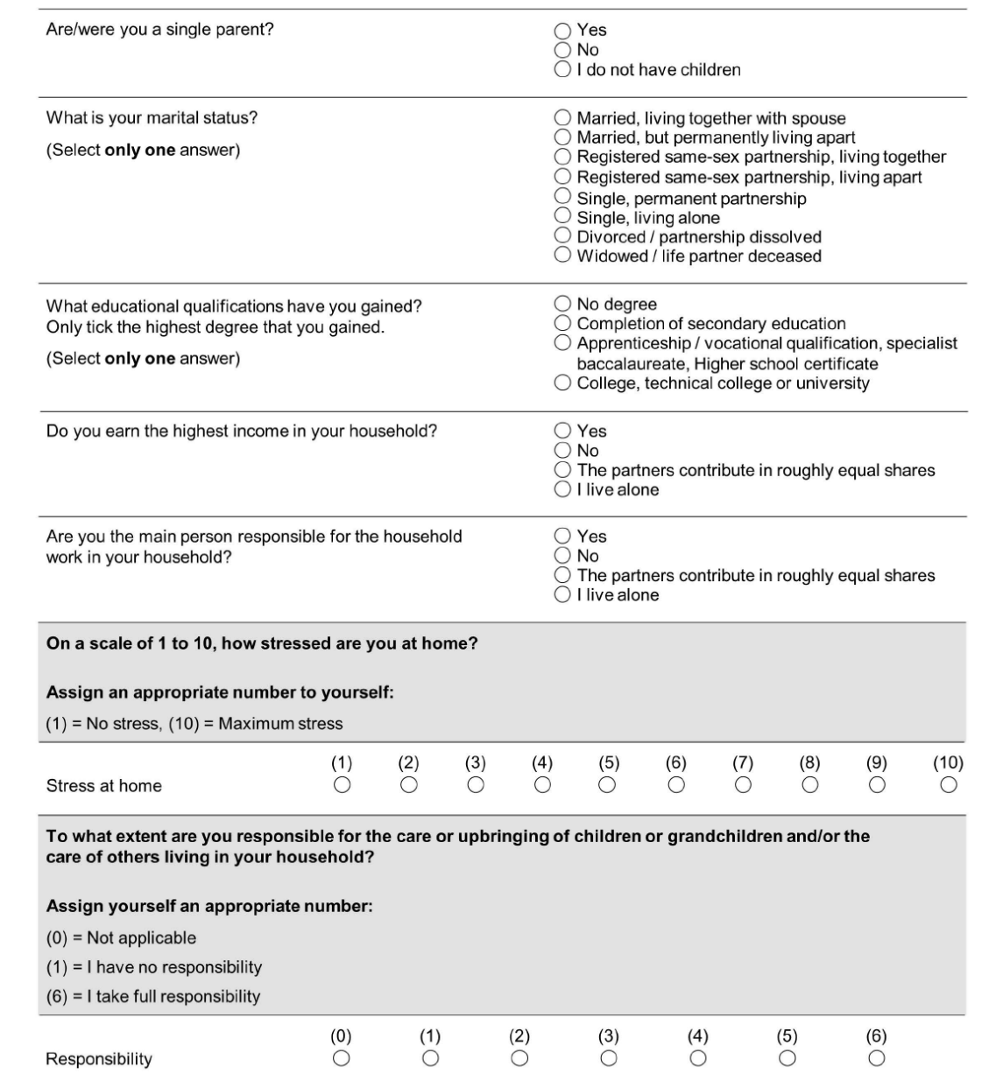
Supplementary Figure 1: Gender-related questions included in the questionnaire.

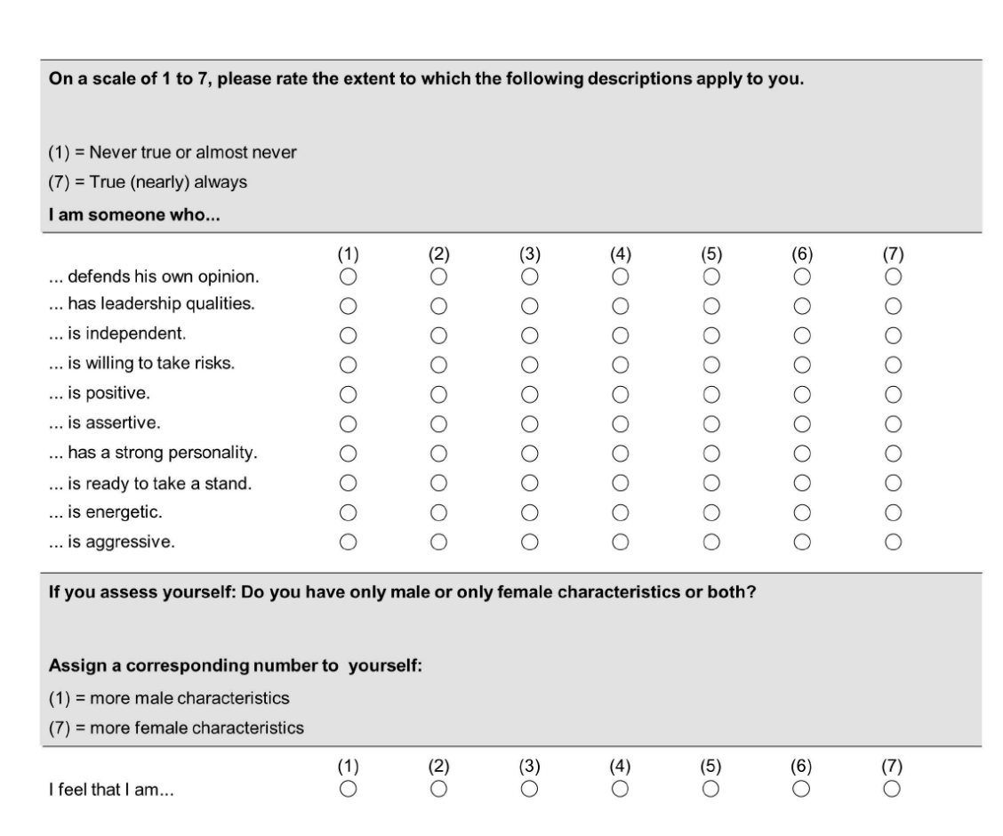

Supplementary Figure 2: Flowchart providing an overview of the estimation and validation data sets.

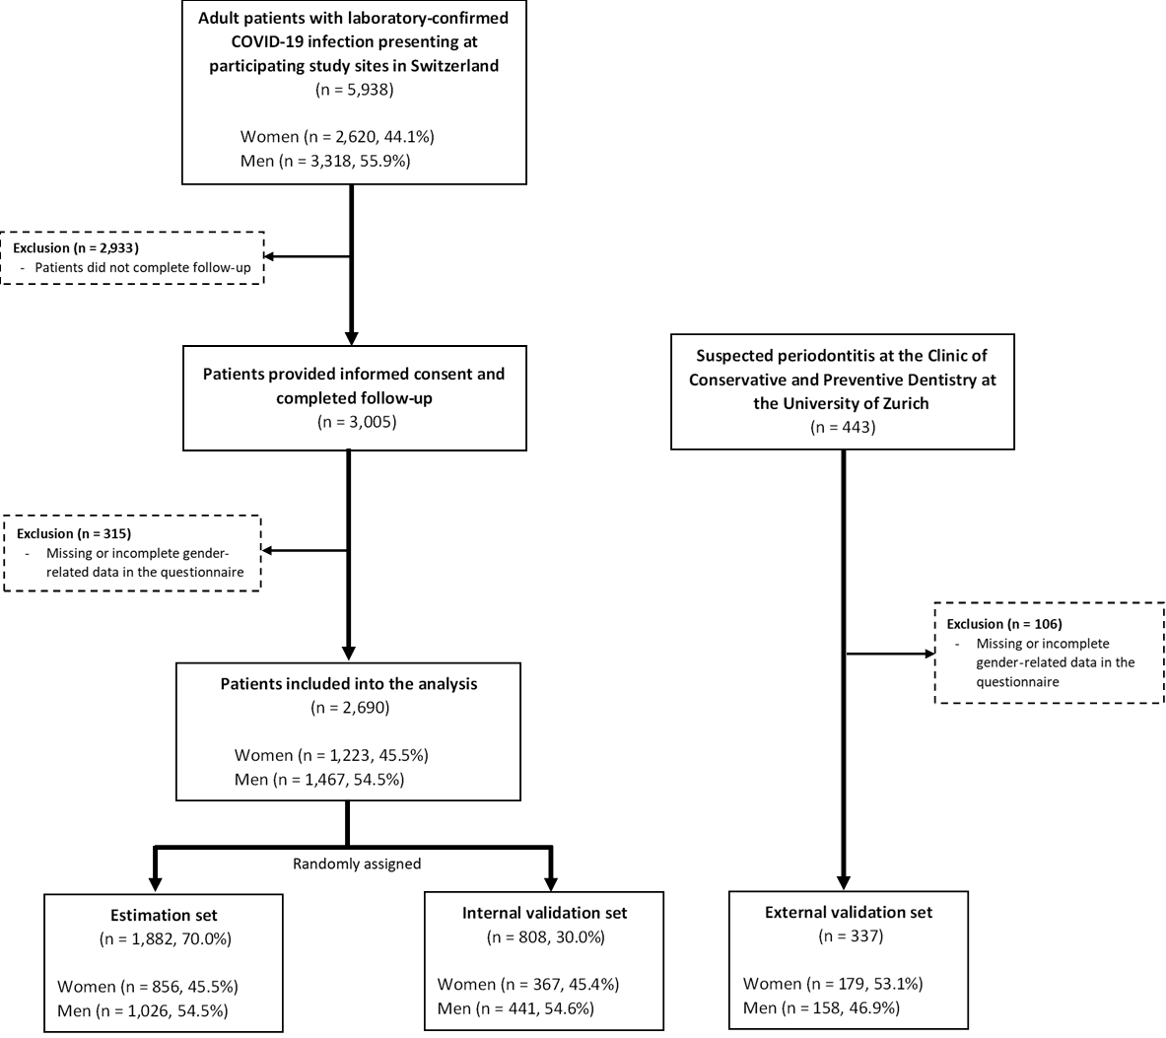

Supplementary Figure 3: Distribution of the gender score by biological sex across the estimation, internal validation, and external validation cohorts. Violin plots display the distribution of gender scores within each dataset, with embedded boxplots showing medians and interquartile ranges.
